Kindergarten Math Assignment
This assignment is partially aligned to the standards.
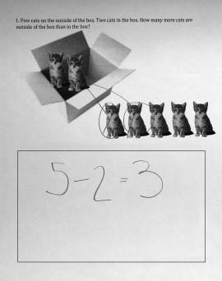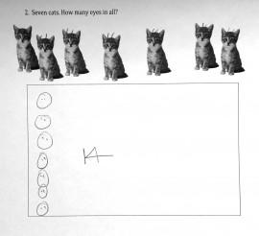

Overview
Kindergarten students complete two addition and subtraction word problems about cats. This assignment gives students a chance to model real-world situations mathematically, but only one of the two problems is well-aligned with a kindergarten standard.

Related Standards
KY.K.CC.5: Count to answer "how many?" questions about as many as 20 things arranged in a line, a rectangular array, or a circle, or as many as 10 things in a scattered configuration; given a number from 1-20, count out that many objects.
KY.K.OA.2: Solve addition and subtraction word problems and add and subtract within 10 by using objects or drawings to represent the problem.

Why is this assignment partially aligned?
The assignment includes one problem that is well-aligned with a kindergarten standard and one problem that isn’t.
The first problem, in which students solve a “how many more?” subtraction word problem, is well aligned with KY.K.OA.2. The number types (5-2) and representations (pictures of cats) are appropriate because the standard requires subtracting within 10 using visual representations.
The second problem, in which students count the number of total eyes for seven cats, is not well aligned with KY.K.CC.5. The number of objects (14) is appropriate, but the standard also specifies that when counting 11-20 objects, the objects should be arranged in an organized way (a line, array, or circle) to help students grasp one-to-one correspondence. In this assignment, the objects (cats’ eyes) are arranged in a scattered configuration, which—according to the standard—should be reserved for counting less than 11 objects. And because students are counting pairs of eyes, there is an implicit focus on counting by 2s, which is above grade level for kindergarten (as standard KY.K.CC.1 only requires that Kindergarten students count by 1s, 10s and count backwards from 30 by ones ).
KY.K.CC.5 focuses on the procedural skill of counting within 20, and the second problem requires that students count to 14. However, Kindergarten students should be practicing the procedural skill of counting between 11-20 objects arranged in a line, circle, or array (not in a scattered configuration, as students do in this assignment). KY.K.OA.2 focuses on the application of addition and subtraction to the real world, and the first problem requires students to subtract within the real-world context of number of cats in boxes.
Practice Standards
This assignment allows students to engage with two mathematical practice standards. Interpreting what the word problem is asking students to do in the first problem gives students the chance to engage with Mathematical Practice Standard #1 ("Make sense of problems and persevere in solving them"). Representing the real-world topic in both problems (number of cats and number of eyes) symbolically with written numerals gives students the chance to engage with Mathematical Practice Standard #4 ("Model with mathematics").

