Kindergarten Math Assignment
This assignment is weakly aligned to the standards.
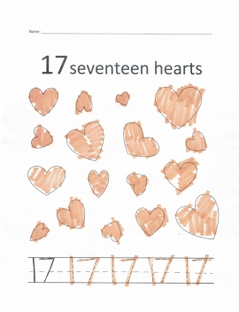
Overview
Kindergarten students color in 17 hearts and trace the numeral 17. This assignment is weak because it only requires students to color and trace; students do not actually have to count anything or write any numerals independently.

Related Standards
KY.K.CC.3: Write numbers from 0 to 20. Represent a number of objects with a written numeral 0-20 (with 0 representing a count of no objects).
KY.K.CC.5: Count to answer "how many?" questions about as many as 20 things arranged in a line, a rectangular array, or a circle, or as many as 10 things in a scattered configuration; given a number from 1-20, count out that many objects.

Why is this assignment weakly aligned?
The assignment is not well aligned with either of the target standards:
KY.K.CC.3 requires students to write numerals from 0 to 20 and represent a set of objects with the corresponding numeral. In this assignment, students were not required to write the numeral 17 independently and there is no evidence that they were prompted to connect the numeral 17 with the number of hearts on the worksheet.
KY.K.CC.5 requires students to count up to 20 objects, with larger numbers of objects arranged in an organized way (a line, array, or circle) to help students grasp one-to-one correspondence, the understanding that one number represents one object being counted. In this assignment, the number of objects (17) is appropriate, but the objects are not organized as the standard requires (as scattered configurations of objects, such as the hearts in the assignment, should be reserved for counting fewer than 11 objects). There also isn’t evidence that students actually had to count the objects at all; the assignment title states that there are 17 hearts and students could color them in without making any connection to counting.
This assignment doesn’t help students build conceptual understanding, which is required by KY.K.CC.3. Kindergarten students are just beginning to learn the foundational concept that a set of objects can be represented symbolically with a written numeral. Assignments that ask students to count objects and write numerals should explicitly make that connection (for example, by having students count the amounts of objects in multiple sets and independently write the corresponding numerals).

