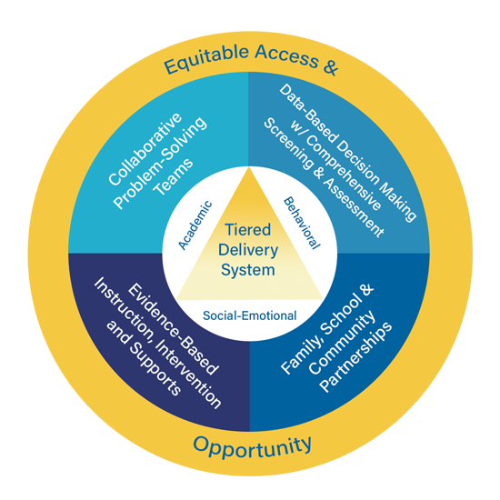
Multi-Tiered System of Supports (MTSS)

In Secondary Schools

Facilitator Guide

Approximate Time Breakdown

Facilitator Module Preparation
- MTSS in Secondary Schools Video Module (10 minutes and 20 seconds)
- Review Facilitator Guide and Participant Guide (20 minutes)

Video and Discussion Session
- Video (10 minutes and 20 seconds)
- Team Discussion and Activities: (30 to 45 minutes)

Facilitator Preparation and Resources

- Review the Facilitator Guide;
- Watch MTSS in Secondary Schools Video Module;
- Review Participant Guide;
- Reference Kentucky Multi-Tiered System of Supports (KyMTSS) common language key terms and video outline sections as needed prior to and during the professional learning session as needed;
- Review the Post Video Discussion and Questions and select the questions to use with the team; and
- Review optional activities section.

Facilitator Guide Purpose and Goal

The purpose of the facilitator’s guide is to assist with virtual or in-person professional learning sessions regarding KyMTSS. This guide is intended to be used by administrators, instructional coaches or anyone leading a professional learning session on KyMTSS. The primary goal is to support the learning and implementation of MTSS at the district, school, classroom and student level. The guide provides the overview and resources needed for the facilitation of video viewing and team discussion.

Session Focus

In this module, KyMTSS in secondary schools will be explored. The content focuses on effective MTSS at the secondary level. Participants will get an overview of the essential elements at the secondary level to create a learning environment that meets the needs of every student.

Session Participant Materials

- Participant Guide
- Pen or pencil
- Optional highlighter and post-it notes.

Video and Team Discussion

Facilitator Prompt to Activate Learning: Prior to showing the video, allow participants time to complete the “my current understanding and questions” portion MTSS as an Integrated Framework in Secondary Schools portion on the participant guide. The facilitator may use the “my current understanding and questions” section below to record any notes. Initially, participants will only focus on the first key concept, MTSS as an Integrated Framework in Secondary Schools. Allow time for discussion and sharing, and then watch the video. While watching the video, participants will continue to take notes and generate questions using the table on the next page. Refer to the directions in the participant guide for further information. The documents and sites referenced in the video are hyperlinked in the facilitator and participant guides.

As the facilitator, you may choose to pause at any time in the viewing process for team discussion, questions and clarifications.

Icon Legend
These icons indicate the suggested grouping for reflection, discussion and activities.

Individual | Partner or Small Group | Whole Group

Facilitator Note Taking Tool

Key Concept | My Current Understanding | Questions
MTSS as an Integrated Framework in Secondary Schools

Directions: While watching the video, use the table below to write notes and questions regarding the key concepts related to MTSS at the secondary level. The participant guide provides this table too. Teams may discuss the key concepts and respond to the questions after the video.

Key Concept | New Learning | Questions
Unique Features of MTSS at the Secondary Level
Scheduling Secondary School MTSS
Teaming in Secondary School MTSS
Universal Screening in Secondary School MTSS
Data Usage in Secondary School MTSS

Participant Video Reflection

Directions: After watching the video, use the table on the next page to write down your thoughts, questions and any realization regarding MTSS at the secondary level.

Thoughts
Questions
Realizations
- Allow time for participants to share initial thoughts, lingering questions, and key concept realizations.

Post Video Discussion and Questions

Directions: The questions below are intended to guide a discussion regarding the learning from the video. Prior to the time with the team, determine the questions you wish to use. Consider the time, content and groupings for the discussion as you select the questions.

- How does our current MTSS Framework incorporate the six essential elements of KyMTSS?
- How might this learning impact our MTSS implementation process or planning for next steps?
- How do we ensure everyone in our district or school has a represented voice?
- Does our schedule provide:
  - Time for common planning and/or meetings?
  - Dedicated intervention and enrichment blocks?
  - Content experts’ involvement in MTSS Team?
- How are we choosing a scheduling model based on data and works best for student needs?
- Where do we have strengths in our current schedule?
- What unique challenges does our school have that need to be addressed to meet the needs of every student?
- How might we ensure the effectiveness of the MTSS layered, tiered delivery system in our school or district?
- How might we provide additional support for Tier 1 academic, behavioral and social emotional learning?
- When does non-academic instruction occur in our school?
- How does non-academic instruction occur in our school?
- Discuss how, when and where Tier 2 and Tier 3 instruction might occur in the school?
- What questions do you have regarding MTSS implementation in secondary school?
- How might I provide additional support for Tier 1 instruction, intervention and support for my students?
- What professional learning or resources might be needed to support?
- How might this learning impact your role in the MTSS System?
- What next steps might you consider based on today’s learning?

Post Video Closing Questions

Closing  Questions | - How might this learning impact the MTSS implementation process or planning for next steps?  - How might we address potential logistical barriers to an integrated MTSS Framework?  - Who else might benefit from this learning?  - What information confirmed your beliefs about the importance of MTSS in ensuring student success at the secondary level?

Next Steps

Directions: The facilitator and participants may use the table below to discuss and write down the next steps with MTSS implementation in the school or district. Use the questions and prompts to guide the process.

Guiding Questions | Who will lead the work? Who might need to be included in the next step? What resources are available or what resources might be needed? | Start and Projected Completion Date

What is the next step for our team or me regarding MTSS implementation?

Resources

Referenced in Video:

- Four-Step Problem Solving Model

KyMTSS Implementation Guide
- Teaming Structure
- Team Member Roles and Responsibilities
- Team Communication Plan Template
- National Center on Intensive Intervention (Screening Tools Chart)
Resources (continued)

- Assessment Calendar Template
- Data Inventory Template

For Further Guidance:
- Resources for Collaborative Problem-Solving Teams
- KyMTSS Self-Assessment Tool
- NIRN Communication Plan Worksheet
- CIBRS Initiative Inventory
- Data Inventory Template
- NIRN Initiative Inventory

Optional Activities (Extended Time)

Directions: Below are two optional activities for the team, other staff members or individuals to extend the learning from the video and discussion. The activities provide a more in-depth look at the resources available through KyMTSS to support MTSS implementation. With the MTSS Team, gather the materials and use the Optional Activity Slides as a guide for the optional activities below.

MTSS Team Review of Current Practices
Materials needed:
  - MTSS Secondary Level Slides
  - Master Schedule
  - Intervention Schedule (academic, behavioral and social emotional)
  - Enrichment Schedule (academic, behavioral and social emotional)
  - School-wide Comprehensive Data for review and reference as needed (academic, behavioral and social emotional)

MTSS Team Self-Assessment and Action Planning
Materials needed:
  - KyMTSS Self-Assessment Slides – Slides for guiding the self-assessment and action planning process.
  - KyMTSS Self-Assessment Tool – Template for team to use during the self-assessment and planning process.
  - KyMTSS Implementation Guide – Team may use this guide as an accompanying resource to the self-assessment tool.
  - Other resources and data as determined by the team.

KyMTSS Common Language Key Terms

- American College Testing (ACT): The ACT is an entrance exam used by most colleges and universities to make admissions decisions. The ACT covers four academic skill areas; English, mathematics, reading, and scientific reasoning and composite scores range from 1 to 36.
- Bell schedule: A school schedule that specifies the start time and duration of instructional periods.
- Classification Accuracy: The ratio of the number of correct predictions to the total number of input samples; used to understand how well scores on a screening assessment correctly identify students at risk versus those not at risk. Classification accuracy includes reliability and validity.
- Communication Plan: A document that specifies what information needs to be communicated, the recipient of the information, the delivery timeline, the platform used for the sharing the information (e.g., email, social media, mail) and how the communication will be tracked and analyzed.
- Content Area Teachers: A teacher certified in a specific domain of knowledge and skill; subject areas such as math, English, science, social studies and others.
- Discipline Referrals: A written communication from one person to another describing a student's misconduct that has violated classroom or school rules. Typically, the referral represents a request by the teacher for disciplinary action.
- Domains: An area of knowledge and skills; within KYMTSS the three domains include academic, behavior and social emotional wellness.
- Essential Elements: KDE has identified six elements as essential to the implementation, improvement, and sustainability of an effective multi-tiered system of supports:
1.) Collaborative Problem-Solving Teams;
2.) Data-Based Decision Making with a Comprehensive Screening and Assessment System;
3.) Tiered Delivery System;
4.) Evidence-Based Instruction, Intervention, and Supports;
5.) Equitable Access and Opportunity; and
6.) Family, School, and Community Partnerships

KyMTSS Common Language Key Terms (continued)

- Early Warning Tool: A tool that evaluates each student’s Infinite Campus record as it relates to their likelihood of being promoted to the next grade level or graduate.
- Elective: A course outside of a school’s core that students choose to take.
- Evidence-based interventions: An intervention that demonstrates a statistically significant effect on improving student outcomes when implemented with fidelity.
- Enrichment: Supplementary education provided to enhance a student’s academic experience and challenge the student; not a replacement for Tier 1 instruction.
- Equity Dashboard: The Equity Dashboard utilizes risk ratios to examine the equity of outcomes between different student groups. When a group experiences inequity in outcomes, the Equity Dashboard identifies them as at-risk.
- Four Step Problem Solving Process: A data-based decision-making protocol used for problem solving and consists of four steps:
  - Define the problem.
  - Analyze the why.
  - Plan and Implement
  - Evaluate
- Grade Point Average (GPA): An indication of a student's academic achievement, calculated as the total number of grade points received over a given period divided by the total number of credits awarded.
- Intervention: Evidence-based instruction and support aligned to student needs that is in addition to high-quality Tier 1 instruction.
- Kentucky Academic Standards: A set of standards that contain the minimum required skills all Kentucky students should have the opportunity to learn at each grade level in each content area.
- KyMTSS Multi-tiered System of Supports: A multi-level prevention system to support student achievement and social-emotional behavioral competencies through an integration of differentiated core instruction, assessment and intervention.
- National Center on Intensive Intervention (NCII): A technical assistance center funded by the U.S. Department of Education’s Office of Special Education Programs (OSEP) managed by the American Institutes for Research that reviews assessments, intervention programs, conducts evaluation from the field and disseminates information. NCII’s mission is to build capacity to support implementation of intensive intervention.

KyMTSS Common Language Key Terms (continued)

- Positive Behavioral Interventions and Supports (PBIS): An evidence-based, tiered framework for supporting students’ academic, behavioral and social-emotional learning. Research shows PBIS improves social-emotional competence, academic success, school climate, and teacher well-being by creating positive, predictable and safe learning environments.
- Scholastic Aptitude Test (SAT): The SAT is an entrance exam used by many colleges and universities to make admissions decisions. The SAT has three main sections: Reading, Writing and Language, and Math. The total SAT scores range from 400 to 1600.
- School Mental Health: Mental health services provided to a student within the school day or provided at an outside agency.
- Secondary School: A school that provides education after elementary school, typically grades 6 through 12 in the United States and many times referred to as middle or high school.
- Tier 1, Tier 2, and Tier 3:
  - Tier 1: The foundational or universal level of support where all students receive instruction and support through a coherent, high-quality curriculum and evidence-based practices grounded in the Kentucky Academic Standards, aligned with schoolwide expectations and designed to support Tier 1 universal social-emotional competencies.
  - Tier 2: The supplemental or targeted level of support intended for some learners who require support or extension beyond what is provided to all students. This level is intended for short-term, evidence-based intervention aligned with Tier 1 instruction and targeting the skills needed to support the learning and objectives of the universal academic, behavioral and social-emotional instruction.
  - Tier 3: The most intensive level of support is intended for learners whose needs extend well beyond the reach of the universal level. Intensification in Tier 3 includes an increase in frequency and intensity.
- Social Skills: Skills used every day to effectively interact and communicate with others.
- Stakeholders: Anyone who is invested in the welfare and success of a school and its students; including administrators, teachers, staff members, students, parents, families, community members, local business leaders, and elected officials such as school board members.
- Sub-Committee: A committee composed of some members of a larger team, committee, board, or other body. The sub-committee reports information and findings back to the larger committee.
- KyMTSS Common Language Key Terms (continued)

- Tools Chart: A chart developed by the National Center on Intensive Intervention (NCII) used to inform the selection of evidence-based assessment tools and interventions; chart displays expert ratings on technical rigor based on rubric and key implementation features; tools and interventions are not ranked or compared but rather rated on established criteria.
- Technical Standards: A document that provides requirements, specifications, guidelines or characteristics that can be. used consistently to ensure that materials, products, processes and services are fit for their intended purpose.
- Universal Screening: Assessments conducted with all students from a grade level and used to identify students who may be at risk for poor learning outcomes. Universal screening assessments are typically brief, reliable and valid.
- Usability: The extent to which a product can be used to achieve specified goals with effectiveness, efficiency and satisfaction in a specified context of use. Information on the implementation of the tool or intervention that includes assessment format, rater/scorer and the usability study conducted.

Video Outline

Directions: The facilitator may use the outline below to focus on key terms and concepts throughout
the video module. The talking points focus on key concepts and give the facilitator a quick point of reference. The key concepts are essential to understanding the KyMTSS Framework and
implementation process at the secondary level.

Video | Key Points for Discussion
MTSS at the secondary level:
- Continuous improvement process
- Encompasses all 6 Essential Elements
Focus of this module:
- Scheduling
- Teaming
- Universal Screening
- Data
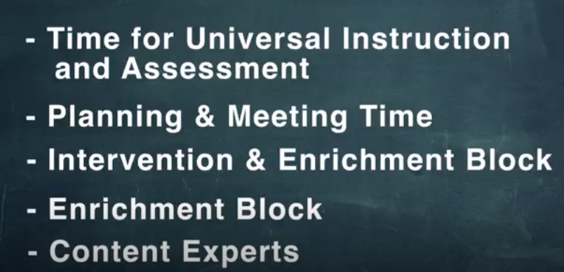 | Scheduling at the middle and high school level can be a challenge.  Effective schedules include:  - Adequate time for Tier 1 Universal Instruction and Assessment  - Dedicated planning and meeting time built into the schedule.  - Intervention and enrichment blocks within the schedule  - Need to be equitable for all students.  - Content experts in each domain and content area  - Review and revise schedule on an annual basis based on data
Scheduling Challenges include:
- Bell schedule with all students having a unique schedule
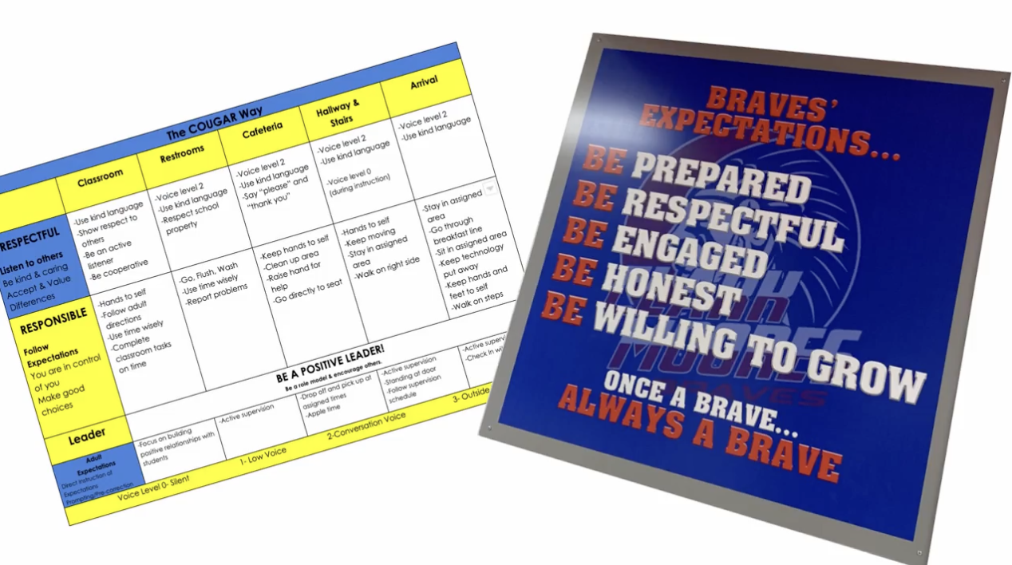 | Tier 1  Content area teachers are responsible for:  - Tier 1 academic instruction based on Kentucky Academic Standards  - Tier 1 behavior and social skills
Tier 2 and Tier 3
- Students may need additional time and instruction in their schedule.
- When and how will interventions be delivered?
- Who is responsible for interventions?
- Who is responsible for progress monitoring?
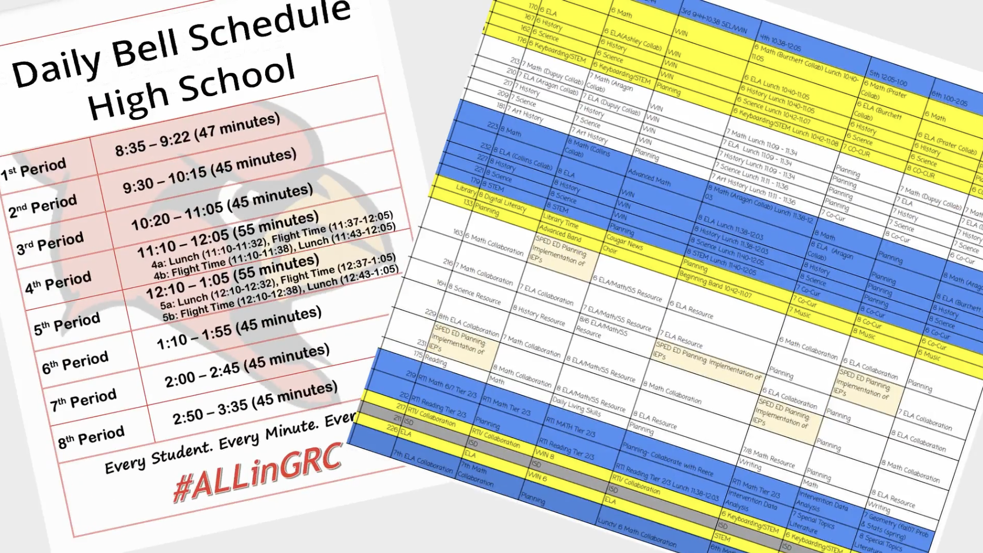 | MTSS scheduling models for intervention:  - Lab class periods that focus on intervention for students missing foundational skills  - Schoolwide time such as advisory, What I Need (WIN) period, or Enrichment period for enrichment and intervention that all students will receive.  - Special bell schedule on specific days or for specific class periods  Scheduling model decisions should be based on student needs and data
School Examples:
- Advisory period used to teach social skills.
- All teachers teach social skills and have dedicated faculty meeting time to preview lessons, plan, and ask questions.
- WIN time dedicated block where students are intentionally scheduled based on areas of strength, areas or growth.
- All teachers have student groups based on universal screening and early warning system data.
- Behavior and attendance are considerations when placing students in small groups for WIN time
Secondary interventions must be in ADDITION to Tier 1 instructional time, it is layered.
Evidence-based Interventions can take place before, during, or after school as well as during an elective block.
Scheduling is KEY to implementing effective MTSS for Secondary Schools
- Building level MTSS Problem-solving team should make scheduling decisions based on student needs and data
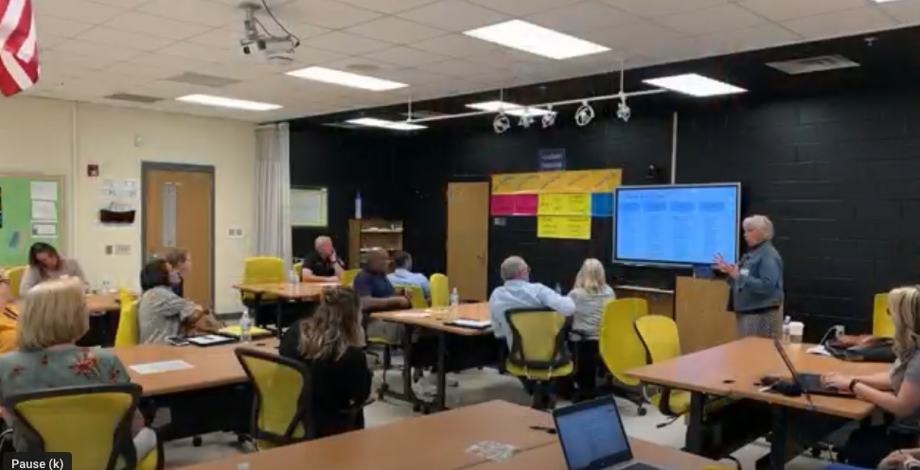  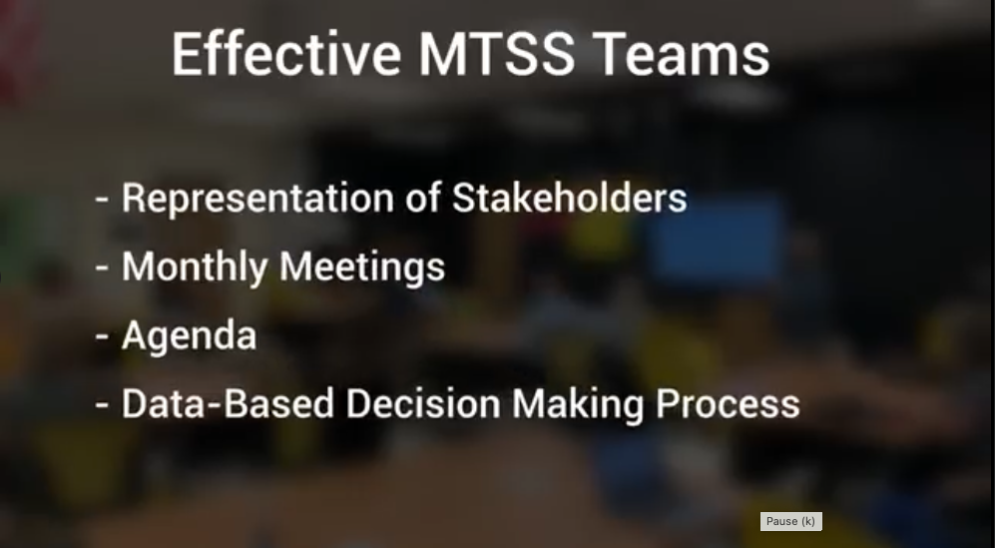  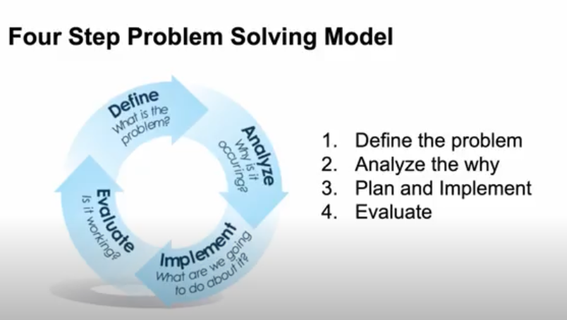 | Role of the building level MTSS Problem Solving Team  - Serves as the executive leadership team.  - Representation from across the school  - Meet monthly.  - Have an established agenda.  - Responsible for data-based decisions at the school level  - Use a 4-step problem solving model to make decisions.
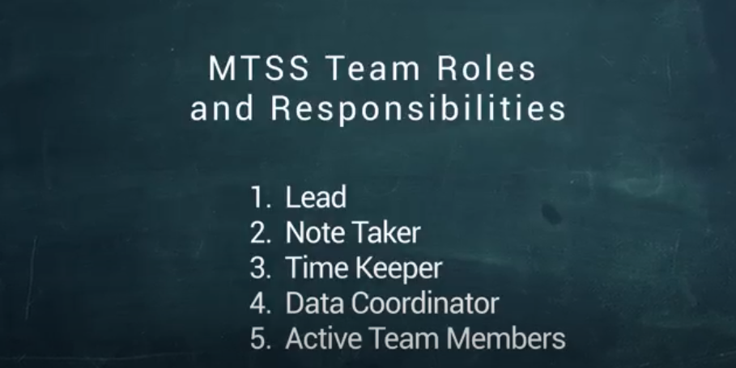 | Roles and Responsibilities of the MTSS Team Members include:  - Lead  - Notetaker  - Timekeeper  - Data Coordinator  - Active Team Members
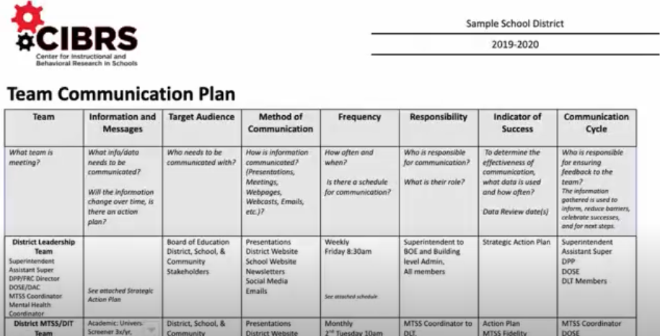 | MTSS Teams should have a Team Communication Plan that identifies:  - Team membership  - Data that is to be communicated.  - Stakeholders that will receive the communication.  - Responsible for ensuring communication occurs.  - How often the communication will occur.
Decisions at the secondary level include:
- What staff are responsible for universal screening for academics and behavior?
- When and where students will take universal screening assessments?
- How data will be analyzed and disseminated for all staff to utilize in a meaningful way?
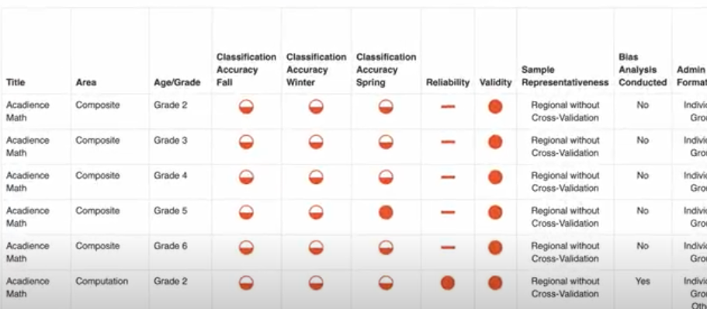 | Valid and reliable universal screeners are administered to all students for each domain; academic, behavior, and social-emotional.  Screeners should also be administered in the same setting throughout the year. For example, during first period or advisory each of the 3 times per year they are given, fall, winter, and spring.
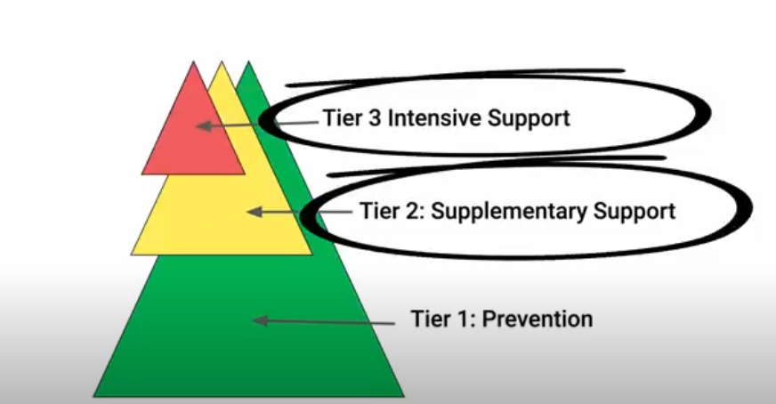 | Universal Screening data should be used in triangulation with other data sources to connect students to appropriate evidence-based interventions for Tier 1, Tier 2 or Tier 3 supports.
Secondary data that can be used for triangulation and data-based decisions:
Academic Domain
- Universal Screening
- Course Failures
- ACT/SAT Benchmarks
- KYOTE Assessment
Behavior and Social-Emotional Domains
- Office Discipline Referrals/Infinite Campus/Tableau Data
- Universal Screeners
- Attendance
- Nurse Visits
- School Counselor Referrals
- Outside Agency Referrals
- Equity Dashboard
- Early Warning Tool

 | Middle school and high school structure and size make it important to have integrated teams that analyze data to make decisions about instruction, intervention, and movement between the tiers making systems more efficient. When implemented effectively, secondary MTSS supports positive outcomes for ALL students.

