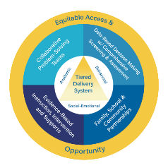
Multi-Tiered System of Supports

Selection of Evidence-Based Practices (EBP)

Video Facilitator Guide

Approximate Time Breakdown

Facilitator Module Preparation
- MTSS Selection of Evidence-Based Practices Video Module (10 minutes and 59 seconds)
- Review Facilitator Guide and Participant Guide (20 minutes)

Video and Discussion Session
- Video (10 minutes and 59 seconds)
- Team Discussion and Activities: (30-45 minutes)

Facilitator Preparation and Resources

- Review the Facilitator Guide;
- Watch MTSS Selection of Evidence-Based Practices Video Module;
- Review Participant Guide;
- Reference Kentucky Multi-Tiered System of Supports (KyMTSS) common language key terms and video outline sections as needed prior to and during the professional learning session;
- Review the Post Video Discussion and Questions and select the questions to use with the team; and
- Review optional activities section.

Facilitator Guide Purpose and Goal

The purpose of the facilitator’s guide is to assist with virtual or in-person professional learning sessions regarding KyMTSS. This guide is intended to be used by administrators, instructional coaches or anyone leading a professional learning session on KyMTSS. The primary goal is to support the learning and implementation of MTSS at the district, school, classroom and student level. The guide provides the overview and resources needed for the facilitation of video viewing and team discussion.

Session Focus

In this module, the content focuses on evidence-based practices within an MTSS Framework. Participants will get an overview of the use of evidence-based practices. Additionally, the video provides credible sources for locating evidence-based practices within the context of the local school community.

Session Participant Materials

- Participant Guide
- Pen or pencil
- Optional highlighter and post-it notes.

Video and Team Discussion

Facilitator Prompt to Activate Learning: Prior to showing the video, allow participants time to complete the “my current understanding and questions” portion for Evidence-Based Practices portion on the participant guide. The facilitator may use the “my current understanding and questions” section on the next page to record any notes. Initially, participants will only focus on the first key concept, Evidence-Based Practices. Allow time for discussion and sharing and then watch the video. While watching the video, participants will continue to take notes and generate questions using the table on the next page. Refer to the directions in the participant guide for further information. The documents and sites referenced in the video are hyperlinked in the facilitator and participant guides.

As the facilitator, you may choose to pause at any time in the viewing process for team discussion, questions and clarifications.

Icon Legend
These icons indicate the suggested grouping for reflection, discussion and activities.

Individual | Partner or Small Group | Whole Group

Facilitator Note Taking Tool

Key Concept | My Current Understanding | Questions
Evidence-Based Practices

Directions: While watching the video, use the table below to write notes and questions regarding the key concepts related to the evidence-based practices. The participant guide provides this table too. Teams may discuss the key concepts and respond to the questions after the video.

Key Concept | New Learning | Notes and Questions
Evidence-Based Practices
Every Student Succeeds Act (ESSA)
EBP Selection Process
- Review existing data and practices to determine improvement areas.
- Conduct an inventory of current practices.
- Determine if EBPs need to be selected, deselected and reviewed.
- Utilize Clearinghouses to locate, review and discuss and research.
- Selection of best practices.
Effect Size, Efficiency and Fidelity (Refer to Common Language Section for definitions.)

Participant Video Reflection

Directions: After watching the video, use the table below to write your thoughts, questions and any realization regarding the evidence-based practices within the MTSS Framework.

Thoughts
Questions
Realizations
- Allow time for participants to share initial thoughts, lingering questions, and key concept realizations.

Post Video Discussion and Questions

Directions: The questions below are intended to guide a discussion regarding the learning from the video. Prior to the time with the team, determine the questions you wish to use. Consider the time, content and groupings for the discussion as you select the questions.

- How might exploring and learning more about evidence-based practices support the work in our school or district?
- How does our process for selecting evidence-based practices regarding instruction, intervention and support in all tiers support our school’s student population? What unique factors define our student population?
- What is the collaborative, problem-solving team’s role in selecting evidence-based practices in all tiers?
  - What data is used during the selection process for evidence-based practices?
  - How might the use of an EBP initiative inventory support the selection process?
  - How does research inform the MTSS problem-solving team and other stakeholders when selecting EBPs?
- Are there any unique factors that may need to be considered when selecting Tier 2 or Tier 3 EBPs for our school or district? (Think about student population and data.)
- How do we ensure that every student on our campus has access and opportunity to
evidence-based practices?
- What questions do you have regarding the use of MTSS evidence-based practices?
- Do we know what the EBP selection process is in our school? Have we participated in the process? How does the selection process impact our instruction, intervention, and support for our students?
- Do we know what EBPs our school has chosen for our three-tiered delivery model?
- Fidelity refers to how closely prescribed procedures are followed and, in the context of schools, the degree to which educators implement programs, assessments, and implementation plans the way they were designed and intended. Using this definition, think about how we ensure we are delivering evidence-based instruction, interventions and supports with fidelity in our classroom or school. How do we measure fidelity?
- How might this learning impact your role in the MTSS System?
- What next steps might you consider based on today’s learning?

Post Video Closing Questions

Closing  Questions | - How might this learning impact the evidence-based practices selection process and planning for next steps?  - Who else might benefit from this learning?  - What information confirmed your beliefs about the importance of utilizing evidence-based practices within the MTSS Framework to ensure student success?

Next Steps

Directions: The facilitator and participants may use the table below to discuss and write down the next steps with MTSS implementation in their school or district. Use the questions and prompts to guide the process.

Guiding Questions | Who will lead the work? Who might need to be included in the next step? What resources are available or what resources might be needed? | Start and Projected Completion Date

What is the next step for our team or me regarding MTSS implementation?

Resources

Referenced in Video:
- Initiative Inventory
- What Works Clearinghouse
- National Center on Intensive Intervention
- EdReports

For Further Guidance:

KyMTSS Implementation Guide
- KyMTSS Self-Assessment Tool
- Data Inventory Template
- Four-Step Problem Solving Model
- NIRN Initiative Inventory
- Every Student Succeeds Act (ESSA)
  - Evidence for ESSA
  - Every Student Succeeds Act (ESSA)
  - Every Student Succeeds Act (ESSA) | U.S. Department of Education
  - Every Student Succeeds Act (ESSA) - Kentucky Department of Education
  - ESSA Tiers of Evidence: What You Need to Know
  - WWC | ESSA Tiers Of Evidence
Optional Activities (Extended Time)

Directions: Below are optional activities for the team, other staff members or individuals to extend the learning from the video and team discussion. The activities provide a more in-depth look at the resources available through KyMTSS to evidence-based practices.

Clearing House Resource Exploration

Individually or as a team, explore the clearing houses listed below. Consider your current practices and how you might utilize the resources for the school or district EPB selection process. Add action items to Next Steps or an MTSS Action Plan.
- Explore Clearinghouse- EdReports
- Explore Clearinghouse- National Center on Intensive Intervention
- Explore Clearinghouse- What Works Clearinghouse. WWC | Find What Works!
  - Practice Guides https://ies.ed.gov/ncee/wwc/Search/Products?productType=1
Locate a practice guide published within the last 5 years as a small group. Read independently. Discuss as a group what you found helpful within the Practice Guide and how you could use this information in your school or district.

  - Intervention Reports https://ies.ed.gov/ncee/wwc/Search/Products?productType=2
Small groups are each assigned a practice guide for a program or strategy that is currently in use in the school or district. Read and review the intervention report as a group. Determine if the practice guide supports continuing the program or practice with the student population. Discuss how reading intervention reports could be helpful in your current role. Share information with other small groups.
- Explore the filters in Practice Guides and Intervention Reports. Which filters do you think would be most helpful in locating research for your setting? Discuss why.

KyMTSS Common Language Key Terms

- Clearinghouse: Registries of programs and interventions that have been reviewed and rated according to criteria set by each clearinghouse. Ratings typically reflect whether, and to what extent, the impact of the programs or interventions is supported by evidence.
  - National Center on Intensive Intervention (NCII): A technical assistance center funded by the U.S. Department of Education’s Office of Special Education Programs managed by the American Institutes for Research that builds district and school capacity to support implementation of intensive intervention, in reading, mathematics, and behavior for students with severe persistent learning and/or behavioral needs.
  - What Works Clearinghouse (WWC): What Works Clearinghouse was established by the U.S. Department of Education's Institute of Education Sciences to provide educators, policymakers, and the public with a central, independent, and trusted source of scientific evidence revealing what works in education.
  - EdReports: An independent, non-profit organization designed to help educators identify and demand instructional materials that are effective, reliable and aligned to high standards.
- Effect Size: A standardized measure of the magnitude of a difference; effect size represents the change measured in standard deviations an average student’s outcome is expected if that student receives the intervention being measured.
- Efficiency: The extent to which a school or teacher utilizes time for academic, behavioral and social emotional development of all students.
- Every Student Succeeds Act (ESSA)- A Federal K to 12 education law of the United States, signed into law in 2015 and replaced the previous education law called “No Child Left Behind.” ESSA extends flexibility to States in education and lays out expectations of transparency for parents and for communities. ESSA requires states to measure and report performance.
- Evidence-Based Practices (EBPs): Activities, strategies and interventions that are derived from or informed by objective evidence—most commonly, educational research or metrics of school, teacher and student performance.
- Fidelity: How closely prescribed procedures are followed. In the context of schools, the degree to which educators implement programs, assessments and implementation plans the way they were designed and intended.
- High Quality Instructional Resources (HQIR): Materials that are aligned with Kentucky Academic Standards; research and/or externally validated; comprehensive to include engaging texts (books, multimedia, etc.), tasks and assessments; based on fostering vibrant student learning experiences; culturally, relevant, free from bias and accessible for all students.
- Improvement Goals: The target a school or district plans to meet in a specified amount of time.
- Kentucky Academic Standards (KAS): A set of standards that contain the minimum required skills all Kentucky students should have the opportunity to learn at each grade level in each content area.

KyMTSS Common Language Key Terms (continued)

- KyMTSS Multi-tiered System of Supports: A multi-level prevention system to support student achievement and social-emotional behavioral competencies through an integration of differentiated core instruction, assessment and intervention.
- Institute of Educational Sciences (IES): A research arm of the U.S. Department of Education.
- Intervention Report: A summary of findings of the highest-quality research on a given program, practice or policy in education.
- Reliability: The dependability or consistency of a measure.
- Rural: Typically, the least populated living areas are an open and spread-out country area away from a city or town.
- Selection Process: The steps involved in selecting Evidence-Based Practices.
- Stakeholders: Anyone who is invested in the welfare and success of a school and its students; including administrators, teachers, staff members, students, parents, families, community members, local business leaders and elected officials such as school board members.
- Strategy: Methods, techniques, procedures and processes that a teacher uses during instruction.
- Suburban: A place where people live away from a city or town; typically, a suburb primarily provides residential housing and surrounds an urban area.
- Universal Screeners: Assessments that are typically brief, reliable and valid. The assessments are conducted with all students from a grade level used to identify students who may be at risk for poor learning outcomes.
- Urban: Typically a densely populated metropolitan city with a continuously growing area with over 50,000 people.
- Validity: An assessment measuring what it intends to measure.

Video Outline

Directions: The facilitator may use the outline below to focus on key terms and concepts throughout
the video module. The talking points focus on key concepts and give the facilitator a quick point of reference. The key concepts are essential to understanding the use of evidence-based practices within KyMTSS Framework.

Video | Key points for discussion
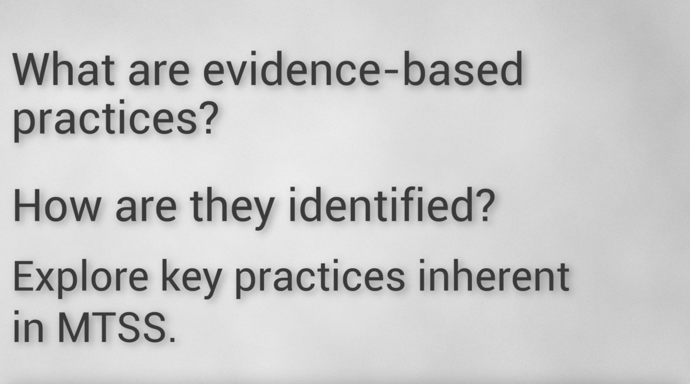 | Evidence-Based Practices include resources, programs, strategies and interventions.
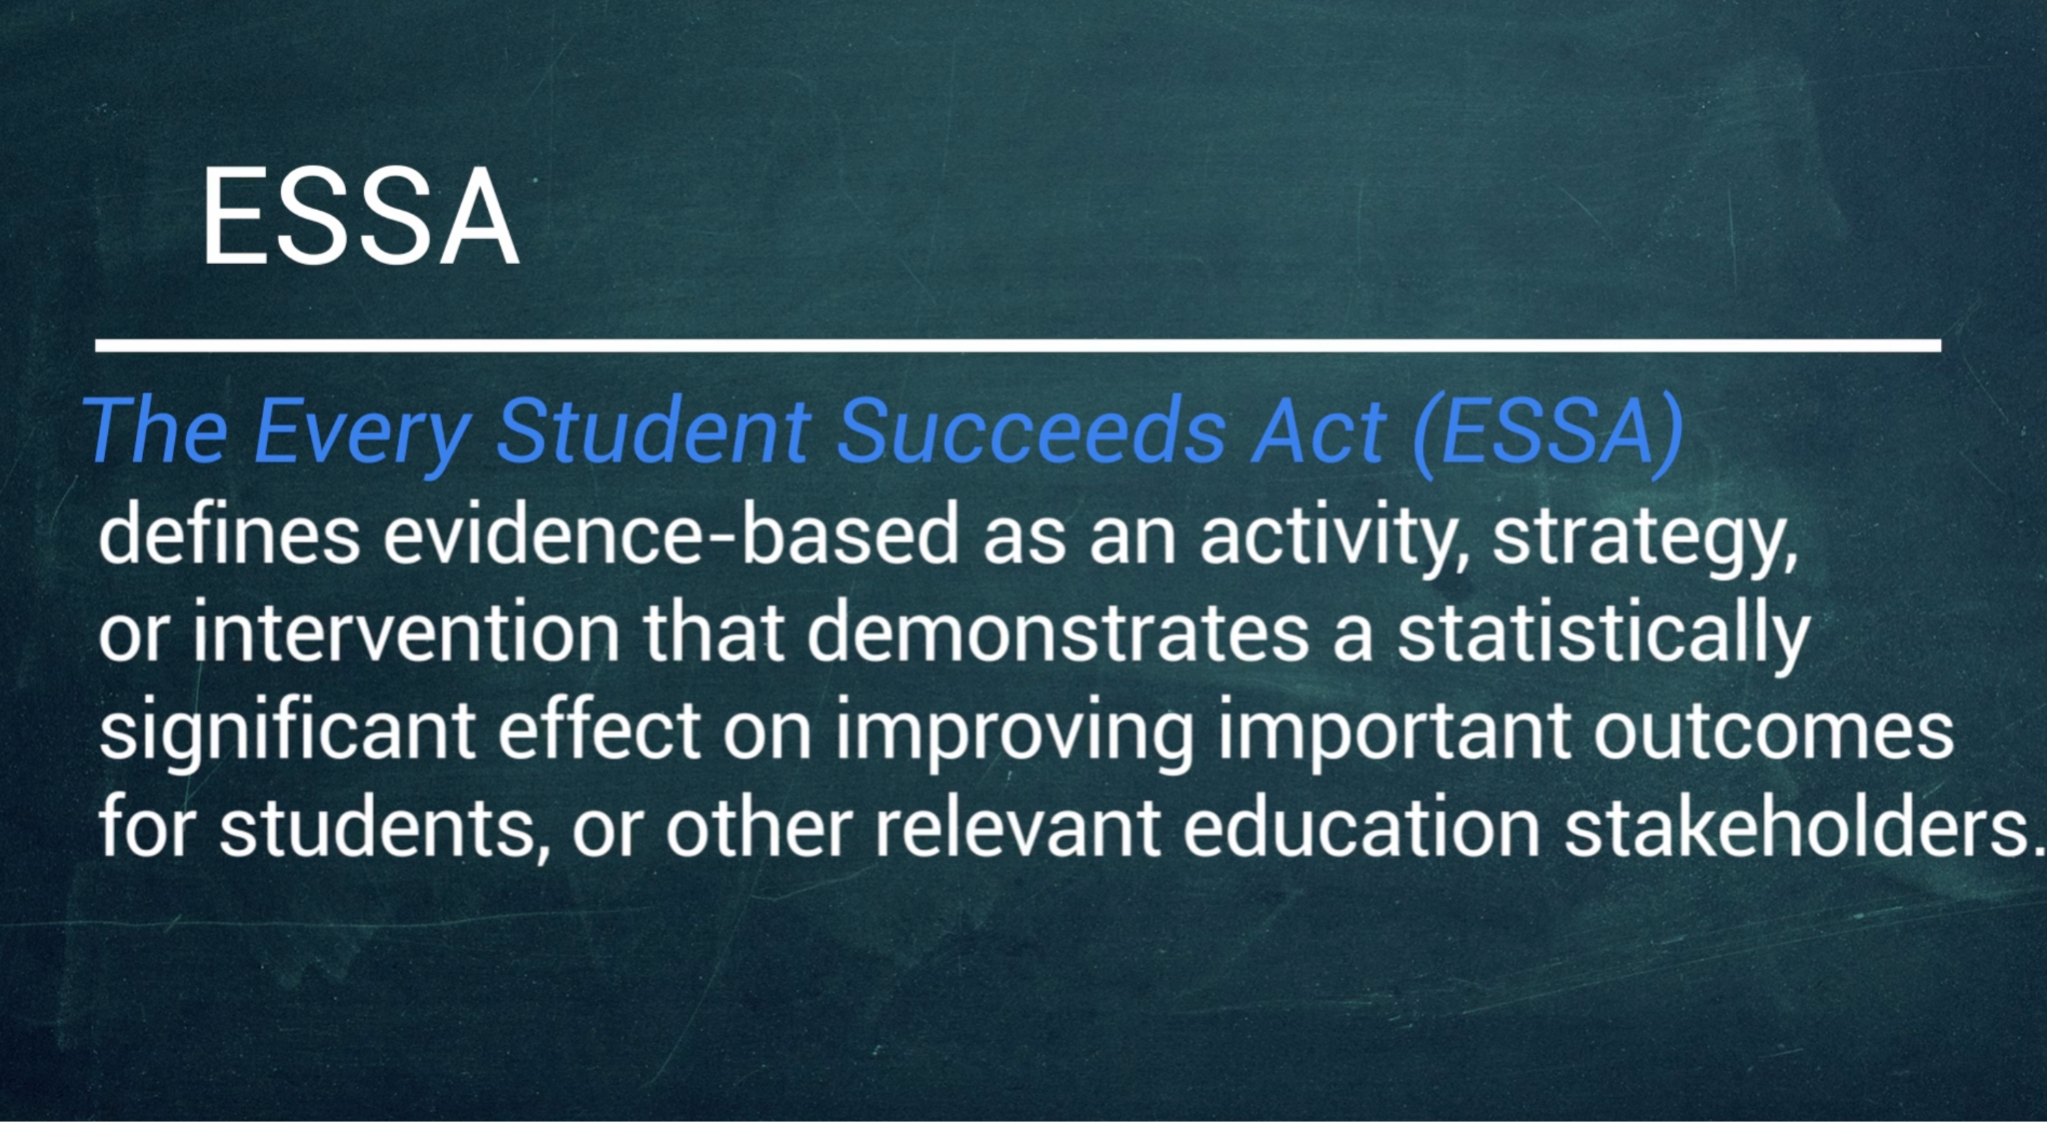 | The Every Student Succeeds Act (ESSA), a federal law passed in 2015, defines evidence based as an activity, strategy, or intervention that demonstrates a statistically significant effect on improving important outcomes for students or other relevant educational stakeholders.
 | Some practices have a larger effect size than others or are more likely to optimize student success, and these are the practices we want to use.
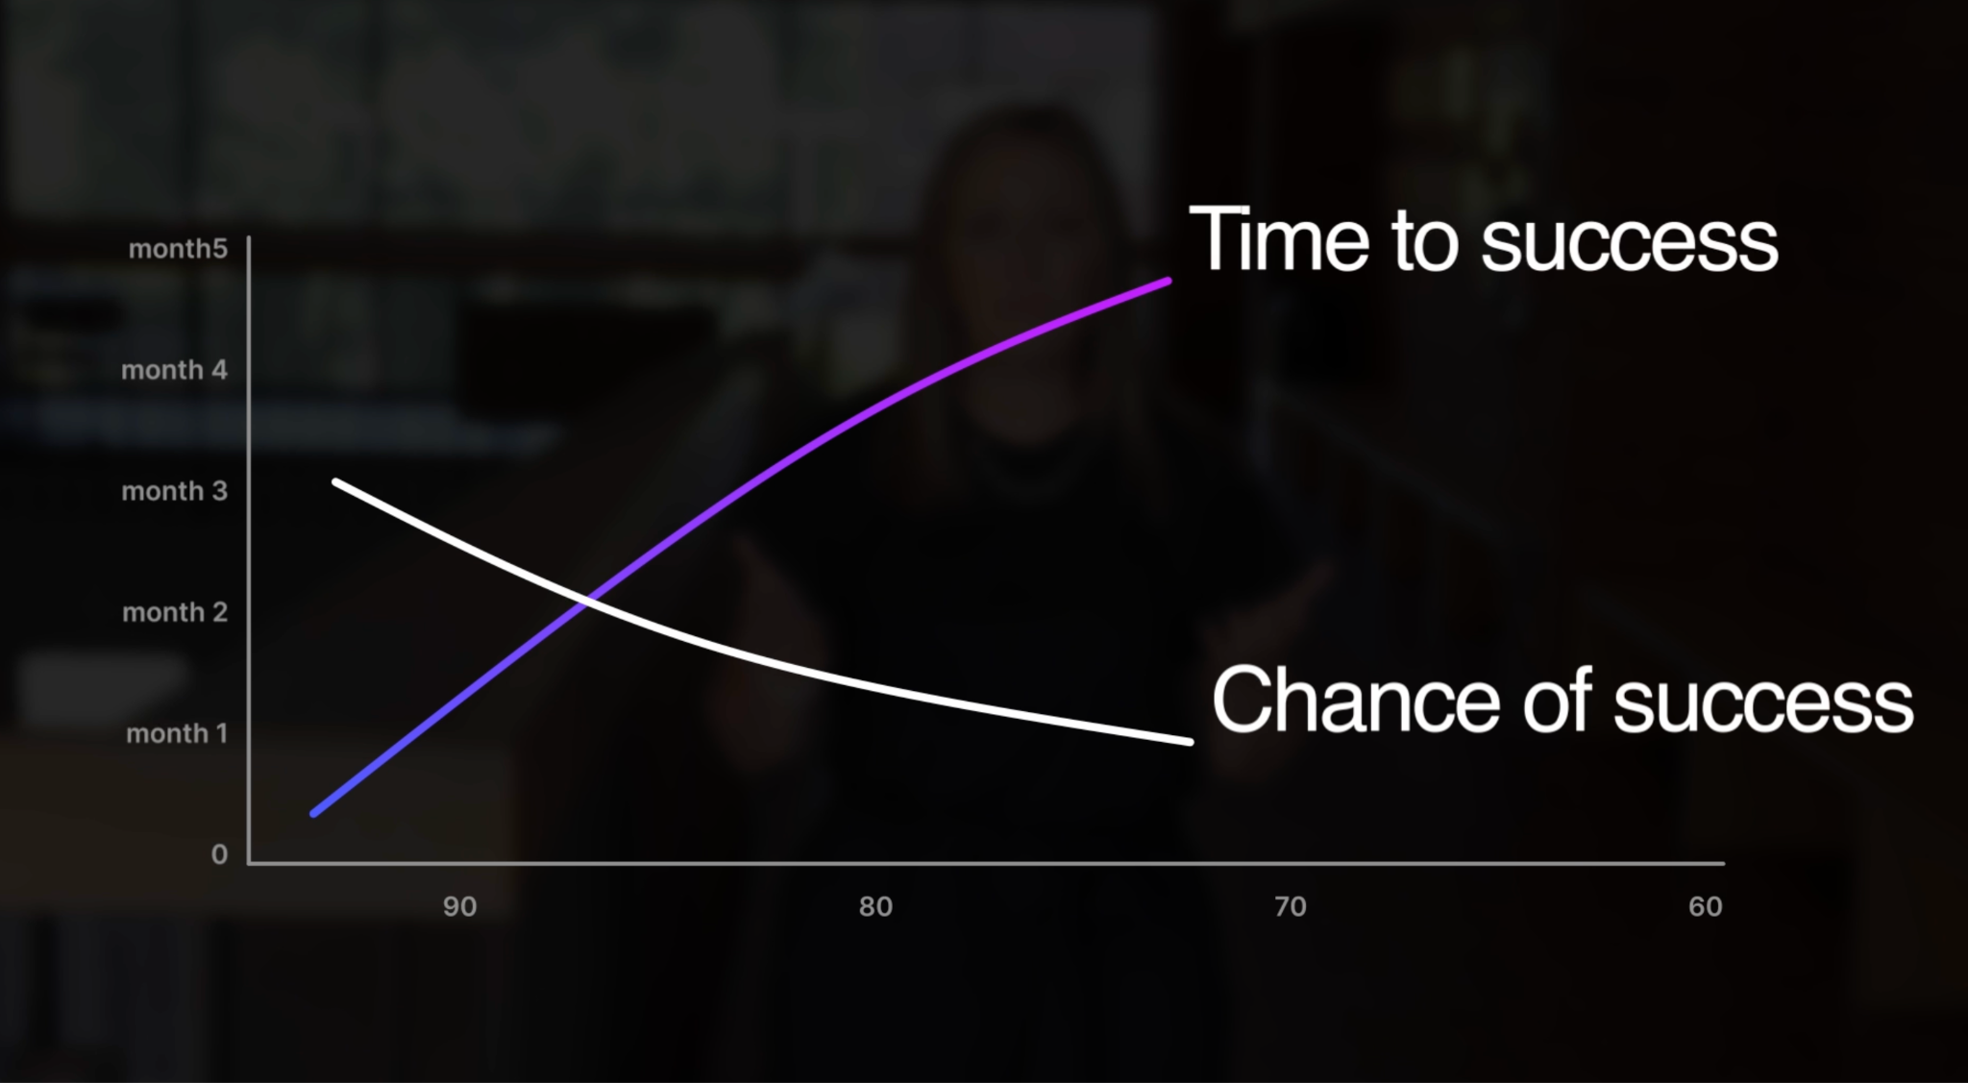 | The longer it takes to create success for students, the more there is to overcome. That is one reason it is so important to identify the practices that have the largest effect size and will result in the best outcomes for students.
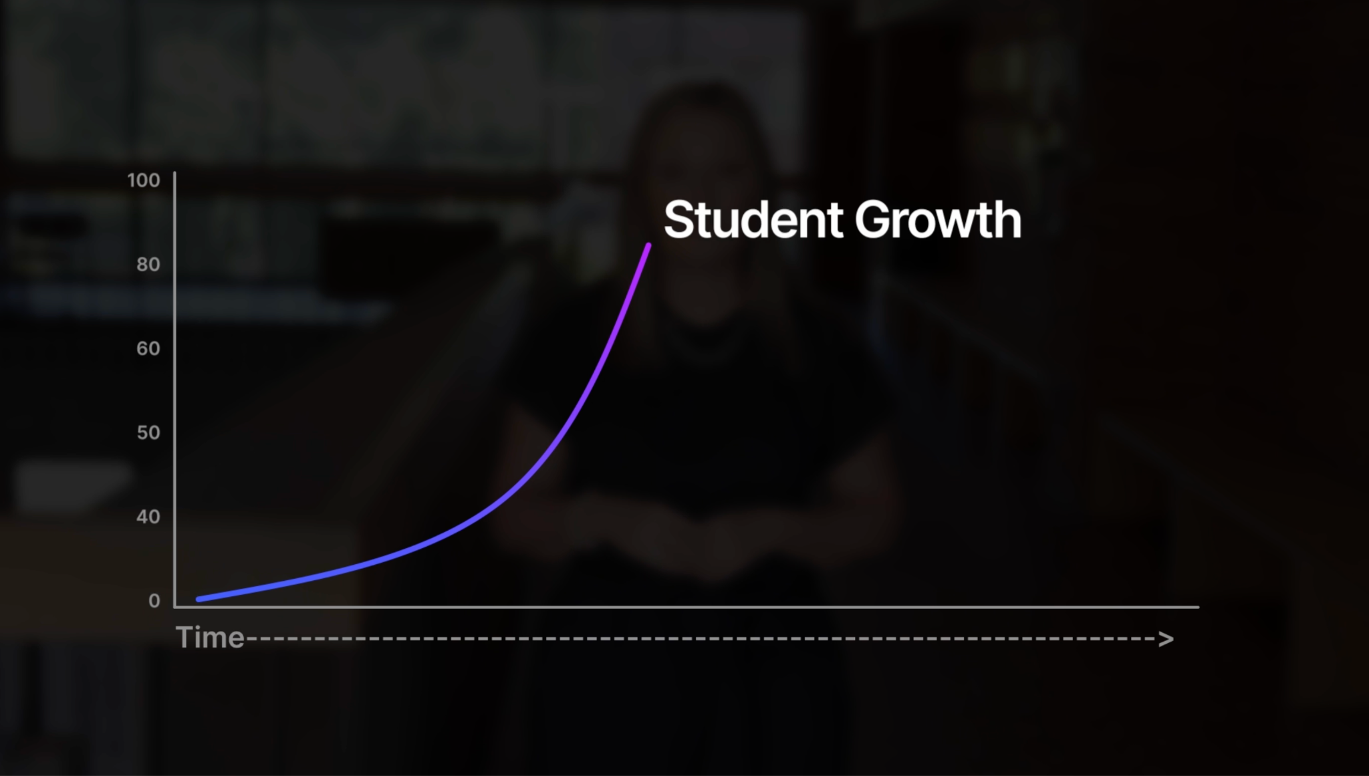 | We want to see student growth in the shortest amount of time possible.
 | MTSS problem-solving teams must have a process to follow when selecting evidence-based practices in all tiers and across all domains; this is called an evidence-based selection process.
 | The EBP selection process allows teams to use data to determine the needs to identify appropriate EBPs. Problem-solving teams should also consider the evidence of the specific student population being targeted.
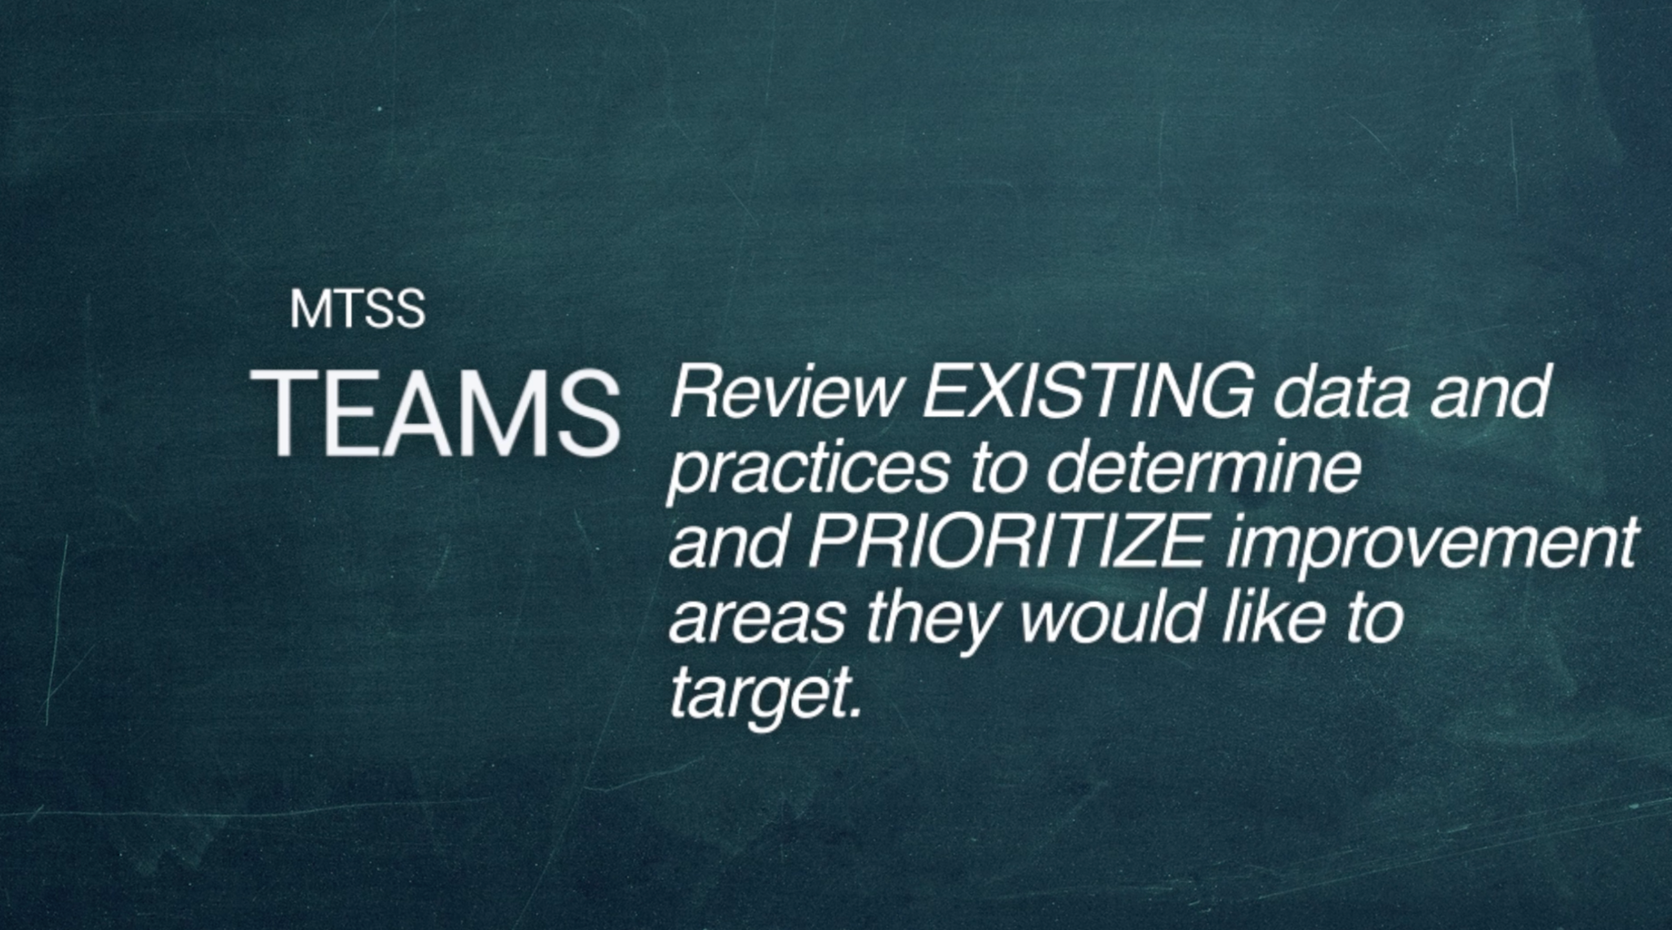 | Step 1 is for the MTSS problem-solving team to review the existing data and practices to determine and prioritize improvement areas they would like to target.
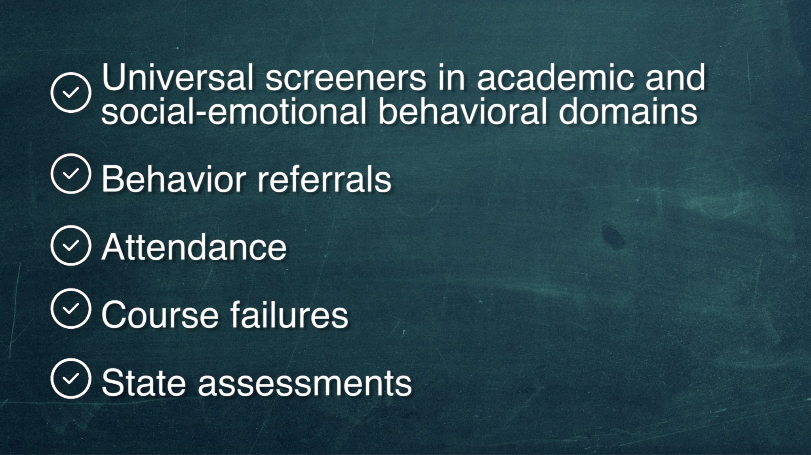 | Data used could include:  - Universal screeners  - Behavior referrals  - Attendance  - Course failures  - State assessments
 | Completing an inventory of practices that are currently being implemented is helpful to determine what tiers and domains are using evidence-based practices and which practices are effective with the student population as well as aligned with the Kentucky Academic Standards as well as behavioral and social competencies.
 | Once areas of improvement are identified, teams may need to identify areas where the selection process needs to be used to choose new practices, deselect old practices or determine practices that are more effective.
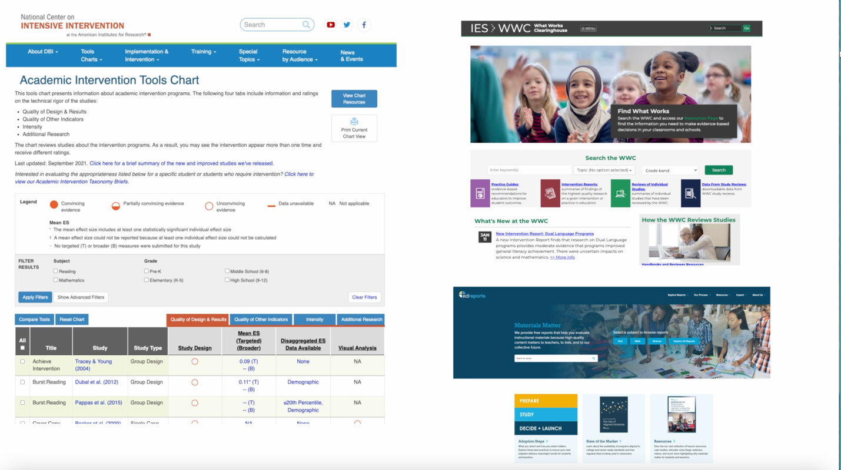 | Online clearinghouses with research on practices are where teams should start locating the evidence of effectiveness for practice currently being implemented as well as when the team determines a new practice needs to be selected. These clearinghouses are organized by domain, improvement area, student outcomes and have filters to help teams locate research.  Clearinghouses include:  - What Works Clearinghouse  - National Center on Intensive Intervention  - EdReports
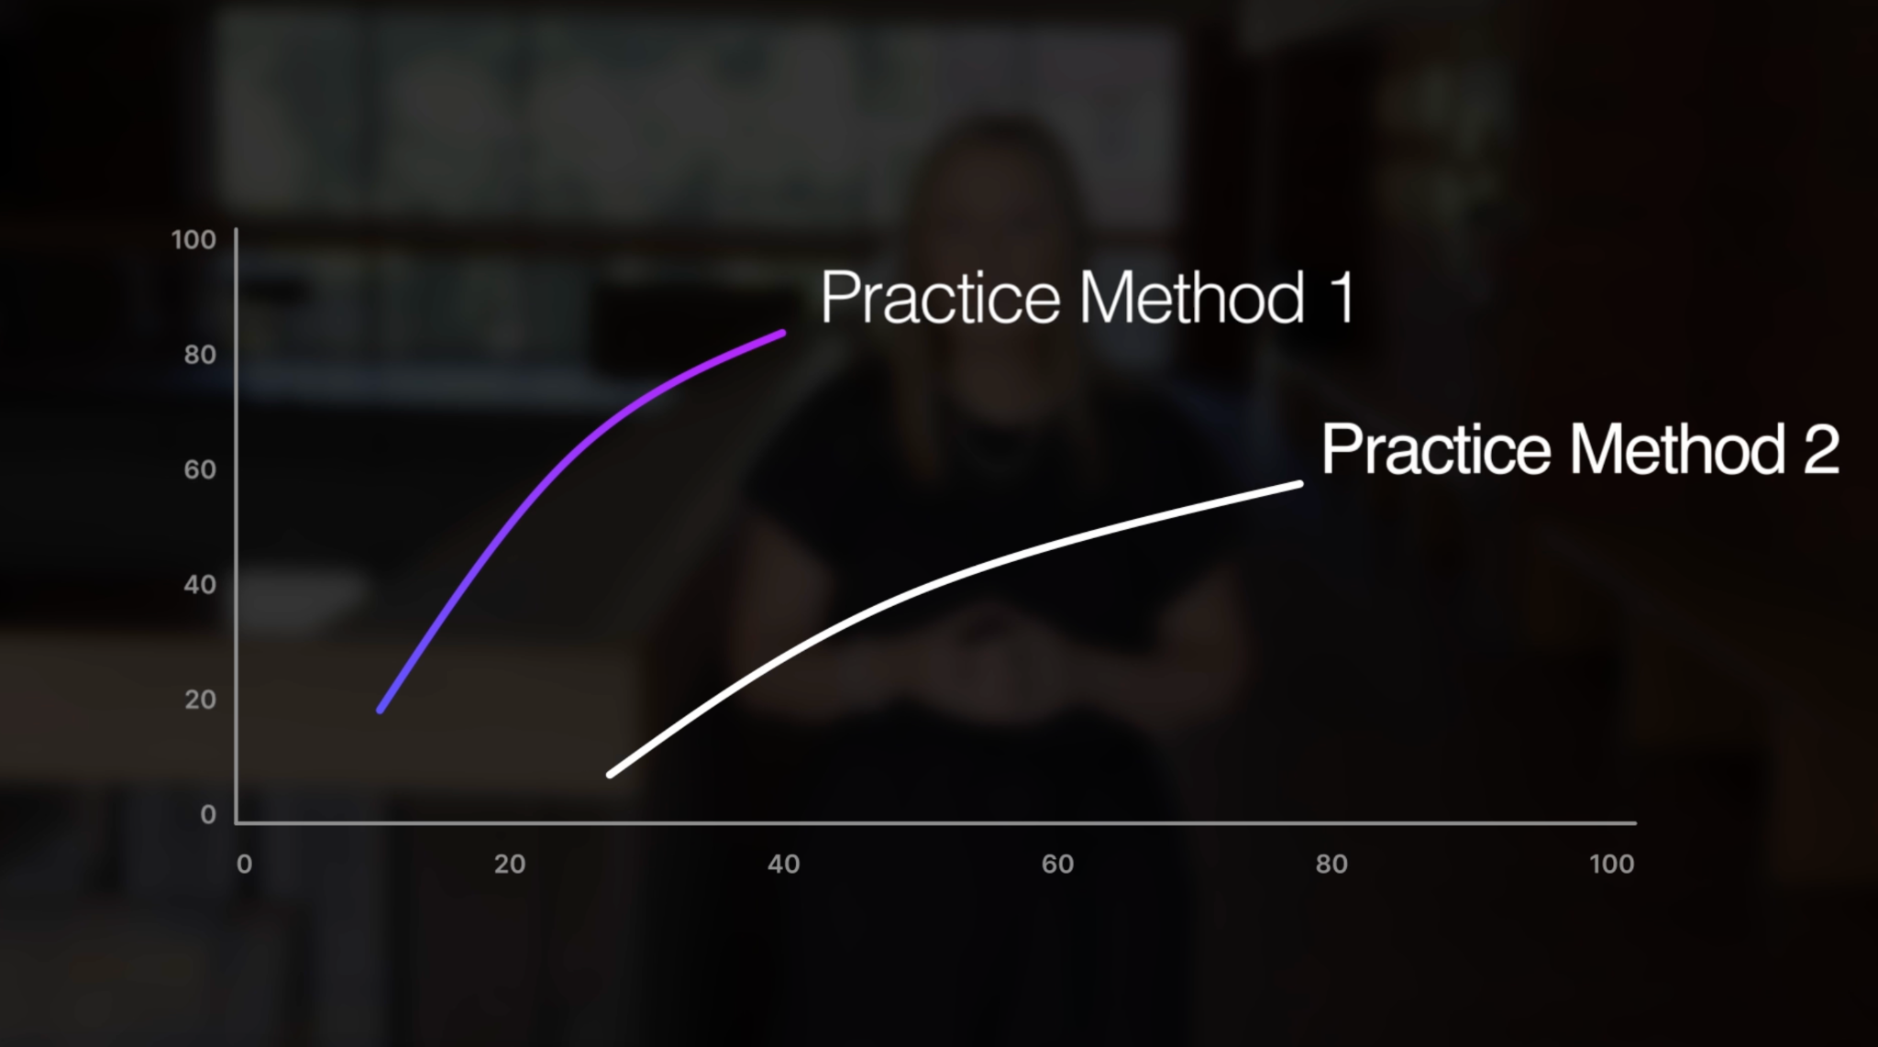 | Teams must intentionally schedule time to locate, review and discuss research on practices since these clearinghouses are always being updated with the most recent research. Discussion should be around the comparison and selection of the most effective practices for each school or district’s student population.
 | Selecting the best practices requires teams to consider both effective sizes, how likely the practice is to work, efficiency and how quickly this practice is likely to work. Teams should also consider the amount of time for each practice to produce positive outcomes with students. When making decisions for Tier 3 practices, we need to consider which practice will be effective in the shortest amount of time possible or work the quickest to close gaps.
 | The last part of the selection process includes ensuring the practices selected will be effective with the student population being served and align with the cultural context. The question for teams is, “Does the research show positive outcomes with students similar to our population?”
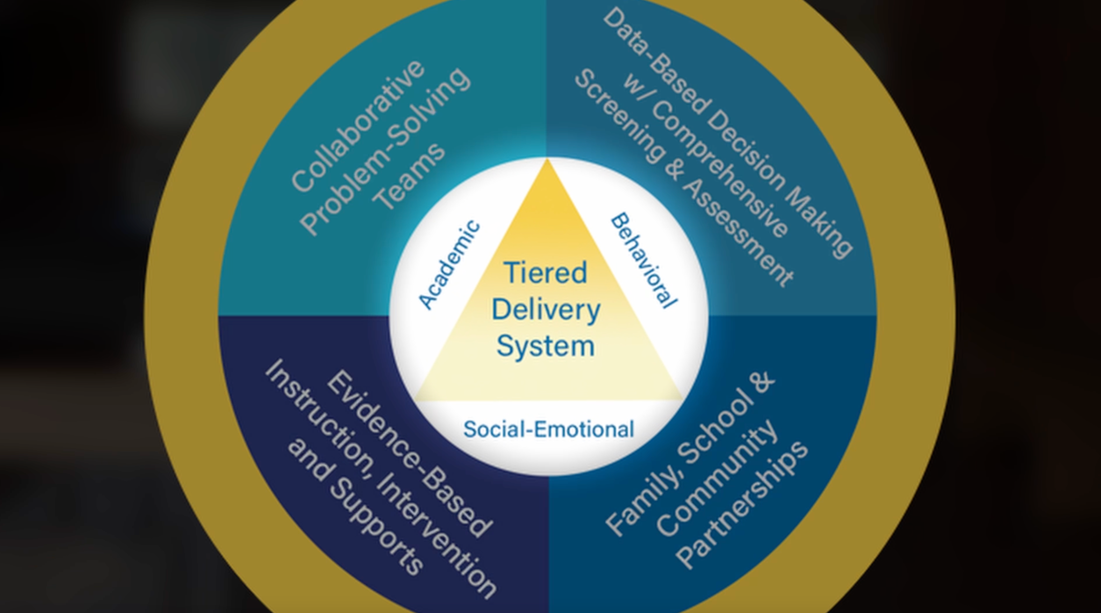 | The EBP selection process should be completed for all tiers of the prevention model and across all domains of KyMTSS, this includes academic, behavior, and social-emotional.
 | In summary, teams at the district and building level need to use data to determine needs, review evidence of practices and then review selected practices for their student population.
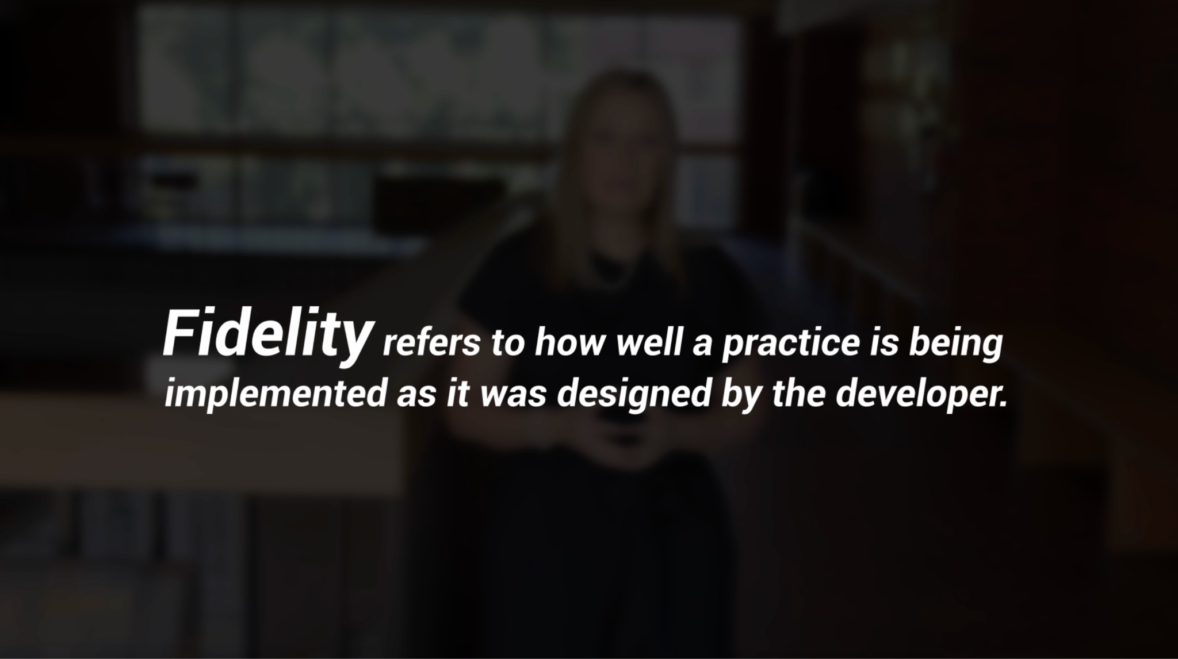 | Once practices have been selected, the team needs to determine how staff will be trained to implement the practices and how to measure fidelity. Fidelity refers to how well a practice is being implemented as the developer designed it. Fidelity is critical as practice not implemented with fidelity will not produce the positive student outcomes expected during the selection process.
 | The selection of evidence-based practices is key in an effective MTSS.

