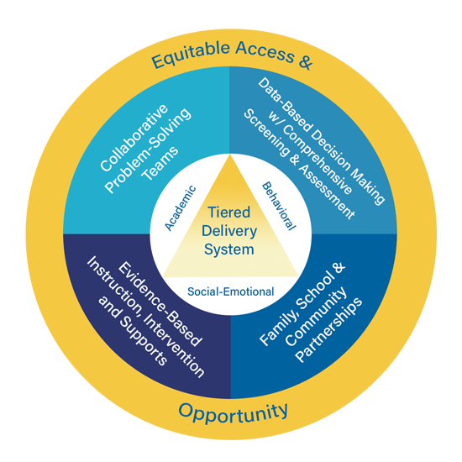

Multi-Tiered System of Supports (MTSS)

Tier 2 and Tier 3 Processes

Facilitator Guide

Approximate Time Breakdown

Facilitator Module Preparation
- MTSS Tier 2 and Tier 3 Processes Video Module (7 minutes and 13 seconds)
- Review Facilitator Guide and Participant Guide (20 min.)

Video and Discussion Session
- Video (7 minutes and 13 seconds)
- Team Discussion and Activities: (30 to 45 minutes)

Facilitator Preparation and Resources

- Review the Facilitator Guide;
- Watch MTSS Tier 2 and Tier 3 Processes Video Module;
- Review Participant Guide;
- Reference Kentucky Multi-Tiered System of Supports (KyMTSS) common language key terms and video outline sections as needed prior to and during the professional learning session;
- Review the Post Video Discussion and Questions, and select the questions to use with the team; and
- Review optional activities section.

Facilitator Guide Purpose and Goal

The purpose of the facilitator’s guide is to assist with virtual or in-person professional learning sessions regarding KyMTSS. This guide is intended to be used by administrators, instructional coaches or anyone leading a professional learning session on KyMTSS. The primary goal is to support the learning and implementation of MTSS at the district, school, classroom and student level. The guide provides the overview and resources needed for the facilitation of video viewing and team discussion.
Session Focus

In this module, the content focuses on Tier 2 and Tier 3 Processes within an effective MTSS Framework. The video provides an overview of Tier 2 and Tier 3 Processes, which include collaborative problem-solving teams engaging in assessment, identification, intervention and evaluation as part of data-based decision making.

Session Participant Materials

- Participant Guide
- Pen or pencil
- Optional highlighter and post-it notes

Video and Team Discussion

Facilitator Prompt to Activate Learning: Prior to showing the video, allow participants time to complete the “my current understanding and questions” portion for Tier 2 and Tier 3 Processes on the participant guide. The facilitator may use the “my current understanding and questions” section on the next page to record any notes. Initially, participants will only focus on the first key concept, Tier 2 and Tier 3 Processes. Allow time for discussion and sharing, and then watch the video. While watching the video, participants will continue to take notes and generate questions using the table on the next page. Refer to the directions in the participant guide for further information. The documents and sites referenced in the video are hyperlinked in the facilitator and participant guides.

As the facilitator, you may choose to pause at any time in the viewing process for team discussion, questions and clarifications.

Icon Legend
The icons below indicate the suggested grouping for reflection, discussion and activities.

Individual | Partner or Small Group | Whole Group

Facilitator Note Taking Tool

Key Concept | My Current Understanding | Questions
Tier 2 and Tier 3 Processes

Directions: While watching the video, use the table below to write notes and questions regarding the key concepts related to Tier 2 and Tier 3 Processes. The participant guide provides this table too. Teams may discuss the key concepts and respond to the questions after the video.

Key Concept | New Learning | Questions
Building Level MTSS Team Responsibilities
Student Level Team
Tier 2 and Tier 3 Team Experts
Data Sources
Evidence-Based Interventions
Fidelity and Progress Monitoring
Decision Rules

Participant Video Reflection

Directions: After watching the video, use the table below to write down your thoughts, questions and any realization regarding the Tier 2 and Tier 3 Processes within the MTSS Framework.

Thoughts
Questions
Realizations
- Allow time for participants to share initial thoughts, lingering questions, and key concept realizations.

Post Video Discussion and Questions

Directions: The questions below are intended to guide a discussion regarding the learning from the video. Prior to the time with the team, determine the questions you wish to use. Consider the time, content and groupings for the discussion as you select the questions.

- How does Tier 1 provide a layered continuum of instruction, intervention and support in all three tiers?
- How does universal screening data inform our tiered delivery system of instruction, intervention and support?
- How does diagnostic assessment data inform our tiered delivery system of instruction, intervention and support?
- Identify what % of students meet proficiency, do not meet proficiency or exceed proficiency. Consider the academic, behavioral and social-emotional domains of Tier 1 universal instruction, intervention and support.
  - If 80% or more of the students meet proficiency in Tier 1, what systems are in place that support instruction, intervention and support for all students?
  - If less than 80% of the students do not meet proficiency in Tier 1, consider how to strengthen instruction, intervention and support.
    - What might we proactively and preventatively do to reduce the number of students needed instruction, intervention and support through Tier 2 and Tier 3?
- What team is in place in the building that makes decisions for small groups or individual students receiving Tier 2 and Tier 3 instruction, intervention and support?
  - How does this team communicate with families, teachers providing support to students and other providers in the decision-making process?
  - What is the current process used for determining if students are making adequate progress? Who is responsible for these decisions? Are there decision rules in writing?
  - What is the current process used by the Tier 2 and Tier 3 team(s) to determine if interventions are being delivered with fidelity? How is this monitored for academic, behavior and social-emotion wellness?
- Discuss the Four-Step Problem Solving Process:
  - What is the current process used for data-based decisions and evidence-based intervention selection?
  - How does the school or district implement all 4 steps of the problem-solving process?
    - How do you ensure this process occurs at the building, grade and individual student level?
- How is progress monitoring data collected in the school or district? Who is responsible for the data collection? Are data presented and shared in graph format? Is data shared during team meetings and with families?
- How do you ensure that all staff understand and follow the processes for intervention selection, progress monitoring and fidelity measures in place?
- How are universal screeners, diagnostic assessments and other data sources currently used to determine student instruction, intervention and support?
- Are there any data sets we need to consider moving forward to help determine the most appropriate evidence-based intervention?
- What is your role and responsibility for Tier 1, Tier 2 and Tier 3 instruction, intervention and support?
  - How do you support students receiving Tier 2 and Tier 3 services within the general education classroom?
- What is the purpose of a universal screener, diagnostic assessment and progress monitoring tool? (Refer to the KyMTSS common language and key terms section of this guide.)
- What additional learning or support might be needed for providing instruction, intervention and support at all tiers of the layered delivery system? (Tier 1, Tier 2, and Tier 3)
- How do you ensure fidelity of instruction, intervention and supports provided to all students in your classroom?
- Do you see or have access to progress monitoring data in real time? Are the data in graph format? Is there a dedicated meeting time and process for sharing with those providing student supports?
- What next steps might you consider based on today’s learning?

Post Video Closing Questions

Closing Questions | - How might this learning impact the MTSS implementation process or planning for next steps?  - Who else might benefit from this learning?  - What are the next steps needed to increase usage of the four-step problem solving process in data-based decision making for Tier 2 and Tier 3?

Next Steps

Directions: The facilitator and participants may use the table on the next page to discuss and write down the next steps with MTSS implementation in their school or district. Use the questions and prompts to guide the process.

Guiding Questions | Who will lead the work? Who might need to be included in the next step? What resources are available or what resources might be needed? | Start and Projected Completion Date

What is the next step for our team or me regarding MTSS implementation?

Resources

Referenced in Video:
- Four-Step Problem Solving Model

For Further Guidance:
System Support

KyMTSS Implementation Guide

KyMTSS Self-Assessment Tool
- CIBRS Initiative Inventory Template
Data
- Data Inventory Template
- AIR MTSS for Success Resource – Data Rich, Information Poor?
Evidence-Based Practices
- What Works Clearinghouse
- National Center on Intensive Intervention
- EdReports
- Evidence for ESSA

Optional Activities (Extended Time)

Directions: Below are two optional activities for the team, other staff members or individuals to extend the learning from the video and team discussion. The activities provide a more in-depth look at the resources available through KyMTSS.org to support the tiered delivery system of instruction, intervention and support.

Conduct an Initiative Inventory

With the MTSS Team, use the Initiative Inventory Optional Activity Slides as a guide to complete an inventory of existing practices. The process may be completed for any tier of instruction, intervention, domain or subject.

Develop a Menu of Interventions

With the MTSS team use the Develop a Menu of Interventions Guidance Document and the
Menu of Intervention Template to develop a list of evidence-based strategies for student, grade, content, school or district use.

KyMTSS Common Language Key Terms

- Aim line: Represents the expected rate of growth for a student on a graph.
- Assessment: Tools or methods used to evaluate, measure, and document the academic readiness, learning process, skill acquisition, progress, or needs of students. There are a variety of assessments with an effective MTSS including universal screeners, targeted screeners, diagnostic assessments, pre-assessments, interim assessments, formative, summative, and standardized assessments. Within an effective MTSS, schools and districts should have a standardized and systematic process for collecting and analyzing assessment data to improve student outcomes. Assessment in MTSS is used for several purposes: to assess fidelity of implementation, screening, diagnostics, progress monitoring of both students and interventions and general outcome measures.
- Decision Rules: Guidelines or criteria articulated in writing and used by teams to facilitate the problem-solving process at all levels of MTSS.
- Evaluation: A process in which assessments are used to determine student progress.
- Evidence-based interventions: An intervention that demonstrates a statistically significant effect on improving student outcomes when implemented with fidelity.
- Goal line: Represents desired student performance on a progress monitoring graph.
- Intervention: evidence-based instruction aligned to student needs that is in addition to high-quality core instruction.
- KyMTSS Multi-tiered System of Supports: A multi-level prevention system to support student achievement and social-emotional behavioral competencies through an integration of differentiated core instruction, assessment and intervention.
KyMTSS Common Language Key Terms (continued)

- Progress Monitoring: A type of formative assessment or measure where valid and reliable tools are used to continuously evaluate and measure a student's rate of improvement over time in response to intervention. Within MTSS progress monitoring,

data should be presented in graph format and helps teams make decisions regarding changes to a student's intervention plan or continuing with the current intervention plan. Changes could include fading intervention, intensifying intervention, or changing intervention. Progress monitoring is also used to effectively communicate adequate or inadequate progress of academic skills to students, families, and other school professionals. One type of progress monitoring is a curriculum-based measure.
  - Curriculum-Based Measurement (CBM): A progress monitoring method teachers use to determine if students are progressing in targeted skills or basic academic areas such as reading, math, and writing. CBMs typically provide current, week-by-week progress.
- Tier 1, Tier 2 and Tier 3:
  - Tier 1: The foundational or universal level of support where all students receive instruction and support through a coherent, high-quality curriculum and evidence-based practices grounded in the Kentucky Academic Standards, aligned with schoolwide expectations and designed to support Tier 1 universal social-emotional competencies.
  - Tier 2: The supplemental or targeted level of support intended for some learners who require support or extension beyond what is provided to all students. This level is intended for short-term, evidence-based intervention aligned with Tier 1 instruction and targeting the skills needed to support the learning and objectives of the universal academic, behavioral and social-emotional instruction.
  - Tier 3: The most intensive level of support is intended for learners whose needs extend well beyond the reach of the universal level. Intensification in Tier 3 includes an increase in frequency and intensity.
- Trend line: Represents the general direction data points seem to be going.

Video Outline

Directions: The facilitator may use the outline below to focus on key terms and concepts throughout
the video module. The talking points focus on key concepts and give the facilitator a quick point of reference. The key concepts are essential to understanding the KyMTSS Framework and Tier 2 and
Tier 3 Processes.

Video | Key points for discussion
 | MTSS is a multi-level prevention system focused on prevention for all students.
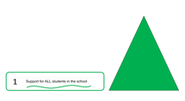 | Tier 1:  - Includes ALL students  - Differentiated universal instruction
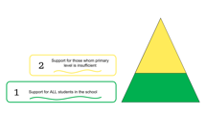 | Tier 2  - Additional targeted support for SOME students  - Additional targeted support layered on top of or in addition to Tier 1  - Small group setting
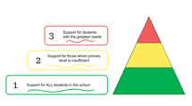 | Tier 3  - Intensive support for FEW students
 | Think about the tiers of instruction and intervention as layers. Yellow will not be effective without green, and red will not be effective without green and yellow.
 | The building-level MTSS team is responsible for making data-based decisions regarding instruction at Tier 1. In addition to the building level MTSS team, another team is responsible for making decisions regarding individual students at Tier 2 and Tier 3. This team is typically a separate team from the school-level MTSS Leadership Team and could include grade level, content experts, and intervention specialists, in addition to classroom teachers.
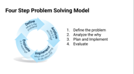 | Teams should use the 4-step problem-solving process to make decisions for individual students. The steps are:  - Define the problem.  - Analyze the problem to determine the root cause.  - Plan and implement.  - Evaluate to determine if s that were implemented changed the data and addressed the problem.
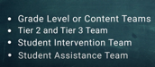 | The focus of the individual student teams is to determine, monitor and adapt interventions in Tier 2 and 3. These teams can have a variety of names; grade level team, Tier 2 and Tier 3 Team, Student Intervention Team, or Student Assistance Team.
 | Tier 2 and 3 Teams should have experts in specific areas such as an academic, behavior or social emotional specialist and someone with decision-making authority.
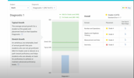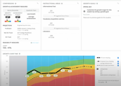 | Data sets that are helpful in determining student strengths and areas of growth include:  - Universal Screening Data,  - Classroom Performance Data, and  - Diagnostic Assessment Data.
 | Diagnostic assessments help teams determine a student’s strengths and areas of growth to choose an appropriate intervention that matches the area of concern.
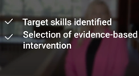 | When considering instruction and intervention it is critical that the EBP has research to support the effectiveness of the specific student population being served.
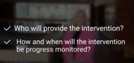  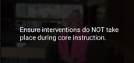 | Tier 2 and Tier 3 teams must also decide who will provide the evidence-based intervention, how the intervention will be progress monitored and when progress monitoring will occur. Key to this process is ensuring interventions do not occur during Tier 1 universal instruction.
 | Fidelity means ensuring interventions are delivered as designed, intended and planned by the developer. This includes components of the strategy or program and the amount of time required.
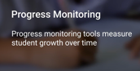 | Progress monitoring tools measure student growth over a specific amount of time. Progress monitoring is important data, so teams will know if the evidence-based intervention is working to improve students' skills in the specified area of concern.
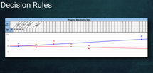 | Decision rules help teams make data-based decisions and determine if students are successfully responding to the evidence-based interventions being implemented. Decision rules can help teams determine if students’ interventions need to be faded, need to be intensified, need to be changed or need to remain in place.

