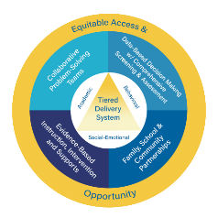
Multi-Tiered System of Supports

(MTSS) as an Integrated Framework

Video Facilitator Guide

Approximate Time Breakdown

Facilitator Module Preparation
- MTSS as an Integrated Framework Video Module (10 minutes and 16 seconds)
- Review Facilitator Guide and Participant Guide (20 minutes)

Video and Discussion Session
- Video (10 minutes and 16 seconds)
- Team Discussion and Activities: (30 to 45 minutes)

Facilitator Preparation and Resources

- Review the Facilitator Guide;
- Watch MTSS as an Integrated Framework Video Module;
- Review Participant Guide;
- Reference Kentucky Multi-Tiered System of Supports (KyMTSS) common language key terms and video outline sections as needed prior to and during the professional learning session;
- Review the Post Video Discussion and Questions, and select the questions to use with the team; and
- Review optional activities section.

Facilitator Guide Purpose and Goal

The purpose of the facilitator’s guide is to assist with virtual or in-person professional learning sessions regarding KyMTSS. This guide is intended to be used by administrators, instructional coaches or anyone leading a professional learning session on KyMTSS. The primary goal is to support the learning and implementation of MTSS at the district, school, classroom and student level. The guide provides the overview and resources needed for the facilitation of video viewing and team discussion.

Session Focus

In this module, KyMTSS will be defined and presented as an integrated, layered three-tiered prevention framework. The six essential elements of KyMTSS will be introduced. KyMTSS promotes the idea of MTSS being an integrated organizational system with a focus on three domains: academic, behavioral and social-emotional.

Session Participant Materials

- Participant Guide
- Pen or pencil
- Optional highlighter and post-it notes.

Video and Team Discussion

Facilitator Prompt to Activate Learning: Prior to showing the video, allow participants time to complete the “my current understanding and questions” portion on the participant guide. The facilitator may use the “my current understanding and questions” section below to record any notes. Initially, participants will only focus on the first key concept, MTSS as an Integrated Framework. Allow time for discussion and sharing, and then show the video. While watching the video, participants will continue to take notes and generate questions using the table on the next page. Refer to the directions in the participant guide for further information. The key concepts, documents and sites referenced in the video are hyperlinked in the facilitator and participant guides.

A designated pause is scheduled at 4:44 minutes. This is denoted in the facilitator and participant guide with a pause icon. During the pause, the team may share new learning and ask questions. As the facilitator, you may choose to pause at any time in the viewing process for team discussion, questions and clarifications.

Icon Legend
These icons signal the grouping for reflection, discussion and activities.

Pause | Individual | Partner or Small Group | Whole Group

Facilitator Note Taking Tool

Key Concept | My Current Understanding | Questions
MTSS as an Integrated Framework

Directions: While watching the video, use the table below to write notes and questions regarding the key concepts related to the KyMTSS Framework and the six essential elements. The participant guide provides this table too. Teams may discuss the key concepts and respond to the questions after the video.

Key Concept | New Learning | Questions
KyMTSS 6 Essential Elements
This pause icon signals a designated pause scheduled at 4:44 of the video. During the pause, the team may share new learning and ask questions.
Opportunity and Access for All
Tiered Delivery System (Academic, Behavior and Social-Emotional)
Collaborative Problem-Solving Teams
Data-Based Decision Making
Evidence-Based Instruction, Intervention and Supports
Family, School and Community Partnerships
The icon signals a designated pause at the end of the video. During the pause, the team may share new learning and ask questions.

Video Reflection

Directions: After watching the video, use the table below to write your thoughts, questions and any realizations regarding the MTSS Framework and the six essential elements of KyMTSS.

Thoughts
Questions

Realizations

- Allow time for participants to share initial thoughts, lingering questions and key concept realizations.

Post Video Discussion and Questions

Directions: The questions below are intended to guide a discussion regarding the learning from the video. Prior to the time with the team, determine the questions you wish to use. Consider the time, content and groupings for the discussion as you select the questions.

- How might exploring and learning more about an essential element support the work in our school or district? (Consider the essential element.)
- Of the three domains (academic, behavioral and social-emotional), which domain(s) and/or tiers of instruction and intervention do we think is the focus of most of our efforts? Discuss how we might further develop our integrated system.
- How might we ensure that every student on our campus has access and opportunity to educational resources and rigor needed at the right moment?
- How is our MTSS Framework guided by data-based decision-making? Does this occur in all three tiers and domains?
- Are collaborative problem-solving teams (district, school, grade/content, individual student) in place? How do we ensure our teams represent all stakeholders?
- How do we ensure the instruction, intervention and support are evidence-based for our student population?
- How do we promote positive relationships with students, families and the community? What other strategies or methods might we incorporate to increase positive relationships?
- What questions do you have regarding MTSS implementation?
- Which essential elements would you like to explore and learn more about to support the work in our school or district? Which essential elements do you think are in place in our school or district?
- Consider if our school or district operates in a preventative or responsive framework. Discuss ways to ensure we focus on both prevention and response.
- Discuss the logic of a layered system of support. How does the current system support a layered approach of instruction, intervention and support in all three tiers?
- How might this learning impact your role in the MTSS System?
- What next steps either in learning or in practice might you consider based on the discussions today?

Post Video Closing Questions

Closing  Questions | - How might this learning impact the MTSS implementation process or planning for next steps?  - How might we address potential barriers to an integrated MTSS Framework?  - Who else might benefit from this learning?  - On which of the six essential elements do we need to focus as a next step for our current MTSS system?  - What information confirmed your beliefs about the importance of MTSS in ensuring success for every student?

Next Steps

Directions: The facilitator and participants may use the table below to discuss and write down the next steps with MTSS implementation in their school or district. Use the questions and prompts to guide the process.

Guiding Questions | Who will lead the work? Who might need to be included in the next step? What resources are available or what resources might be needed? | Start and Projected Completion Date

What is the next step for our team or me regarding MTSS implementation?

Resources

Referenced in Video:

Institute of Educational Sciences: What Works Clearinghouse
- High-Quality Instructional Resources
- Data Inventory Template

Resources for Further Guidance:
- KyMTSS Implementation Guide
- KyMTSS Self-Assessment Tool

Optional Activities (Extended Time)

Directions: Below are two optional activities for the team, other staff members or individuals to extend the learning from the video and discussion. The activities provide a more in-depth look at the resources available through KyMTSS to support MTSS implementation.

- Website Exploration: www.kymtss.org
  - Review the essential elements and practice briefs.
  - Review the KyMTSS Implementation Guide and Self-Assessment Tool.
  - Explore the Resource Library.
  - Explore the Why KyMTSS tab.
- Jig Saw: Divide participants into 6 groups, each group explores one essential element and creates a poster on large chart paper or digitally with key ideas to share with the whole group.
  - Jig Saw Activity Slides
  - 3-2-1 Jig Saw Participant Handout

KyMTSS Common Language Key Terms

- Domains: An area of knowledge and skills. Within KyMTSS the three domains are academic, behavior and social emotional wellness.
- Essential Elements: KDE has identified six elements as essential to the implementation, improvement and sustainability of an effective multi-tiered system of supports: Collaborative Problem-Solving Teams; Data-Based Decision Making with a Comprehensive Screening and Assessment System; Tiered Delivery System; Evidence-Based Instruction, Intervention, and Supports; Equitable Access and Opportunity; and Family, School, and Community Partnerships.
- Kentucky Multi-tiered System of Supports (KyMTSS): A multi-level prevention system to support student achievement and social-emotional behavioral competencies through an integration of differentiated core instruction, assessment and intervention.
- Response to Intervention (RtI): A multi-tiered approach to the early identification and support of students with learning and behavior needs. Struggling learners are provided interventions at increasing levels of intensity to accelerate the rate of learning.
- Social Emotional Competencies: Skills that support students with human development and success in the classroom, school, with families and in the community. These skills include managing emotions, responsible decision-making, establishing and maintaining positive relationships, social awareness and self-awareness. These skills transfer into post-secondary and career settings.
- Tier 1, Tier 2, and Tier 3:
  - Tier 1: The foundational or universal level of support where all students receive instruction and support through a coherent, high-quality curriculum and evidence-based practices grounded in the Kentucky Academic Standards, aligned with schoolwide expectations and designed to support social-emotional competencies.
  - Tier 2: The supplemental or targeted level of support intended for some learners who require support or extension beyond what is provided to all students. This level is intended for short-term, evidence-based intervention aligned with Tier 1 instruction and targeting the skills needed to support the learning and objectives of the universal academic, behavioral and social-emotional instruction.
  - Tier 3: The most intensive level of support is intended for learners whose needs extend well beyond the reach of the universal level. Intensification in Tier 3 includes an increase in frequency and intensity.

Video Outline

Directions: The facilitator may use the outline below to focus on key terms and concepts throughout
the video module. The talking points focus on key concepts and give the facilitator a quick point of reference. The key concepts are essential to understanding the KyMTSS Framework and
implementation process.

Video | Key Points for Discussion
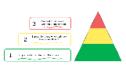 | - MTSS logic is based on a three-tiered layered delivery model.
 | - United States Department of Education identifies MTSS as an evidence-based practice.
- Interventions and supports are Tier 2 or Tier 3.
- Important to focus on the actions of adults.
- We do not refer to Tier 2 or Tier 3 students, only Tier 2 or Tier 3 interventions.
- All efforts are preventative.
- MTSS logic model has been well researched and is proven to reduce:
  - Academic Failure
  - Disciplinary Removal
  - Disproportionality
  - Social Emotional Challenges
- The triangle represents a three-tiered model of prevention where tiers are layered.
- Tier 1 is represented by green and is the instruction all students receive daily. The focus is on prevention. The goal of Tier 1 is 80% of students meet benchmark with universal instruction.
- Tier 2 is represented by yellow and is provided to some students. Tier 2 does not take the place of Tier 1 but is in addition to Tier 1.
- Tier 3 is represented in red and is delivered to a few students. Tier 3 does not take the place of Tier 1 or Tier 2.
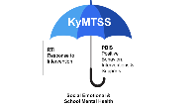 | - MTSS is an umbrella term used to describe any multi-tiered system of supports.  - PBIS and RtI are two other multi-tiered prevention systems that are embedded within an effective MTSS Framework.
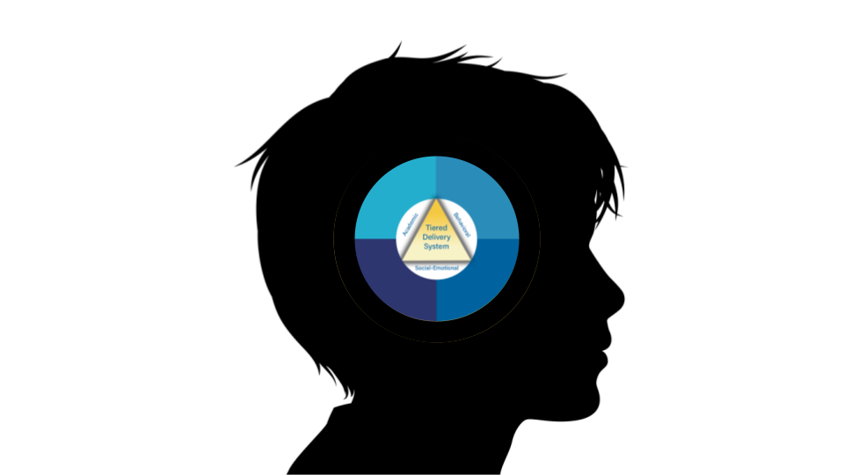 | - KyMTSS integrates the academic, behavioral and social-emotional domains.  - KyMTSS supports a whole child approach.  - Each domain impacts the other domains.  - Behavioral challenges impact academic performance, and academic performance impact behavior and social-emotional well-being.
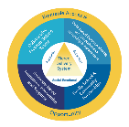 | The Kentucky Department of Education has identified six essential elements.  - Equitable Access and Opportunity  - Tiered Delivery System  - Collaborative Problem-Solving Teams  - Data-Based Decision Making  - Evidence-Based Instruction, Intervention, and Supports  - Family, School and Community Partnerships
 | - Equitable access and opportunity ensure every student across the state receives what they need at the right moment.
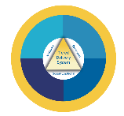 | - Tiered delivery system refers to a continuum of supports.  - Supports are both preventative and responsive across all tiers and domains.  - Tier 1, Tier 2, Tier 3  - Academic, Behavioral, and Social-emotional  - Movement through the tiers is a fluid process based on student data and needs.
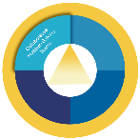 | - Collaborative problem-solving teams exist at multiple levels.  - District  - School  - Grade Level or Content  - Individual Student  - Teams should represent stakeholders and have a goal of promoting positive student outcomes.  - Teams are responsible for design, implementation, and evaluation of MTSS.
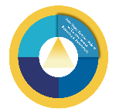 | - Data-based decision-making with a comprehensive screening and assessment system occurs in all levels of teaming for academic, behavioral, and social-emotional domains.  - Data-based decision making includes utilizing data from universal screeners, diagnostic assessments, and other data sources for all domains.
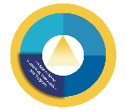 | Evidence-based instruction, intervention, and support are practices that have been shown by rigorous research to improve student outcomes.
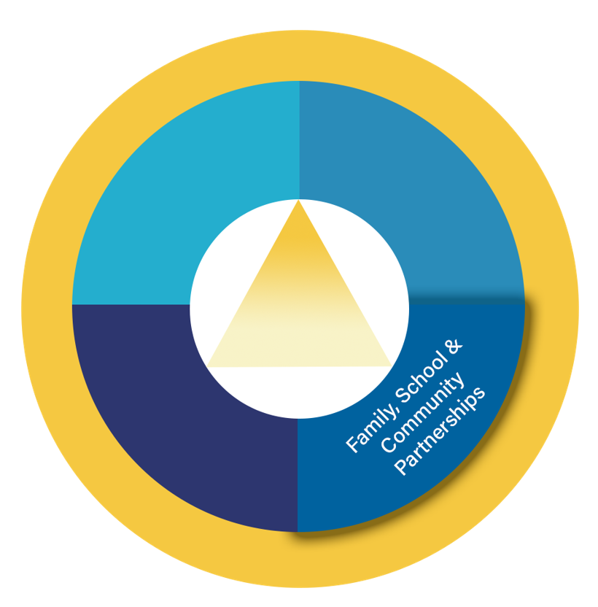 | Family, school and community partnerships build relationships with stakeholders to engage in culturally appropriate collaboration to improve student, family, and community outcomes.
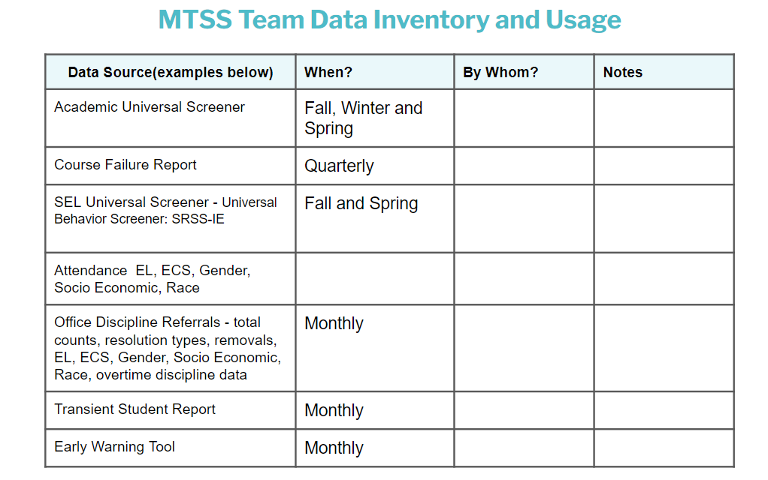 | Universal Screening and Data Inventory and Usage Table
 | What Works Clearinghouse

