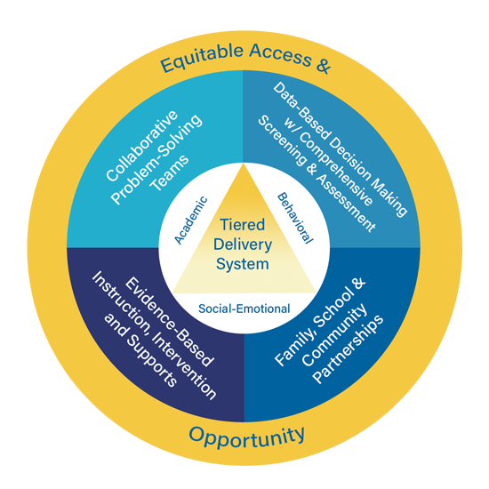
Multi-Tiered System of Support (MTSS) as an Integrated Framework Participant Guide

Session Focus

In this module, Kentucky Multi-Tiered System of Supports (KyMTSS) will be defined and presented as an integrated, layered three-tiered prevention framework. The six essential elements of KyMTSS will be introduced. KyMTSS promotes the idea of MTSS being an integrated organizational system with a focus on three domains: academic, behavior and social-emotional learning.

Session Participant Materials

- MTSS as an Integrated Framework Video Module (10 minutes and 16 seconds)
- Participant Guide
- Pen or pencil
- Optional highlighter and post-it notes.

Icon Legend
The icons below signal the grouping for reflection, discussion and activities.

Pause | Individual | Partner or Small Group | Whole Group

Participant Note Taking Tool

Directions: Prior to watching the video, use the table below to write your current understanding and any questions you may have regarding an integrated MTSS Framework.

Key Concept | My Current Understanding | Questions
MTSS as an Integrated Framework

Directions: While watching the video, use the table below to write your new learning and any questions you may have regarding an integrated KyMTSS Framework and the six essential elements.

Key Concept | New Learning | Questions
KyMTSS 6 Essential Elements
This pause icon signals a designated pause at 4:44 minutes of the video. During the pause, the team may share new learning and ask questions.
Opportunity and Access for All
Tiered Delivery System (Academic, Behavior and Social-Emotional)
Collaborative Problem-Solving Teams
Data-Based Decision Making
Evidence-Based Instruction, Intervention and Supports
Family, School and Community Partnerships
The icon signals a designated pause at the end of the video. During the pause, the team may share new learning and ask questions.

Participant Video Reflection

Directions: After watching the video, use the table below to write down your thoughts, questions and any realization regarding the MTSS Framework and the six essential elements of KyMTSS.

Thoughts
Questions
Realizations
- Allow time for participants to share initial thoughts, lingering questions, and key concept realizations.

Post Video Discussion and Questions

Directions: The facilitator will use the questions below to guide a discussion regarding the learning from the video.

- How might exploring and learning more about an essential element support the work in our school or district? (Consider the essential element.)
- Of the three domains (academic, behavior and social-emotional), which domain(s) and/or tiers of instruction and intervention do we think is the focus of most of our efforts? Discuss how we might further develop our integrated system.
- How might we ensure that every student on our campus has access and opportunity to educational resources and rigor needed at the right moment?
- How is our MTSS Framework guided by data-based decision-making? Does this occur in all three tiers and domains?
- Are collaborative problem-solving teams (district, school, grade/content, individual student) in place? How do we ensure our teams represent all stakeholders?
- How do we ensure the instruction, intervention and support are evidence-based for our student population?
- How do we promote positive relationships with students, families and the community? What other strategies or methods might we incorporate to increase positive relationships?
- What questions do you have regarding MTSS implementation?
- Which essential elements would you like to explore and learn more about to support the work in our school or district? Which essential elements do you think are in place in our school or district?
- Consider if our school or district operates in a preventative or responsive framework. Discuss ways to ensure we focus on both prevention and response.
- Discuss the logic of a layered system of support. How does the current system support a layered approach of instruction, intervention and support in all three tiers?
- How might this learning impact your role in the MTSS System?
- What next steps might you consider based on today’s learning?

Post Video Closing Questions

Closing  Questions | - How might this learning impact the MTSS implementation process or planning for next steps?  - How might we address potential barriers to an integrated MTSS Framework?  - Who else might benefit from this learning?  - On which of the six essential elements do we need to focus as a next step for our current MTSS system?  - What information confirmed your beliefs about the importance of MTSS in ensuring student success?

Next Steps

Directions: Use the table below to discuss and write down the next steps with MTSS implementation in your school or district. Use the questions and prompts to guide the process.

Guiding Questions | Who will lead the work? Who might need to be included in the next step? What resources are available or what resources might be needed? | Start and Projected Completion Date

What is the next step for our team or me regarding MTSS implementation?

Resources

Referenced in Video:

Institute of Educational Sciences: What Works Clearinghouse
- High-Quality Instructional Resources
- Data Inventory Template

For Further Guidance:

KyMTSS Implementation Guide
- KyMTSS Self-Assessment Tool

KyMTSS Common Language Key Terms

- Domains: An area of knowledge and skills. Within KYMTSS the three domains are academic, behavior and social emotional wellness.
- Essential Elements: KDE has identified six elements as essential to the implementation, improvement and sustainability of an effective multi-tiered system of supports: Collaborative Problem-Solving Teams; Data-Based Decision Making with a Comprehensive Screening and Assessment System; Tiered Delivery System; Evidence-Based Instruction, Intervention, and Supports; Equitable Access and Opportunity; and Family, School, and Community Partnerships.
- Kentucky Multi-tiered System of Supports (KyMTSS): A multi-level prevention system to support student achievement and social-emotional behavioral competencies through an integration of differentiated core instruction, assessment and intervention.
- Positive Behavioral Interventions and Supports (PBIS): An evidence-based, tiered framework for supporting students’ behavioral, academic and social emotional learning. Research shows PBIS improves social-emotional competence, academic success, school climate, and teacher well-being by creating positive, predictable and safe learning environments.
KyMTSS Common Language Key Terms (Continued)

- Response to Intervention (RtI): A multi-tiered approach to the early identification and support of students with learning and behavior needs. Struggling learners are provided interventions at increasing levels of intensity to accelerate the rate of learning.
- Social Emotional Competencies: Skills that support students with human development and success in the classroom, school, with families and in the community. These skills include managing emotions, responsible decision-making, establishing and maintaining positive relationships, social awareness and self-awareness. These skills transfer into postsecondary and career settings.
- Tier 1, Tier 2, and Tier 3:
  - Tier 1: The foundational or universal level of support where all students receive instruction and support through a coherent, high-quality curriculum and evidence-based practices grounded in the Kentucky Academic Standards, aligned with schoolwide expectations and designed to support social-emotional competencies.
  - Tier 2: The supplemental or targeted level of support intended for some learners who require support or extension beyond what is provided to all students. This level is intended for short-term, evidence-based intervention aligned with Tier 1 instruction and targeting the skills needed to support the learning and objectives of the universal academic, behavioral and social-emotional instruction.
  - Tier 3: The most intensive level of support is intended for learners whose needs extend well beyond the reach of the universal level. Intensification in Tier 3 includes an increase in frequency and intensity.

