AFR & BALANCE SHEET VALIDATION INSTRUCTIONS
The audit contract requires the Audited Annual Financial Report/Balance Sheet (AFR/BS) and the financial statements within the audit report agree. The “AFR & Balance Sheet Validation” module is a tool the Kentucky Department of Education (KDE) provides to assist in identifying variations between the audited AFR/BS and the financial statements with the audit report. Utilization of this tool is strongly recommended by KDE. This tool can only be utilized after the Audited AFR/BS has been submitted to KDE. Please see the detailed instructions below.

Accessing the Validation Module
- Log in to the SEEK District Data Submission application at https://opsupport.education.ky.gov/webforms/Login.aspx login screen to submit the district’s fiscal year 2023 Audited AFR/BS through the application as instructed in the ‘Audited AFR Submission Guide’ and ‘Fiscal YE Processing BGL2’ located at MUNIS Support and Guides. Once logged on, it will take you to the “Applications” page where you will see all available applications. Click on the SEEK link.
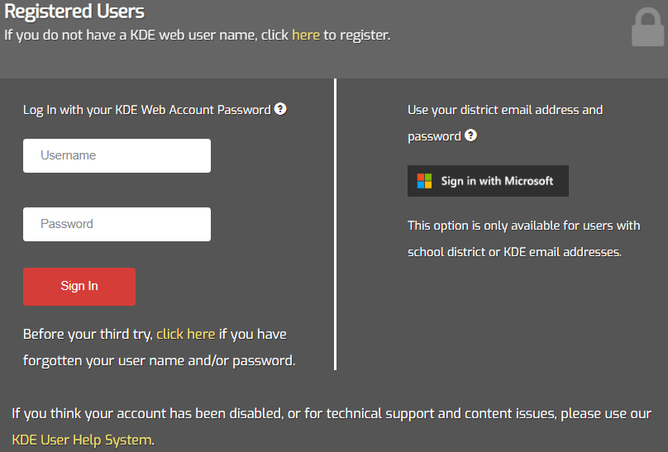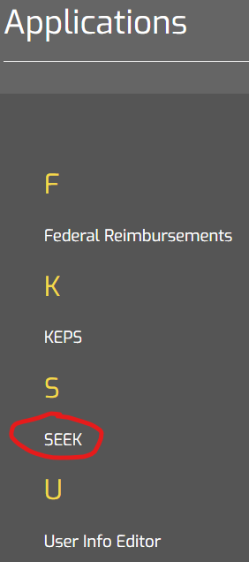
- This will take you to the “SEEK District Data Submission” Home page.
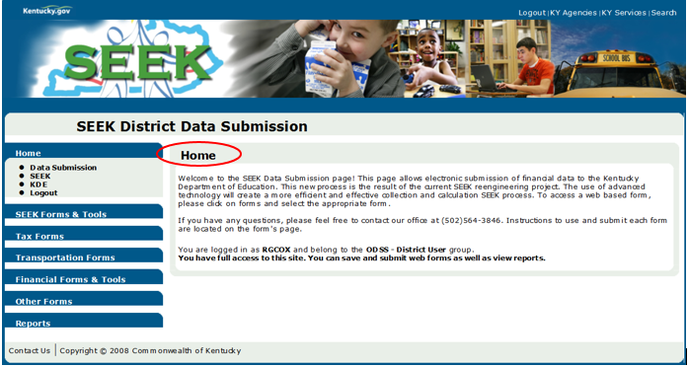
- Click the Financial Forms & Tools option in the main list and click on ‘Audited AFR’.
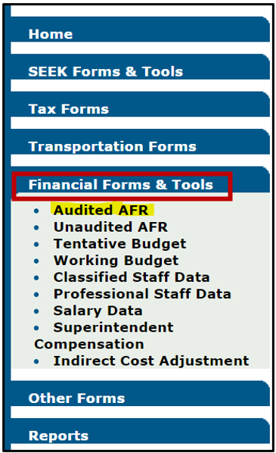
- The Annual Finance Record – Audited screen will appear. Your assigned district name will appear in the ‘District’ field. The ‘Form History’ field will consist of ‘Approved’, followed by the submitted date and the user who submitted the record. This message indicates the district’s Audited AFR was successfully uploaded in the SEEK Application. Once the district’s Audited AFR/BS successfully passes the Audited AFR submission business rules, the ‘Validate’ button at the bottom of the screen will become available. Click the ‘Validate’ button in order to enter the district’s selective FY 2023 Financial Audit Report data and comments.
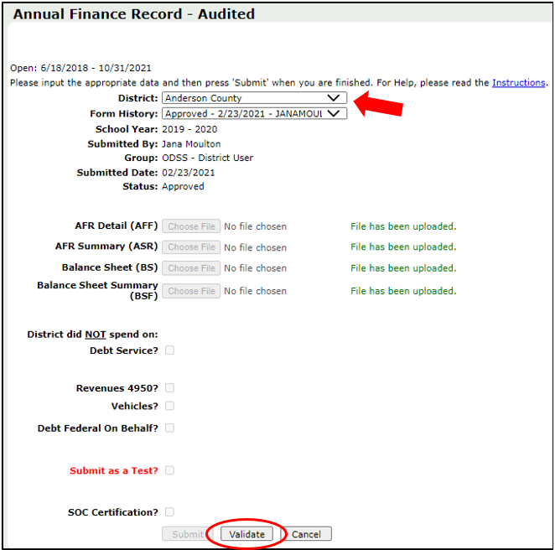

Entering Audit Report Data
Step 1: The AFR and Balance Sheet Validation – Audited screen will appear. Confirm the ‘AFR Calculations’ tab is presented first on the screen and the ‘Section:’ field consists of ‘Fund 1 (General)’. Then click the ‘Import All’ button to import the district’s predetermined selective Audited Annual Financial Report and Balance Sheet data into the ‘Audited AFR (A)’ column within the ‘AFR Calculations’ and ‘Balance Sheet Calculations’ tabs.
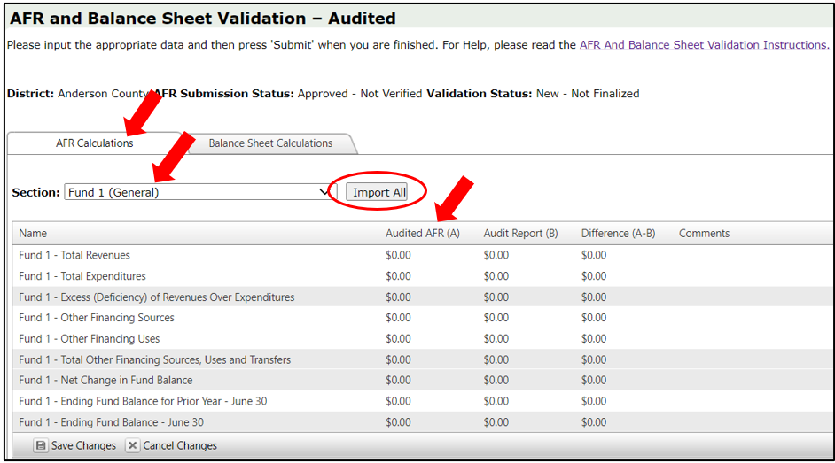
Step 2: Under the ‘AFR Calculations’ tab, the selective Audited AFR data will display in the ‘Audited AFR (A)’ column. Use the district’s FY 2023 Financial Audit Report or proposed FY 2023 audit data received from the district’s auditor to obtain the amount that corresponds to the individual fund, row description, and Audited AFR amount.
Please use the Financial Audit Report’s “Statement of Revenues, Expenditures, and Changes in Fund Balance Governmental Funds” for Funds 1, 2, 21, 22, 23, 25, 310, 320, 360, & 400 to obtain the amounts that will be entered into the ‘Audit Report (B)’ column within the SEEK Application. NOTE: Some of the funds may be recorded in the “Combining Statement of Revenues, Expenditures, and Changes in Fund Balances - Nonmajor Governmental Funds”.
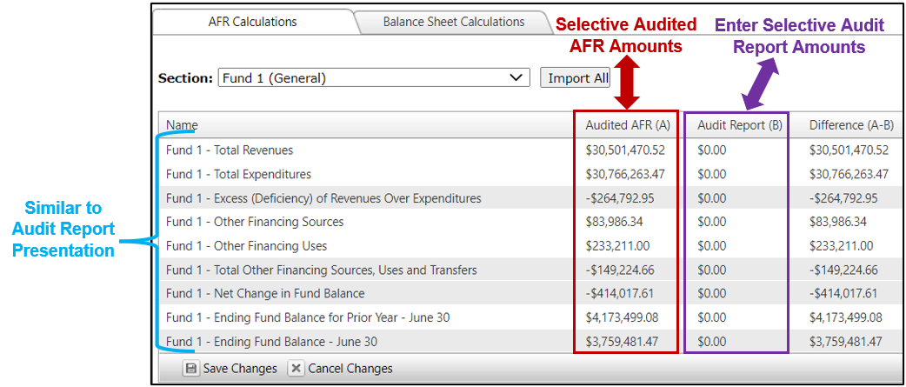
Step 3: Place your cursor over the ‘$0.00’ within the ‘Audit Report (B)’ column and ‘Fund 1 - Total Revenues’ row, then click on the cell and enter the corresponding amount from the Audit Report. Enter any comments in the ‘Comments’ section by clicking on the specific comment field. To move to the next row, click on the designated cell in the ‘Audit Report (B)’ column. Repeat this process until all required ‘Audit Report (B)’ fields are completed for Fund 1. The shaded fields or areas contain built in formulas; therefore, it will not allow you to enter any amounts into the shaded fields. However, you may enter comments in the shaded fields corresponding ‘Comments’ sections. To determine ‘Other Financing Sources’ and ‘Other Financing Uses’, refer to the next step.
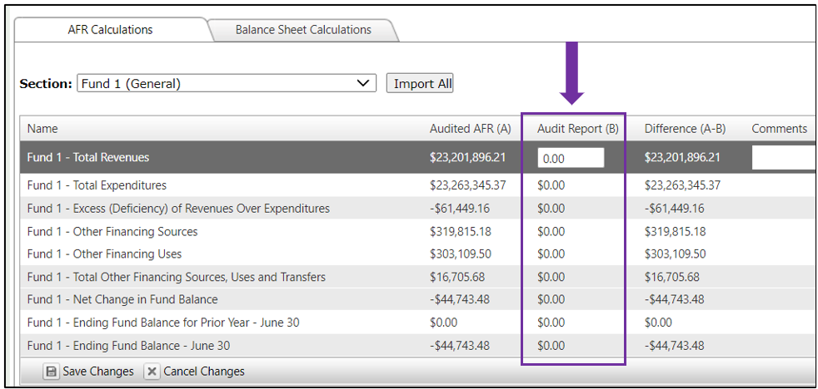
Please add the Transfers In amounts and the Other Financing Sources amounts listed in the Audit Report together and enter the combined amount into the ‘Other Financing Sources’ field within the ‘AFR Calculations’ tab.
Please add the Transfers Out amounts and the Other Financing Uses amounts listed in the Audit Report together and enter the combined amount into the ‘Other Financing Uses’ field within the ‘AFR Calculations’ tab. The total dollar amount should be entered in the SEEK Application as a positive amount although the amounts are recorded in the Audit Report as negative amounts.
NOTE: These instructions do not apply to the Proprietary Funds: Food Service and Day Care Funds. Instructions for Food Service - Funds 51 and 81 and Day Care - Funds 52 and 82 are presented separately.
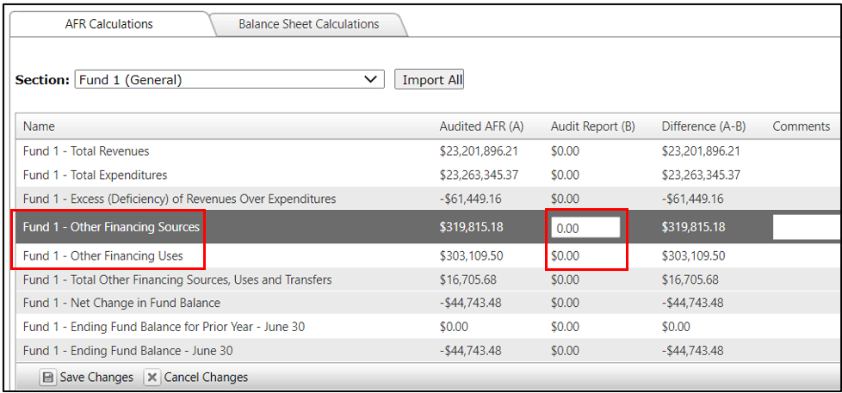
Step 4: If a prior period adjustment is recorded in the Audit Report, a calculation is required. The adjustment must be combined or netted with the Ending Fund Balance for Prior Year - June 30 in the Audit Report before the total combined amount is entered into the SEEK Application, Fund 1 – Ending Fund Balance for Prior Year – June 30 row. Once the amounts have been entered for Total Revenues, Total Expenditures, Other Financing Sources, Other Financing Uses, and Ending Fund Balance for Prior Year – June 30 in the SEEK Application, click the ‘Save Changes’ button at the bottom of the screen in order to save the entered data for that specific ‘Fund’ section. Once you click this button, the amounts that are derived from formulas will appear on the screen. This is illustrated in the following screenshot.
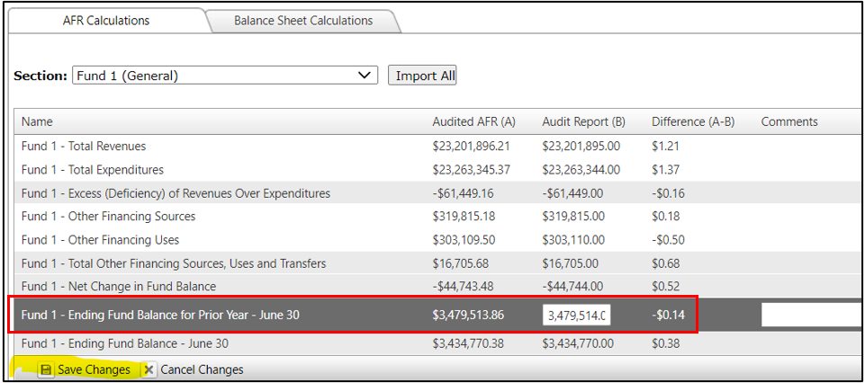
As previously mentioned, the amounts listed in the ‘Difference (A-B)’ column were updated after the ‘Save Changes’ button was clicked. The formulas have now calculated, and the user should not see the discrepancies that were previously shown. If a difference remains, work to reconcile the difference. Consider speaking with your auditor and, if needed, the District Financial Management Branch for assistance.
To proceed to the next Fund, click on the dropdown arrow by the ‘Section:’ field to choose the next Fund under the ‘AFR Calculations’ tab. Do the same under the ‘Balance Sheet Calculation’ tab.
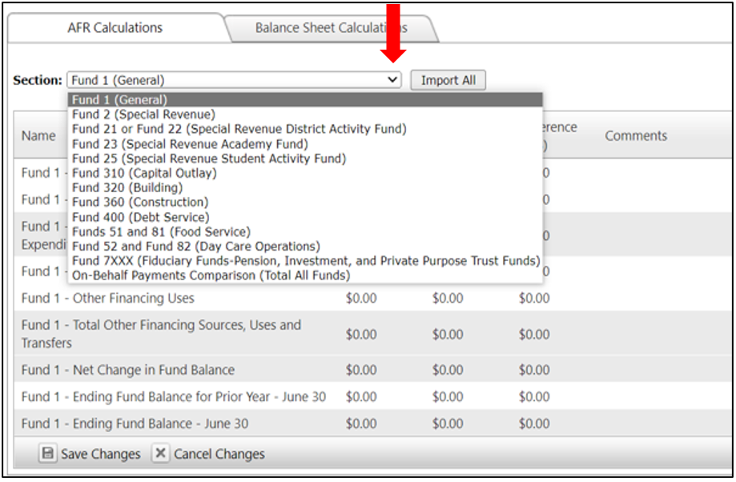

Proprietary Funds – Instructions for “Transfers In” and “Transfers Out”
Step 5: For Fund 51 and 81 Food Service and Fund 52 and 82 Day Care Fund, use the Financial Audit Report’s “Statement of Revenues, Expenses and Changes in Net Position – Proprietary Funds”. Transfers Out may be included in Non-Operating Revenues as a negative number. To obtain the actual total for the Total Revenues in the SEEK Application, add Operating Revenues and Non-Operating Revenues in the Audit Report together, then add the Transfers Out amount as a positive number into the calculation. If Transfers In have been included in the Non-Operating Revenues, then subtract the Transfers In amount as a negative number in the calculation. Some Audit Reports may have Transfers In and Transfers Out listed separately from the Revenues so this calculation will not apply.
For the illustration below, the district had $379,470 in Total Operating Revenues and $1,642,542 in Total Non-Operating Revenues in the Audit Report. Transfers Out of ($83,986) and Transfers In of $2,823 is included in the $1,642,542 Total Non-Operating Revenues. To obtain the Total Revenues amount to insert in the SEEK Application, the calculation would be, $379,470 + $1,642,542 + $83,986 - $2,823 = $2,103,175.
Enter the ‘Transfers In’ amount from the Audit Report into the Transfers In Only row in the SEEK Application. Enter the ‘Transfers Out’ amount from the Audit Report into the Transfers Out Only row in the SEEK Application as a positive amount, although it is recorded as a negative amount in the Audit Report. See below.
NOTE: If a Net Position Adjustment is recorded in the Audit Report, a calculation is required. The adjustment must be combined or netted with the Ending Net Position for the Prior Year - June 30 before the total combined amount is entered in the Seek Application.
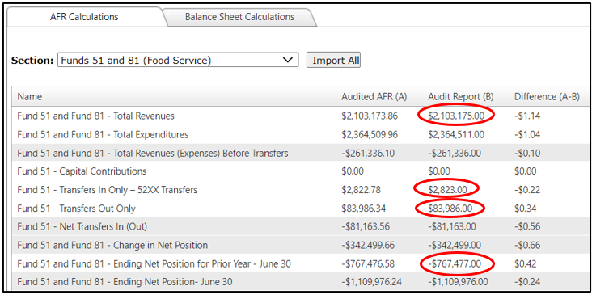
Step 6: For the Fiduciary Funds, use the Financial Audit Report’s ‘Statement of Changes in Fiduciary Net Position - Fiduciary Funds’ or ‘Statement of Revenues, Expenses & Changes in Net Position – Fiduciary Funds’ to obtain the amounts to be entered in the ‘Audit Report (B)’ column within the SEEK Application.
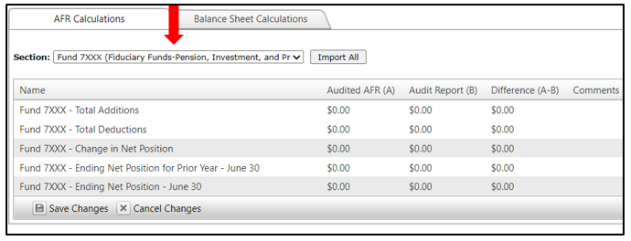
For the On-Behalf Payments Comparison, enter the total on-behalf payment amount recorded in the Financial Audit Report’s Notes to the Financial Statements into the ‘Audit Report (B)’ column within the SEEK Application. The On-Behalf payments per KDE’s website section comes from the KDE On-Behalf Payments Summary Report.
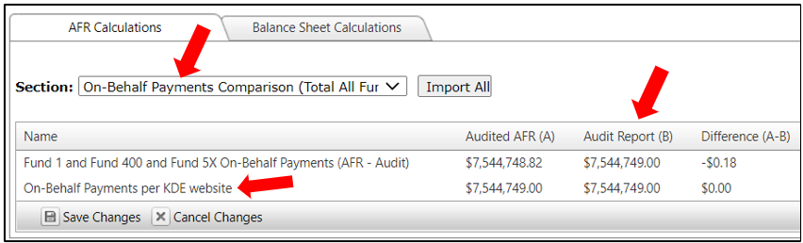
Step 7: Click on the ‘Balance Sheet Calculations’ tab, then complete the individual Fund sections like the processes referenced in the previous steps for the “AFR Calculations” using the Financial Audit Report’s “Balance Sheet Governmental Funds” for Funds 1, 2, 21, 22, 23, 25, 310, 320, 360, & 400 to obtain the amounts that will be entered into the ‘Audit Report (B)’ column within the SEEK Application. NOTE: Some Funds may be recorded in the Combining Balance Sheet-Nonmajor Governmental Funds. The Proprietary Funds and Fiduciary Funds require the use of different financial statements, and the screen layout varies slightly. Please remember to click on the “Save Changes” button before changing funds.

Balance Sheet Calculations Tab - Proprietary Funds:
For Fund 51 and 81 (Food Service) and Funds 52 and 82 (Day Care) use the Financial Audit Report’s ‘Statement of Net Position - Proprietary Funds’ to obtain the amounts that will be entered into the ‘Audit Report (B)’ column within the SEEK Application:
- For the Fund 51 and 81/Fund 52 and 82 - Total Assets Plus Total Deferred Outflows of Resources row within the SEEK Application, add the ‘Total Assets’ and ‘Deferred Outflows of Resources’ amounts from the Audit Report, then enter the combined amount in the ‘Audit Report (B)’ column.
- For the Fund 51 and 81/Fund 52 and 82 - Total Liabilities Plus Total Deferred Inflows of Resources row within the SEEK Application, add the ‘Total Liabilities’ and ‘Deferred Inflows of Resources’ amounts from the Audit Report, then enter the combined amount in the ‘Audit Report (B)’ column.
NOTE: For the Fund 51 and 81/Fund 52 and 82 – Net Position row within the SEEK Application ‘Audit Report (B)’ column, the total will populate automatically based on the entries above.
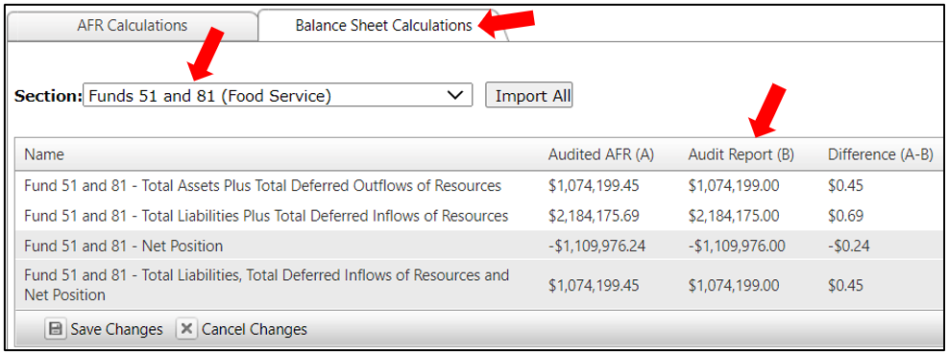

Balance Sheet Calculations Tab - Fiduciary Funds:
For the Fiduciary Funds, use the Financial Audit Report’s ‘Statement of Fiduciary Net Position - Fiduciary Funds’ or ‘Combining Statement of Net Position All Agency Funds’ to obtain the amounts entered into the ‘Audit Report (B)’ column within the SEEK Application.
NOTE: The School Activity funds are required to be reported under Fund 25 (Special Revenue Student Activity Fund) as part of the implementation of GASB 84.
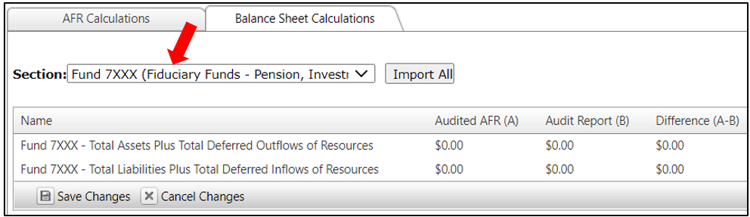
Step 8: After the ‘AFR Calculations’ and ‘Balance Sheet Calculations’ tabs are completed; you will be ready to print the ‘Annual Financial Report’ and ‘Balance Sheet Report’. The reports can be opened or saved as a PDF or Excel file prior to printing. Select the report name and format using the dropdown arrows and click the download button. Once the reports are printed, check the reports for accuracy.
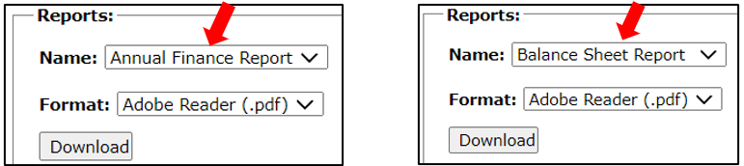
Step 9: Once you have confirmed the reports are correct, the document is ready to be submitted to KDE. Click the ‘Submit’ button and the following message will display on the screen. Click the ‘OK’ button to complete the submission process.
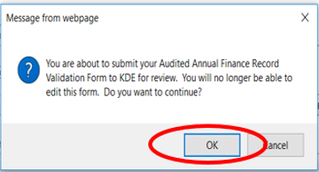
After the ‘Audited AFR and Balance Sheet Validation’ data is submitted to KDE, a Confirmation notice will display on the screen.
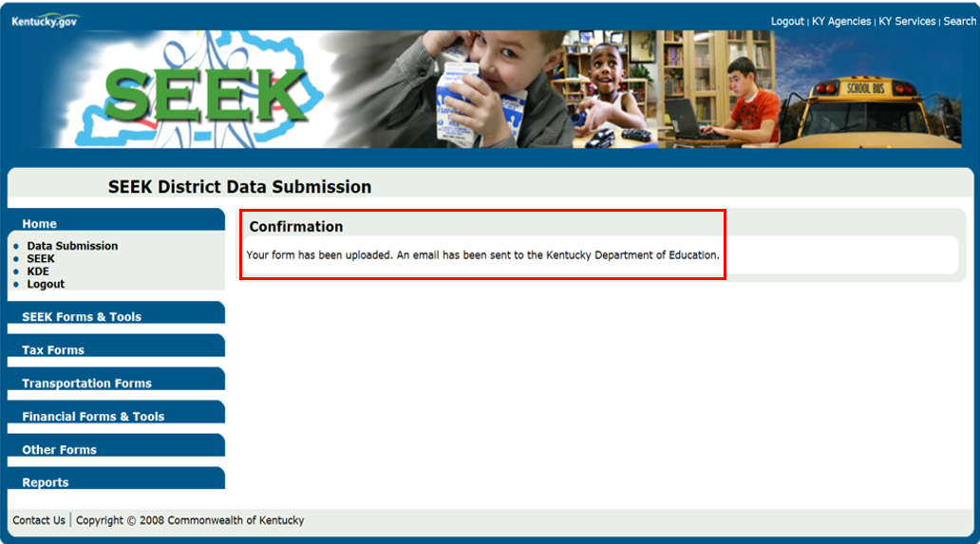

Variances Note:
The Kentucky Department of Education (KDE) realizes there may be some variances between the selective Audited AFR/BS and Audit Report data, mainly due to rounding issues. These should be handled accordingly:
- Please state the reason for any unresolvable difference in the ‘Comment’ section that corresponds to that row.
- Finance officers should identify and correct all resolvable differences between the Audited AFR/BS and Audit Report. If a corrected Audited AFR/BS must be resubmitted, then email DFMB at Finance.Reports@education.ky.gov to deny the original AFR/BS. If the audit report will need to be corrected inform DFMB that a revised copy will be issued.

Kentucky Department of Education
Office of Finance & Operations
Division of District Support
District Financial Management Branch
Dated: 09/27/23

