Educational Cooperative

Federal Reimbursement

“CVS” File Conversion

Kentucky Department of Education
Office of Finance and Operations
Division of District Support
District Financial Management Branch
Dated 8/14/18

FEDERAL REIMBURSEMENT “CSV” FILE CONVERSION

- Open your previous month’s Federal Reimbursement spreadsheet.
- Now click on “Save As” and make sure that the file name has this naming feature “F0116705001” only change the month to match the month that is being submitted and confirm that the district number matches your district. Save this file in Excel. Once this is set up properly the first time you will NOT have to format again. Save this file in a location that will be easy for you to find or remember. Now click on “Save”.
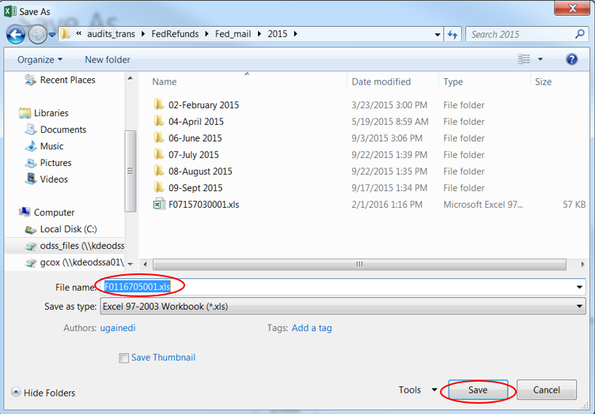
- You will need to change the format of the spreadsheet. In the top left corner of the spreadsheet click the corner box to highlight the entire spreadsheet.
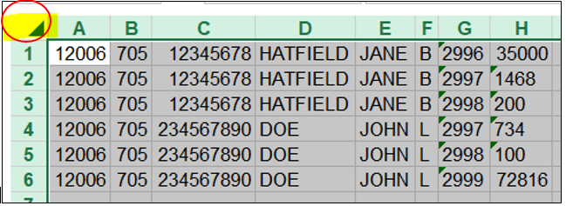

- Now you need to change the format to text. While it is highlighted right click in body of the spreadsheet and click on “Format Cells”. The following box will appear. On the “Number” tab choose Text then click OK.
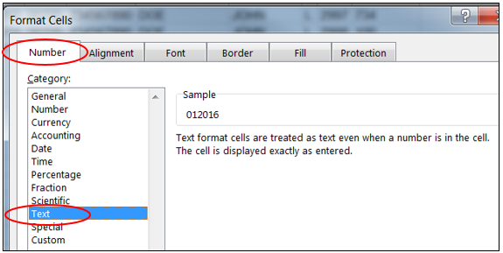
- This will allow you to use zeros as a beginning filler for the first three columns that are required to have a certain number of digits in order to convert properly.
- “Column A” reflects the Billing Period, 2 digit Month (01-January) and 4 digit Year (2016). You will need to type in the zero, if needed, in order to make this column have 6 digits appear. The first 2 digits are the month and the last 4 digits are the year.
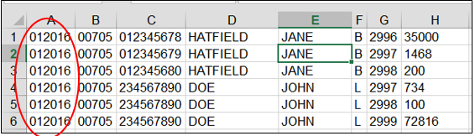
- “Column B” must have 5 digits in this column. You will need to insert two zeros in front of the district number (00705).
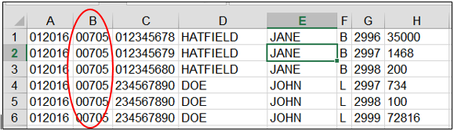
- “Column C” consists of the employees’ 9 digit Social Security Numbers (SSN) (012345678). Some SSNs have zeros at the beginning of the SSN so be sure to type in that zero to make it a 9 digits.
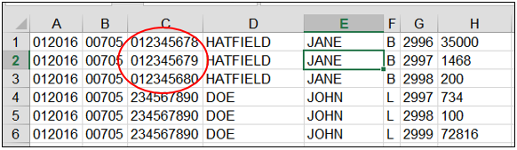
- “Column D” reflects the employees’ “Last Name” (Hatfield). This column can be up to 20 digits.
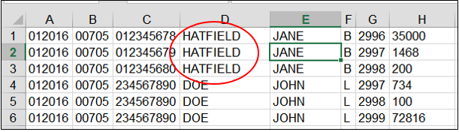
- “Column E” reflects the employees’ “First Name” (Jane). This column can be up to 15 digits.
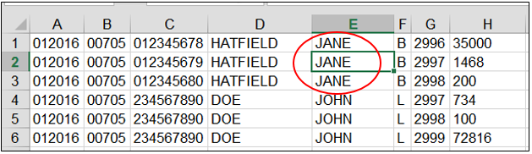
- “Column F” reflects the employees’ “Middle Initial”. This column should only be 1 digit.
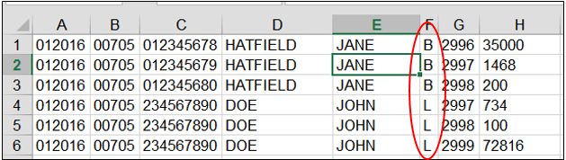
- “Column G” reflects the “Codes” (2996, 2997, 2998 & 2999). This column width should only be 4 digits.
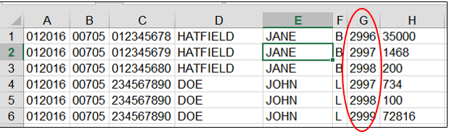
- The definition of the Codes are as listed below:
- 2996 – HRA (17500)
- 2997 – Administrative Fee (734)
- 2998 – Life Insurance Premium (100)
- 2999 – Health Insurance Premium per KEHP Employer Contribution rate chart

- “Column H” reflects the “Premium Amount” (HRA, Admin Fee, Life Ins. & Health Premium). This column can be up to 9 digits. When reporting a negative amount just apply the minus sign in front of the amount. Also please remember do NOT use decimals.
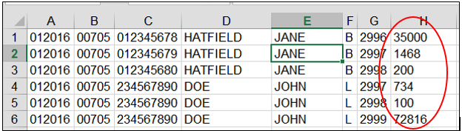
- You can Total “Column H” in order to verify it, and then remove the total.
- Be sure to click on SAVE before converting.
- In your excel file highlight all of your content information like you would if you were going to set the print area, then right click and COPY.
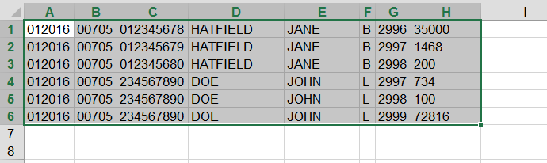
- In that same excel file click on a new tab at the bottom by clicking on the plus sign (+)
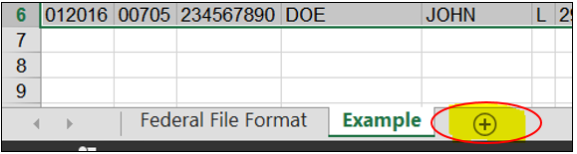
- In the new tab right click and then click on Paste Special.
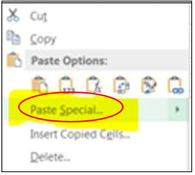

- In the pop up box you will need to check the box beside Skip Blanks
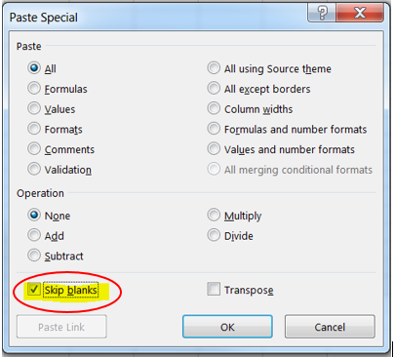
- Now click on “File” and then “Export”.
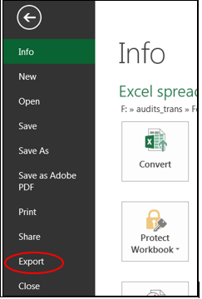
- Then click on “Change File Type”, then click on CSV (Comma Delimited) (*.csv) then click on “Save As”.
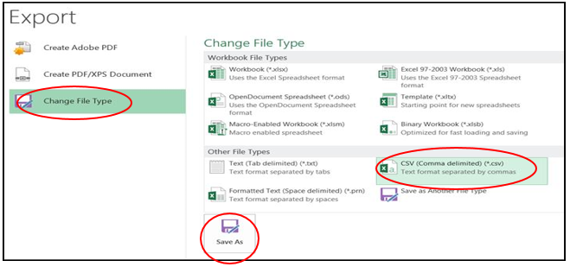
- Now the “Save As” box will appear and you will need to make sure the file name is correct for the file that you are uploading, then just click SAVE.
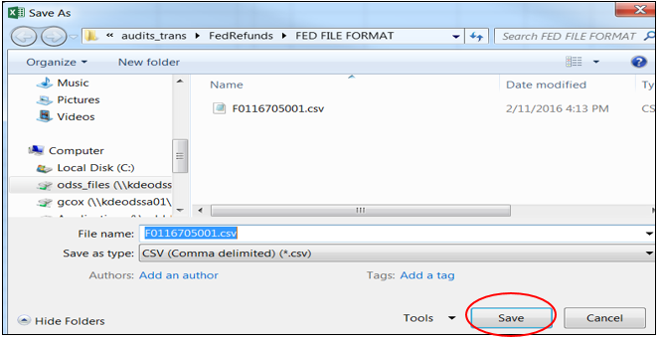
- When the below message appears on the screen, click “Yes”.
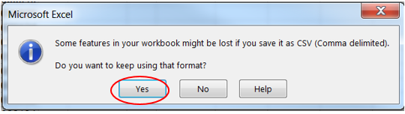
- Close the file. When trying to close the file, the below message will appear. Click on “Don’t Save” then the file will close.
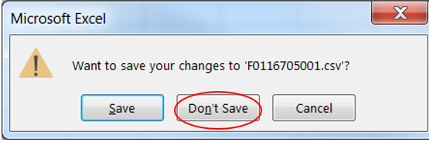
- In order to view the information in the file you will need to open the CSV file in “Notepad” or “Wordpad”. If you open the file in excel the information will not appear correctly.
- The CSV file information when opened in Notepad will look like the below picture. The zeros should still be there, where needed. Also there should not be any blank spaces:
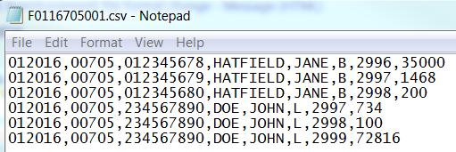
- This file is now in the correct format needed to transfer the Federal Reimbursement file securely via through the Federal Reimbursement Web Submission program that KDE has set up.
- All the Coops that are not on MUNIS have been setup in the program, so that you will have access to transfer this file. If you are not registered please refer to the “Federal Reimbursement ID Setup” instructions to register, then contact your Web Apps Admin Point of Contact (WAAPOC) so they can grant you access to this program.
If you need further assistance, please call 502-564-3846 for Gail Cox at extension # 4462 or Gail.Cox@education.ky.gov or Jackie Chism at extension # 4445 or jackie.chism@education.ky.gov.

KDE USE: F:\audits_trans\Audit Branch SOP's\Federal Reimbursement SOP's

