Federal Reimbursement Instructions for KDE SharePoint Submission

Kentucky Department of Education Office of Finance and Operations Division of District Support

District Financial Management Branch

Dated 3/4/25

**Federal Reimbursement Submission Process**

The Kentucky Department of Education (KDE), District Financial Management Branch (DFMB) has a process the districts, along with the Cooperatives (coop) that are on MUNIS, are required to utilize for exporting a specific report generated from Enterprise ERP (EERP) to upload into the KDE SharePoint site. Below are the instructions that each district/coop will follow to export this specific report from EERP to export to the KDE SharePoint site each month. **PLEASE NOTE:** This process is separate from the payment process. The payment process has NOT changed.

Please refer to the “[Federal Reimbursement of Health Benefits](https://education.ky.gov/districts/FinRept/Pages/Federal-Reimbursement-of-Health-Benefits.aspx)” website document titled “*Guidance on ACH Pay Application*” for more information.

# STEPS TO GENERATE THE EXPORT DETAIL REPORT

## NOTE: The steps below are detailed in generating a report that does NOT contain employee social security numbers. The report below is different from the report that was submitted in years past.

1. Each month you will generate the Federal Reimbursement File according to the “[KY Employee](https://education.ky.gov/districts/Documents/KY%20Employee%20Benefits%20Munis%20Processing%20Guide.pdf) [Benefits Munis Processing Guide](https://education.ky.gov/districts/Documents/KY%20Employee%20Benefits%20Munis%20Processing%20Guide.pdf)”. **NOTE:** This process has not changed and must be done first. Do **NOT** send this report as it contains SSN’s.
2. Once you have generated the Federal Reimbursement File (step #1), follow the steps below to generate the **Federal Excel Report.** In EERP from the **KY Employee Benefits** main screen, select **Federal Reimbursement.**

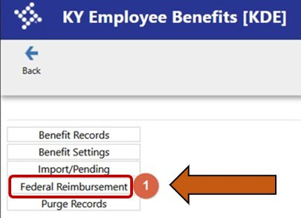

1. On the **Federal Reimbursement** screen ribbon select the “**Maintain”** button.

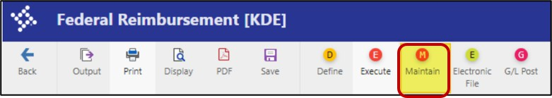

1. On the **Maintain** screen select the “**Search**” button.

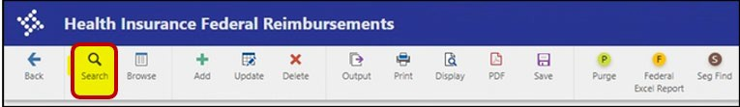

1. In **Search,** enter the details to generate the report for a specific month and year. Choose **Billing Year and** **Billing Month** since the files are based on those parameters. Once the search fields are chosen, click “**Accept**”.

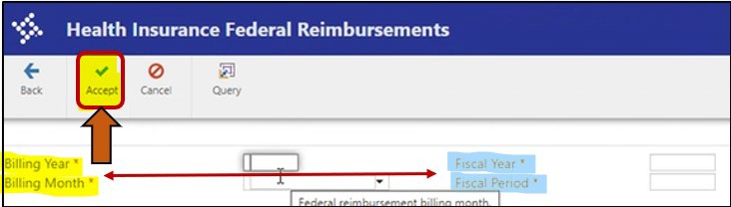

1. A popup box will appear, and click “**Yes, Continue**”.

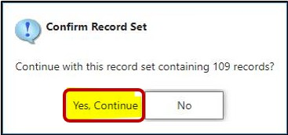

1. Click the “**Federal Excel Report”** button.

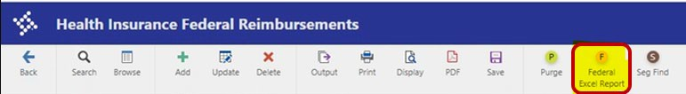

1. You will get a pop-up box with two options, choose the “**Export Detail**” option. Once the report has opened, you will need to save the report to your computer for submission to KDE (see the details in the following step).

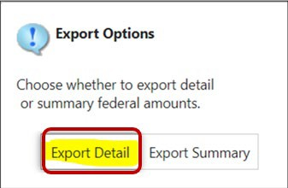

1. When saving the file and helping prevent files from being overwritten, you must save the file with the following naming features. **Failure to follow these steps could cause the loss of critical data.**
   * For the original file, add “ORG” to the file name **Example** FRMMYYNNNorg.
   * For a revised file add “REV” to the file name **Example** FRMMYYNNNrev.
   * For the June, July and/or August summer files add “SUM” to the file name **Example**

FR**06**23NNNsum, FR**07**23NNNsum & FR**08**23NNNsum.

**Breakdown of the File Name:**

* + - FR – Federal Reimbursement
    - MM – 2-digit Billing Month (01-Jan, 02-Feb, 03-March, etc.) this is the calendar month
    - YY – 2-digit Billing Year (23 = 2023) this is the calendar year
    - NNN – Your District/Coop’s 3-digit Number ([refer to the “List of District & Coop numbers”](https://education.ky.gov/districts/FinRept/Pages/Federal-Reimbursement-of-Health-Benefits.aspx) [posted on the website](https://education.ky.gov/districts/FinRept/Pages/Federal-Reimbursement-of-Health-Benefits.aspx))
    - Org, Rev, or Sum – Original, Revised, or Summer file for that Billing Month & Billing Year.

1. Please **NOTE** for June, July and/or August files, you may have two files to submit to KDE. You will generate multiple files for the **summer payrolls** run in June. You may have a file for July and August with **SUM** added to the file name for the summer payroll (10- or 11-month employees) and you may have a second file for July and/or August with **ORG** added to the file name for the regular payroll (12-month employees)- if you choose to generate them separately. For June, you will only have one ORG file (this would include all June payrolls) excluding the summer payrolls for July and August.

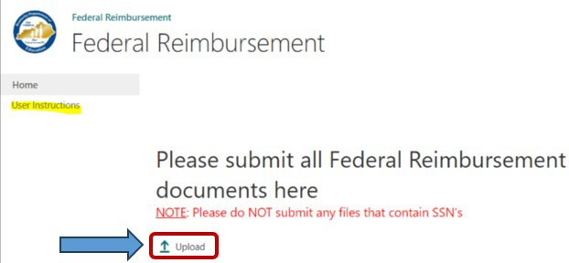

1. Below is an example of the “**Federal Excel Report**” (Export Details).

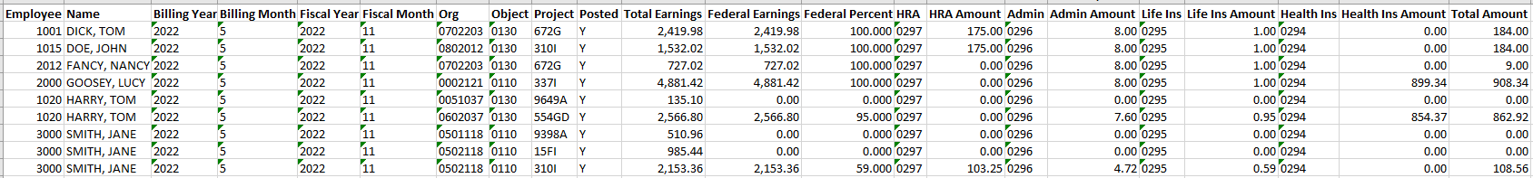

# STEPS TO SUBMIT THE EXCEL REPORT ONLY

## NOTE: Do NOT submit any documents that contain employee social security numbers. Any document that is submitted with SSN’s will NOT be accepted.

1. To submit the **Federal Excel Report** to KDE, click on the following SharePoint link: <https://staffkyschools.sharepoint.com/sites/dsapps/fedreimburse/SitePages/Home.aspx>. **NOTE:** Please note that SharePoint works better in a modern web browser like Microsoft Edge or Google Chrome.
2. If prompted, enter your appropriate Microsoft Credentials. **NOTE:** Please make sure that the email address used is [employee.name@districtname.kyschools.us](mailto:employee.name@districtname.kyschools.us) or you will not be able to gain access to the program. If you continue to have problems logging in, please send an email to [finance.reports@education.ky.gov](mailto:finance.reports@education.ky.gov) with “Federal Reimbursement access issue – (district name)” in the subject line.

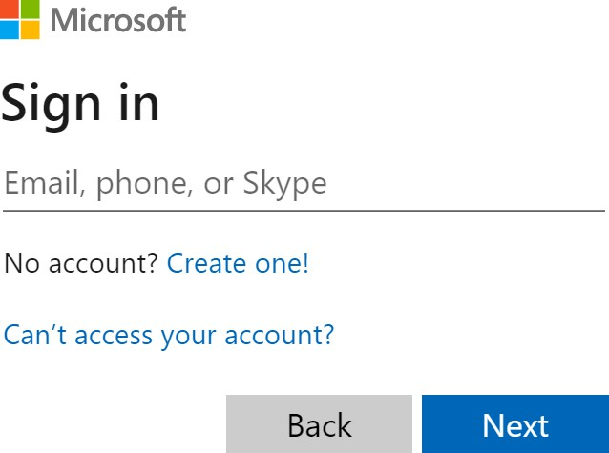

1. Once logged in, you will see the webpage screen below. To submit a report, click on the “**Upload**” button. **NOTE:** There is a link to the left that will take you to the most recent “User Instructions” located on the website.
2. A dialog box will appear, click “**Choose File**” button to upload the specific report. In the box beside the **Version Comments,** please provide a **comment** that indicates if this file is the original file or a revised file. Also, provide the billing month, and billing year that the file corresponds to, then click the “**OK**” button. **NOTE:** The checkbox should always be checked.

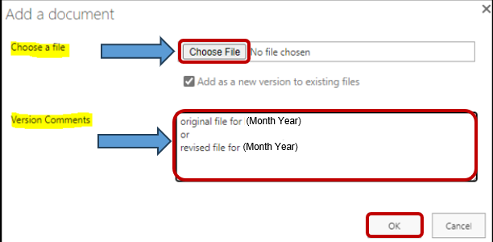

1. In the second dialog box, the “**Name**” field will be prepopulated. This is the name of the file that you chose in the previous dialog box. Next, click on the dropdown box beside each item and select the corresponding **District/Coop**, **Billing Month**, and **Billing Year**, then click either of the “**Check In**” boxes to finish. Please **note** at the top of this dialog box, it indicates the document was **uploaded successfully**. *See example screenshot below*.

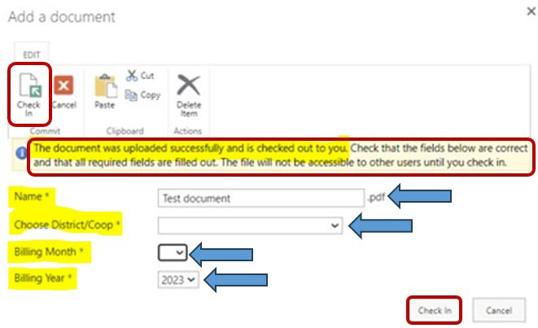

1. Once the file has been **Checked In,** you will receive a confirmation email that the file has been received. If you do not get a confirmation email, please let our office know.

## KDE requests that the Federal Reimbursement file and payment be submitted to KDE within 30 days of the last payroll for the month.

If you have questions or a problem with the SharePoint submission process, please contact the District Financial Management Branch (DFMB) Staff at 502-564-3846:

* + Jackie Chism extension #4445 or [jackie.chism@education.ky.gov](mailto:jackie.chism@education.ky.gov)
  + Kelli Young extension #4417 or [kelli.young@education.ky.gov](mailto:kelli.young@education.ky.gov)

**NOTE:** To add or remove a User from the **Federal Reimbursement of Health Benefits process,** please send an email to [finance.reports@education.ky.gov](mailto:finance.reports@education.ky.gov) with “Federal Reimbursement user change – (district name)” in the subject line.

**KDE USE:** F:\audits_trans\Audit Branch SOP's\Federal Reimbursement SOP's\District Use