Instructions to submit the
Fidelity Bond through the
SEEK Web Based Form

Kentucky Department of Education
Office of Finance and Operations
Division of District Support
District Financial Management Branch

Dated: 8/4/21

Fidelity Bond Web Based Form Submission Instructions
- In the month of April, KDE will post the Penal Sum “Exposure Calculation Report” on the “Bonds” website. It is the responsibility of the district to make sure they have their employees bonded for the proper amount for the next fiscal year according to the “Exposure Calculation Report”.
- On June 1, KDE will OPEN the window in the SEEK Application to allow the districts to update, delete and/or add bonded employee information through the “Fidelity Bond” Web Form. NOTE: If the district needs to make changes during the FY, they must contact KDE so the window can be OPENED for editing.
- Go to the SEEK District Data Submission - https://opsupport.education.ky.gov/webforms/Login.aspx login screen. NOTE: The district must use Internet Explorer web browser in order for the web form to work properly.
- The login process has changed effective June 2021. On your first login, you with enter your “Username” and “Password” for SEEK.
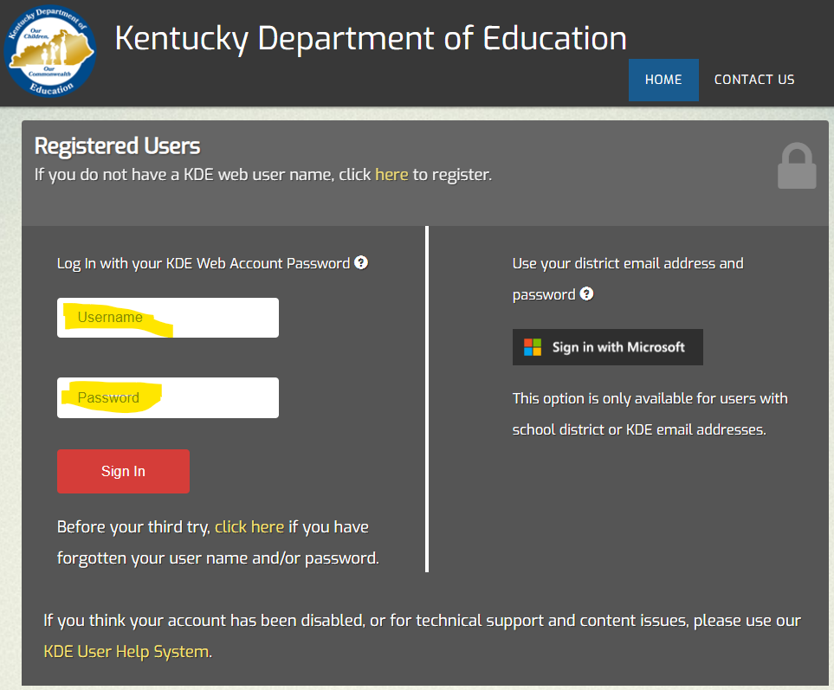
- Once you click the “Sign In” button, it will prompt you to log in using your Microsoft email. Click on your work email and sign in.
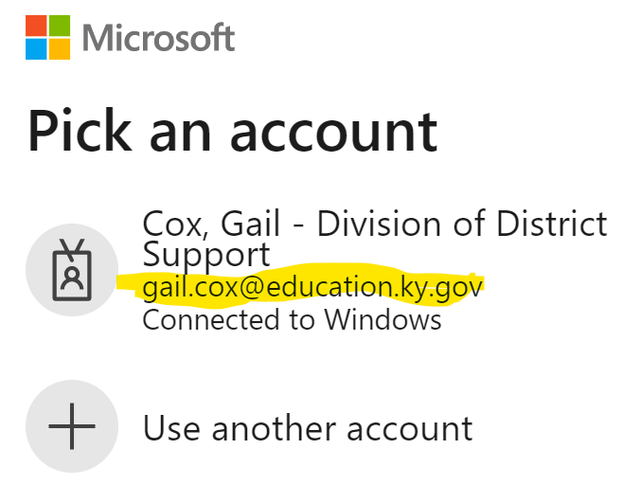
- Once signed in it will take you to the “Applications” page where you will see all the applications you can access. You will click on the SEEK link.
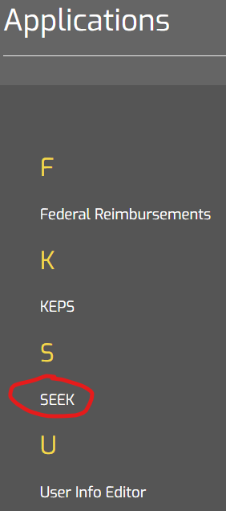
- This will take you to the “SEEK District Data Submission” Home page.
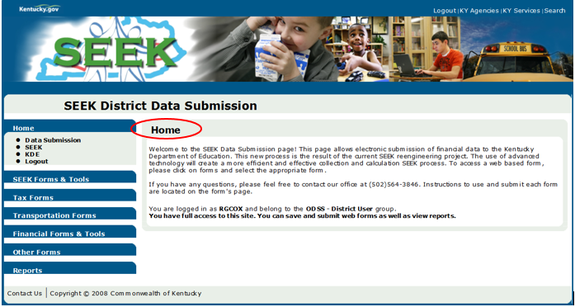
- Click the Other Forms link on the left side of the screen to see the web forms listed under that folder.
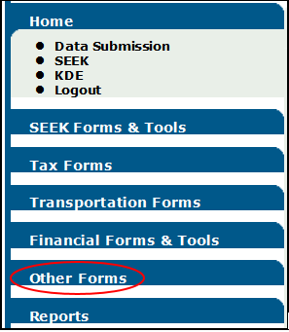
- Select and click the Fidelity Bonds web form.
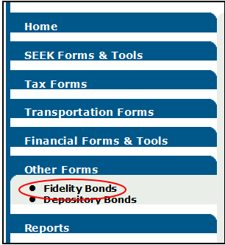
- The District field will automatically be populated with the district name you have permission to enter the Fidelity Bond data for. If you have more than one district you are entering data for, please use the drop-down arrow key to select the proper district.
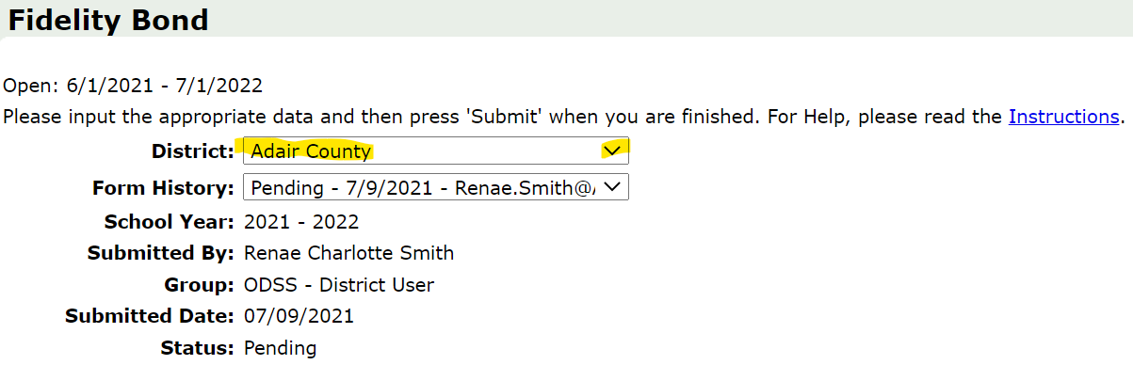
- The status of the district’s bond will be listed in the Form History field.
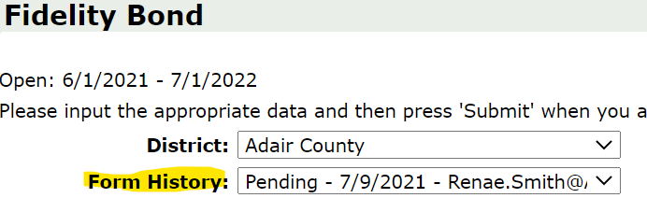
Definition of the status in the Form History field:
- “NEW” will automatically display in the box if this is a new FY and the district has not yet updated any information.
- “SAVED” will appear when the district has started entering information and had clicked on the save button before closing the form without submitting the information to KDE.
- “PENDING” will appear if the form is waiting for approval from KDE
- “APPROVED” will appear when approved by KDE
- “DECLINED” will appear if KDE has denied the Fidelity Bond for some reason. This will reopen the window for the district to correct and resubmit. This will remove the new information the district submitted and will default back to the last approved information.
- The Fidelity Bond web form screen will automatically populate the following fields:
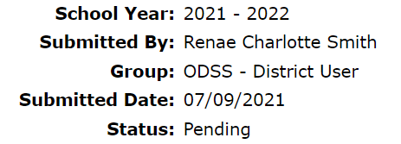
- School Year – The current Fiscal Year will show by default.
- Submitted By – This is the person who logged in and submitted the district’s information to KDE.
- Group – User Group, which would say ODSS – District User
- Submitted Date – Date bond information was submitted to KDE
- Status
- New – This mean the information has not been completed yet.
- Pending – This means it has been submitted to KDE and is waiting on KDE.
- Denied – This means it has been denied by KDE.
- Approved – This means it has been approved by KDE.
- In the top right corner of the “Fidelity Bond” web form is a link that says Instructions. This link will take you to the “Bonds” webpage where you can find the “Fidelity Bond Web Base Form Submission Instructions”.
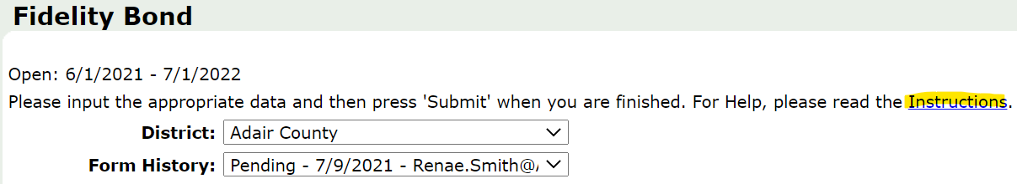
UPDATE, DELETE AND/OR ADD BONDED EMPLOYEES
- Scroll down to see the section called “Bonded Employees”. This is a list of bonded employees the district has submitted to KDE.
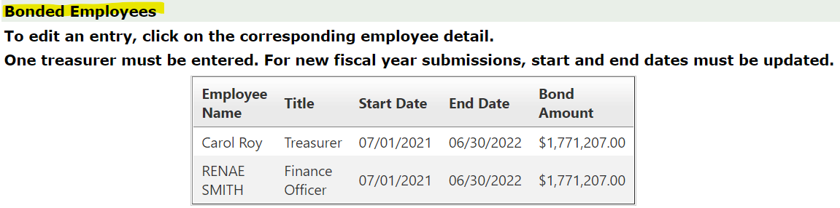
- For the district’s convenience, brief instructions have been placed above the current bond records.
- The instructions stating “To edit an entry, click on the corresponding bond detail”, means you will need to click on that bond record for it to populate the Bond Details for editing.
- The statement “One treasurer must be entered” means if the district does not have a treasurer listed, it will NOT let them submit the bond information for anyone.
- The instructions stating “For new fiscal year submissions, start and end dates must be updated” only applies when editing a bond record. When you click on NEW, it automatically populates the correct start and end dates.
- IMPORTANT MESSAGE: The district will have to do something with each current bonded employee’s records every year whether it is to UPDATE or DELETE the bonded employee’s record. You will NOT be able to submit the information unless you do one of these steps for each currently listed record.
- NOTE: If you are seeing an EDIT button, the screen is not appearing properly and will NOT let you submit your information. See steps 4-6 below to fix this problem.
- In your Internet Browser, click on “Tools”
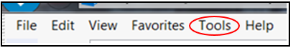
- Then click on “Compatibility View Settings” and add the ky.gov website to this setting, then click Close.
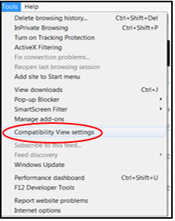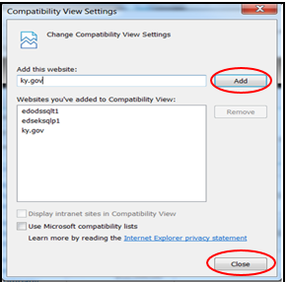
- Now you will need to logout and log back in and the website should appear like the screenshot in step 8. If it doesn’t and you did steps 4-6, contact KDE.
- To UPDATE an employee’s record, click on the “Employee Name” listed in the table under “Bonded Employees”.
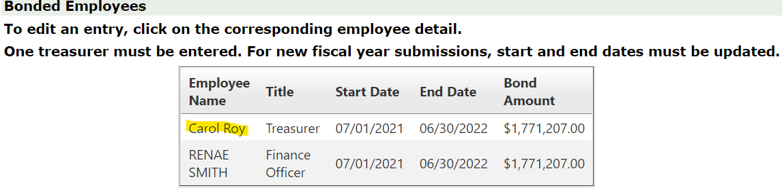
NOTE: Each Bonded Employee’s record must be either UPDATED or DELETED. If duplicate employees are listed, your bond will be DENIED by KDE. When denied, all updated information is lost. The program automatically lists the last approved bonded employee’s records.
- Once the Employee Details have been populated, UPDATE the “Start Date” (7/1/**) and “End Date” (6/30/**). Dates should follow the FY. There is a check in the program to verify the “Bond Amount”. The Bond Amount is also listed in the “Exposure Calculation Report” on the “Bonds” website. Once all information has been verified, click on the “UPDATE” button. If there are any errors, an error message will appear in red somewhere on the screen. You may have to scroll up to see the top of the screen for messages. NOTE: Clicking on UPDATE, saves the information.
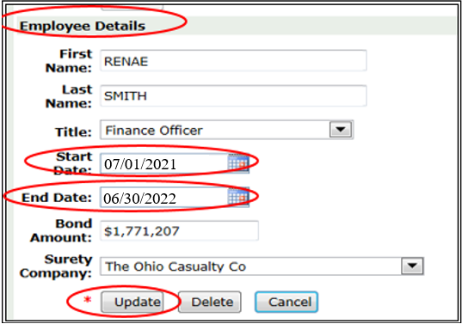
- To DELETE one of the Bonded Employees listed, click on the “Employees Name” in order to populate the “Employees Details”, then click the “DELETE” button. This will remove that employee’s information from the Bonded Employees table.
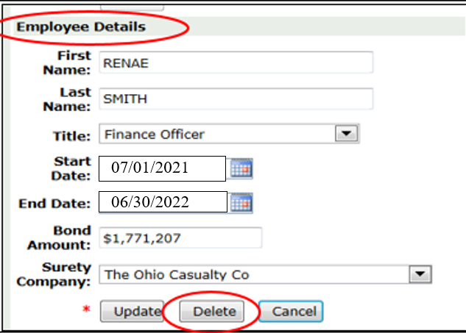
- NOTE: If the DELETED employee was the only TREASURER listed, the district must UPDATE the title of another employee listed to reflect the “TREASURER” or the “INTERIM TREASURER” title or add a NEW employee with the TREASURER or the “INTERIM TREASURER” title. If an employee with the TREASURER title is NOT listed, the district will NOT be able to submit their information and will get an ERROR message.
- To add a NEW person, click the “NEW” button under “Bonded Employees”. This will give you blank fields under the “Employee Details” to enter all of their information. Once all information has been entered, click on the “Update” button. To see a definition of each listed item, review the “Quick Reference Guide” listed at the bottom of these instructions.
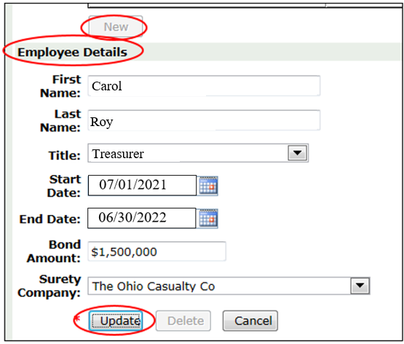
- NOTE: The program will NOT allow duplicate names by looking at the first and last name. Please do NOT report a person more than once under a different name. If a person is listed twice, the bond will be DENIED.
- If adding a NEW employee without updating the current employee record on the same person, the district will NOT be able to submit. There is NOT an error message stating this so please remember to UPDATE or DELETE all current employees’ records.
- When a currently bonded employee is replaced with a new bonded employee, you will need to contact KDE so the window can be opened for you to make changes.
- Click on the bonded employee who is leaving and change their end date to the date their bond ended, if in the current year. If their bond ended before the current fiscal year, just delete their record.
- Click on NEW to add the new bonded employee. Be sure to change their start date to the date their bond began in the current fiscal year. Their end date will still be the end of the current fiscal year.
- Please verify all the Bonded Employees information has been updated to the correct Start Date and End Date and a Treasurer is listed.
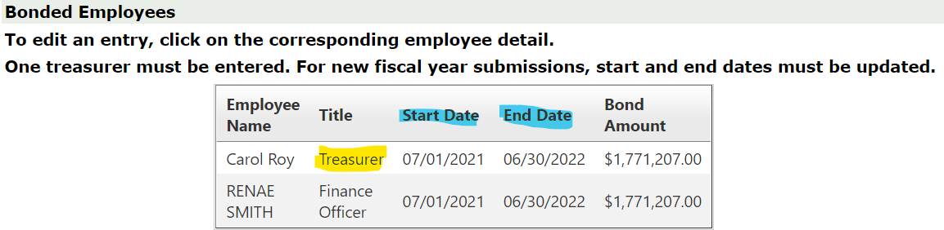
- If all this information is correct, the “Submit” button will be highlighted for the district to submit the fidelity bond information to KDE for approval.
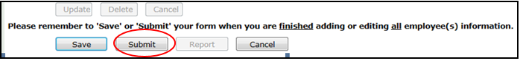
- If the district has NOT filled out the Fidelity Bond web form and they need to close the form, click the “SAVE” button. This will save the information so the district can log back into SEEK later and complete the process. (NOTE: Saving the Fidelity Bond does NOT submit it to KDE.)
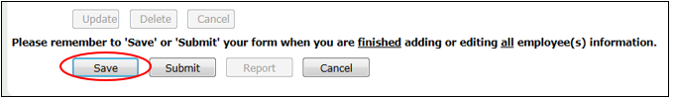
- Once the district has submitted the bond information to KDE, it will automatically go back to the home page with a confirmation. See example below:
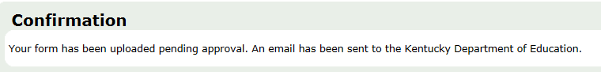
- If the Fidelity Bond has NOT been approved yet and has been reported with incorrect information or the district needs to make a change to the bond, they will need to contact KDE to deny the Fidelity Bond. When the bond information is denied by KDE, the window is re-opened, but all information changed or added, will be lost. The Bonded Employee information will revert to the last approved bond information.
- Once the Fidelity Bond has been approved by the Commissioner of Education, an email will be sent stating it was approved, along with a link to the list of approved Fidelity Bonds. For the new FY, this is usually communicated in August.
- To view a complete list of all bonded employees, go to the Fidelity Bond - Kentucky Department of Education web site, and open the file titled “Fidelity Bond Approval Reports FY20**”.
- For a list of only your district bonded employees, log into the SEEK Application and go to the Fidelity Bond, scroll to the bottom and click on the “Report” button. This will generate a PDF report listing all the bonded employees for the district’s records. This report will only work if the Fidelity Bond is in “Pending” or “Approved” status reported under “Form History”.
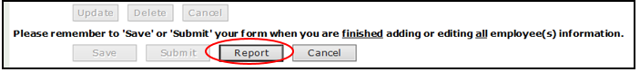
- A link to the PDF will be in the download folder in the browser. Go to the download folder and click on the PDF file to open the report. Make sure the “Report” is the Fidelity Bond. The “Fiscal Year” should automatically show the current fiscal year. The report can be saved in a different format by clicking on the dropdown box beside “Save As”. Click on the “Run” button to generate the report.
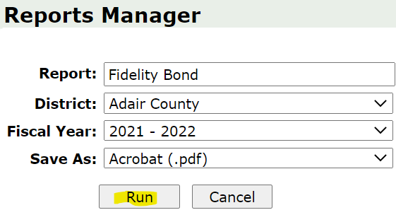
- Here is an example of the report. Print the report for the district’s records.
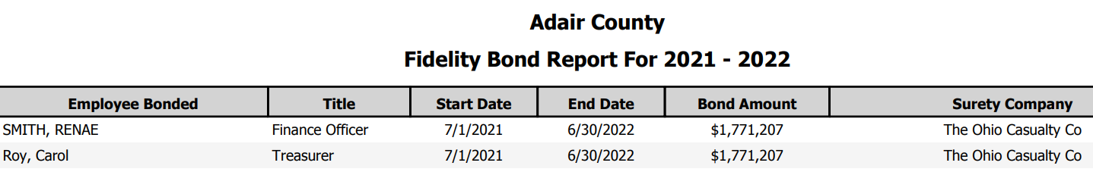

All Fidelity Bonds that have been approved by the Kentucky Department of Education’s Commissioner will be posted to the following web site: Fidelity Bond - Kentucky Department of Education under “Fidelity Bond Approval Reports”.

If the Fidelity Bond has been approved and the district needs to make a change to the bond information, contact KDE so the window can be opened for changes. Resubmission of the district’s bond information will need to go through the approval process again.

Please forward questions relating to the Fidelity Bonds to Jackie Chism at 502-564-3846, extension # 4445 or email Jackie.chism@education.ky.gov or Gail Cox at 502-564-3846 extension # 4462 or email gail.cox@education.ky.gov.
QUICK REFERENCE GUIDE TO ENTER THE FIDELITY BOND INFORMATION
- The current employee bond record MUST BE UPDATED or DELETED. The following descriptions will assist in determining which box to click during different stages of the updating, deleting and/or adding process.
- UPDATE - To UPDATE the current employee bond record, click the “Employees’ Name” to be updated from the table under “Bonded Employees”. This will populate the “Employee Details” with the employees’ bond information. Once the employee details are populated, click the cell beside the information needing to be changed and make the changes. When updating the Start Date and the End Date, they MUST be changed to follow the FY. The web form will only allow a one-year period, with dates following the FY. Once all changes have been made to the “Employee Details”, click on the “Update” button. This SAVES the information, so the changes should appear in the table under “Bonded Employees”. If the changes did NOT appear in the table, make sure there are no ERROR messages at the top of the screen in red.
- DELETE - To DELETE a current employee bond record, click the “Employees’ Name” from the table under “Bonded Employees”. This will populate the “Employee Details” with the employees’ bond information. Once the employee details are populated, click the “Delete” button to remove that employee’s bond record from the table. This SAVES the changes and the record should be removed from the table under “Bonded Employees”.
- NEW – To add a NEW employee who is not listed in the table under “Bonded Employees”, click on the “New” button located above the “Employee Details” section. This highlights the “Employee Details” so the new employee bond information can be entered. It automatically populates the “Start Date” and “End Date”. Once all the information has been entered click the “Update” button. This SAVES the information, so the changes should appear in the table under “Bonded Employees”. If the changes do NOT appear in the table, scroll up to make sure there are no ERROR messages at the top of the screen in red. (NOTE: There must be a TREASURER listed.)
- CANCEL – To CANCEL the previous action performed, click the “Cancel” button.
- First Name: Enter the employee’s first legal name as it appears on the Fidelity Bond form.
- Last Name: Enter the employee’s last legal name as it appears on the Fidelity Bond form.
- Title: This is a drop-down box with the 4 titles listed. Choose one of the titles for that employee. (NOTE: As required by KRS 160.560 each district must list a bonded Treasurer.)

- Treasurer
- Finance Officer
- Treasurer & Finance Officer
- Other
- Interim Treasurer

- Start Date: Enter the first day of the New Fiscal Year - 7/1/20xx. This can only be changed to a date that falls within the current fiscal year, but before the end of the FY.
- End Date: Enter the last day of the Fiscal Year - 6/30/20xx. This date can be changed but cannot be before the current fiscal year start date. The web form is set to only allow a one-year period.
- Bond Amount: This amount is pulled from the “Exposure Report” on the “Bonds” website. The amount is figured through the SEEK application and is an edit check in the web form. If the amount entered is less than the “Exposure Calculation Report” amount, an ERROR message will appear. Each employee listed on this Fidelity Bond is required to be bonded at least the minimum penal sum amount required by 702 KAR 3:080.
- Surety Company: Click on the arrow box drop down list and scroll down to the appropriate Surety Company, then click on that company. If a company is NOT listed, contact KDE to get the company added to the list.

- After entering all the bonded employees’ information, decide which action will need to be taken next.
- SAVE - Click on the “SAVE” button if NOT ready to submit a completed Fidelity Bond web form to KDE. The district will be able to come back to this record and make any changes or updates as needed. NOTE: Clicking on SAVE, does NOT submit to KDE.
- SUBMIT - Once all the employees’ information has been updated, deleted and/or added, click the “SUBMIT” button to upload the district’s Fidelity Bond information to KDE. If there are no errors within the bond information being submitted, the information will submit to KDE successfully and the submitter will receive an e-mail notification stating the bond information has been received by KDE. (NOTE: If there are any errors in the bond information, an error message(s) will display at the top of the screen or above the “Bond Detail” in red font type. The district must correct the information prior to submitting the information to KDE.)
- REPORT - Click on the “REPORT” button to review and/or print the district’s “Fidelity Bond Report” that lists the employees who have been entered by the district.
- CANCEL - When clicking on the “CANCEL” button, it will automatically go back to the “SEEK District Data Submission Home page”. It will NOT save any information which has NOT already been saved.
CHANGE or UPDATE DURING CURRENT FISCAL YEAR
When you have a change in the bonded employee status during the current FY, the district will need to contact KDE to have the window opened in order to make changes to the bonded employee’s records. When a bonded employee leaves and is replaced by a new employee, you will need to change the end date of the old employee to reflect the end date of their bond. When adding the new employee, you must use the beginning date of their bond that falls within the current FY. Their end date would still be the end of the current FY.

All Fidelity Bonds that have been approved by the Kentucky Department of Education’s Commissioner will be posted to the following website Fidelity Bond - Kentucky Department of Education under “Fidelity Bond Approval Reports”.

Please forward questions relating to the Fidelity Bonds to Jackie Chism at 502-564-3846, extension # 4445 or Jackie.chism@education.ky.gov or Gail Cox at 502-564-3846, extension # 4462 or gail.cox@education.ky.gov.

KDE USE: F:\audits_trans\Audit Branch SOP's\Fidelity Bond SOP's\

