Assessing the Equity of Kentucky’s SEEK Formula:
A Ten-Year Analysis

Prepared for
The Kentucky Department of Education

by
Lawrence O. Picus
Allan Odden
Mark Fermanich

September 2001
Assessing the Equity of Kentucky’s SEEK Formula:
A Ten-Year Analysis

Introduction
In response to the landmark ruling of the Kentucky Supreme Court in Rose v. Council for Better Education in June 1989, the Kentucky General Assembly dramatically changed the system of public K-12 education in that state. Among the many components of that ruling, the Kentucky Supreme Court upheld an earlier Circuit Court ruling holding that the state’s school finance system violated the Kentucky Constitution’s education clause, which requires the General Assembly “to provide an efficient system of common schools throughout the Commonwealth.” In assessing the constitutionality of the Kentucky school finance system, the Circuit Court had found that (Augenblick, 1991):
- There was marked variation in property wealth of school districts
- The allocation of state aid did not compensate for the variation in wealth
- There was a wide disparity in the per-pupil revenue of schools districts
- The quality of education was contingent on available revenue
The Circuit Court concluded that an efficient school finance system required substantial uniformity and substantial equality of financial resources.
In response to the ruling in Rose, the Kentucky General Assembly completely overhauled the organization and structure of K-12 education, including the introduction of a new school finance system. The new system, called Support Education Excellence in Kentucky, or SEEK was designed to dramatically improve the equity of Kentucky’s school finance system.
Earlier analyses of the SEEK formula have concluded that the equity of the system improved substantially between 1989-90 and the implementation of SEEK in 1990-91 (See Augenblick, 1991 and Adams, 1994). However, in the last decade, no analysis of the changes in school finance equity over time has been conducted to ascertain whether or not equity has improved further. This report remedies that deficit by providing a ten-year analysis of school finance equity in Kentucky. Specifically, it computes standard school finance equity statistics for each of ten years using a variety of measure of school district per-pupil revenue. The analysis is designed to help Kentucky policy makers understand how the SEEK formula has changed revenue patterns among school districts, and to provide objective data to assess whether or not the system continues to meet the mandate of Section 183 of the Kentucky Constitution.
The first section of this report provides a brief description of the operation of the SEEK formula, describing the various components of the system, how they interact and how they have changed over time. The second section discusses the various approaches to measuring school finance equity and identifies the statistics used to measure the equity of SEEK. The third section offers a description of the data provided by the Kentucky Department of Education for analysis and describes in detail the specific analyses that were conducted for this report. The fourth section discusses our findings in detail providing both a ten year analysis of the revenue measure we deemed to be the best measure of school district resources, and a detailed analysis of all measures and statistics for 1999-2000, the last year for which data were available. Finally, we offer our conclusions and suggestions for policy makers in the fifth section of this report.
We would like to thank Kyna Koch, Susan Goins and Pam Young of the Kentucky Department of Education who helped define the parameters of the study, and provided us with the data necessary to complete the analyses described herein.

The SEEK Formula
Developed a decade ago as part of Kentucky’s wide ranging school reform, the SEEK formula has not been substantially revised since its inception. Today, the SEEK formula relies on three levels of funding for school districts as follows:
- Adjusted Base Guarantee: This is a foundation program that provides each district with $2,994 per-pupil (2000-01) through a combination of local taxes and state aid. The number of pupils is adjusted by a series of factors or “add-ons” that affect the cost of providing services to students including:
- A pupil weighting system for exceptional children with special needs. This includes weights of 2.35 for severely handicapped children, 1.17 for moderately handicapped children and 0.24 for children requiring speech programs.
- A transportation adjustment based on the population density of a school district.
- A weight of 0.15 for students participating in the free lunch program.
- An adjustment of the base guarantee less the capital outlay allotment of $100. for students unable to attend regular school due to short-term health problems.

Each district levies a property tax of 30 cents per hundred dollars of assessed value, or an equivalent amount through a combination of taxes for school purposes on property, utilities, motor vehicles, occupational license receipts, or as an excise tax on income. The difference between the foundation guarantee and the district’s locally raised revenue is provided by the State. The amount of the unadjusted per-pupil basic allotment for each of the ten years in the study is displayed in Table 1.

- Tier I: This is an optional component that allows a district to raise up to an additional 15 percent of the Adjusted Base Guarantee through an equalized property tax or property tax equivalent. Districts with property wealth less than 150 percent of the state average receive state equalization aid that makes up for the difference between the local tax base and equalization level. For 1999-2000, the Tier I equalization level was $410,000 and it grew to $470,000 for 2000-01. Table 1 shows the equalization level for Tier I for each of the ten years analyzed in this report. It should be noted that fiscal year 1994-95 was the first year in which a uniform system of valuing property at 100 percent of fair cash value was required across Kentucky.
- Tier II: Another optional component of the system allows school districts to generate additional revenue up to 30 percent of the total of the Adjusted Base Guarantee plus the revenue generated in Tier I. This revenue is not equalized by the state. Thus, a district taking full advantage of both Tier I and Tier II authority could raise a total of $4,371 per ADA before the add-ons are computed. This is 49.5 percent higher than the adjusted base guarantee. Obviously, the add-ons for special education, compensatory education, transportation, and home/hospital children establish a unique (and slightly higher) adjusted base guarantee for each individual district. However, the formula still allows each district to raise nearly half again as much as the adjusted base guarantee.

Table 1
Adjusted Base Guarantee and Tier I Equalization Level: 1990-91 through 1999-2000

Year | Adjusted Base Guarantee  ($ per ADA) | Tier I Equalization Level ($ per ADA)
1990-91 | 2,305 | 225,000
1991-92 | 2,420 | 225,000
1992-93 | 2,420 | 280,000
1993-94 | 2,495 | 280,000
1994-95 | 2,517 | 295,000
1995-96 | 2,593 | 295,000
1996-97 | 2,673 | 365,000
1997-98 | 2,756 | 365,000
1998-99 | 2,839 | 410,000
1999-2000 | 2,924 | 410,000

In addition to the funding in the SEEK formula, the state provides limited funding to school districts through a number of categorical programs including programs for: Extended School Services; State Agency Children; Gifted and Talented; Early Childhood Education; Vocational Education; Textbooks; Teacher testing and internships; Staff Development; Family Resource/Youth Service Centers; and Regional Service Centers. These programs are relatively small, and according to Murray (2001) represented less than nine percent of total state aid in 1998-99.

II. Measuring Equity in School Finance
There are many ways to conceptualize how to assess a state’s school finance system, and traditional frameworks have focused largely on equity. During the late 1970s and early 1980s, Berne and Stiefel (1984) proposed an equity framework that helped bring conceptual, intellectual and technical clarity to school finance equity discussions. Although Berne and Stiefel were not the only scholars to outline a school finance equity framework (see also, for example, Wise, 1969 and 1983; Garms, 1979; and Alexander, 1982), theirs was the most comprehensive and was used by many analysts to conduct empirical studies of the equity of state school finance structures (see for example Adams, 1997; Goertz, 1983; Hickrod, et.al., 1981; Kearney, et.al. 1988; Odden, 1978, 1995; Picus & Hertert, 1993a, 1993b)
As issues in school finance evolved to include adequacy and productivity as well as equity, Berne and Stiefel (1999) modified their framework. We borrow heavily from the revised Berne and Stiefel history of equity in school finance in developing a framework to assess Kentucky’s school finance structure.
The School Finance Framework in Brief
Berne and Stiefel’s (1984) original framework for assessing a state's school finance structure required answers to four key questions:
1. The group for whom equity was the issue. This was the "who" question. Who is the group for whom school finance should be equitable? There were two major groups: a) children who attend the public schools, and b) taxpayers who pay the costs of public education. The equity issues for each group were quite different. Equity for children was discussed largely within an educational opportunity framework. Equity for taxpayers was discussed largely in the public finance context of tax burden.
2. What resource objects or educational services should be distributed equitably among the group of concern? The traditional answer to this question for children was dollars or revenues. But educational processes such as curriculum and instruction were also key educational resources. Outcomes such as student achievement also were possible objects to analyze. Deciding on the specific object was important to assessing the degree of school finance equity. Some objects could be distributed equitably; others inequitably.
3. How was equity to be defined, or what were the specific equity principles used to determine whether a distribution was equitable? There were three equity principles: a) horizontal equity, in which all members of the group were considered equal; b) vertical equity in which differences (for which unequal resource distributions are legitimate) among members of the group were recognized; and, c) equal opportunity which identified variables such as property value per-pupil that should not be related to resource distribution.
4. How much equity was in the system, or what is the specific status of equity? This component included the specific statistics used to measure the degree of equity in the system.
Assessing the status of school finance entailed answering in specific terms four questions: who is the group, what is the object, what is the principle, and what is the statistic used to measure the status of equity. As Berne and Stiefel (1984) demonstrated, different answers to these questions could result in different conclusions about the equity of the system. One major objective in developing and using a school finance equity framework was to help clarify how one analyst could declare a system equitable while another, using the same data, could declare it inequitable, and the reason could simply be that they had different answers to these four key questions. The framework helped to sort out the issues and to show how these more complex conclusions could be made.
Equity Concepts
Once an object has been selected, an approach to assessing equity or adequacy needs to be determined. This entails defining and selecting an equity principle. There are four different but related children's equity principles:
• Fiscal neutrality
• Horizontal equity
• Vertical equity
• Adequacy
The purpose of this report is to address the first three of these concepts. Another paper submitted to the Kentucky Department of Education – Assessing SEEK From an Adequacy Perspective – addresses the issue of adequacy. This section discusses several issues surrounding each of the three equity principles.
Fiscal Neutrality for children
This principle targets the traditional school finance problem and states that resources, or educational objects, should not vary with local fiscal capacity, such as property wealth per-pupil, property value per-pupil, household income, or any other measure of local fiscal capacity. This equity principle derives from the standard fiscal disparities that have plagued state school finance structures throughout the twentieth century, and directly relates to the legal standard of fiscal neutrality typically used in most school finance court cases.
Assessing the degree of fiscal neutrality entails analyzing the relationship between two variables: 1) the object chosen and 2) the variable identified as something that should not be linked to resource differences. Traditional fiscal neutrality analysis assesses the relationship between current operating expenditures per-pupil and property wealth per-pupil, or local and state general revenues per-pupil and property wealth per-pupil. But analysis of the relationship between any object discussed above and any measure of fiscal capacity, such as household income or even the sales tax base per capita, reflects analysis according to the fiscal neutrality principle. Analyzing fiscal neutrality is different from analyzing either horizontal or vertical equity, because the former requires at least two variables and is a bivariate or multi-variate analysis, while the latter requires only one variable and is a univariate analysis.
Fiscal Neutrality Statistics
To measure the degree of fiscal neutrality, statistics that indicate the relationship between two variables are needed. Two have become increasingly common in school finance:
• The correlation coefficient, and
• The elasticity, i.e., the elasticity calculated from a simple one-variable regression.
For both statistics, measures of two variables are needed: 1) the measure of fiscal capacity, such as property value per-pupil; and 2) the measure of the object of concern, such as current operating expenditures per-pupil. Both fiscal neutrality statistics indicate whether the educational object is a function of some variable to which it should not be related, such as the local tax base.
The simple correlation is a statistic that indicates the degree to which there is a linear relationship between two variables, i.e., whether as one variable increases the other increases (or decreases). It ranges in value between -1.0 and +1.0. A value of +1.0 or close to +1.0 indicates a positive relationship, i.e., for example, as property wealth increases so does expenditures per-pupil. A negative correlation indicates that as one variable increases the other decreases; it indicates that there is an inverse relationship between the two variables. In school finance, there is usually a negative correlation between state aid per-pupil and property wealth per-pupil, indicating that state aid is inversely related to wealth, that the poorer the district, the greater the state aid. A correlation coefficient of zero indicates that there is no linear relationship between the two variables.
While a correlation coefficient indicates whether or not there is a linear relationship between two variables, the elasticity indicates the magnitude or policy importance of that relationship. For example, expenditures and wealth could be strongly related, but if a ten-fold increase in property wealth only resulted in a small increase in revenues, one could argue that the magnitude of the relationship was not significant and of little policy significance.
Technically, the elasticity indicates the percent change in one variable, say expenditures per-pupil, relative to a one percent change in another variable, say property value per-pupil. It is a statistic that usually ranges in value from zero to any positive number, although it also can be negative. In school finance, an elasticity that equals 1.0 or higher indicates that spending increases in percentage terms at the same or higher rate as property wealth. Elasticities below 1.0 indicate that spending does not increase at the same percentage rate as local property wealth local property wealth.
The simple elasticity between a dollar object, such as expenditures per-pupil, and property wealth per-pupil, can be calculated using the slope of the simple linear regression of expenditures on wealth; the elasticity equals the slope (the regression coefficient for wealth) times the ratio of the mean value of property wealth per-pupil and the mean value of expenditures per-pupil.
It often is wise to assess the correlation coefficient and elasticity jointly. If the correlation is high and the elasticity is low, there is a relationship between the two variables -- fiscal neutrality does not hold -- but the relationship is not of policy importance. On the other hand, if the correlation is low and the elasticity is high, even the tenuous link might have policy significance. If both the correlation coefficient and elasticity are high, then fiscal neutrality clearly does not exist -- the two variables are linked and the magnitude of the link is strong.
A correlation less than 0.5 with an elasticity less than 0.1 could function as a standard to determine whether a state system met the fiscal neutrality standard. Figure 1 displays graphically examples of the relationship between revenue per-pupil and property wealth per-pupil, providing examples where there is virtually no fiscal neutrality and where there is considerable fiscal neutrality.
Berne and Stiefel (1984) discuss other relationship statistics for fiscal neutrality. Further, more complex econometric methods can be used to quantify the relationship between educational objects such as revenues per-pupil and 1) property wealth, 2) the composition of the local property tax base (residential, commercial and industrial property), and 3) household income (Feldstein, 1975; Ladd, 1975; Adams and Odden, 1981).
Figure 1
Graphical Representation of Fiscal Neutrality Measures

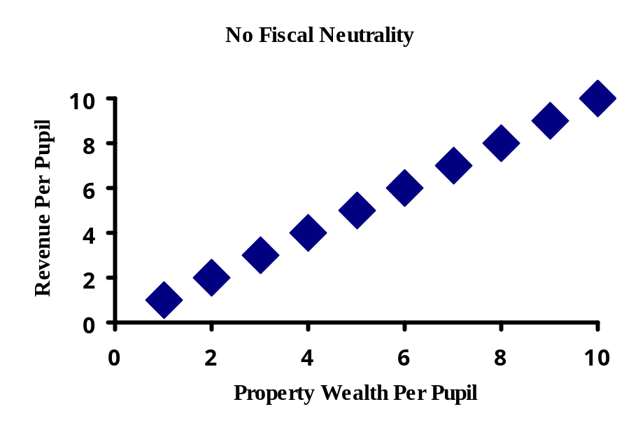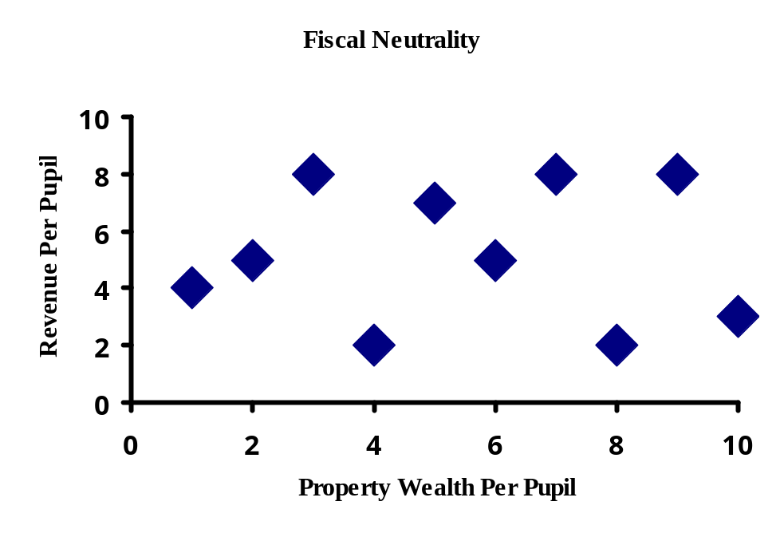

Horizontal Equity.
This principle is similar to the horizontal principle in public finance; indeed, Berne and Stiefel (1984) used traditional public finance principles and concepts initially to construct their school finance equity framework. Horizontal equity provides that students who are alike should be treated the same: “Equal treatment of equals” reflects the horizontal equity principle. Horizontal equity requires that all students receive equal shares of an object such as total local and state general revenues per-pupil, total current operating expenditures per-pupil, instructional expenditures per-pupil, instruction in the intended curriculum, focus on thinking and problem solving, and equal minimum scores on student criterion referenced assessments.
When horizontal equity is used, one assumes that all students are alike. While this is a crude assumption at best, it is implied when it is argued that spending should be equal across school districts or schools. Thus, horizontal equity has been widely used in school finance, despite its assumption that all students are alike.
The principle of horizontal equity is best used for subgroups of students, for example, all elementary students in the regular program, or all high school students in an academic track, or all students performing below the first quartile on a student achievement measure. For carefully selected subgroups of students, it is reasonable to require equal distribution of resources, or the object selected for equity analysis. Of course, care must be taken to create a legitimate subgroup of students, for which homogeneity claims are accurate.
Assessing the degree of horizontal equity entails measuring inequality or dispersion. Such measures, or statistics, are univariate, i.e., they measure aspects of the distribution of one variable, specifically the object chosen for analysis.
Horizontal Equity Statistics.
There are numerous statistics that assess the degree of equality for one variable, such as expenditures per-pupil in school finance. Berne and Stiefel (1984) identified several and analyze their various properties. Five statistics are discussed below, although many more are discussed by Berne and Stiefel.
1. The first is the range, which is the difference between the value of the largest and the smallest observation. The larger the range, the greater the inequality. This statistic indicates the maximum difference in the distribution of this variable among students in a state. That also is a disadvantage. It indicates the difference between only two observations, the top and the bottom. The fact is that there are a few outlier districts in every state: some very poor, low property wealth and low income rural districts, and some very wealthy districts that might have a nuclear power plant or oil wells and few students. These districts are anomalies, and do not reflect common circumstances.
The range does not indicate the degree of equality or inequality for any of the other observations, and thus is a poor indicator for assessing the degree of equity of the system. Furthermore, the range increases with inflation. As inflation occurs, and all other structural variables remain the same, the range will increase. Indeed, one reason the range statistic might be used in some school finance court cases is that each year the range generally increases. An increasing range indicates a system with increasing inequality. Nevertheless, although used extensively and routinely by many school finance analysts, and showing the maximum degree of inequality in a distribution, the range has several detracting features and is not a preferred univariate statistic.
2. The second horizontal equity statistics is the restricted range, which is the difference between an observation close to the top and an observation close to the bottom, such as the difference between the 5th and 95th percentile, or the 10th and 90th percentile. The restricted range generally avoids the problem of outliers that afflicts the range, but the restricted range still measures the degree of inequality between just two observations, and not the overall system. Further, just as with the range, the restricted range increases, i.e., worsens with inflation, even if all other characteristics of the finance system remain the same. If a range statistic is used, the restricted range is preferred to the unrestricted range, but neither are good indicators of the equality of the distribution of the object for the entire education system.
A variation of the restricted range is the federal range ratio, which is the restricted range divided by the observation at the 5th percentile. Though the federal range ratio shares most of advantages and disadvantages of the restricted range, because it is a ratio it eliminates the inflation problem, i.e., the federal range ratio does not increase with inflation. In addition, the federal range ratio has been a statistic used to determine whether states can include federal Impact Aid in calculating state equalization aid (Sherman, 1992).
3. The third horizontal equity statistic is the coefficient of variation (CV), which is the standard deviation divided by the mean (i.e., the average); it can be expressed in decimal or percent form. Its value usually varies between zero and one, or in percentage terms, from zero to one hundred, although the values can be larger. A coefficient of variation of zero indicates that the object is distributed uniformly among all children.
The coefficient of variation (CV) indicates the percent variation about the mean. For example, a coefficient of variation of 10 (or 0.1) percent indicates that 2/3 of the observations have a value within one standard deviation of the mean, i.e., 10 percent above or below the value of the average, and 95 percent of the observations have a value within two standard deviations of the average, i.e., 20 percent above or below the mean. So if the average expenditure per-pupil is $6,000 and the CV is 10 percent, it means that two-thirds of all districts have an expenditure per-pupil between $5,400 ($6,000 minus ten percent) and $6,600 ($6,000 plus ten percent).
The coefficient of variation is a statistic that includes all values of a data set, unlike the range, which includes only selected values. Also, the coefficient of variation does not change with inflation, an attractive characteristic. Thus, if the structural properties of a school finance system remain constant, but all economic and dollar variables rise with inflation, the coefficient of variation would remain the same, correctly indicating that the equity of the system had not changed. The coefficient of variation is also easy to understand. Because of these attractive features, the coefficient of variation is being used increasingly by analysts.
Another issue, however, is determining the value that indicates an equitable or fair distribution of school funds. Determining a standard for the coefficient of variation is a value judgment. Berne and Stiefel (1984) suggest a variety of ways to determine what the standard should be. The key distinction is whether to use a relative standard, which would compare districts in the top, middle and bottom quartiles or an absolute standard which establishes a cut-off point for determination of equity. The problem with a relative standard is that some observations are always at the bottom, no matter how small the degree of inequality. An absolute standard provides a cut-off point, which separates equitable from inequitable resource distribution patterns. It is difficult to determine an absolute standard. Nevertheless, an absolute standard of about 10 percent for the coefficient of variation is generally used throughout this report. This is a high standard, because few states have a coefficient of variation for revenue per-pupil figures below 10 percent. It is worth remembering that standard setting is an issue of both values and politics; different states and analysts might reasonably set different levels as an acceptable coefficient of variation.
4. A fourth horizontal equity measure is the Gini Coefficient, a statistic taken from economists' measures of income inequality. To determine the Gini Coefficient, a graph is made by plotting the cumulative value of the measure of the object as a percent of the total value on the vertical axis and the percent increments of the number of observations on the horizontal axis. The resulting graph indicates the degree to which the object is distributed equally to children at various percentiles; put differently, the graph indicates the degree to which children at different percentiles have the same amount of the object. If the object is perfectly distributed, the Gini graph would be a straight, 45 degree line. If the object is not perfectly distributed, the Gini graph would be a concave curve below that line. In school finance, the measure on the vertical axis is typically the cumulative percentage of school district expenditures, and the measure on the horizontal axis is typically percent of students enrolled in the state, as shown in Figure 2.
The Gini Coefficient is the area between the Gini Curve and the 45 degree line divided by the area under the 45 degree line. Its value ranges from 0 to 1.0 with a completely equitable distribution occurring when the Gini Index equals zero. Most values in school finance are in the 0.1 to 0.2 range. The Gini Coefficient includes all observations and is insensitive to inflation, i.e., it remains the same when inflation is the only intervening variable.
The Gini Coefficient is hard to understand conceptually. What does it mean when the area between the Gini curve and the 45 degree line -- even in a system with what most would call large differences in expenditures or revenues per-pupil -- is 0.1 or very close to zero? A value close to zero suggests equality, but the system may, in school finance terms, be quite unequal. Nevertheless, the Gini Coefficient is a popular horizontal equity statistic in school finance. A standard for it has not been set, although a value less than 0.05 is probably desirable. The smaller the Gini Coefficient, the more equal the distribution of the object.
5. A fifth measure of horizontal equity is the McLoone Index, which is a statistic unique to school finance, actually created by and named after an economics professor at the University of Maryland, Eugene McLoone. The McLoone Index was created to provide a measure of the bottom half of a distribution, to indicate the degree of equality only for observations below the 50th percentile. Since the American political culture often shows more interest in the condition of those at the bottom, the McLoone Index is a statistic that reflects that perspective.
Technically, the McLoone Index is the ratio of the sum of the values of all observations below the 50th percentile (or median) to the sum of all observations if they all had the value of the median. It ranges in value from zero to one, with a one indicating perfect equality. The value of the McLoone Index for most school finance data sets is generally in the 0.7 to 0.90 range. Again, a standard has not been set for a "good" McLoone index, but higher than 0.95 is desirable. Though Berne and Stiefel (1984) analyzed other standard statistics that are sensitive to changes in the bottom half of the distribution, they are complex statistics that are difficult for policymakers to understand. Because the McLoone Index is a measure of the equity of the distribution for the bottom half and more straightforward, it has become popular in school finance and is included in many school finance equity analyses.
6. A new horizontal equity statistic is the Verstegen Index, which is the opposite of the McLoone Index, in that it is a measure of disparity in the top half of the distribution. Nearly all analyses of school finance assess either characteristics of the entire distribution, or characteristics of the bottom half of the distribution. An issue that is gaining more attention is the behavior of the districts in the top half of the distribution. It seems that in some states the differences in fiscal resources among these districts have increased over time, even while the disparities for those in the bottom half have diminished (Verstegen, 1996). The result is a McLoone Index closer to one but a larger CV. Since the CV has become such a popular school finance equity statistic, a rising CV could be interpreted to indicate that fiscal disparities are increasing, but such an interpretation would not indicate the differences in the nature of the distribution among the top and bottom half.
The Verstegen Index helps to show this phenomenon; it is the ratio of the sum of the values of all observations above the median to the sum of all observations if they were all at the median. It has a value of 1.0 or greater, and, as the McLoone and CV, does not increase with inflation. It would increase as disparities in the top half increase. A careful analyst would calculate all three statistics: the CV, the McLoone and the Verstegen Indices, and determine whether overall disparities have improved (a lower CV), whether differences below the median have improved (a higher McLoone) and whether differences in the top half have improved (a lower Verstegen). The Verstegen Index is relatively new to school finance and as yet no benchmark has been established in the literature.
Measuring and assessing vertical equity
There are two general ways to assess vertical equity. The first is to weight all students who need extra services and then to conduct a horizontal equity analysis using the number of weighted pupils as the pupil measure. This approach combines vertical and horizontal equity in a joint analysis. Vertical equity is reflected in the weights; having recognized factors that can lead to different resource levels and made appropriate adjustments, equality of resources per weighted child indicates the degree of resource equality.
This approach can be used only when there are good data to quantify the degree to which students with different needs require different levels of resources. This approach is strengthened if some independent analysis is made of the weights themselves, to assess whether they accurately represent the degree of extra services needed. It is more valid when the different weights have been calculated relative to the statewide average expenditure per-pupil. The 1997 GAO study, and the National Center for Education Statistics (1997) studies used this approach, weighting each handicapped student an extra 1.3, and each low-income student an extra 0.2.
This is the approach used in Kentucky as well. The add-ons for special education, transportation, compensatory education and home/hospital students serve as the weights. What is not clear is whether or not the current weights are appropriate for the services required by the students they are intended to serve. But in this report, we use the Kentucky weights for compensatory education, special education and home/hospital students in the weighted pupil analyses.
An alternative way to measure vertical equity is to use categorical revenues to provide funds for extra services and programs. Then an equity analysis is conducted only for general revenues. This approach assesses the degree of equality of the base program for all students, but essentially skirts analysis of vertical equity.
If price differences are part of the state aid formula, the equity analysis should be conducted with price-adjusted dollars, not with nominal dollars, which is the usual approach (Barro, 1989; Chambers, 1995; McMahon, 1994). Furthermore, all dollars should be price adjusted, not just those that might be adjusted by a state formula price factor. This approach was taken by GAO (1997), Odden & Busch (1998) and Murray, Evans & Schwab (1998). And we also conduct an equity analysis using a geographic cost index calculated for all districts in the country, including those in Kentucky, by Jay Chambers, under a contract to the National Center for Education Statistics.
In the next section of this report, we describe the approach we used to measure the equity of Kentucky’s SEEK formula over the first ten years the program was in existence.

III. Analyzing the Equity of SEEK: Methodology
This report assesses the equity of the SEEK program over its first ten years – 1990-91 through 1999-2000. An analysis of the equity of the system in 2000-01 was not conducted, as the appropriate data were not available from the Kentucky Department of Education at the time the analyses were conducted.
The major question facing any school finance equity analysis is determining the measure of revenue to use for comparisons. While this seems like a simple task on the surface, determination of which programs are included and which are not can have important consequences in the outcome of the analysis. For example, should transportation costs be included in an assessment of school finance equity? On the surface the answer may appear to be “yes.” However, since the transportation characteristics of districts vary widely (terrain, population density, and school size) the per-pupil costs of transportation are likely to vary for very legitimate reasons due to transportation needs and district characteristics. If the system funds the real differences in transportation costs across districts, then disparities based only on transportation costs could lead one to conclude that the system is relatively inequitable, when in fact, all revenues other than transportation costs are highly equalized.
Federal funds, frequently targeted at children from low-income families (Title I is the largest Federal program for education), are another example. If they are included in the computation of revenue, many districts with low state and local revenues may appear to be better off than if the Federal revenues are not included in the computation. Again, the final determination of the system’s equity depends on the assumptions that are made.
Above, we suggested that differences in the cost of educational inputs need to be considered in any equitable distribution formula. Yet it should be clear that if cost differentials are carefully measured, and adjustments made to districts on the basis of those cost factors, the statistics traditionally used in school finance are likely show greater disparities in funding across districts than the current formula requires.
Revenue Measures for Kentucky
To ascertain how equitable SEEK really is, and how equity has changed in the last decade, we assembled a multi-year data set, with a variety of revenue statistics and used each to compute the statistics described above. Specifically we conducted 24 separate analyses for each year, or a total of 240 individual equity analyses. We created four analysis categories and within each of those four categories prepared six different per-pupil revenue figures for each district. The district revenues we estimated for this analysis included the following measures:

  - Set 1 (Revenue per ADA)

    - SEEK (Base + Tier I + Tier II) with transportation funds
    - SEEK (Base + Tier I + Tier II) without transportation funds
    - Data in “i” plus state and local out of formula funds
    - Data in “ii” plus state and local out of formula funds
    - Data in “iii” plus Federal dollars
    - Data in “iv” plus Federal dollars

  - Set 2 -- Same as set 1 but using weighted pupils

    - SEEK (Base + Tier I + Tier II) with transportation funds
    - SEEK (Base + Tier I + Tier II) without transportation funds
    - Data in “i” plus state and local out of formula funds
    - Data in “ii” plus state and local out of formula funds
    - Data in “iii” plus Federal dollars
    - Data in “iv” plus Federal dollars

  - Identical to set 1, but using a cost of education adjustment across districts

  - Identical to set 2, but using a cost of education adjustment across districts

Equity statistics were computed using the Excel simulation model developed as part of the Odden and Picus (2000) school finance text. Set A computes district revenue based on Average Daily Attendance (ADA) dividing the total revenue described in each of the six revenue computations by the district’s ADA. Set B is similar, but uses weighted ADA. This figure is computed by applying the weights in the SEEK formula to each district’s student population, and summing the total number of weighted pupils in ADA yielding a total WADA. This has the effect of increasing the number of pupils in the district, and reducing the per-pupil revenue of each district. Set C again relies on ADA but divides each revenue figure by the geographic cost index, which increases the revenue figures for districts with a cost index below 1.0 and reduces the figures for districts with a cost index above 1.0. Set D computes the statistics on the basis of weighted ADA adjusted by the geographic cost index.
Sets A and B represent analyses conducted in nominal dollars, while sets C and D interject the use of a cost index to consider the impact of geographic cost differentials on the assessment of school finance equity. The geographic cost adjustment utilized in this study is based upon the Geographic Cost of Education Index (GCEI) developed by Jay Chambers for the National Center for Education Statistics. Chamber’s nationally scaled index takes into consideration the costs of three categories of school inputs: 1) certified school staff; 2) non-certified school staff; and 3) non-personnel inputs. The personnel cost adjustments are made using the hedonic wage model, which holds level and quality of school inputs constant and takes into consideration only those cost differentials attributable to factors outside of the control of school districts. The index represents the average of these personnel and non-personnel inputs, weighted by the average district budget shares for each district input. This national index has been rescaled for Kentucky data, so that an index of 1.0 represents the average cost of district inputs in Kentucky. Dividing all district revenue figures by the cost index produces dollar figures that have equal purchasing power in all Kentucky school districts.
The appendix to this report displays the results from the analysis of each of these revenue measures over each of the ten years. The data are too complex to easily comprehend changes in school finance equity over that time. To help make sense of the vast array of data, we have taken two approaches to summarizing what we found. First, we provide a static equity analysis for each of the revenue variables identified above for the year 1999-2000, which is the most recent year for which data are available. Then, using one of the equity measures – SEEK (basic + Tier I + Tier 2) plus state and local out of formula funds, minus transportation – we assess the equity of SEEK between 1990-91 and 1999-00. We chose this specific measure of revenue as being the most appropriate because it includes all state and local resources available to school districts except for transportation, which as described above varies with the characteristics of districts and therefore exhibits legitimate differences in per-pupil revenues.
Our one year analysis thus contains 24 separate equity analyses for 1999-00, while the ten year analysis describes the changes in measures of equity over the ten year period on a per ADA and per weighted ADA basis in both nominal and cost adjusted dollars.
VI. Assessing the Equity of SEEK: Results
One-Year Equity Analysis: 1999-2000
Table 2 presents all the results of our equity analysis using all 24 revenue measures and all of the horizontal and fiscal neutrality equity measures described in section II. Vertical equity is assessed through the use of weighted pupils in analyses sets B and D. Table 2 has four panels of data. Panel A displays the equity statistics for the analysis conducted on a per ADA basis. Panel B displays equity statistics computed on a weighted ADA basis. These analyses are repeated in panels C and D but in this case, district revenues are adjusted by the cost of education index. Columns 1-6 represent the six different revenue measures described above. In effect, 24 separate equity analyses are reported in Table 2.

Table 2
SEEK Equity Measures for 1999-2000

 | Col. 1 | Col. 2 | Col. 3 | Col. 4 | Col. 5 | Col. 6
Measure | Base+Tiers Per ADA | Col. 1-Trans. Per ADA | Col. 1+Local & State Out of Formula Rev. Per ADA | Col. 3-Trans. Per ADA | Col. 3+ Fed. Rev. Per ADA | Col. 5-Trans. Per ADA
Set A: ADA
Mean Per Pupil Revenue | 5,072 | 4,764 | 5,995 | 5,687 | 6,734 | 6,426
Horizontal Equity
Range ($) | 2,028 | 2,074 | 5,289 | 5,680 | 4,874 | 5,265
Restricted Range ($) | 1,327 | 1,480 | 1,659 | 1,832 | 2,120 | 2,073
Federal Range Ratio | 0.296 | 0.352 | 0.317 | 0.373 | 0.366 | 0.377
Coef. Of Variation | 0.108 | 0.115 | 0.101 | 0.108 | 0.107 | 0.112
Gini Coefficient | 0.183 | 0.133 | 0.089 | 0.059 | 0.036 | 0.010
McLoone Index | 0.964 | 0.966 | 0.955 | 0.957 | 0.942 | 0.934
Verstegen Index | 1.050 | 1.056 | 1.070 | 1.074 | 1.083 | 1.081
Fiscal Neutrality
Correlation | 0.126 | 0.179 | 0.198 | 0.220 | (0.084) | (0.054)
Elasticity | 0.023 | 0.037 | 0.054 | 0.068 | (0.026) | (0.018)
Set B: Weighted ADA
Mean Per-Pupil Revenue | 4,153 | 3,901 | 4,909 | 4,657 | 5,514 | 5,262
Horizontal Equity
Range ($) | 1,322 | 1,629 | 4,712 | 5,047 | 4,434 | 4,695
Restricted Range ($) | 1,175 | 1,137 | 1,419 | 1,395 | 1,404 | 1,437
Federal Range Ratio | 0.310 | 0.322 | 0.324 | 0.336 | 0.287 | 0.311
Coef. Of Variation | 0.100 | 0.109 | 0.095 | 0.104 | 0.090 | 0.097
Gini Coefficient | 0.216 | 0.155 | 0.106 | 0.073 | 0.067 | 0.038
McLoone Index | 0.976 | 0.974 | 0.964 | 0.961 | 0.956 | 0.952
Verstegen Index | 1.048 | 1.061 | 1.066 | 1.076 | 1.062 | 1.072
Fiscal Neutrality
Correlation | 0.554 | 0.534 | 0.468 | 0.457 | 0.159 | 0.174
Elasticity | 0.083 | 0.097 | 0.117 | 0.131 | 0.038 | 0.046

Table 2 (Continued)
SEEK Equity Measures for 1999-2000

 | Col. 1 | Col. 2 | Col. 3 | Col. 4 | Col. 5 | Col. 6
Measure | Base+Tiers Per ADA | Col. 1-Trans. Per ADA | Col. 1+Local & State Out of Formula Rev. Per ADA | Col. 3-Trans. Per ADA | Col. 3+ Fed. Rev. Per ADA | Col. 5-Trans. Per ADA
Set C: ADA CEI
Mean Per-Pupil Revenue | 4,899 | 4,600 | 5,794 | 5,495 | 6,514 | 6,215
Horizontal Equity
Range ($) | 1,661 | 1,673 | 4,884 | 5,250 | 4,711 | 4,884
Restricted Range ($) | 1,200 | 1,134 | 1,361 | 1,401 | 1,869 | 1,721
Federal Range Ratio | 0.276 | 0.278 | 0.268 | 0.299 | 0.343 | 0.329
Coef. Of Variation | 0.080 | 0.085 | 0.079 | 0.084 | 0.097 | 0.100
Gini Coefficient | 0.001 | 0.031 | 0.067 | 0.086 | 0.119 | 0.119
McLoone Index | 0.951 | 0.956 | 0.939 | 0.940 | 0.907 | 0.907
Verstegen Index | 1.039 | 1.044 | 1.050 | 1.055 | 1.055 | 1.059
Fiscal Neutrality
Correlation | (0.249) | (0.175) | (0.065) | (0.018) | (0.286) | (0.254)
Elasticity | (0.049) | (0.035) | (0.019) | (0.005) | (0.101) | (0.093)
Set D: Weighted ADA/CEI
Mean Per-Pupil Revenue | 4,012 | 3,767 | 4,745 | 4,499 | 5,334 | 5,089
Horizontal Equity
Range ($) | 1,243 | 1,412 | 4,453 | 4,671 | 4,281 | 4,360
Restricted Range ($) | 784 | 794 | 1,075 | 1,129 | 1,089 | 1,165
Federal Range Ratio | 0.212 | 0.230 | 0.254 | 0.283 | 0.231 | 0.265
Coef. Of Variation | 0.067 | 0.074 | 0.069 | 0.075 | 0.075 | 0.079
Gini Coefficient | 0.003 | 0.039 | 0.074 | 0.098 | 0.116 | 0.118
McLoone Index | 0.966 | 0.966 | 0.953 | 0.952 | 0.938 | 0.937
Verstegen Index | 1.028 | 1.034 | 1.045 | 1.053 | 1.049 | 1.054
Fiscal Neutrality
Correlation | 0.129 | 0.212 | 0.206 | 0.236 | (0.113) | (0.078)
Elasticity | 0.018 | 0.032 | 0.051 | 0.064 | (0.030) | (0.022)

To facilitate the analysis of the equity of SEEK, four of the statistics presented in Table 2 are displayed graphically below. To help understand both the degree of equity in the system, and how it varies with the choice of per-pupil measure, the revenues included and the use of a cost index, the four statistics analyzed in more depth are the coefficient of variation (CV), the McLoone Index, correlation and elasticity.
The difficulty in using the range, range ratio and Federal range ratio statistics can be seen clearly in the first panel of data in Table 2. In columns 1 and 2 (basic guarantee plus Tiers I and II), the range is $2,028 with transportation and $2,074 without transportation. When other state and local resources, and Federal funds are added, the range swells to over $5,000 in three of the measures (columns 3,4 and 6) and nearly $5,000 in the fourth. Yet when outliers are eliminated in the restricted range and in the computation of the Federal range ratio, the change is not nearly so dramatic. This shows the impact that one or two districts can have on the computation of the range statistics, which as was pointed out above is dependent on the observation of only two of the 176 districts in the state.
For that reason, the CV, which uses all 176 districts, and the McLoone Index, which relies on the half of the districts with the lowest revenues per-pupil, are better representations of the horizontal equity of SEEK. Figure 2 provides a graphical summary of the variation in the CV across the six different revenue measures and four types of analysis.

Figure 2
Assessment of SEEK Equity Using the Coefficient of Variation: 1999-2000

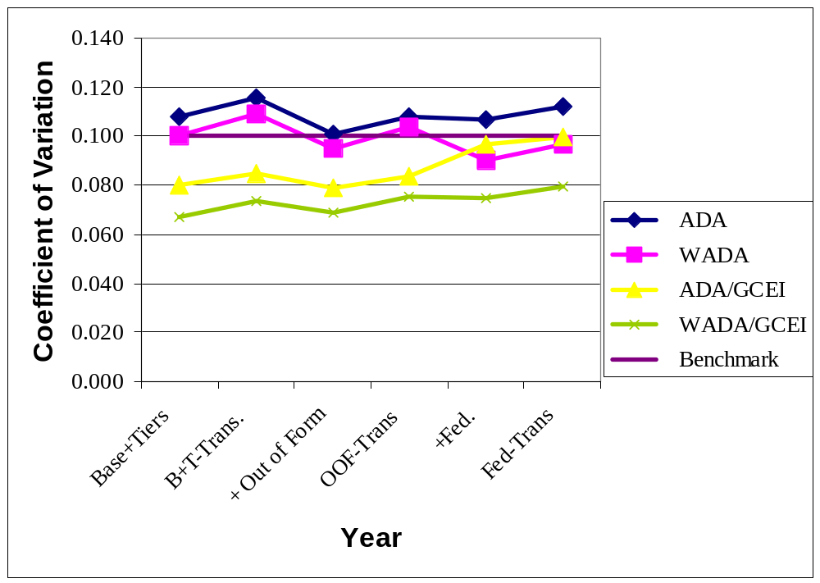

Odden and Picus (2000) suggest using a CV of 0.10 as a benchmark for assessing the equity of a state’s school finance system. Table 2 and Figure 2 show that SEEK meets or just misses that standard depending on the analysis conducted. When the CV is computed on the basis of ADA using nominal dollars, it ranges from 0.101 when computed for the basic allotment plus the two tiers and including all other state and local funds, to a high of 0.115 when the base plus the two tiers minus transportation is used as the measure of revenue. When weighted ADA is used, and when the revenue figures are adjusted by the cost of education index, the value of the CV is consistently lower than the 0.1 standard, regardless of the revenue measure used. In fact, Figure 2 shows that when revenues are adjusted by the cost index, the CV never exceeds the benchmark of 0.10, and is as low as 0.067 using weighted ADA and the cost index. These conclusions about the equality of overall per-pupil revenue are particularly noteworthy because, as previously noted, SEEK allows districts to raise about 50 percent above the Adjusted Guaranteed Base per-pupil revenue figure, so some variation in revenue per-pupil should be expected.
Figure 3 is similar to Figure 2, but displays the computed values of the McLoone Index for each of the revenue options being analyzed. Odden and Picus (2000) suggest a benchmark of 0.95 for the McLoone index, which would indicate that there is substantial equity across districts in the bottom half of the revenue distribution. Figure 3, as well as Table 2 show that except for the revenue computations that include Federal funds, and some of the cost adjusted analyses, in 1999-2000, SEEK exceeded the benchmark of 0.95. When weighted ADA are used with nominal dollars, the McLoone Index exceeds the benchmark of 0.95 for all six revenue measures. Again this high degree of equality in revenue per pupil is noteworthy because the SEEK law allows for considerable local choice in revenues per pupil. But since the McLoone focuses on the bottom half of the districts, where the goal is be to insure that any variation would be above a figure deemed “adequate,” the adequacy of the SEEK base (discussed in an accompanying report) becomes an even more important policy issue.
The McLoone Index declines (an index of 1.0 is best) as additional revenues are added to the calculation. This suggests that there is more variation in non-formula state and local revenues and in the receipt of Federal funds, at least among the half of the districts with the lowest revenue per-pupil.
The cost adjusted revenue figures also led to generally lower values of the McLoone Index. This suggests that there may be a number of low revenue districts in high cost areas. The effect of the cost index would be to make such district real revenues appear even lower and thus decrease the McLoone Index. This would suggest that the adequacy and equity of the out of formula revenues, including federal revenues, need to be monitored closely over time. However, regardless of the revenue measure, or the pupil count, or whether or not the cost index is used, the value of the McLoone Index just beats or is just shy of the rigorous 0.95 benchmark suggesting a considerable degree of equity among the bottom half of the districts in Kentucky. Even the lowest values of the McLoone Index – cost adjusted dollars per ADA – exceed 0.90, which itself is a high standard of equity.

Figure 3
Assessment of SEEK Equity Using the McLoone Index: 1999-2000

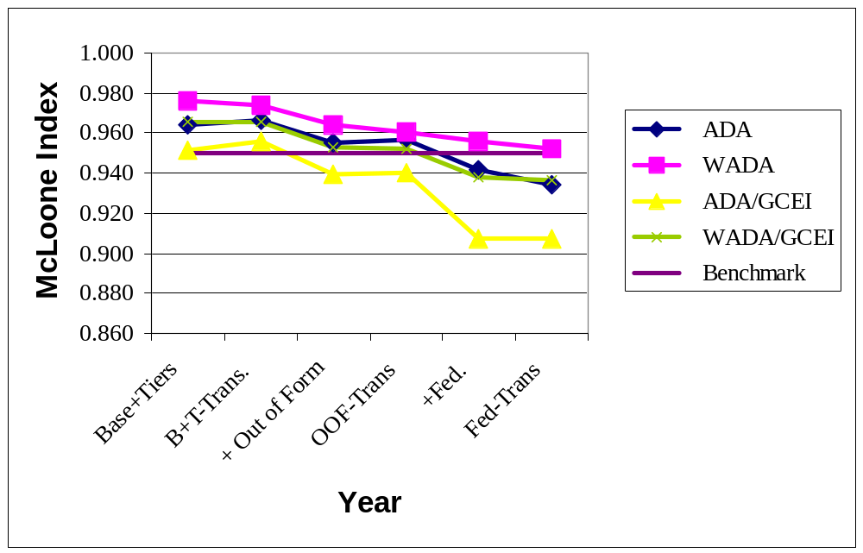

Overall, Table 2 and Figures 2 and 3 suggest a high degree of horizontal equity under SEEK in 1999-2000. Moreover, analyses based on weighted ADA suggest that there is a considerable degree of vertical equity as well. Next an analysis of the fiscal neutrality of Kentucky’s system for 1999-2000 is presented.
Figure 4 displays the correlation between property wealth per-pupil and revenue per-pupil for all six revenue measures, and both pupil counts in nominal and cost adjusted dollars. Odden and Picus (2000) suggest a benchmark value for this correlation of 0.5. Interestingly, with the exception of the weighted ADA revenues computed in nominal dollars using the SEEK revenues with and without transportation, all of the correlation coefficients computed for this analysis are below the proposed benchmark. This suggests that other state and local revenues, as well as Federal revenues are not highly correlated with property wealth, a somewhat surprising finding. When Federal funds are added to the mix, the correlation is even lower, and often negative, suggesting that low wealth districts receive more Federal revenue per-pupil than higher wealth districts. This is not unexpected since Federal funds are heavily focused on low-income children who often, but not always, live in lower wealth districts.
Figure 4 also shows that for the cost adjusted revenues per ADA, all of the correlation measures are negative. This implies that low wealth correlates with a low relative cost of living. As a result, low wealth districts generally have access to at least the same price adjusted level of resources as do the wealthier districts in the state.
The important conclusion to draw from Figure 4 is that there is relatively little relationship between property wealth and revenues for school districts in Kentucky. This indicates that SEEK has been successful in improving school finance equity. However, as suggested above, this analysis is not complete without a discussion of the elasticity or the strength of any relationship between wealth and revenue that does exist.

Figure 4
Assessment of SEEK Equity Using the Correlation Between Property Wealth Per-pupil and Revenue Per-pupil: 1999-2000

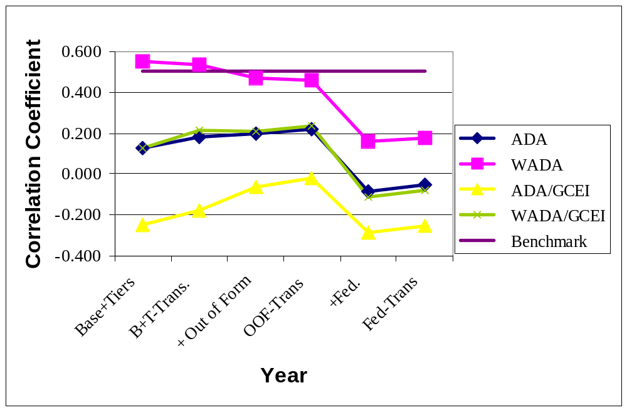

Figure 5 displays the results of our analysis of the elasticity of the Kentucky school finance system in 1999-2000. Using the Odden and Picus (2000) benchmark of 0.10, Figure 5, along with Table 2 suggest a relatively low elasticity which means that the changes in property wealth per-pupil lead to relatively small changes in revenues per-pupil. What is particularly notable in this analysis is that in some instances the elasticity is negative, which implies that as property wealth increases, revenues per-pupil decline somewhat, or as property wealth per-pupil decreases, revenues per-pupil rise. This occurs when revenues are adjusted by the cost of education index, and is most notable when Federal funds are included in the computation of revenue. What this suggests is that lower property wealth districts might also have higher numbers of lower income families, a characteristic that frequently triggers higher levels of federal aid. When combined with the impact of SEEK, one of the goals of which is to improve fiscal neutrality particularly for poor school districts, the negative elasticies result.

Figure 5
Assessment of SEEK Equity Using the Elasticity Between Property Wealth Per-pupil and Revenue Per-pupil: 1999-2000

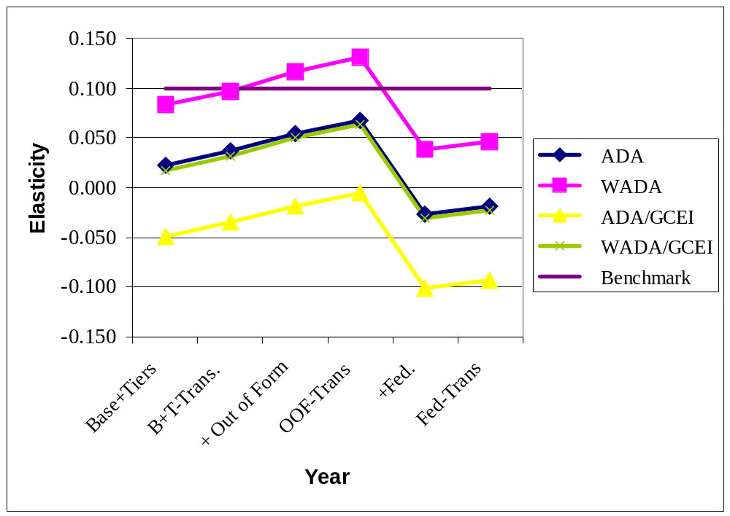

The analysis presented above suggests that today, Kentucky’s school finance system under SEEK is highly equitable. Regardless of the measure used to estimate that equity, the system either meets or nearly meets the benchmarks that have been established in the literature.
Ten-Year Equity Analysis: 1990-91 to 1999-2000
The analysis above suggests that today the SEEK formula has created a high degree of equity for Kentucky school finance. This section considers how the level of equity has changed over SEEK's first decade, using measures of school finance equity for ten years from 1990-91 to 1999-2000. To conduct this analysis, we relied on one revenue measure, specifically the SEEK formula (basic allotment plus Tiers I and II), plus all other state and local out of formula funds, minus transportation. This is column 4 in Table 2 above. We computed equity statistics using both ADA and weighted ADA in both nominal and cost adjusted dollars. The results of this analysis are presented in both table form and graphically below. Table 3 displays equity statistics for all ten years. Shown in the table are the CV, McLoone Index, correlation and elasticity for each year, using both ADA and weighted ADA in both nominal and cost adjusted dollars.
Table 3

Ten Year Analysis of SEEK Equity: 1990-91 to 1999-2000

 | Year
 | 1990-91 | 1991-92 | 1992-93 | 1993-94 | 1994-95 | 1995-96 | 1996-97 | 1997-98 | 1998-99 | 1999-00

Coefficient of Variation
ADA | 0.143 | 0.126 | 0.126 | 0.113 | 0.120 | 0.106 | 0.090 | 0.111 | 0.113 | 0.108
WADA | 0.136 | 0.117 | 0.116 | 0.102 | 0.108 | 0.096 | 0.081 | 0.102 | 0.106 | 0.104
ADA/GCEI | 0.106 | 0.098 | 0.102 | 0.091 | 0.102 | 0.085 | 0.078 | 0.086 | 0.089 | 0.084
WADA/GCEI | 0.097 | 0.083 | 0.087 | 0.076 | 0.086 | 0.072 | 0.065 | 0.073 | 0.077 | 0.075
McLoone Index
ADA | 0.956 | 0.946 | 0.947 | 0.950 | 0.948 | 0.943 | 0.955 | 0.962 | 0.958 | 0.957
WADA | 0.942 | 0.949 | 0.951 | 0.957 | 0.959 | 0.958 | 0.948 | 0.959 | 0.962 | 0.961
ADA/GCEI | 0.946 | 0.933 | 0.921 | 0.933 | 0.920 | 0.928 | 0.939 | 0.944 | 0.941 | 0.940
WADA/GCEI | 0.951 | 0.949 | 0.949 | 0.952 | 0.945 | 0.944 | 0.954 | 0.957 | 0.954 | 0.952

Correlation
ADA | 0.494 | 0.356 | 0.332 | 0.315 | 0.231 | 0.335 | 0.184 | 0.228 | 0.262 | 0.220
WADA | 0.661 | 0.552 | 0.545 | 0.517 | 0.410 | 0.528 | 0.404 | 0.458 | 0.503 | 0.457
ADA/GCEI | 0.241 | 0.098 | 0.13 | 0.113 | 0.033 | 0.123 | (0.031) | (0.001) | 0.022 | (0.018)
WADA/GCEI | 0.451 | 0.312 | 0.366 | 0.339 | 0.219 | 0.337 | 0.195 | 0.256 | 0.298 | 0.236

Elasticity
ADA | 0.148 | 0.108 | 0.105 | 0.097 | 0.082 | 0.107 | 0.058 | 0.068 | 0.075 | 0.068
WADA | 0.19 | 0.155 | 0.159 | 0.152 | 0.133 | 0.159 | 0.118 | 0.129 | 0.139 | 0.131
ADA/GCEI | 0.069 | 0.03 | 0.04 | 0.035 | 0.012 | 0.039 | (0.010) | (0.000) | 0.006 | (0.005)
WADA/GCEI | 0.117 | 0.083 | 0.101 | 0.095 | 0.069 | 0.097 | 0.056 | 0.067 | 0.077 | 0.064

Figure 6 provides a graphic display of the change in the CV over ten years. The figure shows a pattern of declining values for the CV implying that equity has improved over time in Kentucky. There was a substantial drop in the value of the CV between 1994-95 and 1996-97 and a subsequent increase after that. The drop appears to be attributable to a substantial increase in state aid through the SEEK formula in 1995-96 and 1996-97 and a commensurate reduction in off formula funding. While the CV did increase after 1996-97, it still remains below the values computed for the early years of SEEK.

Figure 6
Kentucky SEEK Equity Analysis
Coefficient of Variation: Base + Tiers + Out of Formula
(Excludes Transportation and Federal Revenue)

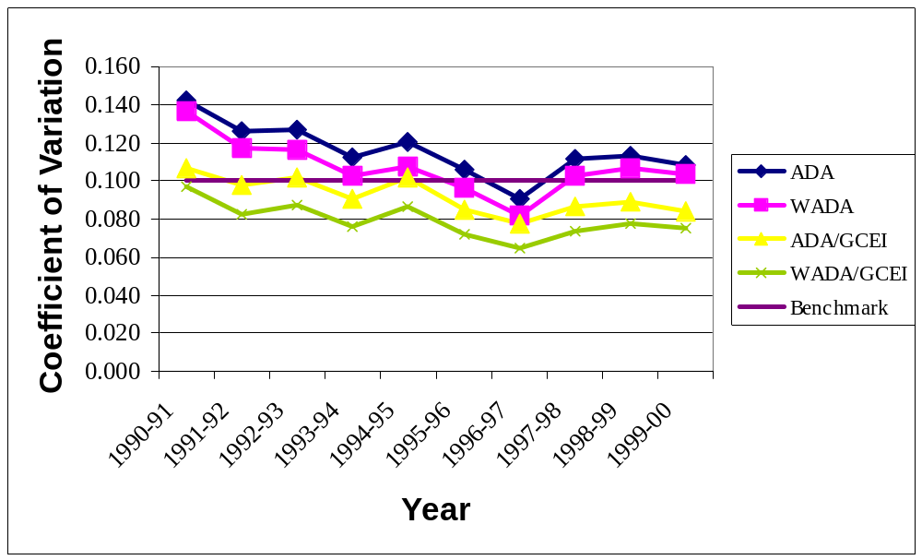

It is also interesting to note that when revenues are adjusted for cost of education differences, the value of the CV becomes smaller, indicating an increase in fiscal equity. In fact when analyzed using the cost index, the CV is at or below the benchmark of 0.10 in all years. When nominal dollars are used for the analysis, the values of the CV are below the benchmark only for 1996-97, although they are above the 0.10 benchmark by just a small amount, particularly during the last three years. We would focus on the results of the weighted pupil figures and/or the cost adjusted CV figures, nearly all of which are better than the 0.10 standard. Thus, we conclude that SEEK provides substantial fiscal equality across all school districts. Again this is a noteworthy conclusion because the SEEK formula allows for substantial inequality by letting districts spend up to 50 percent above the SEEK adjusted per pupil base.
Figure 7 displays the McLoone index for the same ten-year period. The figure shows that the McLoone index, when measured using nominal dollars has remained relatively constant over that time period. In fact, the values of the McLoone index are approximately the same for all of the revenue measures except for the cost adjusted ADA figures which are somewhat lower. In recent years, the McLoone Index has exceeded the rigorous benchmark of 0.95 for all revenue measures except the cost adjusted ADA revenue computation. The values displayed in Table 3 and graphed in figure 7 for the McLoone index suggest that the SEEK formula has established considerable equity for the districts in the bottom half of the distribution. More importantly, that equity has been maintained over the life the of SEEK formula.

Figure 7
Kentucky SEEK Equity Analysis
McLoone Index: Base + Tiers + Out of Formula
(Excludes Transportation and Federal Revenue)

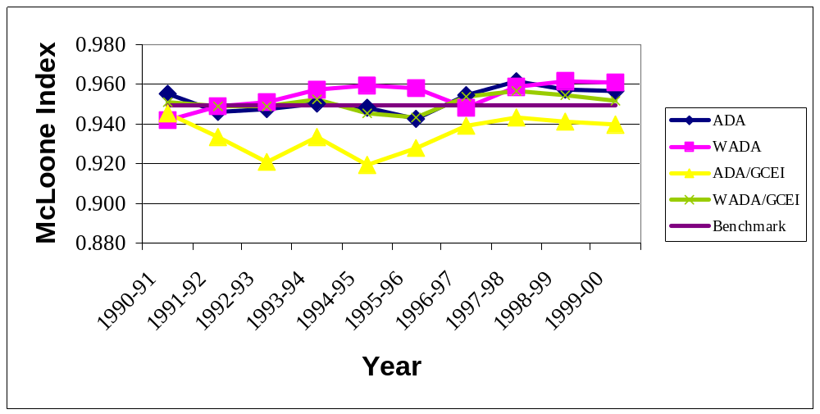

Figure 8 displays the correlation between per-pupil wealth and revenue over ten years. The figure makes clear that regardless of the measure used, the correlation between these two important variables has declined over time, indicating that fiscal neutrality has improved. More importantly, in virtually every measure, the correlation is lower than the benchmark of 0.5. In fact, the correlation only exceeds 0.5 for three of the years of analysis, and then only for the analysis of revenues per ADA in nominal dollars. For each of the other three revenue measures, the correlation is always below 0.5.

Figure 8
Kentucky SEEK Equity Analysis
Correlation Coefficient: Base + Tiers + Out of Formula
(Excludes Transportation and Federal Revenue)

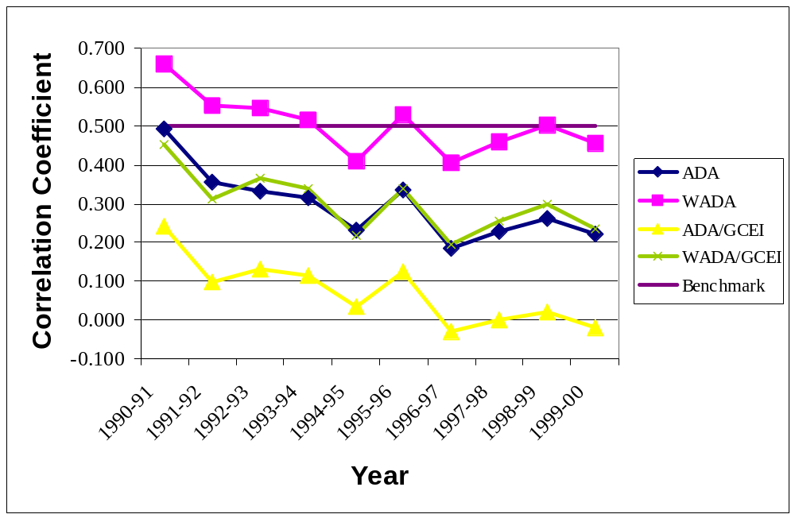

Absent some measure of the strength of the relationship between wealth and revenue, the data presented in Figure 8 only tells part of the story. Figure 9 provides a ten-year picture of the elasticity between these two variables. That figure suggests a reasonably low value for elasticity over the years, and a pattern of slight decline in elasticity between 1990-91 and 1999-2000. With the exception of the analysis of nominal revenues per ADA, almost all of the values for elasticity are below the benchmark of 0.1. This implies that in general, higher property values yield only marginally higher revenue generation among Kentucky school districts.

Figure 9
Kentucky SEEK Equity Analysis
Elasticity: Base + Tiers + Out of Formula
(Excludes Transportation and Federal Revenue)

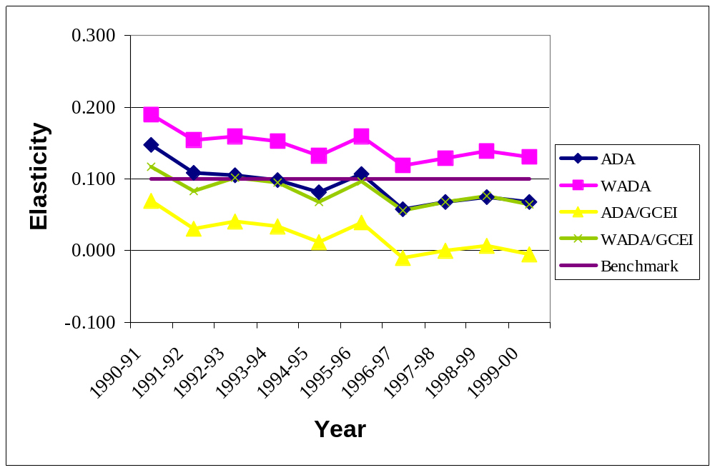

A final question that should be considered is how equity has changed over time for the highest spending districts. The Verstegen index provides a measure of how equity for the top half varies over SEEK’s ten year existence. Table 4 and Figure 10 display the values of the Verstegen Index for the revenue variable that includes the SEEK base plus the tiers I and II plus all state and local out of formula revenue for ten years. The data show very little variation over time in the values of the Index. The cost adjusted figures hover between 1.05 and 1.06, while the nominal dollar figures are somewhat higher. Although the lack of a benchmark makes it difficult to ascertain how well SEEK maintains equity for the top half of the districts, the pattern that emerges from Figure 11 suggests that higher revenue districts have not been advantaged over time and able to increase their revenues at a faster pace than districts in the bottom half.

Table 4
Ten-Year Analysis of the Verstegen Index

Year | ADA | WADA | ADA/GCEI | WADA/GCEI
1990-91 | 1.081 | 1.084 | 1.063 | 1.059
1991-92 | 1.108 | 1.077 | 1.064 | 1.054
1992-93 | 1.058 | 1.066 | 1.056 | 1.055
1993-94 | 1.053 | 1.070 | 1.062 | 1.054
1994-95 | 1.058 | 1.068 | 1.060 | 1.060
1995-96 | 1.073 | 1.080 | 1.053 | 1.050
1996-97 | 1.071 | 1.065 | 1.058 | 1.051
1997-98 | 1.078 | 1.072 | 1.057 | 1.051
1998-99 | 1.081 | 1.077 | 1.056 | 1.047
1999-00 | 1.074 | 1.076 | 1.055 | 1.053

Overall, this ten-year analysis suggests that fiscal equity in Kentucky’s school finance formula – either overall revenue per pupil equality or the linkage between revenues per pupil and wealth -- is quite good, and that over the last ten years it has improved. Our conclusions and recommendations follow.
Figure 10
Kentucky SEEK Equity Analysis
Verstegen Index: Base + Tiers + Out of Formula
(Excludes Transportation and Federal Revenue)

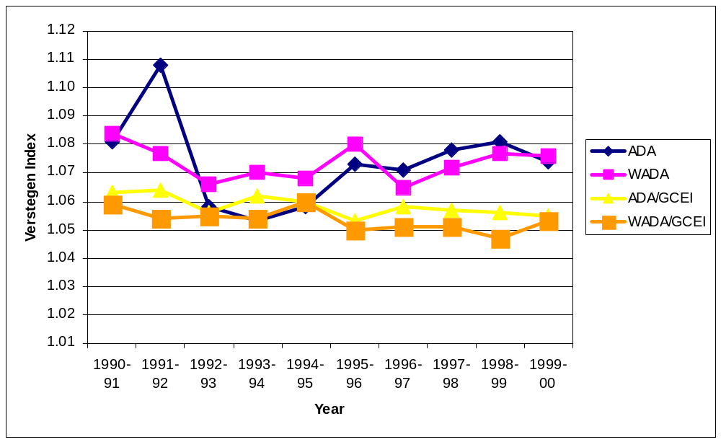

V. Conclusions
Our ten-year equity analysis of the SEEK formula shows that the formula is both equitable, and that the equity of revenues to school districts has improved over the life of SEEK. Using the rigorous standards established in the school finance literature (Odden & Picus, 2000), SEEK meets or exceeds the standards much of the time – even though the SEEK formula itself allows for up to a fifty percent difference in revenues per pupil for those districts that spend the base amount and those districts that add both Tier I and Tier II revenues. When an equity measure does not meet one of the standards, it is by a small amount. More importantly, as the ten-year analysis shows, over time, each measure of equity has improved.
An important consideration in any equity analysis is how the districts at the low end of the revenue spectrum fare. Analysis of the McLoone Index shows that generally there is a high degree of equity among those districts (i.e. the value of the McLoone Index approaches the value 1). On the other end of the spectrum, analysis of the Verstegen Index suggests that over time high revenue districts have not gained in relation to the average revenue per pupil across the state. While those districts obviously have more revenue per pupil, their revenue advantage has not increased nor decreased in ten years.
In assessing the relationship between property wealth and revenue, the values for the correlation coefficient and elasticity almost always meet the stiff benchmarks established for fiscal neutrality. More importantly, over time both measures have declined indicating that the systems fiscal neutrality has improved. This pattern emerges regardless of whether the analysis relies on ADA, WADA, nominal or real dollars, and suggests that overall, SEEK is achieving the fiscal neutrality goals set out by the Legislature a decade ago.
In summary, there is a substantial degree of fiscal equity in Kentucky under the SEEK formula. Revenue per pupil differences are relatively small, and the link between property wealth and revenue per pupil is essentially gone. Although Kentucky policymakers should not become complacent about the equity of the system, it appears that at this time revenue inequities are not a problem for the state.
The remaining question therefore, has to do with adequacy. Do Kentucky school districts have sufficient enough – adequate – resources to allow students to perform at high levels? To insure the system provides adequate funding, the state needs to establish a high SEEK base. This might require increasing the adjusted base guarantee. Doing so would also improve horizontal equity throughout the system.
The next step is to define what that adequate revenue level is. It should be established at a level that will allow school districts to provide enough money for each school in the state to deploy powerful educational strategies to meet the state's 2014 goals, which are to have all students performing at or above the proficiency level on the state's student testing system.
' In addition to determining an adequate level of resources for each school, state policymakers then need to be sure that future appropriations keep pace with inflation. This will establish a system that is adequate and even more equitable – a condition attained by few, if any, school finance systems in the country at this time.
References
Adams, E. Kathleen, and Allan Odden. (1981). Alternative Wealth Measures. In K. Forbis Jordan and Nelda H. Cambron-McCabe (Eds.), Perspectives in State School Support Programs. Cambridge, MA: Ballinger, p. 143-165.

Adams, Jacob E. (1994). “Spending School Reform Dollars in Kentucky: Familiar Patterns and New Programs, But Is This Reform?” Educational Evaluation and Policy Analysis. 16(4), 375-390.

Adams, Jacob. (1997). “School Finance Policy and Students’ Opportunities to Learn: Kentucky’s Experience.” The Future of Children: Financing Schools, 7(3), 79-95.

Alexander, Kern. (1982). “Concepts of Equity.” In Walter McMahon and Terry Geske, eds., Financing Education. Urbana, IL: University of Illinois Press.

Augenblick, John (1991). Report Concerning the SEEK Program. Mimeo

Barro, Stephen. (1989). "Fund Distribution Issues in School Finance: Priorities for the Next Round of Research." Journal of Education Finance, 11(1), 17-30.

Berne, Robert and Leanna Stiefel. (1984). The Measurement of Equity in School Finance. Baltimore, MD: Johns Hopkins University Press.

Berne, Robert and Leanna Stiefel. (1999). “Concepts of School Finance Equity: 1970 to Present.” In Helen Ladd, Rosemary Chalk and Janet Hansen, eds., Equity and Adequacy in Education Finance: Issues and Perspectives. Washington, DC: National Academy Press.

Chambers, Jay G. (1995). “Public School Teacher Cost Differences Across the United States: Introduction to a Teacher Cost Index (TCI).” In Developments in School Finance [On-line]. Available: http://www.ed.gov/NCES/pubs/96344cha.html.

Feldstein, Martin. (1975). “Wealth Neutrality and Local Choice in Public Education.” American Economic Review, 64, 75-89.

Garms, Walter I. (1979). "Measuring the Equity of School Finance Systems." Journal of Education Finance, 4(4), 415-435.

Goertz, Margaret. (1983). "School Finance in New Jersey: A Decade After Robinson v. Cahill." Journal of Education Finance, 8(4), 475-489.

Hickrod, G. Alan, Ramesh B. Chaudhari, and Ben C. Hubbard. (1981). Reformation and Counter-Reformation in Illinois School Finance: 1973-1981. Normal, IL: Center for the Study of Education Finance.

Kearney, Phillip, Li-Ju Chen and Marjorie Checkoway. (1988). Measuring Equity in Michigan School Finance: A Further Look. Ann Arbor, MI: University of Michigan, School of Education.

Ladd, Helen. (1975). “Local Education Expenditures, Fiscal Capacity and the Composition of the Property Tax Base.” National Tax Journal, 28(2), 145-158.

McMahon, Walter W. (1994). Intrastate Cost Adjustment. In Selected Papers in School Finance [On-line]. Available: http://www.ed.gov/NCES/pubs/96068ica.html.

Murray, Sheila, William Evans and Robert Schwab. (1998). “Education Finance Reform and the Distribution of Education Resources.” American Economic Review, 88(4), 789-812.

Murray, Shelia E. (2001). Kentucky. In Dayton, John., Holms, C. Thomas., Sielke, Catherine C. and Jefferson, Anne L. Public School Finance Programs of the United States and Canada, 1998-99. Washington, DC: National Center for Education Statistics. NCES-2001-309.

Odden, Allan and Carolyn Busch. (1998). Financing Schools for High Performance: Strategies for Improving the Use of Educational Resources. San Francisco: Jossey-Bass.

Odden, Allan R. and Picus, Lawrence O. (2000). School Finance: A Policy Perspective, 2nd Edition. New York, NY: McGraw Hill.

Odden, Allan. (1995b). Missouri School Finance System: Fiscal Equity After S.B. 380. Paper prepared for the Missouri Performance Commission.

Odden, Allan. (1975). The Incidence of the Property Tax Under Alternative Assumptions: The Case in Minnesota, 1971. Unpublished paper. Denver, CO: Education Commission of the States.

Picus, Lawrence O. and Linda Hertert. (1993a). “A School Finance Dilemma for Texas: Achieving Equity in a time of Fiscal Constraint.” Texas Researcher, 4: 1-28.

Picus, Lawrence O. and Linda Hertert. (1993b). “Three Strikes and You’re Out; Texas School Finance After Edgewood III. Journal of Education Finance, 18(3), 366-389.

Sherman, Joel (1992). “Review of School Finance Equalization Under Section 5(d) of P.L. 81-874, the Impact Aid Program.” Journal of Education Finance. 18(1).

Verstegen, Deborah. (1996). “Concepts and Measures of Fiscal Inequality: A New Approach and Effects for Five States.” Journal of Education Finance, 22(2), 145-160.

Wise, Arthur. (1968). Rich Schools-Poor Schools: A Study of Equal Educational Opportunity. Chicago: University of Chicago Press.

Wise, Arthur. (1983). "Educational Adequacy: A Concept in Search of Meaning." Journal of Education Finance, 8(3), 300-315.

Rose v. Council for Better Education, Inc., KY No. 88-SC-804-TG
Council for Better Education, Inc. v. Wilkinson, No. 85-CI-1759 (Franklin Circuit Court, Division I). May 31, 1933
Kentucky Constitution Sec. 183.
This material was taken directly from Odden and Picus (2000).
These comments assume a normal distribution.
A value of 1.0 for the McLoone index indicates that per-pupil expenditures in the lowest spending districts containing 50% of the state's children is equal. A value of less than one implies that among the low spending districts with that 50% of school children, expenditures vary. The smaller the McLoone index, the larger the spending differential among the low spending districts.
In high cost areas, the cost index has a high value. When nominal dollars are divided by the cost index, they decline making the real dollar figure lower. Conversely, in low cost areas, division by the cost index will make real dollars higher than nominal dollars. The result is greater equity of revenues. To the extent this happens in the lower half of the districts, the McLoone Index would be expected to be higher.

