Documenting District Health Services Staff

Rev. 10/17/2018

Ownership and History

  - Standard prepared by:

Angela McDonald
  - Data steward(s)
Angela McDonald, (502) 564-5279, ext.4430
  - Office(s)
Office of Finance and Operations
  - Revision history
February 20, 2018
October 17, 2018

Section A – Employment Assignment for District Hired Health Staff
All district hired school health staff should be entered under the District Assignments tab. The information will sync to State Edition and be available for retrieval by KDE. The service providers tracked in this tab will have District Employment Records.

Campus Path: Staff/District Assignments
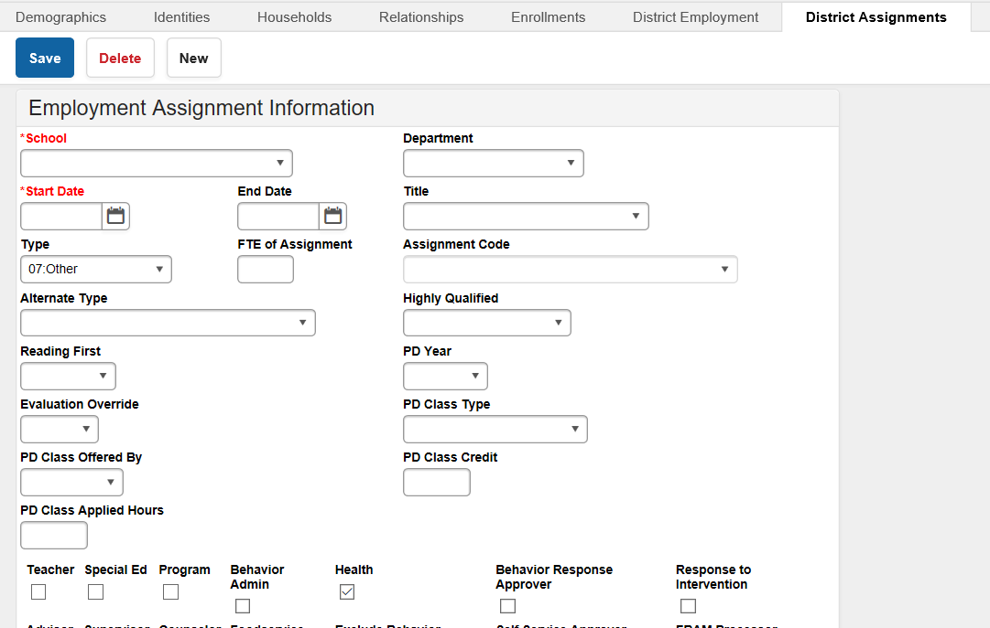

School Name: Choose school name from drop down box.

Date: Add employee hire date.
Type: From drop down box, choose 07: Other.

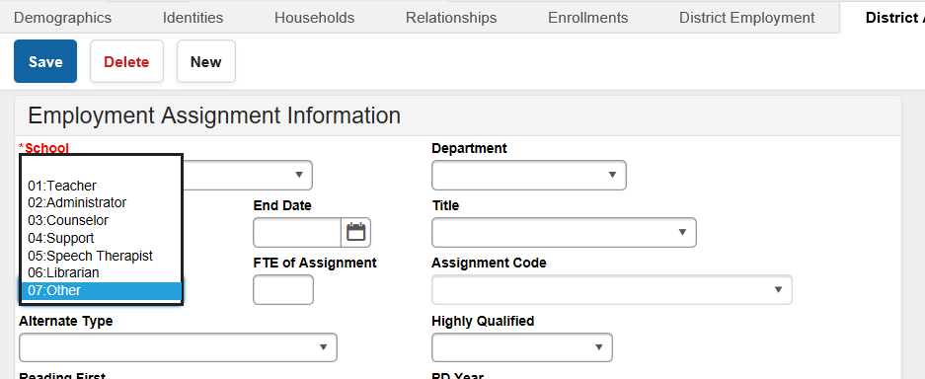

Alternate Type: Choose the correct type of license from the drop down box.
- LPN: Licensed Practical Nurse
- RN: Registered Nurse/Advanced Practice RN

Check the Health box and then Save.

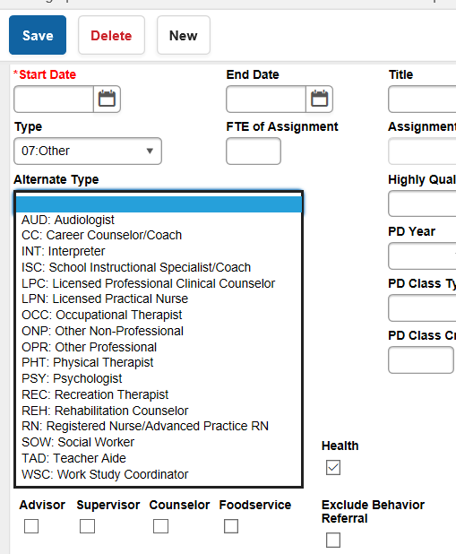

Section B – District Service Providers
The District Service Providers tab tracks contract health service providers in each district by school year based on contract start and end dates. Contracted service providers can be more than one school year in duration. The information will sync to State Edition and be available for retrieval by KDE. The service providers tracked in this tab will not have District Employment Records.

  - Campus Path: System Administration/ Resources / District Information/District Health Service Providers

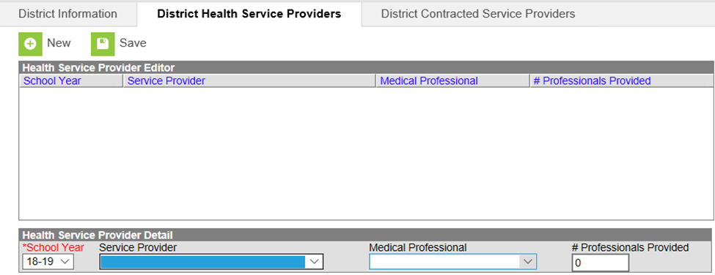

School Year: Enter correct school year
Note: This information should be entered yearly even if the contract is longer than a one year period.

Service Provider: Choose type of service provider from the drop down menu.
- 01. Health Department
- 02. Hospital
- 03. Staffing Agency
- 04. Federally Qualified Health Care Center

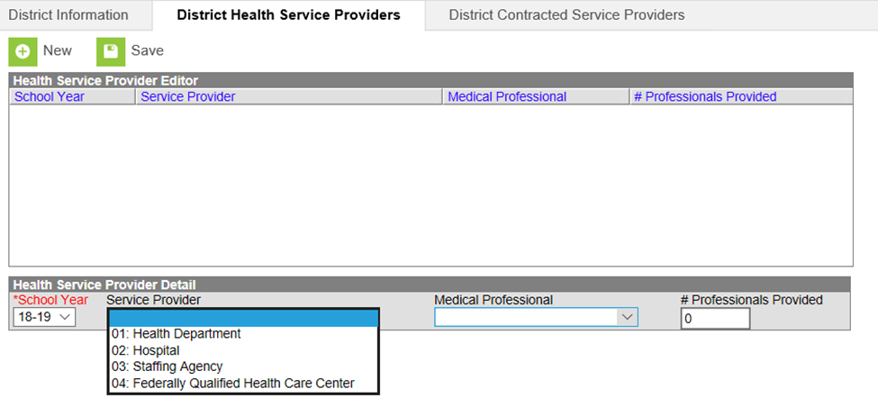

Medical Professional: Choose type of medical professional from drop down menu
- PA: Physician’s Assistant
- APRN: Advanced Practice RN
- RN: Registered Nurse
- LPN: Licensed Practical Nurse
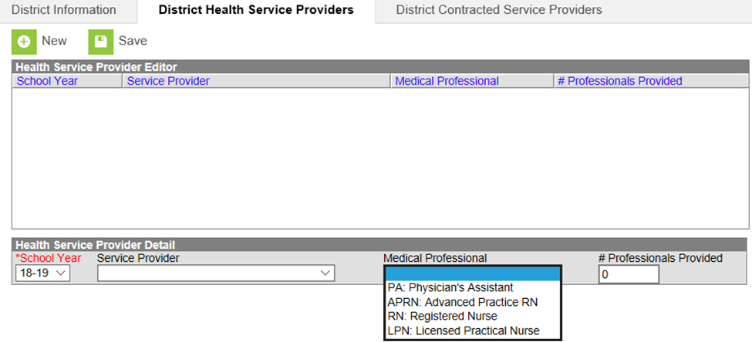
Number Professionals Provided: Enter number of health provider staff

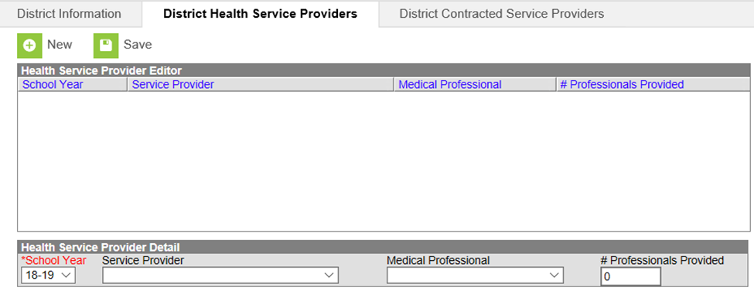

Note: Health providers should only be listed in one of the listed categories. Also, part-time staff should be counted as one provider.

