**Tracking influenza-like illnesses in schools**

Kentucky has already documented flu cases. Since flu activity has stared earlier than usual, the Centers for Disease Control is recommending a heightened effort to promote flu prevention. Flu vaccine clinics and reporting flu like activity are encouraged to promote this effort.

The Kentucky Department of Education (KDE) and the Kentucky Department of Public Health (KDPH), are partnering to track students with flu-like illnesses in the school setting.  When a teacher, school nurse, or attendance clerk is notified that a child is absent due to flu-like symptoms, attendance clerks or other school staff should code the absence with one of the following codes:

|  |  |
| --- | --- |
| **Attendance Codes for Influenza-like symptoms** | **Attendance Description Influenza-like symptoms** |
| ILID | Influenza-like illness excused doctor note |
| ILIE | Influenza-like illness excused |
| ILIP | Influenza-like excused parent note |
| ILIU | Influenza-like illness unexcused |

Influenza-like illnesses should be tracked closely by administrators, school nurses, and district health coordinators to determine if the district flu plan should be activated. Extra cleaning by custodial staff should be performed during the day, including frequently used items such as water fountains, computer keyboards, etc.  The use of shared items such as crayons and scissor should be limited as well.  Students should also be taught to cover coughs and to use good hand washing practices.

School districts should always notify their local health department of any outbreaks or closings as they work with state epidemiologists as well as the CDC for data reporting.

For free CDC resources, including information on how to avoid contracting the flu, click [here](https://www.cdc.gov/flu/resource-center/freeresources/index.htm).

**Entering new attendance codes for influenza-like illnesses in schools**

Path: System Administration > Attendance > Attendance Codes

1. Select New.
2. Enter the attendance excuse abbreviation in the Code field (2-4 characters in length).
3. Enter a brief but descriptive definition for the entered code in the Description field. This description will be used throughout the Attendance module.
4. Select the appropriate status/excuse combination that should be aligned to the entered code in the Status and Excuse dropdown lists.
5. When finished, click Save.

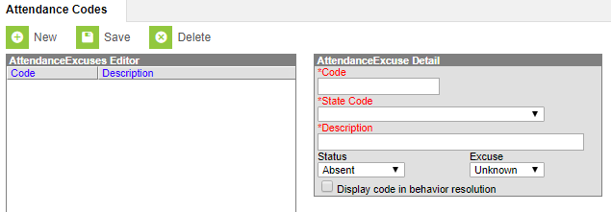

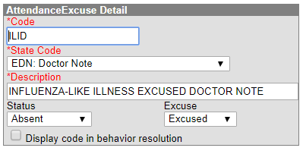

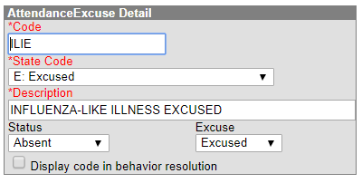

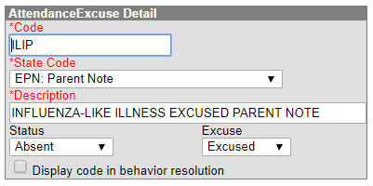

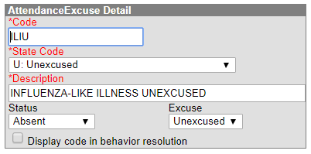

Additional documentation on these and other attendance codes is available in the Pupil Attendance Manual. Questions regarding use of the influenza codes should be directed to Angela McDonald by [email](mailto:angela.mcdonald@education.ky.gov?subject=email) or telephone at (502) 564-5279; questions regarding how to create the codes should be directed to Josh Whitlow by [email](mailto:josh.whitlow@education.ky.gov?subject=email) or telephone at (502) 564-5279.