Tool Rights for District Health Staff

Kentucky Department of Education
Division of District Support
School Year 2019-2020

Tool Rights determine the level of access users have to tools throughout Campus.
- R (Read) - The R right indicates the information on the corresponding tool may be viewed by the user. When applicable, the user is also allowed to print information. The user will NOT have access to the Save, Add or Delete icons in the action bar.
- W (Write) - The W right indicates the user may view and modify the information on the corresponding tool. The Save icon in the action bar will be functional. This right allows the user to modify only existing data in the area since adding new data is controlled by the A right. This right includes the ability to change or remove data from a specific field.
- A (Add)- The A right indicates the user may view, modify and add to the information on the corresponding tool. The New and Add icons in the action bar will be functional. This right allows the user to add new data/records.
- D (Delete) ASSIGN THIS RIGHT WITH CAUTION. The D right indicates the information on the corresponding tool may be deleted. The Delete icon in the action bar will be functional. This right provides the ability to completely remove an existing record, including all data contained within the record. The ability to change/remove data from a field is controlled through the W right.

Health
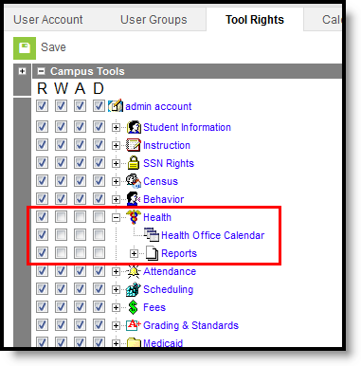

Select the R (Read) tool rights for Heath, Health Office Calendar and Reports
- Health Office Calendar – Allows the user to view scheduled, in progress and completed health office visits.
- Reports – Allows full access to generating health reports.

System Administration > Health
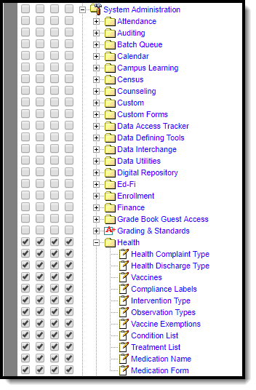
Select the R,W,A,D tools rights for all System Administration > Health
- Health Complaint Type
  - R - Allows the user to see existing complaint types.
  - W - Allows the user to edit existing complaint types.
  - A - Allows the user to add new complaint types.
  - D - Allows the user to remove complaint types from the product.
- Health Discharge Type
  - R - Allows the user to view existing health office discharge options.
  - W- Allows the user to edit existing discharge types.
  - A - Allows the user to add new discharge types.
  - D - Allows the user to remove discharge types from the product.

- Vaccines
  - R - Allows the user to view existing vaccines.
  - W – Allows the user to edit existing vaccines.
  - A – Allows the user to add new vaccines.
  - D - Allows the user to remove vaccines.
- Compliance Labels
  - R – Allows the user to view existing compliance labels.
  - W - Allows the user to edit existing compliance labels.
  - A - Allows the user to add new compliance labels.
  - D - Allows the user to remove compliance labels.
- Intervention Type
  - R - Allows the user to view existing intervention types.
  - W - Allows the user to edit existing intervention types.
  - A - Allows the user to add new intervention types.
  - D - Allows the user to remove intervention types.
- Observation Types
  - R - Allows the user to view existing observation types.
  - W - Allows the user to edit existing observation types.
  - A - Allows the user to add new observation types.
  - D - Allows the user to remove observation types.
- Vaccines Exemptions
  - R - Allows the user to view existing vaccine exemptions.
  - W - Allows the user to edit existing vaccine exemptions.
  - A - Allows the user to add new vaccine exemptions.
  - D - Allows the user to remove vaccine exemptions.
- Condition List
  - R - Allows the user to view existing conditions.
  - W - Allows the user to edit existing conditions.
  - A - Allows the user to add new conditions.
  - D - Allows the user to remove conditions.
- Treatment List
  - R - Allows the user to view existing treatments.
  - W - Allows the user to edit existing treatments.
  - A - Allows the user to add new treatments.
  - D - Allows the user to remove treatments.
- Medication Name
  - R - Allows the user to view existing medication name information.
  - W - Allows the user to edit existing medication names.
  - A - Allows the user to add new medication names.
  - D - Allows the user to remove medication names.

- Medication Form
  - R - Allows the user to view existing medication form information.
  - W - Allows the user to edit existing medication forms.
  - A - Allows the user to add new medication forms.
  - D - Allows the user to remove medication forms.

System Administration > Custom Forms > Health

Select the R,W,A,D tools rights for System Administration > Custom Forms Health
- Custom Forms
  - R - Allows the user to view documents uploaded for supplemental purposes.
  - W - Allows the user to edit documents uploaded for supplemental purposes.
  - A - Allows the user to add new documents uploaded for supplemental purposes.
  - D - Allows the user to remove documents uploaded for supplemental purposes.

Highly Recommended Tool Rights
Ad Hoc Reporting
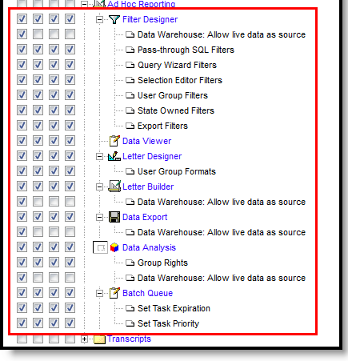
Filter Designer
- Filter Designer
  - R - Access to view the Filter Designer tool
  - W - View and Modify
  - A - View, Modify and Add
  - D - View, Modify, Add and Delete
- Data Warehouse
  - R - View Only
  - W - N/A
  - A - N/A
  - D - N/A
- Pass-through SQL Filters
  - R - Access to view Pass-through SQL filters
  - W - View and Modify
  - A - View, Modify and Add
  - D - View, Modify, Add and Delete
- Query Wizards Filters
  - R - Access to view the Query Wizard
  - W - View and Modify
  - A - View, Modify and Add
  - D - View, Modify, Add and Delete
- Selection Editor Filters
  - R - Access to view the Selection Editor
  - W - View and Modify
  - A - View, Modify and Add
  - D - View, Modify, Add and Delete
- User Group Filters
  - R - Access to view the filters saved into user groups
  - W - View and Modify
  - A - View, Modify and Add
  - D - View, Modify, Add and Delete
- State Owned Filters
  - R - Access to view filters created in State Edition versions of Campus
  - W - View and Modify
  - A - View, Modify and Add
  - D - View, Modify, Add and Delete
- Export Filters
  - R - Access to view exported filters
  - W - View and Modify
  - A - View, Modify and Add
  - D - View, Modify, Add and Delete
- Data Viewer
  - R -Access to view and generate existing reports.
  - W - View and Modify existing reports and folders.
  - A - View, modify and create reports and folders.
  - D - View, modify, create and delete reports and folders.
- Letter Designer
  - R -Access to view the letter designer
  - W - View and Modify
  - A - View, Modify and Add
  - D - View, Modify, Add and Delete
- User Group Formats
  - R - Access to view the User Group formats
  - W - View and Modify
  - A - View, Modify and Add
  - D - View, Modify, Add and Delete
- Letter Builder
  - R - Access to view the Letter Builder
  - W - View and Modify
  - A - View, Modify and Add
  - D - View, Modify, Add and Delete
- Data Warehouse: Allow Live data as source
  - R - View Only
  - W - N/A
  - A - N/A
  - D - N/A
- Data Export
  - R - Allows access to view the Data Export tool
  - W - View and Modify
  - A - View, Modify and Add
  - D - View, Modify, Add and Delete
- Data Warehouse: Allow Live data as source
  - R - View Only
  - W - N/A
  - A - N/A
  - D - N/A
- Data Analysis
  - R - Access to view the Data Analysis tool
  - W - View and Modify
  - A - View, Modify and Add
  - D - View, Modify, Add and Delete
- Group Rights
  - R - Access to view the Group tool rights
  - W - View and Modify
  - A - View, Modify and Add
  - D - View, Modify, Add and Delete
- Data Warehouse: Allow live data as source
  - R - View Only
  - W - N/A
  - A - N/A
  - D - N/A
- Batch Queue
  - R - Access to view the batch queue
  - W - View and Modify
  - A - View, Modify and Add
  - D - View, Modify, Add and Delete
- Set Task Expiration
  - R - Access to view task expiration information
  - W - View and Modify
  - A - View, Modify and Add
  - D - View, Modify, Add and Delete

- Set Task Priority
  - R - Access to view task priority
  - W - View and Modify
  - A - View, Modify and Add
  - D - View, Modify, Add and Delete

