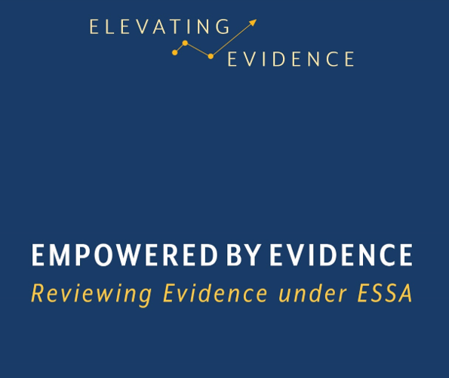

Kentucky Comprehensive Literacy Grant (KyCL)
Guidelines for using the KDE Elevating Evidence document

The goal of the KyCL grant is to provide teacher professional learning to improve comprehensive literacy for all learners from birth to grade 12 and to provide the resources needed to implement literacy strategies to support a robust literacy environment, including a balanced literacy assessment plan.

Districts are required to provide professional learning for each level- early, elementary, middle and high. The KyCL Approved Provider Grid lists already approved professional learning providers. Districts requesting a provider not on the KyCL Approved Provider Grid or a literacy resource should fill out the KDE Elevating Evidence (EE) forms and submit them to the KyCL Directors for approval.
District should consult with KDE before working on EE forms. KDE may be able to give guidance that will enhance the research or save the district time.
EE forms guide districts as they look at one piece of research. However, best practice involves looking at multiple research studies to make an informed decision. Using What Works Clearinghouse and/or other independent research studies is encouraged.

After filling out the Elevating Evidence forms please answer the following questions and submit them with the EE forms to kdekycl@education.ky.gov
Submit the answer to these questions with the EE forms to kdekycl@education.ky.gov
District________________________
Date__________________________

- What is the name of the professional learning provider or resource you are requesting? (This may be an addition to the research.
For example, you may be researching the use of Structured Literacy Strategies. However, the professional learning provider you
requesting is the Special Education Cooperative who is providing training in Structured Literacy Strategies.)
- How does the professional learning provider or resource match the intent of the grant?
- How does the requested professional learning provider or resource support the district and school literacy plan?
- How will the professional learning provider support teachers by providing the extensive training and support needed to change teacher practice?
- How will the resource support the goal of creating a robust literacy environment for students, including a balanced literacy assessment plan?
- Will the resource be a one-time purchase? If not, please explain how you will sustain the initiative.
- What percentage of KyCL grant will funds be used to purchase this resource?

