**Superintendent’s Annual Attendance Report (SAAR) Documentation**

**End of Year**

**2018-2019**



Kentucky Department of Education

Wayne Lewis, Commissioner

KDE Contact

Brad Kennedy

Kentucky Department of Education

300 Sower Building, Fourth Floor

Frankfort, Kentucky 40601

Telephone: (502) 564-5279, ext. 4417

Email: [brad.kennedy@education.ky.gov](mailto:brad.kennedy@education.ky.gov)

**Table of Contents**

|  |  |
| --- | --- |
| Topic | Page Number |
| SAAR Documentation Overview | 5 |
| Record 5 Ethnic Count | 6 |
| Record 7 Aggregate Days Attendance and Absence | 6 |
| State Enrollment Overlap Report | 6 |
| Student Schedule Gaps | 7 |
| Overlapping T-codes Ad hoc | 7 |
| Missing T-codes Ad hoc | 7 |
| Close Gap Period | 8 |
| Partial Day Ad hoc | 9 |
| Record 9 Non-Contract and Over/Underage | 11 |
| Out of District/Resident Students and Non-Contract Students Ad Hoc  Overage/Underage | 12  13 |
| Expulsion Attendance Report | 14 |
| Suspension Attendance Linkage | 14 |
| Home and Hospital Ad Hoc | 15 |
| Kindergarten Code  Funding Gap Audit | 16  17 |
| District Daily Attendance Report | 18 |
| Non-Traditional Days | 24 |
| SAAR Checklist | 26 |
|  |  |
| SAAR Workflow Chart | 27 |
| SAAR Calculation | 28 |
| SAAR Detail Report | 30 |
| Creating SAAR Fixed Width | 32 |
| Submission to KDE | 33 |
| Common Error Messages | 36 |
| Error Guide | 45 |
| Contact Information | 45 |
|  |  |
|  |  |
|  |  |
|  |  |
|  |  |

**SAAR Documentation Overview**

***Purpose***

The Superintendent’s Annual Attendance Report (SAAR) provides year-end attendance information used to calculate the school district’s enrollment, membership, average daily membership (ADM), percent of attendance, home and hospital ADA and adjusted average daily attendance (AADA).

All information is reported by school, grade level, and by transportation code.

***Due Date***

The SAAR is due to KDE by **June 30th**. It is strongly encouraged that districts submit and verify their reports as soon as possible.

Note: If your school offers an extended calendar for programs such as Job Corp or KECSAC, send an e-mail to Brad Kennedy with the expected submission date.

***Adjusted Average Daily Attendance***

The attendance calculation in Infinite Campus does NOT divide grade 00 in half. Once the numbers are sent for SEEK calculating, grade 00 will be adjusted at that point.

***Kindergarten Retention***

If a student is retained in Kindergarten with a 00 for the first year and a 00 for the second year, grade 00 will be adjusted in the SEEK calculation for the second year also.

***Focus Areas***

The SAAR includes the following information for the entire school year aggregate day’s attendance and absence:

* race and gender count
* adjustments for less than full-time attendance (Partial Day)
* nonresident/non-contract
* overage and underage
* virtual/performance based courses with passing grade
* eligible suspensions and eligible expulsions
* up to 10 (ten) low attendance days due to weather
* up to 10 (ten) low attendance days due to weather or health and safety – N Day Approved by KDE
* five (5) lowest attendance days which are automatically selected by the system

Cone to call attention to important note


**Note: All information is reported by school, grade level, and by transportation.**

**SAAR Focus Area Records**

|  |  |
| --- | --- |
| Record 1 | Calendar |
| Record 2 | Enrollment/Reenrollment |
| Record 3 | Withdrawals |
| Record 5 | Ethnic Count (R2 – R3 = R5) |
| Record 7 | Aggregate Attendance |
| Record 9 | Non-Contract Overage/Underage |
| Record H | Home/Hospital |
| Record N | Non-Traditional |
| Record W | Five Low Attendance Days |
| Record L | Ten Low Attendance Weather Days |

**Record 5 – Ethnic Count**

* **Ethnic Count – Active students on the last day of the 10th month of school**

***Path: KY State Reporting > SAAR Report > Check box R2 and R3 and select extract format of PDF, All Calendars, and leave the date range blank.***

Run Record 2 and Record 3 of the SAAR Report, making sure the totals add correctly.

* R2 (Enrollment + Reenrollment) – R3 (Withdrawals) = R5 (Ethnic Count)

Enrollment – Withdrawals = Ethnic Count

**Note:** Ethnicity codes may not match if a withdrawal code was left off or if a student was enrolled and their ethnicity was **not** entered in during enrollment. These are the first two places to check if codes do not match properly.

**Record 7 – Aggregate Days Attendance and Absence**

* **State Enrollment Overlap**

***Path: Student Information > Reports > State Enrollment Overlap***

Enrollment overlaps occur when the begin/end dates of one primary enrollment overlap with that of a second primary enrollment record for the same student. **KDE will not process a district SAAR until after all overlaps more than one day are corrected.**

* *Review Step***:** The State Enrollment Overlap report will identify these overlapping records, which should be corrected.

Note: One day overlaps are allowed and should remain within Infinite Campus with the exception of a one day overlap in the same district. Be very careful which enrollment record gets end dated as attendance and grades are tied to enrollment.

* **Student Schedule Gaps**

***Path: KY State Reporting > Edit Reports > Schedule Gap Report***

This tool is used to locate student schedule gaps. The report shows any days the student has schedule gaps, from the enrollment begin date to the withdrawal date (if applicable).

* + *Review Step***:** Correct any schedule gaps for any dates shown on this report.
* Perform this for any withdrawn students as well, since they do affect the attendance reports.
* Overlapping T Codes

***Path: Ad Hoc Reporting > Filter Designer > State Published > Audit Overlapping T Codes***

Students with overlapping transportation codes need to be corrected. Run this query for each school.

Note**:** If the Year is set to the current school year, then the search function for this ad hoc will only find students active within the current year with a T-code overlap. The overlap could be within any school year.

* + *Review Step***:** Correct any overlapping transportation records.
* Missing T Codes

***Path: Ad Hoc Reporting > Filter Designer > State Published > Audit Missing T Codes***

All students should have a T code associated with their school enrollment record. Run the Missing T Code filter for each school.

* + *Review Step***:** Assign a transportation code and enter a date segment for students. Transportation segments are school specific. An enrollment record at each school should have a transportation record associated with it.
* **Close Gaps in Period Schedules**

***Path: System Administration > Calendar > Calendar > Periods Tab***

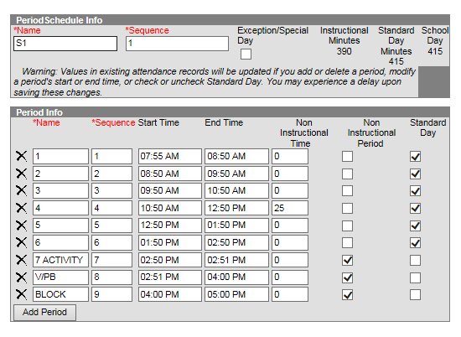

* + *Review Step***:** Ensure no time gap from period end to period start. Include passing time, lunch time and recess within periods.
* Partial Day Attendance Group

***Path: Ad Hoc Reporting > Filter Designer > State Published > Audit Partial Day***

This ad hoc can be used to identify students with a partial day attendance group.

* + *Review Step***:** Ensure that the setup is correct for partial day students.

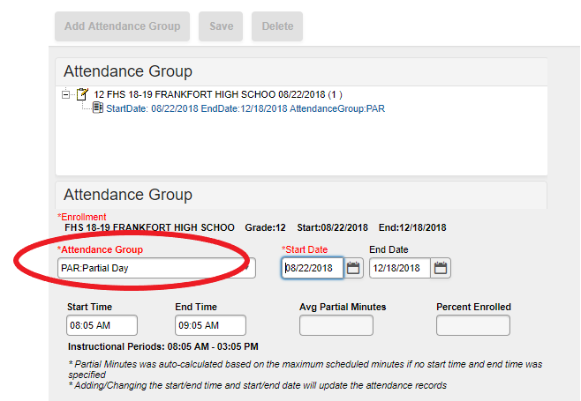

Verify start date, start time and end time match the student’s IEP (as applicable). Further information on partial day setup is available through the Attendance Group (KY).pdf document that can be downloaded from Campus Community with Infinite Campus (user ID and password required). You can also click on the hyperlink below for further details.

[Data Standards 201](https://education.ky.gov/districts/tech/sis/Documents/DataStandardAttendance.pdf)9

* **Missing Enrollment End Status Report**

***Path: KY State Reporting > Edit Reports > Missing Enrollment End Status Report***

This report identifies students who have an enrollment with an end date but no associated end status.

# 

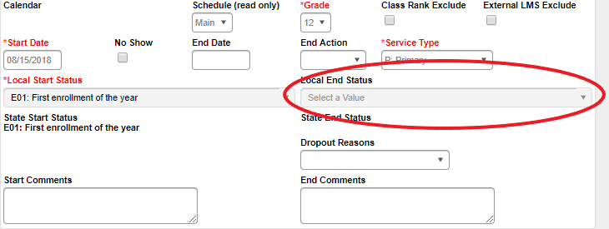

# Record 9 – Non-Contract and Over/Underage

## Non-Resident Non-Contract Students

***Path: Ad Hoc Reporting > Filter Designer > State Published > Audit Non-Resident Non-Contract***

Student Audit Non-Resident Non-Contract ad hoc identifies students who are non-residents and **do not** have a contract agreement.

Note: The ‘Resident District’ value should be maintained by the district to indicate the resident district of any student who does not reside in the district.

* + *Review Step:* Verify that these students reside outside your district and you do not have a contract with that district.

Below is the proper set up for a Non-Contract student

***Path:* *Student Information > General > Attendance Group Tab***

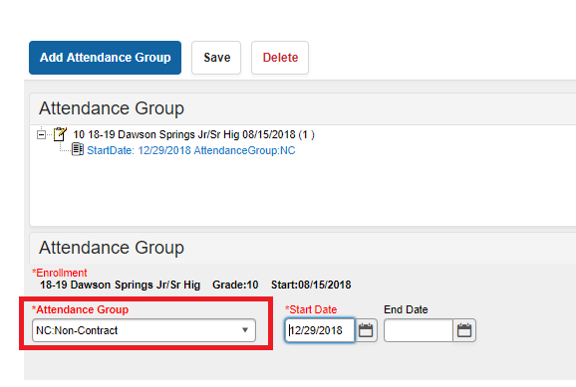

## Non-Resident Contract Students

***Path: Ad Hoc Reporting > Filter Designer > State Published > Audit Nonresident Contract***

The Student Audit Non-Resident Contract ad hoc identifies students who are non-resident and **do** have a contract agreement or are the child of a district employee.

* + *Review Step***:**  Verify that non-resident students have a contract on file.

Note**:** The ‘Resident District’ value should be maintained by the district to indicate the resident district of any student who does not reside in the district. If students on this ad hoc do not reside outside of your district, remove the resident district from their enrollment.

The path shown below is the proper set up for a contract student.

***Path: Student Information > General > Enrollments***

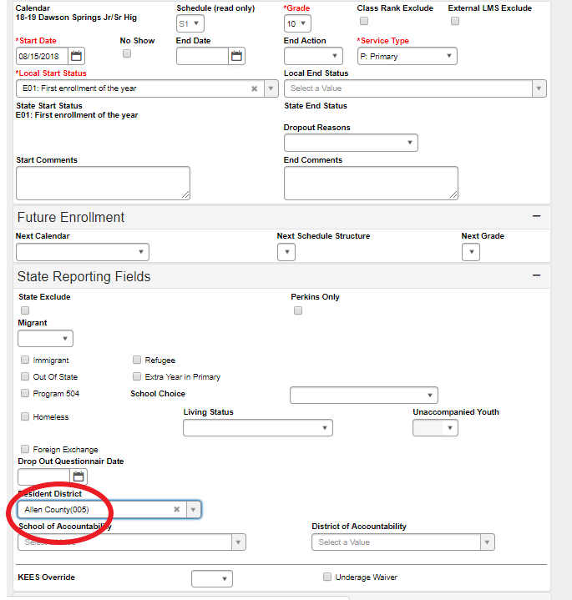

* Overage/Underage

***Path: KY State Reporting>Edit Reports>Overage/Underage Report***

This report identifies underage/overage students for further review. Check the list for accuracy of student DOB or that all students with a waiver are correctly identified.

* + *Review Step*: Run this report for “All Schools, All Calendars.”
* Overage students will not qualify for funding on the SAAR on or after their 21st birthday.
* Grade 14 may only be selected for Special Education Students participating in Alternate Assessment, as determined by the student’s Admissions and Release Committee and documented on his or her IEP. This student must turn 17 years of age on or before October 1st of current school year and must have progressed through a grade 12 assessments.
* State Grade Level 20: Post-Secondary should only be selected for those persons taking adult classes. Adult education students enrolled in this grade level should be marked state exclude and scheduled into a calendar marked Exclude
  + State Grade Level 20 should not be used for a student under 21 that has not receive their diploma.
* **Underage** – Under Age: There are two categories for Under Age students:
  1. A Grade 00 student is considered “Under Age” for the entire year if their 5th birthday occurs **after August 1st of the reporting year.**
  2. A Grade 01 student is considered “Under Age” for the entire year if their 6th birthday occurs **after August 1st of the reporting year.**

Note: An underage student will not receive funding for the entire year unless they qualify for a waiver and the waiver checkbox is marked on the enrollment tab. This is indicated on the waiver checkbox on the Enrollment tab under State Reporting Fields.

***Path: Student Information > General > Enrollments***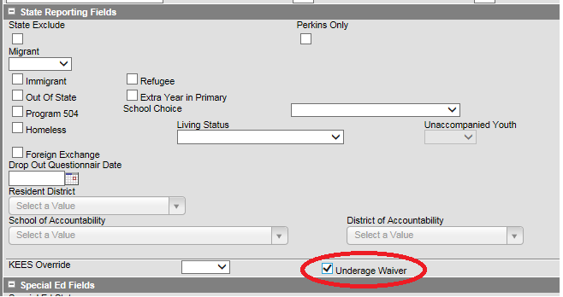

* **Expulsion Attendance Report**

***Path: KY State Reporting>Edit Reports>Expulsion Attendance Report***

This report identifies students who were expelled with state code SSP2 and have invalid data due to the attendance data not being entered properly to match the start date and/or end date/time for the behavior resolution.

* + The state Expulsion code SSP2 for *Expulsion Not Receiving Services* requires that a student have a standard attendance event for Absent / Unexcused that matches exactly the start and end date at the time of resolution.
  + If a student is expelled with or without services, and the event happened during the prior year, an exempt absent code must be used to receive funding. For example, the code, CEX – Carryover Expulsion Excused and CEU – Carryover Expulsion Unexcused (mapped to Status “Absent”, Excuse “Exempt”)
* **Suspension Attendance Linkage**
* ***Path: Behavior>Reports>Behavior Attendance Audit***

This report identifies those students who were suspended and have invalid data. The attendance data was not entered properly to match a behavior resolution, or the behavior resolution doesn’t match attendance data for a state coded suspension.

* + The state suspension code SSP3 – Out of School Suspension - requires the proper associated state attendance code of ‘S’ and the suspension must match the exact date and time of the resolution.
  + There is the possibility a user could input the Suspension attendance entry date without having the associated behavior resolution.

Note: Sometimes this report shows errors when days are shortened, but they are not actually errors.

* State Attendance Groups – Home and Hospital

***Path: Ad Hoc Reporting > Filter Designer > State Published > Audit Home Hospital***

This report identifies students in any of the attendance groups

*Review Step***:** Ensure the attendance is marked properly for the HH students.

Note**:** Use the IC Attendance Wizard to mark the student’s attendance as HH from the initial date of entry into the HH program until the end of the school year. (This prevents teachers from taking attendance for a student who is in the HH attendance group). When the student returns to school, remove the HH attendance code using the Attendance Wizard. The student’s HH attendance group record should be end dated upon the student’s return to the regular school program via the Attendance Group tab.

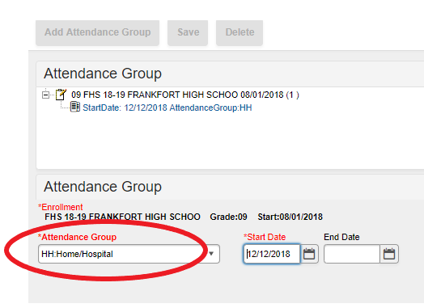

* Any student eligible for HH must be put in the HH attendance group to receive full funding through the SEEK.

Note: Districts with a separate HH only school (*i.e.,* 998, 999 schools) must enroll every student in the HH attendance group.

**Example Ad hoc report:**

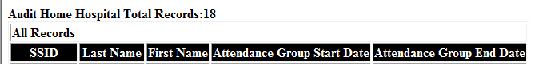

* Kindergarten **Code**

***Path: System Administration > Calendar > Calendar > Grade Levels***

* + Districts may have full or half-day Kindergarten classes or a combination of both. The state of Kentucky provides funding for 50% (half) of Kindergarten ADA even if a school district chooses full day of Kindergarten. This funding adjustment is made after submission of the SAAR to KDE. The appropriate Kindergarten code is selected from the Kindergarten Code dropdown menu:
    - BDK: Full and Half Day Kindergarten
    - FDK: Full Day Kindergarten
    - HDK: Half Day Kindergarten

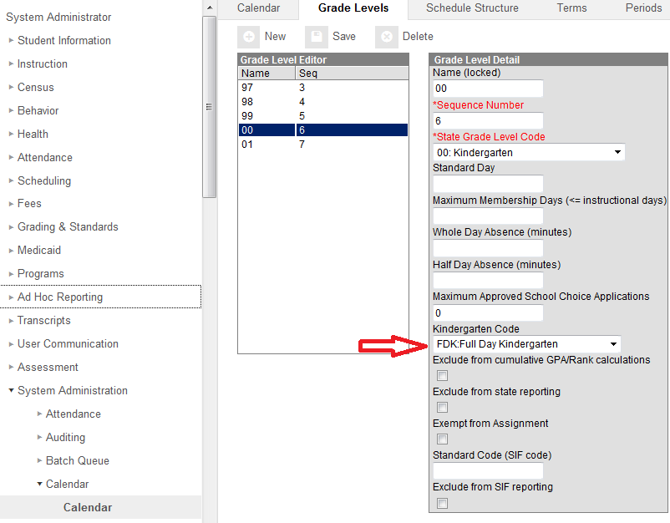

* Funding Gap Audit Report

***KY State Reporting > Funding Gap Audit***

* + This report is to how much seat time the student will earn and how much performance/virtual attendance credit they will earn if they pass.
  + The report is designed to look at a student’s schedule and display the percentage of attendance used to calculate funding for seat time attendance classes and virtual/performance-based classes. You should see approximately 96% total since lunch and passing time are not included.
  + This report is not designed to be “cleared”. It is an auditing tool to help identify potential issues with student schedules that could result in a loss of funding

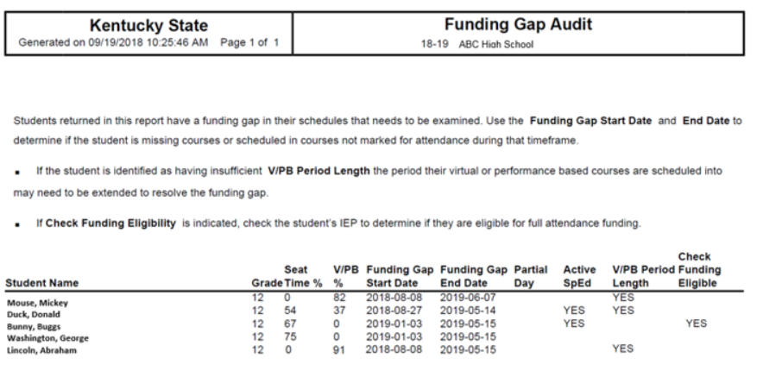

Note: You can run your ADA/ADM Report and your SAAR, Detail Record V and compare it to the Funding Gap Audit Report totals.  These reports will not be exact since the Funding Gap Audit report was not designed to give exact percentages, but should give an idea of attendance possibly earned for students taking performance/virtual based classes.

* **District Daily Attendance Report**

***Path: KY State Reporting > SAAR Report > District Daily Attendance***

The *District Daily Attendance Report* should be used to determine low attendance weather days.

A district can claim up to ten low weather days. Last year’s AADA will be used on the days chosen.

* + This report will show all of the days above last year’s AADA to help determine eligible days.
  + Follow the steps below to determine low weather days for your district.

Note: This is not mandatory. A district does not have to claim weather days.

**Begin the process by finding last year’s AADA. This can be found on the e-mail sent last year. Use the AADA without kindergarten adjustment. That is the number you will need for this report.**

**The example shown is from school year 2018-19. We must go back one year prior to find the previous year’s AADA.**

Previous Year AADA = **593.5**

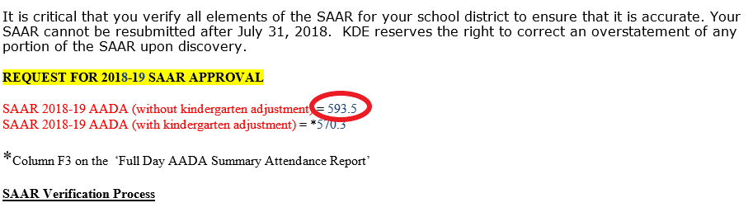

**District Daily Attendance Report**

* + Type in “Last Year’s Full SAAR ADA” found from last year’s e-mail
  + Click “Load 5 Low Att. Days” button which will automatically fill in the five low attendance days
  + Check “District Daily Attendance” box
  + Generate Report

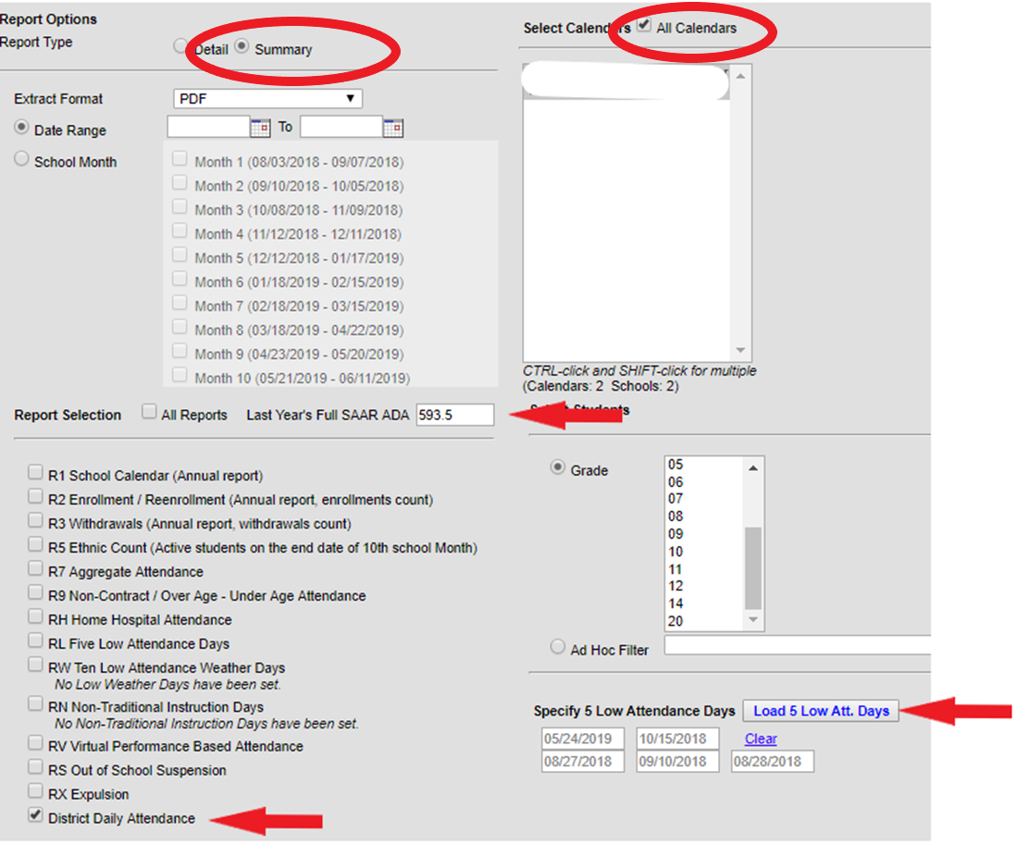

**District Daily Attendance Report**

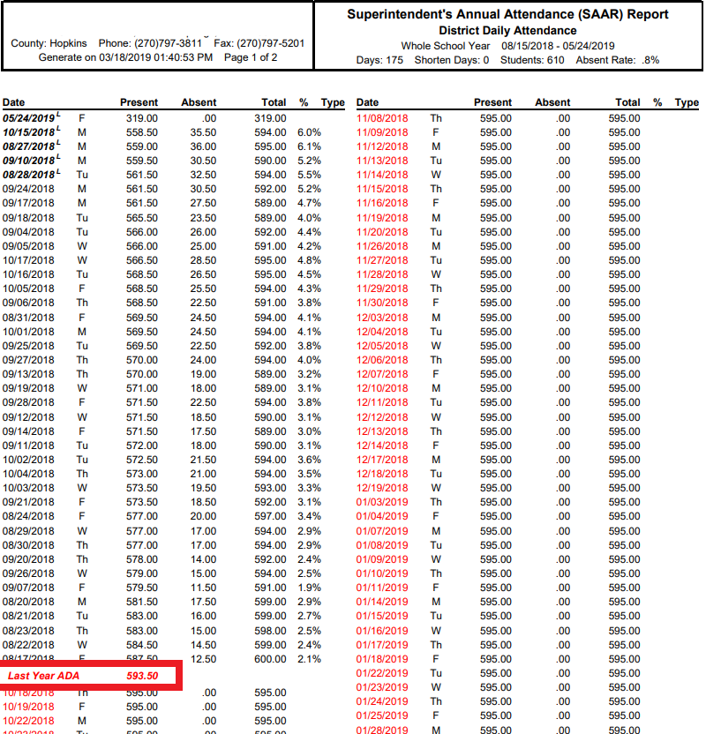

Once the report is generated, last year’s ADA is shown in red, and the days below last year’s AADA are above it in black. The report also shows the five automatic low attendance days that are automatically removed by putting a small ‘L’ out to the side.

After the five (5) lowest attendance days are automatically deducted, a district may request an adjustment for up to ten (10) additional days when district attendance was low due to weather-related conditions *if all schools were in session.*The district average daily attendance on these dates must be lower than the prior year “Full” average daily attendance ADA for the adjustment to be approved.

District Attendance – L Days (Low Weather)

***Path: System Administration > Calendar > Calendar > Days***

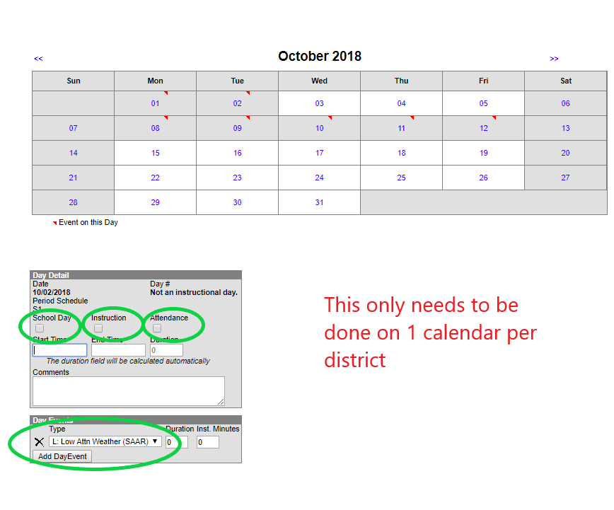

If the district’s request is approved, the aggregate attendance for each day is deducted and replaced with prior year average daily attendance (ADA), prior to calculating the district’s ADA. A district must keep documentation in the central office supporting the weather-related conditions that impacted attendance. See the example showing 1/12/16, 1/19/16, 2/8/16, 2/11/16, 3/18/16, 1/15/16, 3/1/16, 2/25/16, 2/16/16 and 1/21/16, as low weather days.

Once the changes have been made on the calendar, run the District Daily Attendance Report again and visibly see the weather days selected.

**District Daily Attendance Report**

This is what the Report will look like after you’ve selected your low weather days. When you run the report, there will be a ‘W’ next to the days that were chosen.

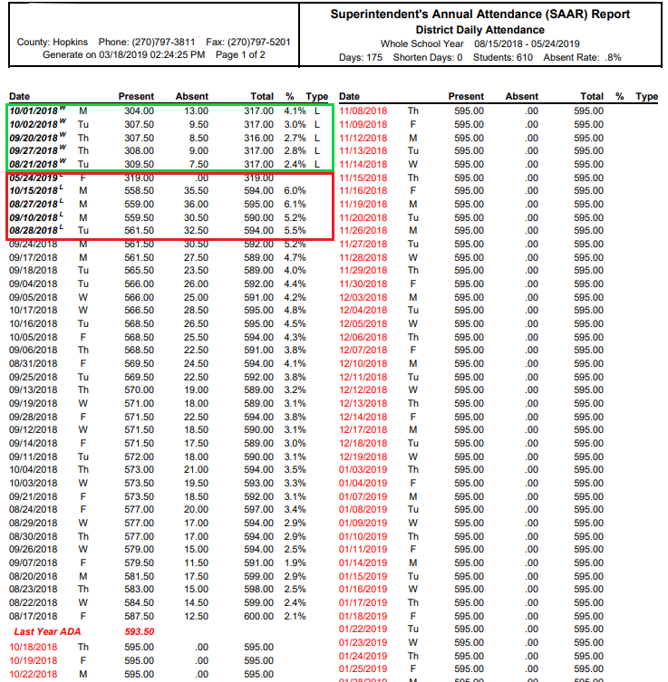

The weather days will appear on the SAAR Enrollment Report.

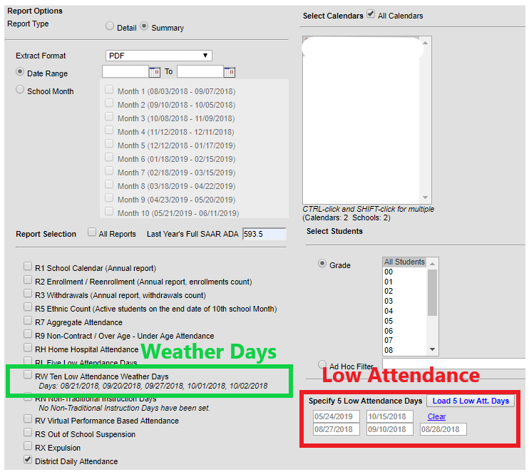

**Note:** The records below will not be available when the ‘state format fixed width’ (text file) is run. It will be populated on R7 under the column ‘Adjusted Aggregate Days.’ All are additions to the base.

***Record V*** = Virtual: Virtual Proficient Aggregate Attendance Days’ attendance for students who receive a proficient (pass) grade are populated on this record.

***Record S*** = Suspension: Eligible (10 day) Out of School Suspension Aggregate Absent Days (SSP3) attendance for students who have been suspended appear on this record (up to10 days per student).

***Record X*** = Expulsion: ‘District Eligible Expelled Aggregate Absent Days’ (SSP1 + SSP2) attendance for students who have been expelled appear on this record, up to 175 of eligible expulsion per student

* **Record N – Non Traditional Days (NTI)**

***Path>System Administration>Calendar>Calendar> Days***

Non-Traditional Instruction Days (NTI) can be used on a day when school facilities are closed due to a weather or health/safety related issue. A Non-Traditional yearly plan must be approved by KDE, prior to the new school year. NTI days are considered a school day with instruction.

House Bill 211 passed “Non-Traditional Days,” making all 173 Kentucky school districts eligible to apply. You can find more information about House Bill 211 and application information by clicking on the link: [Non Traditional Days](http://education.ky.gov/school/innov/Pages/Non-Traditional-Instruction.aspx)

**Note:** **No transportation is calculated for N Days.**

* **Starting new this year, don’t wait for the Commissioner to approve the NTI Day. Mark it as NTI from the start. If it is not approved, KDE will contact the district.**
  + *Review step*: Make sure you are approved for non-traditional days. Follow the path and select “Non-traditional Instruction” day. Check both the ‘School Day’ and ‘Instruction’ boxes. Choose ‘N’ for the event type.

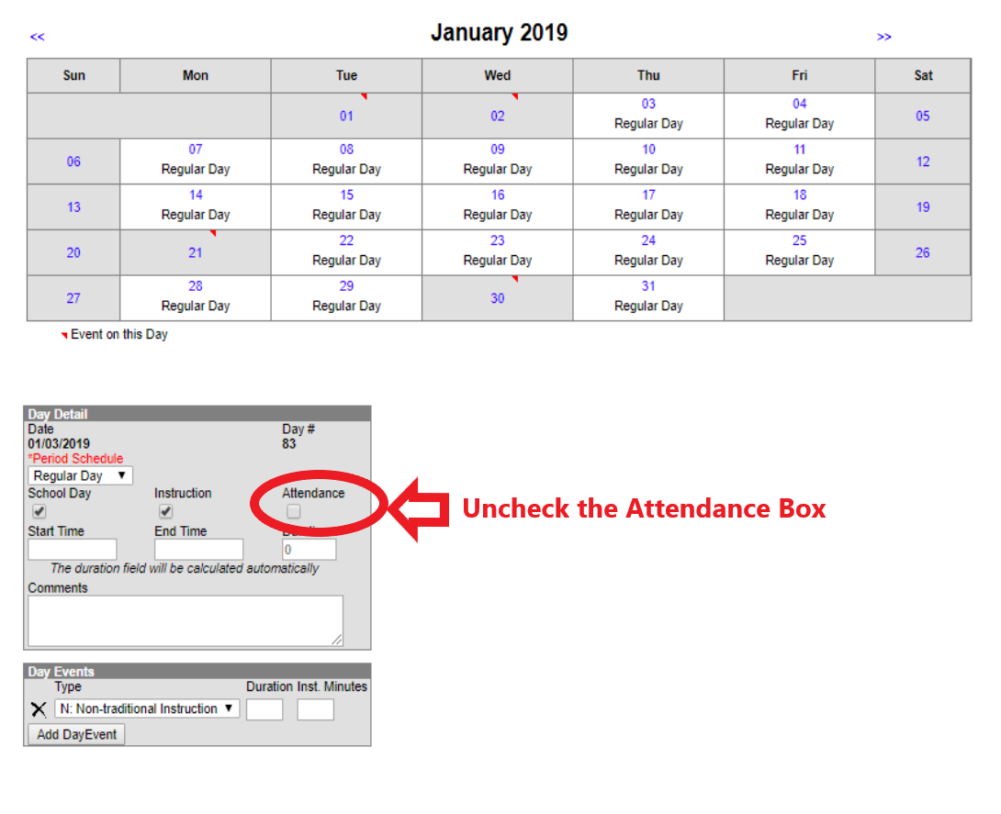

You will see the N Day on the SAAR Report.

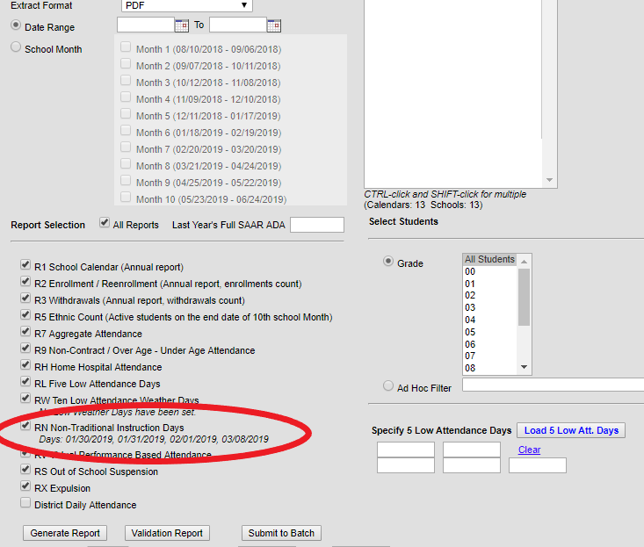

Prior to 2017-18, the attendance from Non-Traditional Days was included in Record 7. Record N showed the amount of attendance that was incorrectly saved in Infinite Campus. That was corrected this year so Record N now shows all zeros since there is no attendance on NTI Days.

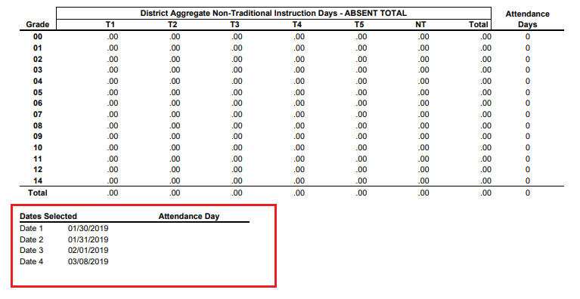

**Checklist**

Make sure you review your data to begin preparation for the SAAR. Use the following as a checklist to ensure all of these reports are corrected and complete:

* + 1. State Enrollment Overlap Report
    2. Ethnicity/Missing Enrollment End Status
    3. Kindergarten Full-Day/Half-Day Indicator
    4. ADA/ADM Report – Full Year
    5. Student Schedule Gap
    6. Overlapping T-Codes/Missing T-Codes
    7. Period Schedule Gaps
    8. Non-Resident/Non-Contract Students
    9. Overage/Underage
    10. Suspension/Expulsion
    11. Partial Day Students
    12. Home Hospital Students
    13. Funding Gap Audit Report

SAAR Workflow Chart

District Start   
On or before June 30th

Infinite Campus

District Extract SAAR PDF and Fixed Width File

District Uploads Fixed-Width File

Clean Data

Delete old files

District cleans data

Error Message on Web Appears

No

Yes

Notification

e-mail to KDE Mailbox

KDE Process SAAR

Clean Data

Delete old files

District cleans data

KDE Notifies District

No

KDE Send Back Reports to be Verified

KDE Send Back Reports to be Verified

KDE Process SAAR

KDE Send Back Reports to be Verified

KDE Process SAAR

KDE Process SAAR

Reports Correct?

Conference Call with KDE

Resolve Issue

KDE Send Back Reports to be Verified

KDE Send Back Reports to be Verified

Delete old files

District cleans data

No

KDE Send Back Reports to be Verified

Reports Correct?

District Verify data

Reports Correct?

Reports Correct?

KDE Send Back Completed Confirmation

KDE Process SAAR

KDE Process SAAR

KDE Send Back Completed Confirmation

Reports Correct?

KDE Process SAAR

This is the end of the SAAR Process.  A district must keep resubmitting the SAAR Report until all errors are resolved and data is clean

End

District Verify data

**SAAR IC PDF Calculation**

End

End

End

## Calculation of SAAR AADA from IC PDF Report

***Record 1*** = Calendar

***Record 2*** = Enrollment/Reenrollment

***Record 3*** = Withdrawals

***Record 5*** = Ethnic Count (R2 - R3 = R5)

***Record 7*** = Aggregate Attendance: ‘Base Aggregate Days Present’ Total Adjustment Aggregate Days Present’ Total = RV, RS, RX (additions to the base)

* RV= Proficient attendance for virtual or performance based courses
* RS= Eligible suspensions (a district may receive up to 10 days for a child who has been suspended)
* RX= Eligible expulsions up to 175 days

***Record 9*** = Noncontract Over/Under Attendance: ‘Non Contract Aggregate Days Present’ and Overage/Underage is the amount of attendance for a student who was either Non Contract or overage/underage that will be deducted from base (subtraction from the base).

***Record H*** = Home/Hospital: Already included in base attendance (R7). RH record comes to KDE for the Home and Hospital ADA calculation. This is funded separately.

***Record L*** = Five Low Attendance Days: ‘Aggregate Low Attendance Days Present Total’ (subtraction from base). Record L equals the aggregate days attendance for the five (5) lowest attendance days district-wide, when all schools are in session. This information reduces the total aggregate days of attendance and the number of days taught prior to the calculation of average daily attendance (ADA).

***Record W*** = Ten Low Weather Attendance Days: ‘Aggregate Low Weather Attendance Days Present’ (addition to the base). The SAAR report reflects Full AADA with no adjustment made for kindergarten. The aggregate day’s attendance for both kindergarten and P-12 for each of selected number of low weather attendance days will be replaced by last year’s kindergarten and P-12 AADA.

# Quality Review and Assurance

# Ethnicity Count

Record 2 minus Record 3 = Record 5

SAAR Record 2 (Enrollment + Reenrollment)

SAAR Record 3 (Withdrawals)

SAAR Record 5 (Ethnicity Count)

# *Formula: Entries + Re-entries – Withdrawals = Ethnicity Count*

Review step: Run Records 2 and 3 of SAAR (PDF, All Calendars, Leave Date Range Blank)

# Enrolled Days vs. Scheduled Days

There are several scenarios when students *enrolled* days do not match their *scheduled* days. These include:

1. Partial Day (Not fully funded)
2. Virtual or Performance Based (School districts with Virtual and Performance based students do not receive attendance credit until a final grade of ‘P’ or ‘Pass’ is entered.)
3. Early Release Days: scheduled minutes will be less than student day minutes.
4. Schedule Gaps
5. Students without a full schedule (e.g., fifth year senior)

Truancy

The ADA/ADM ‘Truancy mode’ should equal ‘Funding mode’ for students who have a full schedule. Students without a full schedule are funded for the part of the day that they are scheduled.

# PDF AADA Report

The Calculation of SAAR AADA is as follows:

(Base Aggregate Days Present (R7) + Adjustment Aggregate Days Present (R7) + (Last Year’s SAAR AADA * Sum of Weather Days and NTI days) – Low Attendance Weather (RW) NTI Days, Aggregate Low Attendance Days Present (RL), Aggregate Days Present (R9)) divided by Number of Days Taught minus 5

End

***R7 + R7 adjustment + AADA (W +N) –W–N-RL-R9***

***Instructional Days – 5***

# 

# SAAR Detail Reports

Several SAAR reports have detail reports that provide additional information. The reports use the same selection criteria, attendance calculation, and business logic as the primary records, but provide additional information at the student level to aid in troubleshooting and analysis. The detail reports provide school-level listings of individual students who appear on the corresponding SAAR records.

Detail reports can be run by selecting the “Detail” option in the extract editor for any of the following records: RV, RS, RX, R9 and RH. (For detail-level information on R7, refer to the ADA/ADM Detail report.)

Detail reports respond in the same manner as their primary records of SAAR for all extract editor features: ad hoc, grade, calendar select, school month selection, and date range.

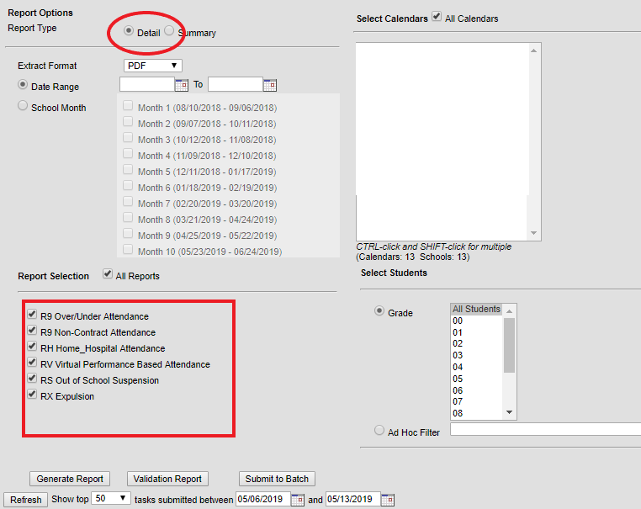

R9 Overage/Underage Detail

Students appear on the R9 detail report when they meet the criteria for the Over Age/Under Age sections of Record 9 (Non-Contract Over/Under Attendance).

R9 Non contract Detail

Students appear on the R9 Non Contract detail report when they meet the criteria for the Non Contract sections of Record 9 (Non-Contract Over/Under Attendance).

RH Detail

Students appear on the RH detail report when they meet the criteria for Record H (Home-Hospital Attendance). The detail report provides a student-level summary of attendance data using the same criteria and calculation as the primary record, Record H.

RV Detail

Students appear on the RV Detail report when they meet the criteria for Record V (Virtual/Performance). The detail report provides a list of students who are proficient.

RS Detail

Students appear on the RS Detail report when they meet the criteria for Record S (Suspension Aggregate Attendance). The detail report provides a student-level summary of attendance data using the same criteria and calculation as the primary record, Record S.

RX Detail

Students appear on the RX Detail report when they meet the criteria for Record X (Expulsion Aggregate Attendance). The detail report provides a student-level summary of attendance data using the same criteria and calculation as the primary record, Record X.

**Creating the SAAR State Format Fixed Width**

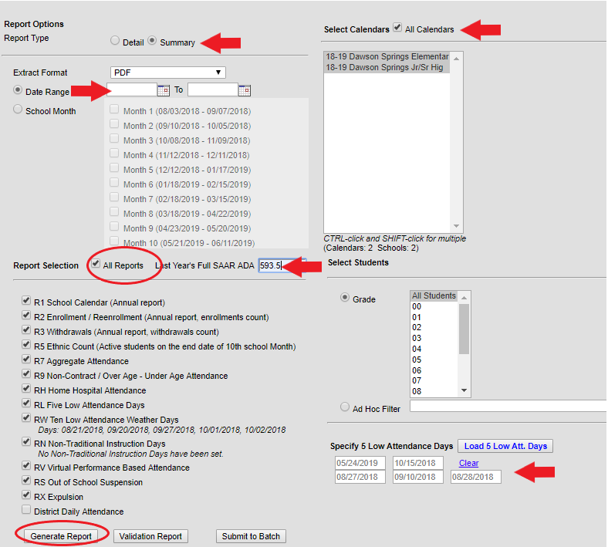

Steps:

1. Extract Format should be set to State Format (Fixed width)
2. Select Date Range and leave the date range blank
3. Report Selection should be marked as All Reports
4. Enter in last year’s Full SAAR AADA (relative for low attendance weather days)
5. Select Calendars should be marked as All Calendars
6. “Last Year’s SAAR ADA” should be entered a last year’s FULL AADA.
7. Generate Report
8. File name should be saved as SAARXXX.YY (XXX = District Number, YY= School Year) Example: SAAR011.18
9. Submit file to KDE.

The same process as listed above should also be completed to generate the SAAR PDF for verification purposes. The SAAR PDF should be generated immediately following the SAAR State Format report. If the SAAR PDF is completed at a later time, the information on the two reports may not match. Select the *Extract Format as PDF* with no other changes and generate the reports. Save these reports in the event they are needed for comparison purposes.

# Submission of the SAAR to KDE

## *Electronic Submission Process*

Each district’s SAAR State Format file is submitted via a Website link on the KDE Web site at:

[Submit SAAR here](http://opsupport.education.ky.gov/saar/)

Steps:

1. The file is submitted and goes through the error check process.
2. Any errors found are listed on the page (See Appendix B).
3. Errors must be corrected before the submission process is complete. (School district personnel may consult with the KDE SAAR contact person for questions regarding errors.)
4. Once errors are corrected the submission process is completed via the KDE Web site.
5. Once the SAAR file is submitted the following steps occur:
   * The KDE Attendance Mailbox receives a notification via email.
   * The school district submitting the file receives a confirmation via email.
   * The .txt file is loaded into KDEADA application.

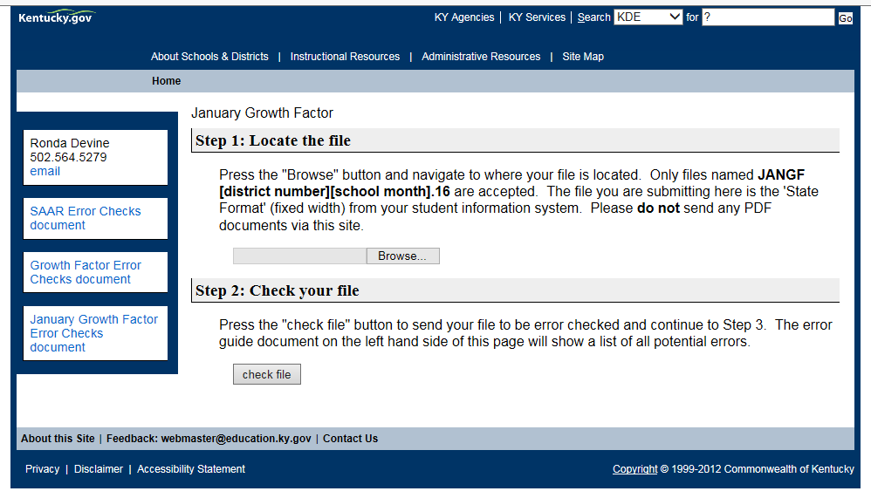

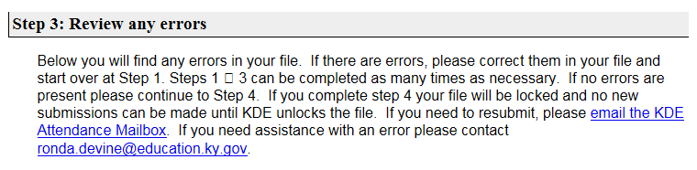

Error Message Example:

This is an example of an error message

A SAAR Error Check document is available from the KDE SAAR file submission.

[Error Checks Document](http://opsupport.education.ky.gov/saar/)

Common errors for file submission are listed and districts may review this document prior to submitting their file.

# Appendix A

**SAAR Report Submission Error Guide**

**Kentucky Department of Education**

**Office of District Support Services**

**Superintendent’s Annual Attendance Report Submission Error Guide**

**Record 1 Error codes:**

("Calendar holidays greater than 4")

("Calendar disaster days greater than 0") – Use of disaster days must be approved.

("Calendar total days less than 185")

(“Sum of calendar days not equal to total days")

**Record 2 Error codes:**

("Entries + Re-entries - Withdrawals not equal to total of

Males and Females in Record 5)

**Record 3 Error codes:**

("W17 count that is not Grade EL (00) “)

**Record 5 Error codes:**

(“Entries + Re-entries – Withdrawals not equal to total of Ethnic membership in Record 5. Please validate All”)

**Record 7 Error codes:**

("No matching Record 2 (enrollment) for this Record 7 (attendance/absence)")

("No matching Record 1 (calendar) for this Record 7 (attendance/absence)")

(“Students were enrolled in the grade level but all enrollments were end dated before the end of the year”)

(“Days taught entered without attendance”)

**Record 9 Error codes:**

("Non-contract student count entered without attendance")

("Non-contract attendance entered without student count")

("Over/underage student count entered without attendance")

("Over/underage attendance entered without student count")

**Record L Error codes:**

("Number of low attendance days not equal to 5")

**Record W Error codes:**

("Number of weather related low days greater than 10")

**Record H Error codes:**

(“Home Hospital attendance entered without student count”)

Common Error Messages

Once the error check is done, there are a few common error messages that may appear.

Note: They are not always an error, but a warning.

* **Record 5 Error Message**

**Record 5 – (Entries + Re-entries – Withdrawals not equal to total of Ethnic membership in Record 5. Please validate all)**

**Three different reasons can cause this Record 5 error.**

1. **Invalid ethnicities** – The state ethnicity code does not match the federal ethnicity code. In some cases, the system does not automatically change to the current code.

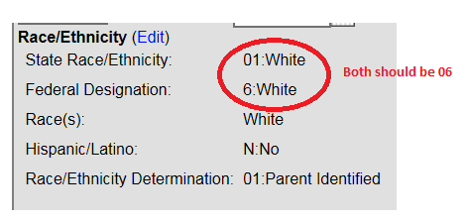

To resolve this, the student’s ethnicity must be corrected by finding the student, changing their ethnicity, saving it, then changing it back to the correct ethnicity. Sometimes, this will sync the two codes and correct the problem.

Search for the student with an ad hoc

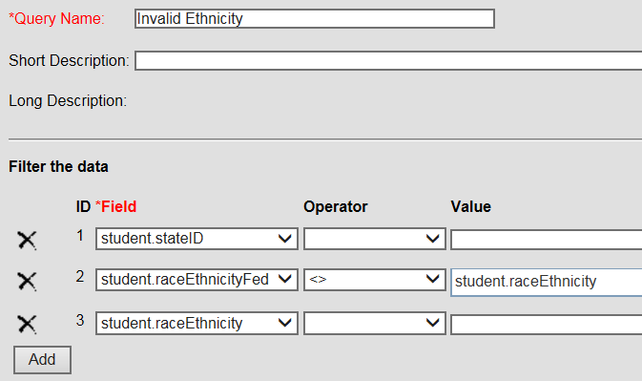

Find the student then follow the path:

***Census> People > Demographics***

Click ‘Edit’

Change their race to something else and ‘Save’

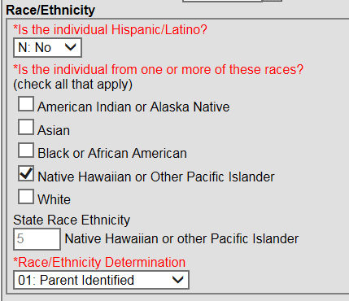

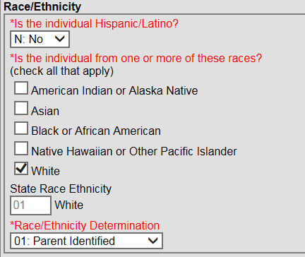Change it back to the correct ethnicity and ‘Save’

This should fix the problem.

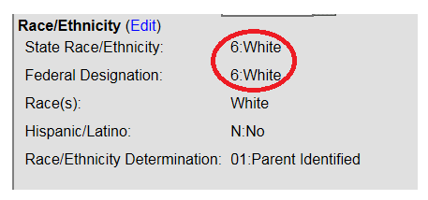

* If it does not fix the problem, then you will have to put in a ticket with IC.

1. **Missing or an invalid CO1 end status**

CO1 is invalid if it is used any date other than the last day of school.

In the example, the error message tells the school number where the error exists, and the student grade.

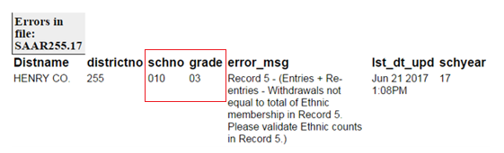

Follow with an ad hoc in the school where the error is occurring.

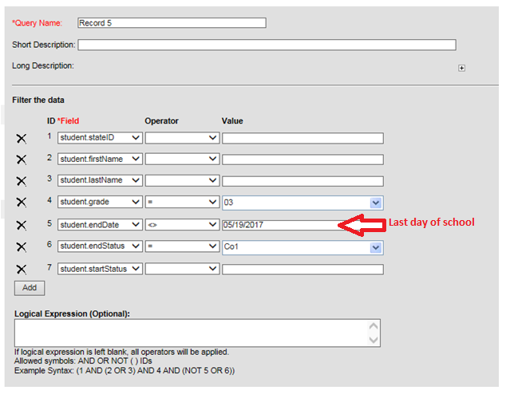

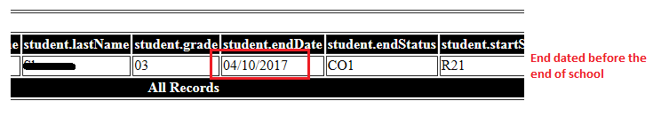

* Change the C01 status to the appropriate code.

**End Status Missing for Many Students**

In this example, there are end statuses missing from many students across different grades and schools.

***Adhoc > Pass-through SQL Query > Student***

Type in what you see in the first box and again for the second box. Click ‘Test Query.’

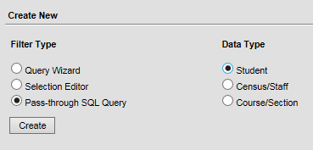

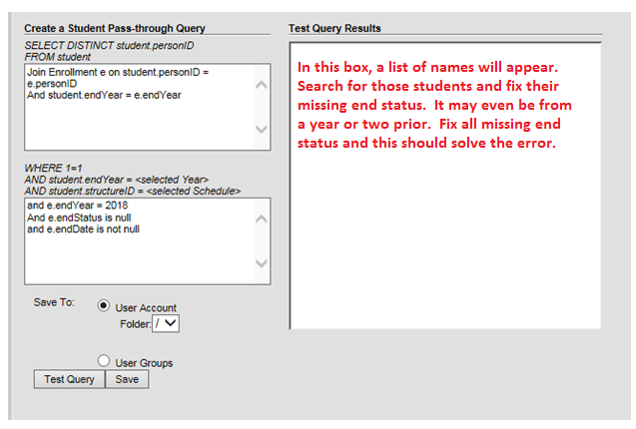

* Use the ad hoc as a search and enter appropriate end statuses.

You can also use the ad hoc below to find students if you still cannot locate the error. You can choose the grade and find the school where the student is missing. The example is looking for a first grader.

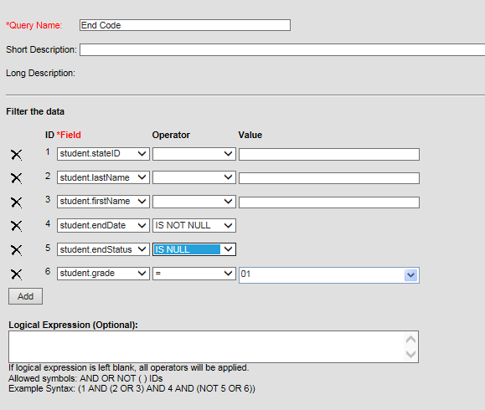

1. **‘No Show’ must be checked**

If the start status is an ‘NS No Show,’ be sure and put the proper end status.

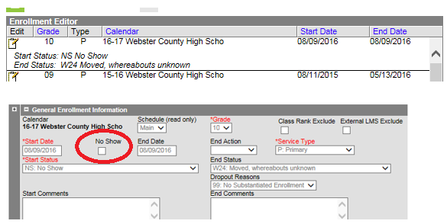

* **Record 7 Error Message**

**No matching Record 5 (Membership for this Record 7 attendance/absence**

Students were enrolled in the grade level but all enrollments were end dated before the end of the year.

The error may be caused due to a student/students were enrolled part of the year, but not there at the end of the year. This could be a student/students that went to a day treatment or alternative school then wasn’t there at the end of the year. However, it would be an error if an incorrect end date caused all students to be accidentally end dated prior to the end of the year.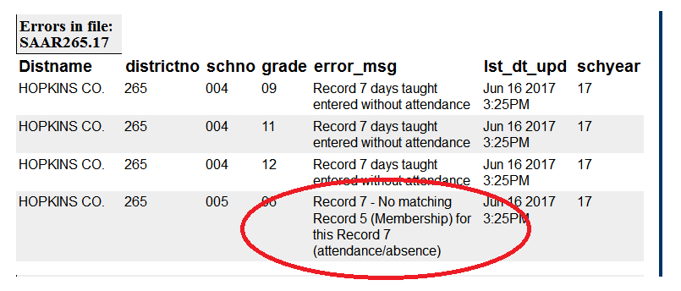

**Record 7 Error Message**

**Days taught entered without attendance**

A Record 7 error message may be a warning. If this error message appears and all students in the grade for the error who are in Virtual/Performance Based Classes, the gap in their schedule will cause this to appear.

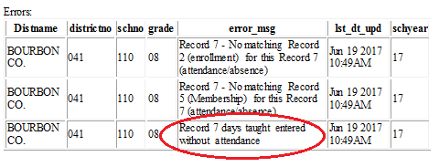

**Record 7 Error Message**

**No matching record 2 (enrollment) for this Record 7 (attendance/absence)**

In the example below, this Record 7 error is not as common but may be caused if there was a no show enrollment. It could be the start status is incorrect or the now show does not have the proper end date and/or the checkbox is not checked.

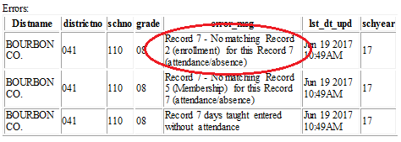

**Record 7 Error Message**

**EC Student**

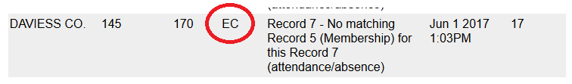In the example below, this Record 7 error was caused by an EC student. An EC student is a Grade 14. You might find an EC student with this error who came to school, finished his classes before the end of the year, and left. If they aged out within that time frame, you would see a Record 9 error as well.

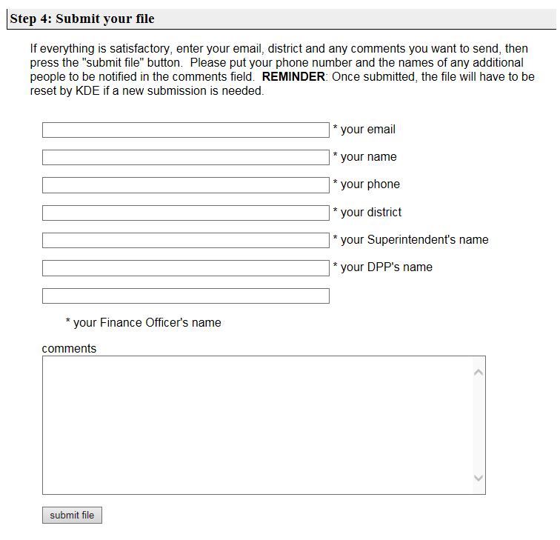

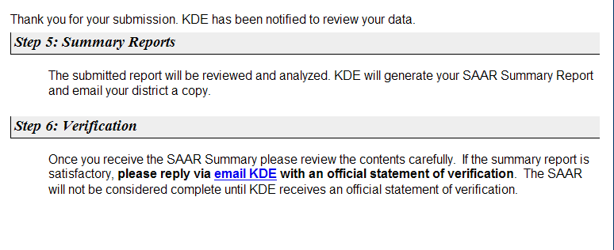

## **Note: Please enter all names as they appear in the Global mail listing**

## Error Guide

## Internet Explorer (IE) Settings

If your file will not download in Internet Explorer (*i.e.,* IE sits and spins) then check your settings for file downloads using the following steps:

1. Go to Tools/Internet Options

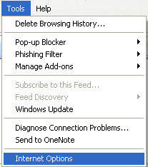

1. Select Security and then click on Custom Level

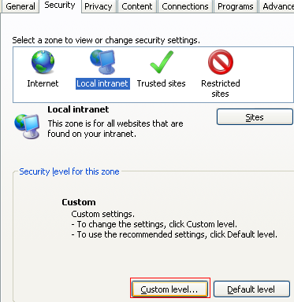

1. Scroll down to Downloads. The ‘Automatic prompting for file downloads’ must be set to ‘Enable’

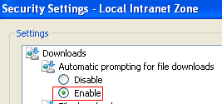

# 

**KDE Contact Information**

**KDE is available for questions during the SAAR submission process. Please contact Brad Kennedy at 502-564-5279, Extension 4417 or via email at brad.kennedy**[**@education.ky.gov**](mailto:ronda.devine@education.ky.gov) **for information and assistance.**