ESSER Real Property Status Report Instructions

Access the site via the URL ESSER Real Property Status Reports . This link can be found on the KDE webpage or in the left navigation pane in FACPAC.

Uploading a document
- Select Upload. A pop-up window will appear to add a document.
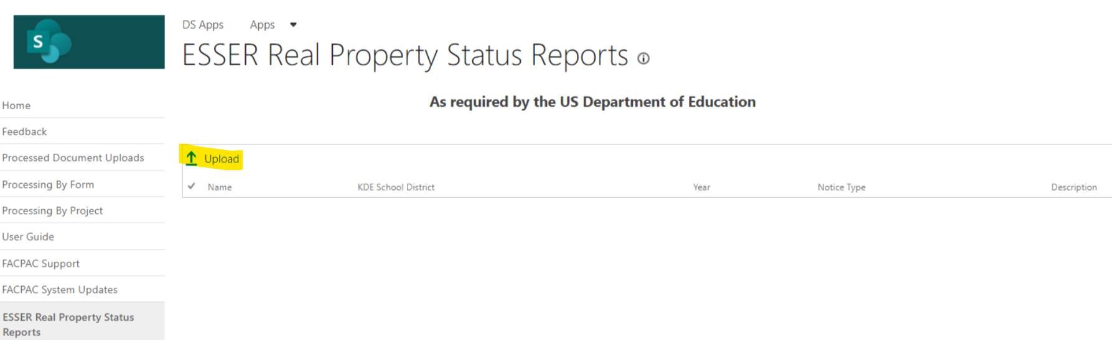
- Select Choose a file. This will allow you to search your computer for the file you would like to upload. Locate the correct file and select OK.
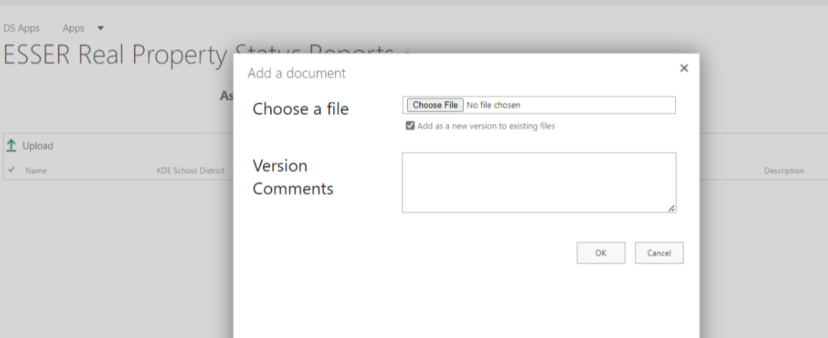

*Under the file name is a checked box indicating you are adding a new version to existing files. Do not uncheck the box. Versioning is determined by the file name. If you upload a file with the same name as a file that has already been uploaded, it will create a new version of the file. Naming standards for files are very important and you should ensure that the file name is unique. If you are trying to create a new version of an existing file, upload a file with the same name as a file that already exist. If you are creating a new version, you should enter comments in the version comments field that indicate the difference between the first version and the second and what is being updated.

**The file has been uploaded successfully but information about the file will need to be completed on the pop up window.

- A pop-up window will appear to enter the data about the file you are uploading. This information helps with search and retrieval of files, as well as reporting.
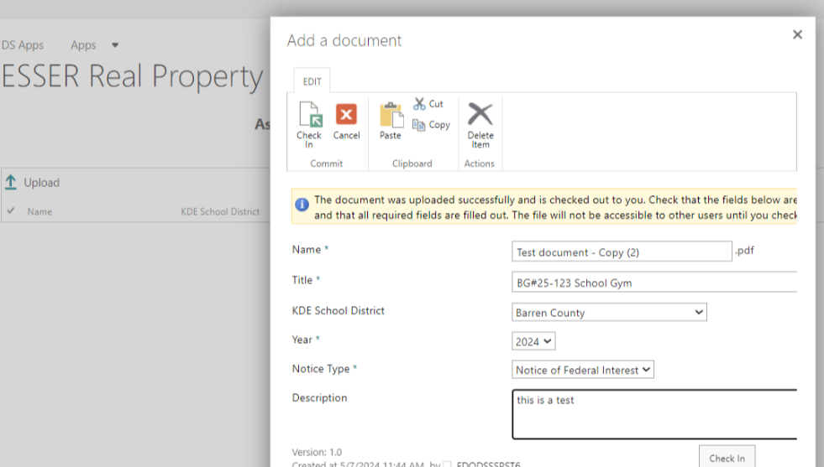

- Name
This is already prepopulated during the upload process and will always have a file extension
- Title
The title should be meaningful to the project. Examples: Franklin County High School Roof, Elkhorn Middle School HVAC. If there is a corresponding construction project (BG#), it may be helpful to use the name of the project for this upload.
- KDE School District
Choose your school district from the dropdown list.
- Year
Select the year of the upload.
- Notice Type
This document repository is used to store the following forms:
SF429
SF429-A
SF429-C
Notice of Federal Interest
- Description
Use this field to enter any pertinent information to the form. Optional.

- Select Check In.
- The uploaded document will appear in your library.
