Uploading the District Funding Assurances Statement

- The Superintendent must be logged into GMAP (not the superintendent designee). The upload is tracked by date and time and by author. If the author is not the Superintendent, then the assurance will not be official.
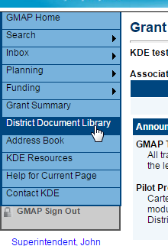
- Select District Document Library in the upper left Main Menu.
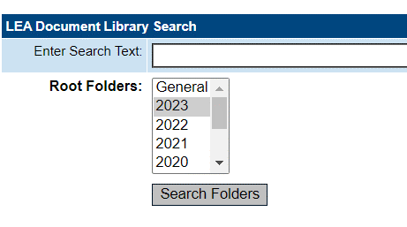
- Click on 2023 for the 2022-2023 school year and click on
Search Folders

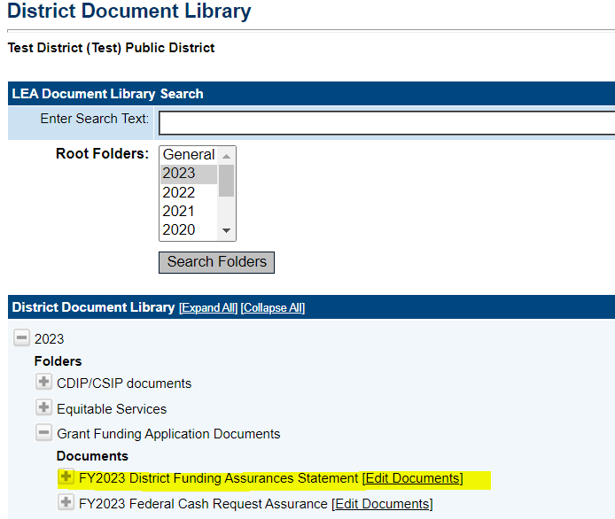
- Open the 2023 folder and click on “Grant Funding Application Documents” and locate the “FY2023 District Funding Assurances Statement” and click
Edit Documents.

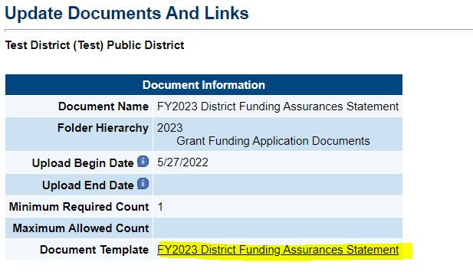
- Click on the Document Template “FY2023 District Funding Assurances Statement”

- Click on the download in the bottom left corner
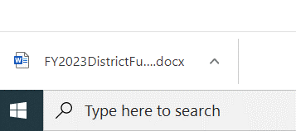
of the screen.
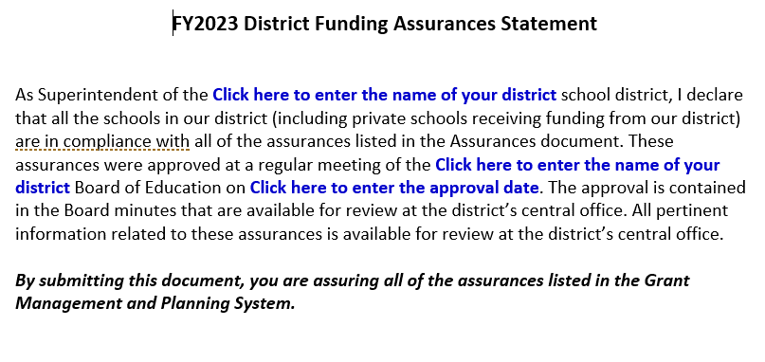
- Enter the necessary information in the blue areas of text.
- Save and name the document to a folder from your computer. Close Microsoft Word.
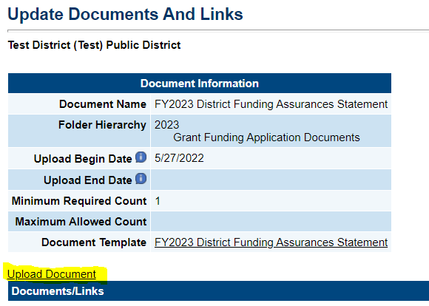
- Return to GMAP and click on Upload Document.

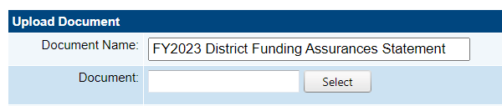
- Click on Select and locate the document created from the template. Enter a Document Name and click Save.

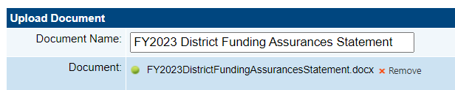

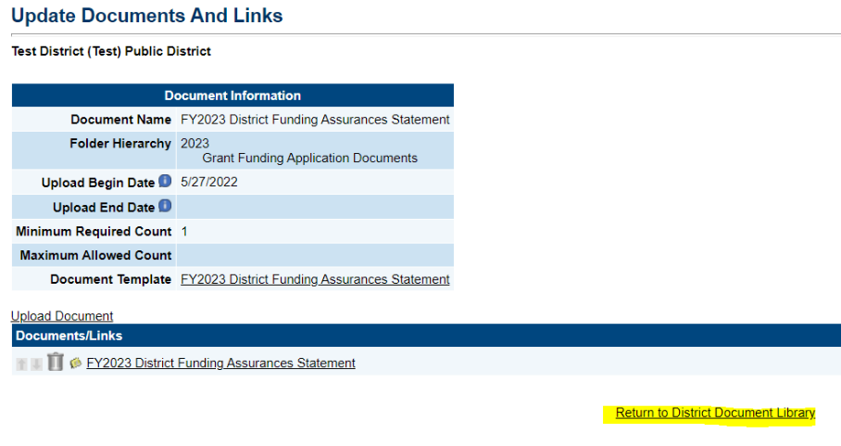
- To verify a successful upload, go to the District Document Library. Click Return to District Document Library.

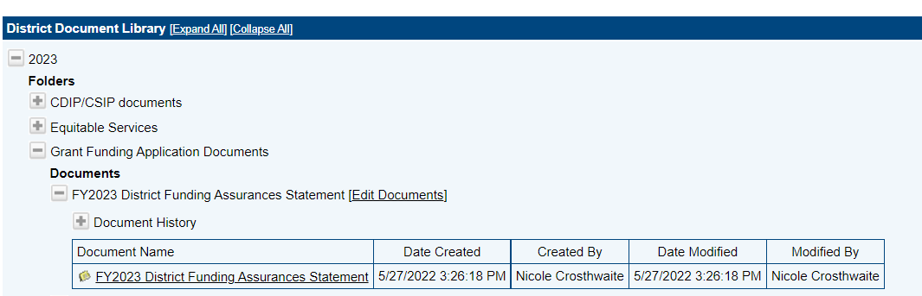
- Click on FY2023 District Funding Assurances Statement. Under Document History, you will see the uploaded file along with the date and time stamp.

Must be Superintendent’s name (not designee)

