Inspection Report Instructions
The monthly inspection reports for School Buses, Board-Owned Vehicles (BOV) and Privately-Owned Vehicles (POV) were revised in 2022. KDE has incorporated feedback from school districts. The documents use a fillable PDF format for those who use online record keeping. However, if you prefer to print it out, you can still do so. Please follow the instructions listed below. The KDE format for the BOV and POV reports are not required. However, there must be some type of documentation for these vehicles showing they have been inspected.
NOTE: You MUST have Adobe Reader Version 11 or newer to properly view the Inspection Reports. If you need an updated version of Adobe, please contact your school district’s WebApps Admin Point of Contact (WAAPOC).

HOW TO PRINT INSPECTION REPORTS
- Go to KDE’s Pupil Transportation Inspector SharePoint webpage
- Under Technician Corner, select the Inspection Reports folder.
- Select the School Bus and Vehicle Inspection Reports folder.
- Select the inspection report you wish to view.
- Once the inspection report is opened, click the Print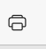button on your browser. (The look of the print icon may vary based on your web browser).

HOW TO COMPLETE THE INSPECTION REPORTS ONLINE VIA FILLABLE FORM
- Go to KDE’s Pupil Transportation Inspector SharePoint webpage
- Under Technician Corner, select the Inspection Reports folder.
- Select the School Bus and Vehicle Inspection Reports folder.
- Select the inspection report you wish to view.
- Once the inspection report is opened, click the Save 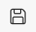 button on your browser. (The look of the print icon may vary based on your web browser).
- Select where on your computer you would like to save the file and rename your file and click Save.
- Go to the location of where you saved your file, right-click and click Open.
NOTE: You should be able to properly complete the fillable inspection report. Below is an example of what a BOV inspection report should look like. Notice how the drop-boxes have a red box around them. That means you are required to select one of the drop-down box selections. If you do not see the red box around the drop-down box, please contact Carl Meehan or Mikala Ferguson via email or telephone. You can view their contact information below.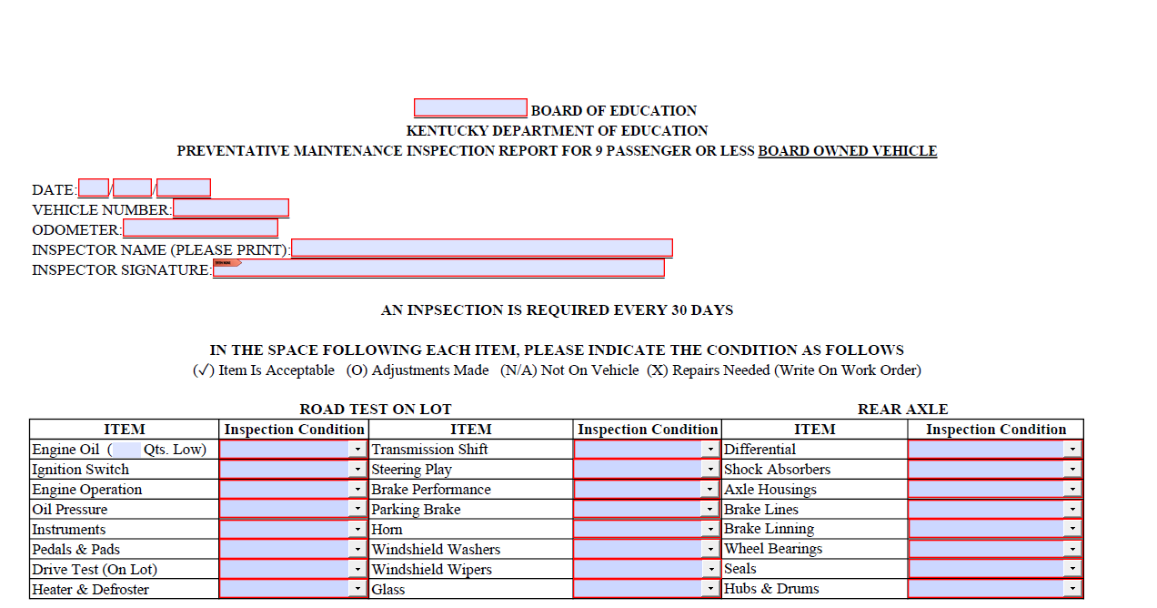
NOTE: Below is an example of what the drop-down box selections are. If you do not see a checkmark listed on your report,please contact Mikala Ferguson or Carl Meehan at the email or telephone number listed below.
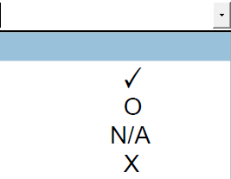

If you have any questions, please email Carl Meehan or call Carl at (502)-564-5279 Ext. 4442 or email Mikala Ferguson or call Mikala at (502) 564-5279 Ext. 4451.

