February 2, 2018

Dear Superintendents and Principals,

In the 2015-16 school year, the United States Department of Education (USED) announced the elimination of the Advanced Placement (AP) Test Fee Grant Program, which provided funding for low-income students to take AP exams at a reduced rate. When the AP Test Fee Grant program ended in 2016, the per exam cost was $93. In recent years, the federal grant paid $38, the College Board provided a $31 fee reduction, and a $9 per exam rebate for low-income students was discounted. This left a balance of $15 per exam, which local districts had to cover.

According to 702 KAR 3:220, Guidelines for Waiver of School Fees, Section 1, schools and districts are required to establish a process to waive any applicable fees charged by the district for pupils who qualify for free or reduced-price meals (F/R).

Last school year, the Kentucky Department of Education (KDE) was able to designate funds to cover all the fees for low-income students, making AP exams free for these students with no outstanding costs passed along to the schools and districts. As a result, the number of AP exams taken by low-income students increased by 13.9% over the previous year. The number of these exams with a qualifying score (QS) of three or more points (the score that typically qualifies students to receive college credit for AP coursework) also increased by 13.9%. KDE recognizes that when given the opportunity and access to take rigorous coursework like AP, Kentucky’s low-income students are finding unprecedented success.

I am delighted to announce that for the 2017-18 school year only, once again KDE has been able to set aside funds to pay for AP exams taken by students who qualify for F/R meals. In other words, the remaining balance of $53 will not be paid by the student, school or district. This amount will be paid by KDE in the hope that schools will continue to provide Kentucky’s low-income students with the opportunity to take rigorous AP courses that prepare them to excel in their future college and career choices.

Here is a breakdown of the 2017-18 AP Exam fee schedule for students who are eligible for free/reduced-priced meals:

Information related to AP exam fees for future years is not available at this time.

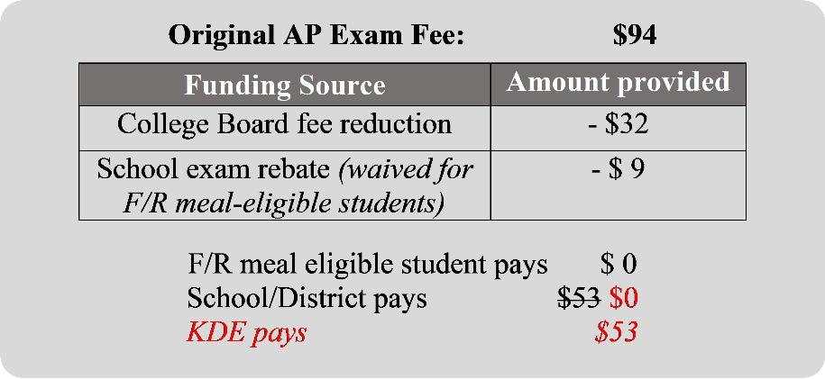
If you have additional questions, please contact Jennifer Pusateri, AP State Coordinator, by email at jennifer.pusateri@education.ky.gov or by phone at 502-564-4970 x.4116.

Sincerely,

Stephen L. Pruitt, Ph.D.
Commissioner of Education

