June 13, 2024

Adam Schott
Deputy Assistant Secretary
Office of Elementary and Secondary Education
U.S. Department of Education
400 Maryland Avenue, SW
Washington, DC 20202

Dear Deputy Assistant Secretary Schott:

The Kentucky Department of Education (KDE) is requesting a waiver pursuant to section 8401 of the ESEA of 1965. The KDE is seeking a Tydings Wavier for the following programs:
- ARP EANS
- ARP ESSER
- Title II Part A of the ESEA

This waiver will allow the KDE to ensure that the selected programs are allowed to continue to advance student academic achievement by allowing the KDE to use funds reserved for administration to address ongoing administrative costs and avoid diverting funds away from critical services for LEAs, schools, students, teachers, and other educational staff.

Schools will continue to provide assistance to the same populations served by the programs included in the waiver by allowing the KDE to continue to focus its resources on meeting student’ academic and other needs, including groups of students most impacted by the pandemic.

The KDE assures that it will use consolidated administrative funds under the respective programs in accordance with the provision of all applicable statues, regulations, program plans, and applications not subject to these waivers and has provided the public and all LEAs in the state with notice of, and the opportunity to comment on, this request by posting information regarding the waiver request and the process for commenting on the KDE’s website in a manner in which the KDE customarily provides such notice and opportunity to comment.

If you have questions about this request, please feel free to contact me at kelly.foster@education.ky.gov. Thank you for your attention to this matter.

Sincerely,
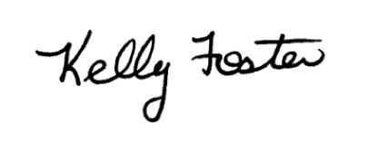
Kelly Foster, Ed.D.
Associate Commissioner
Office of Continuous Improvement and Support

