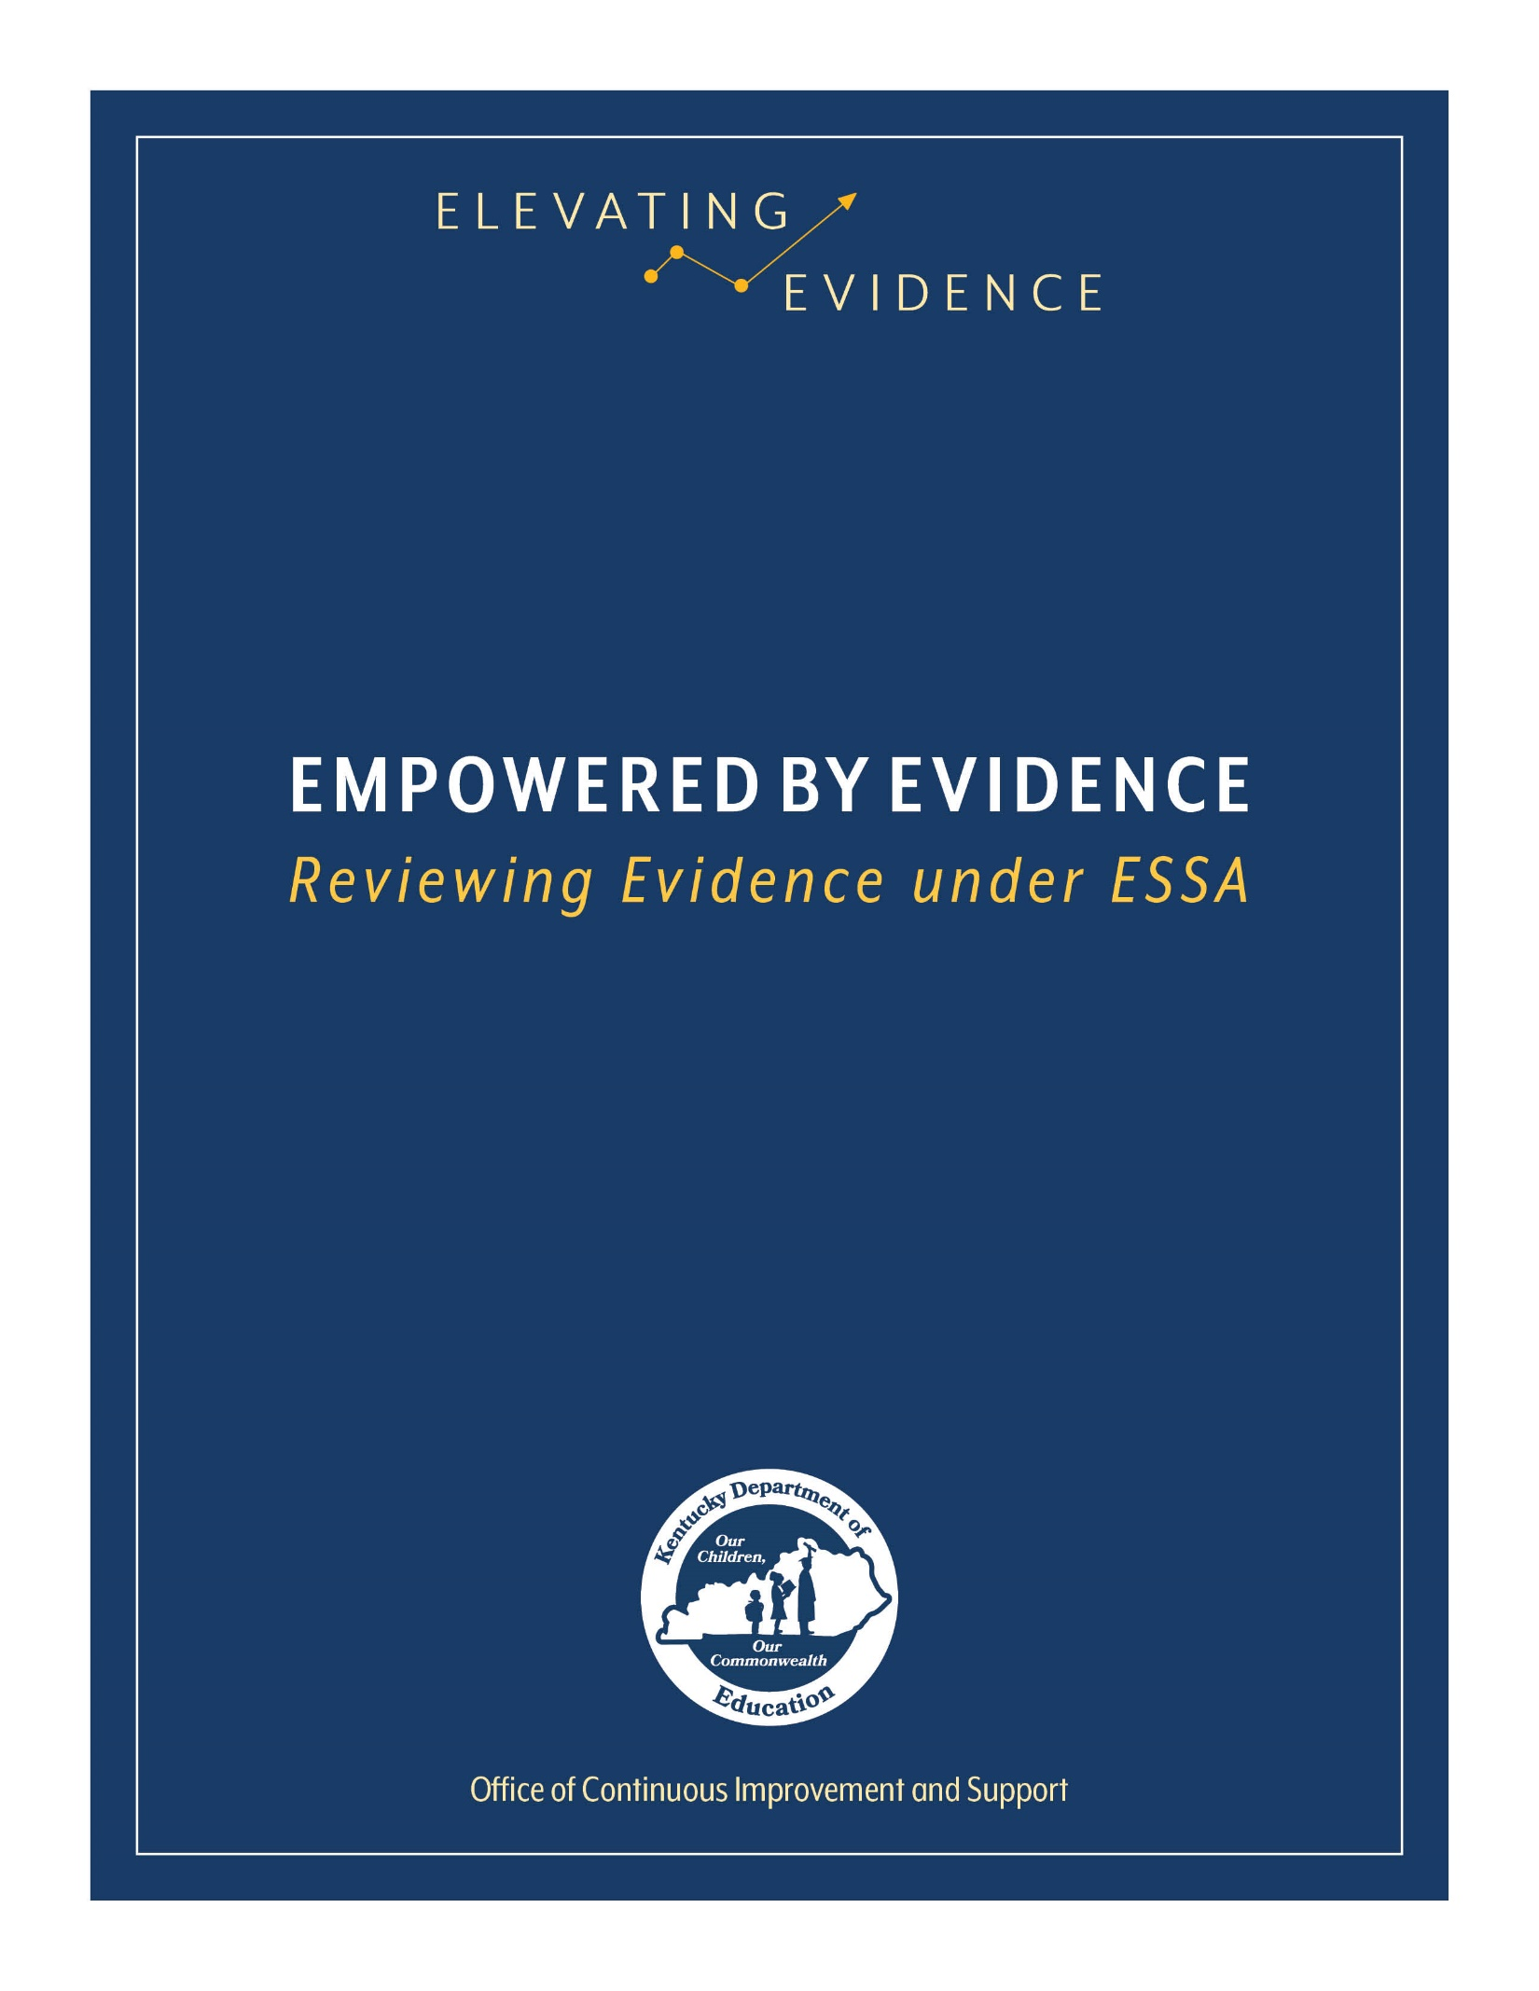

Introduction

In 2015, the U.S. Congress reauthorized the Elementary and Secondary Education Act through a bill known as the Every Student Succeeds Act (ESSA). One of the requirements of ESSA is that school improvement initiatives be rooted in “evidence-based activities, strategies, or interventions.” While many clearinghouses and databases exist to assist schools in identifying and selecting appropriate evidence-based practices, it is important that education leaders and shareholders have the skills necessary to evaluate evidence on their own allowing for more informed decisions. This instrument provides a framework to guide education leaders and shareholders through the process of evaluating evidence.
While completing this instrument, consider the following:
- Examples are provided throughout the instrument; however, these are not comprehensive. There are other possible answers to a question outside of those that have been included. For consistency, each set of examples is limited to only three choices. The Kentucky Department of Education (KDE) encourages shareholders to fully examine a piece of evidence and answer the questions to the best of their abilities, even if the answer is not provided in the exemplar.
- This instrument is for individual use. No two evaluations will look exactly the same. While it is not required, if this instrument will be used as supporting documentation for a grant application or school improvement plan, please be as specific as possible by including exact quotations and American Psychological Association (APA) citations from the source.
- KDE recommends reading and annotating a study in its entirety before attempting to complete this instrument.
- Responses must be typed in the grey boxes, which will expand as information is entered.
- While completing the instrument, a district/school may find it beneficial to consult other resources. Relevant resources may include:

  - Non-Regulatory Guidance: Using Evidence to Strengthen Education Investments
  - ESSA Evidence Levels
  - Evidence-based Practices Glossary of Terms
  - Webinar: Evidence-based Interventions: An Overview
  - Webinar: Evidence for ESSA – An Introduction to Study Design

Study Overview

Reason for Evaluation: Choose an item. If other, describe: Click here to enter text.
Study Citation (APA preferred): Click here to enter text.
Identify the Intervention Studied: Click here to enter text.
Identify the relevant outcome(s) of the study. A relevant outcome is the student outcome(s) (or the ultimate outcome if not related to students) that the proposed process, product, strategy or practice is designed to improve, consistent with the specific goals of a program (i.e., reading comprehension).
Click here to enter text.

Study Design

The study design provides a framework for the development and implementation of a study. A study is a detailed investigation and analysis of a subject or situation. The study design framework guides researchers as they collect and analyze data to test solutions and solve problems. Different study designs provide different levels of rigor and reliability. Education leaders and shareholders should carefully consider the study design used to evaluate an intervention.
In this section, you will evaluate the key features of study design. If you are unsure how to identify a study design, KDE encourages you to reference either the Evidence-based Practices Glossary of Terms or the Evidence for ESSA: An Introduction to Study Design webinar.

- Identify the study design: Choose an item.

- If participants were assigned to groups, describe the method used to assign them to groups. Common group assignment methods include, but are not limited to, random assignment, matched pairs or class assignment. If participants were not assigned to groups, record N/A.
Click here to enter text.

- Describe any statistical controls used to control for study bias. Statistical controls are more common in correlational studies than experimental/quasi-experimental studies, but they can be found in both. Common statistical controls include, but are not limited to, analysis of covariance, difference-in-difference adjustments and correlation. If no statistical controls were used, record N/A.
Click here to enter text.

Analytic Sample

The analytic sample is the sample on which an analysis is based. It is important for education leaders and shareholders to take time to review the analytic sample used in a study. The Non-Regulatory Guidance: Using Evidence to Strengthen Education Investments describes the importance of aligning the analytic sample with the population of your school. The highest quality evidence will align to a school in both setting and population and will include a large and multi-site sample.
- Briefly describe the demographics of the analytic sample. Be sure to include any relevant information, including, but not limited to, grade levels, race/ethnicity, gender, socio-economic status, special education status or English language status.
Click here to enter text.
- How many people or groups of people participated in this study? Click here to enter text.

- How many study participants were assigned to the intervention group? If the study design did not include an intervention group, record N/A. Click here to enter text.

- How many study participants were assigned to the control group? If the study design did not include a control group, record N/A. Click here to enter text.

- Were any additional comparison groups used in this study? If so, describe the demographic makeup of the groups.
Click here to enter text.

- Describe the method used to select study participants.
Click here to enter text.

- How many sites were included in this study? Click here to enter text.

- Which descriptor best describes the setting of the study? Choose an item.

- Are there any special circumstances for the sample? Special circumstances may include, but are not limited to, the reporting of additional subgroups, alignment with common academic labels (such as “at risk” or “gifted”) or the exclusion of certain groups from the analytic sample.
Click here to enter text.

Intervention Delivery

When evaluating evidence, it is important for education leaders and shareholders to consider the specific methods used by the researchers to implement an intervention. Schools should seek to replicate the conditions used in a study in order to achieve similar results. If an evidence-based practice is not implemented in a way that accurately replicates the conditions used in a study, the intervention may not work as reported.
- Describe the way the intervention was implemented in this study. Be sure to include relevant details you may need to replicate the results, such as the intervention delivery method, materials used and other protocols unique to this study.
Click here to enter text.

Results

The Non-Regulatory Guidance: Using Evidence to Strengthen Education Investments suggests that quality evidence “shows a statistically significant and positive (i.e. favorable) effect of the intervention on a student outcome or other relevant outcome.” Education leaders should pay careful attention to the results of a study and how those results were collected.
- Describe the procedures used to collect data for this study. This information may be found in the Methods or Results section of the study. Be sure to include all relevant information such as the names of any standardized assessments, the conditions under which an assessment was given or archival data sets used.
Click here to enter text.

- Describe the findings of this study. Be sure to include the findings for any reported subgroups and relevant outcomes and a discussion of the statistical significance of the results. It is generally accepted that study findings are statistically significant when p is less than 0.05 (p<.05). APA standards state that studies should include the p value when reporting on statistical significance either within the text or in a parenthetical. For example, the results of the statistical test Analysis of Variance should be reported [F (2, 145) = 3.24, p = .04]. In this example, p equals 0.04, which is less than 0.05. This would indicate that the results of this statistical test are significant.
Click here to enter text.

Implication

Once a piece of evidence has been evaluated, education leaders and shareholders should consider the implications of the study on their school’s potential implementation of an evidence-based practice. In this section, you are encouraged to look beyond the items discussed in the study to consider your local context and school’s capacity to implement an intervention with fidelity.
- Describe the implications of this study for your school. Does the study support the use of this intervention in your building? What special considerations are necessary for implementing this intervention? Be sure to examine all relevant factors, including cost, time and manpower.
Click here to enter text.

- Identify any additional pieces of evidence referenced in this study that you may want to review before implementing the intervention.
Click here to enter text.

- Using the ESSA Evidence Levels one-pager, consider all of the information collected here and provide an estimate of the level of evidence provided in this study. Choose an item.

