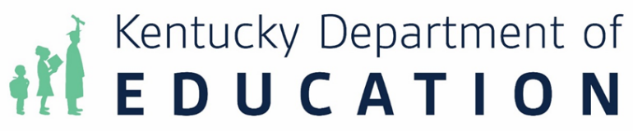

What Works Clearinghouse (WWC) Compliance Requirements for Evidence-based Practices
The Every Student Succeeds Act (ESSA) requires the documentation of evidence-based practices for many federal programs, such as Title I, Part A Parent and Family Engagement, 21st Century, and school improvement. Additionally, KRS 160.346 and 703 KAR 5:280 (Kentucky’s school improvement regulation) requires those schools identified for Targeted Support and Improvement (TSI) (including Additional Targeted Support and Improvement [ATSI]) to document evidence-based practices in their comprehensive school improvement plans (CSIP) and for those schools identified for Comprehensive Support and Improvement (CSI) to document evidence-based practices in their turnaround plans.

The revised Non-Regulatory Guidance: Using Evidence to Strengthen Education Investments (September 28, 2023) includes additional details from the Education Department General Administrative Regulations (EDGAR) that are necessary for inclusion and use in federal grant programs. Evidence-based interventions supported with Section 1003 school improvement funds must be based on strong, moderate, or promising evidence from the What Works Clearinghouse (WWC) that indicates a statistically significant effect on improving student outcomes or other relevant outcomes as defined in ESEA Section 8101(21)(A)(i). Level IV evidence-based interventions previously approved within a Comprehensive School Improvement Plan (CSIP) may not be funded with school improvement funds.

School districts have the responsibility to determine the most appropriate method for collecting, documenting, and monitoring the implementation of evidence-based practices. Compliance requires that evidence of these processes be uploaded to school improvement plans, turnaround plans, and certain grant applications.

The following tool is intended to assist schools in planning for and documenting the…
- compliance requirements;
- alignment of interventions to identified needs and improvement plan activities;
- expected outputs and outcomes; and
- available data by which success will be measured.
After identifying an appropriate practice that meets the required WWC level of evidence, schools will develop and align the components of a logic model, resulting in a road map for implementation and evaluation as well as a tool for communication. The completed document will be uploaded into the Continuous Improvement Platform (CIP) and where appropriate, the Grant Management Application and Planning (GMAP) system.

Definitions
Improvement Priority: List the improvement priority from the most recent Two-Day Review Report that will be addressed by the evidence-based practice.
What Works Clearinghouse Evidence Citation: The citation must provide full access to a Practice Guide, Intervention Report or Single Study from the What Works Clearinghouse (WWC).
Improvement Plan Alignment: List the specific goal area of the Comprehensive School Improvement Plan where this initiative will be included.

Project Component | Resources | Strategies/Activities | Outputs | Outcomes | Monitoring Data
What specific recommendation, practice or intervention from the WWC evidence will you implement? | What resources are necessary to implement the chosen evidence-based practice? | What will you do with each resource? | What evidence will there be that you implemented the activities? | What benefits are expected (to students, staff, systems, etc.) | What data will you collect to measure progress towards our outcomes?

Complete the following template to outline the evidence-based practice(s) that will be supported with school improvement funds. The template may be copied as needed for multiple initiatives.

Compliance Requirements Template
Improvement Priority:
What Works Clearinghouse Evidence Citation:
Improvement Plan Alignment:

Project Component | Resources | Strategies/Activities | Outputs | Outcomes | Monitoring Data

