**Special Education**



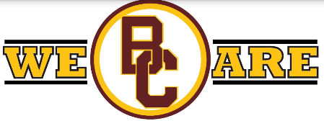 **Barren County**

With a strong emphasis on students' abilities, Barren County High School strives to prepare and equip ALL students for success beyond high school. As COVID wreaked havoc on normal daily activities, Barren County's very own, Katelyn Emberton seized a chance to think outside of the box to continue to meet individual students' needs. Due to the global pandemic, Safe at School guidelines were put into place that prevented students from leaving the school campus to obtain direct hands-on work experience. With creative thinking, students in Mrs. Emberton's class were still provided the opportunity to acquire necessary work-ready skills.

During the 2020-2021 school year, the Moderate to Severe Disabilities classroom successfully launched a brand new school-based enterprise benefiting the district while bringing smiles to customers' faces. The "Trojan Sweet Shoppe" successfully enables students to obtain hands-on work-ready experiences by designing and developing candy grams, budgeting, ordering products, managing sales, and practicing exemplary customer service. As with any new idea, the business started with a mission and a vision. Students thoroughly researched competitors' costs and pitched their business plan to local businesses via virtual platforms while seeking partnerships and support. Students successfully partnered with local companies, including Dollar General and Elmore Realty & Auction, to offset the initial start-up cost.

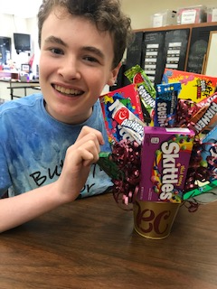 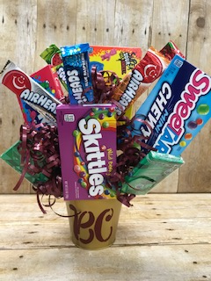

In 2018, Kentucky showed an employment gap of 45.9% between people with and without disabilities, per a study completed by respectability.com. Creating an inclusive community is an achievable and necessary goal to create opportunities for all, but change requires continued focus and attention.

Refusing to sit idle during the pandemic, Mrs. Emberton focused on the next steps for when safety guidelines are lifted, and students are permitted to leave campus again. Mrs. Emberton has developed the "Transition 21" program that promotes work experience in their own community. Students participating in "Transition 21" are on an Academic and Work Ready Pathway. Through this program, students will have the chance to obtain real-world work experience in the community with local community partners' help and support. Community partners have been established for each of the 16 career clusters.

According to the most recent national data, "Companies that employ people with disabilities report higher revenues, bigger profit margins, better morale, and a greater retention rate..." Barren County's "Transition 21" not only has plans to benefit students but also the community and local businesses. "Transition 21" has the potential to improve program quality and staff engagement, particularly when there is a crossover between school and community organization staff. Foster better alignment of programming to support a shared vision for learning, one that aligns curriculum to support state and local employment standards. While also maximizing resources used such as facilities, staff/employees, data, and visions.

Students served in Mrs. Emberton's classroom have developed a mission and a desire to gratefully accept the opportunity to learn job skills in the community and give back to the business as a contributing part of the team. Mrs. Katelyn Emberton and Barren County schools are dedicated to creating pathways for employment and leadership opportunities for ALL students.

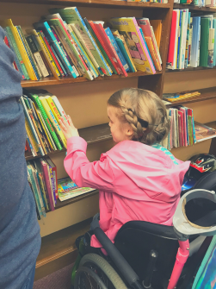 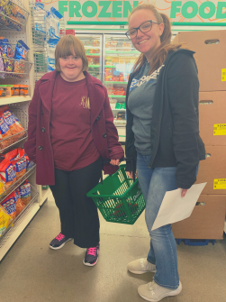 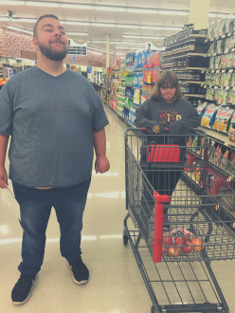

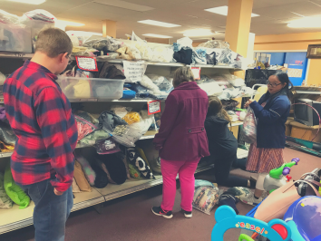

Special Education Cooperatives

[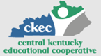](https://www.ckec.org/) [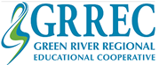](https://www.grrec.org/) [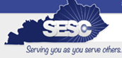](https://sesccoop.org/)

[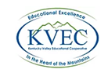](https://www.kentuckyvalley.org/) [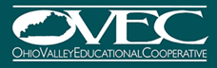](https://www.ovec.org/) [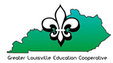](https://www.kyglec.org/)

[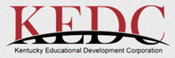](http://www.kedc.org/) [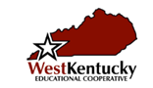](http://www.wkec.org/) 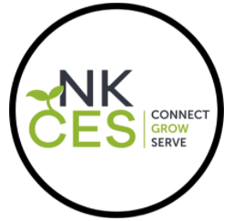

Early Childhood Regional Training Centers 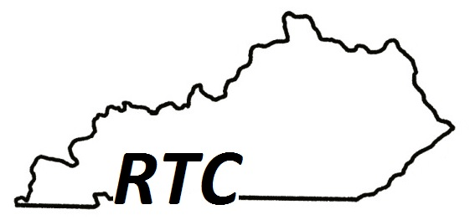

Ashland RTC

Anderson County RTC

Berea RTC

Calloway County RTC

Simpson County RTC