**Special Education**



**BULLITT COUNTY**

Megan Hardin, the Moderate to Severe Disabilities teacher with Roby Elementary in Bullitt County Public Schools and Samantha James with Freedom Elementary in Bullitt County have developed some digital and non-digital tools for their students to enhance their students learning during distance learning.

Both Megan and Samantha have developed Google classrooms with their Instructional Assistants to give students a digital platform that mirrors the classroom environment. Both Megan and Samantha have included academic as well as social emotional well-being into their digital classrooms. Megan and Samantha have created a sensory room within their digital classroom that has activities that students might experience in the classroom. This component provides students with an outlet for calming, breaks and sensory needs.

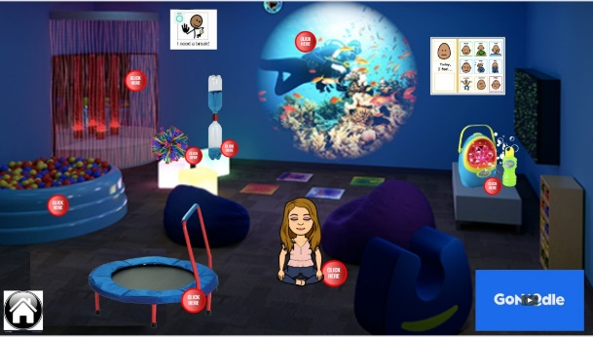Go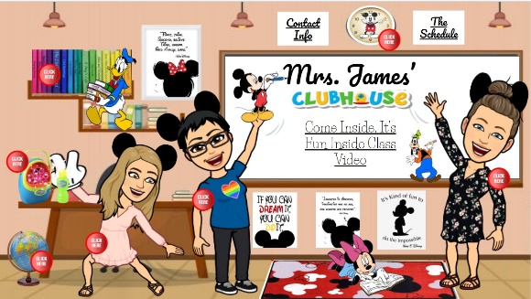

Megan has also created learning boards that will be delivered to her students. The learning boards incorporate tasks that are in alignment with the student’s academic goals. The tasks are familiar activities that students use within the classroom. The learning boards will allow students a more fully inclusive learning experience during distance learning.

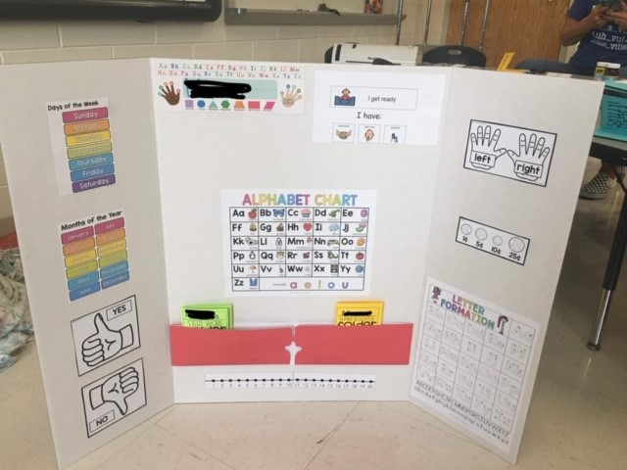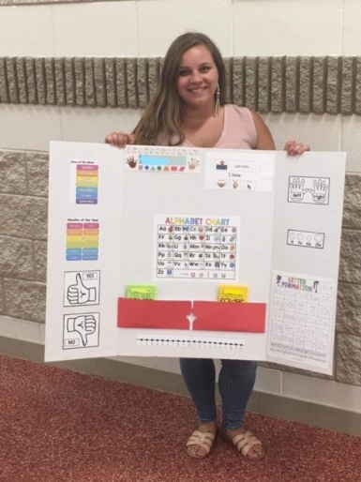

Samantha has also created learning tasks similar to tasks and activities that her students would experience in the classroom. Samantha has created cookie sheet tasks in addition to recording social stories for her students. Samantha also has reached out on social media to assist other teachers and families by offering to record social stories and send them to the person who has requested a recording.

St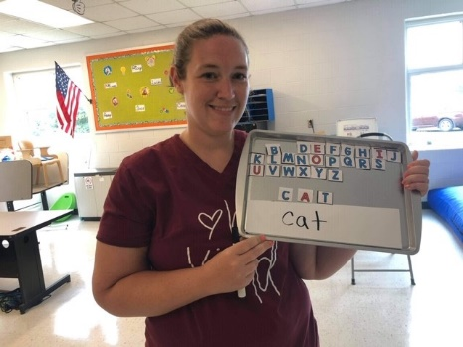Staff


Thank you, Megan and Samantha, for the great supports you are providing to students in a digital and non-digital format during distance learning in Bullitt County Public Schools.

**Special Education Cooperatives**

[](https://www.ckec.org/) [](https://www.grrec.org/) [](https://sesccoop.org/)

[](https://www.kentuckyvalley.org/) [](https://www.ovec.org/) [](https://www.kyglec.org/)

[](http://www.kedc.org/) [](http://www.wkec.org/) [](https://www.nkces.org/)