**Special Education**



**Fayette County Public Schools**



Jacklyn Martin, the IECE Preschool teacher at Coventry Oak Elementary school in Fayette County has taught preschool virtually throughout the COVID-19 pandemic. While there are many unique challenges that face our youngest learners and their teachers, Ms. Martin found ways to keep her students & families engaged.

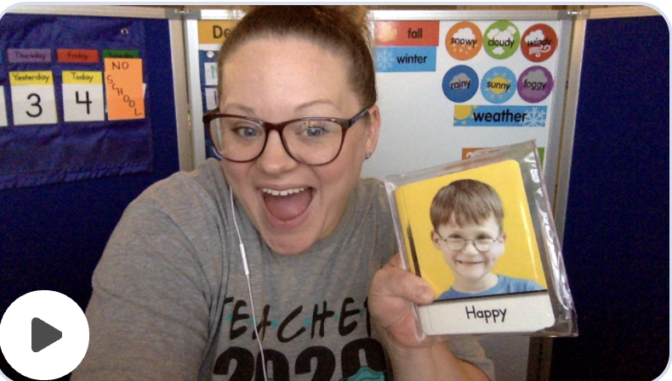

Recognizing that many of the naturalistic opportunities to teach vocabulary and increase language would not be available during remote instruction, Mrs. Martin wanted the challenge of language development to be her focus for this school year. Through small group activities and interactive social tasks like FlipGrid & Buddy Chat, she has been able to witness growth from her students. Mrs. Martin provides families with engagement opportunities through asynchronous activities and offers opportunities for families to learn the importance of language development.

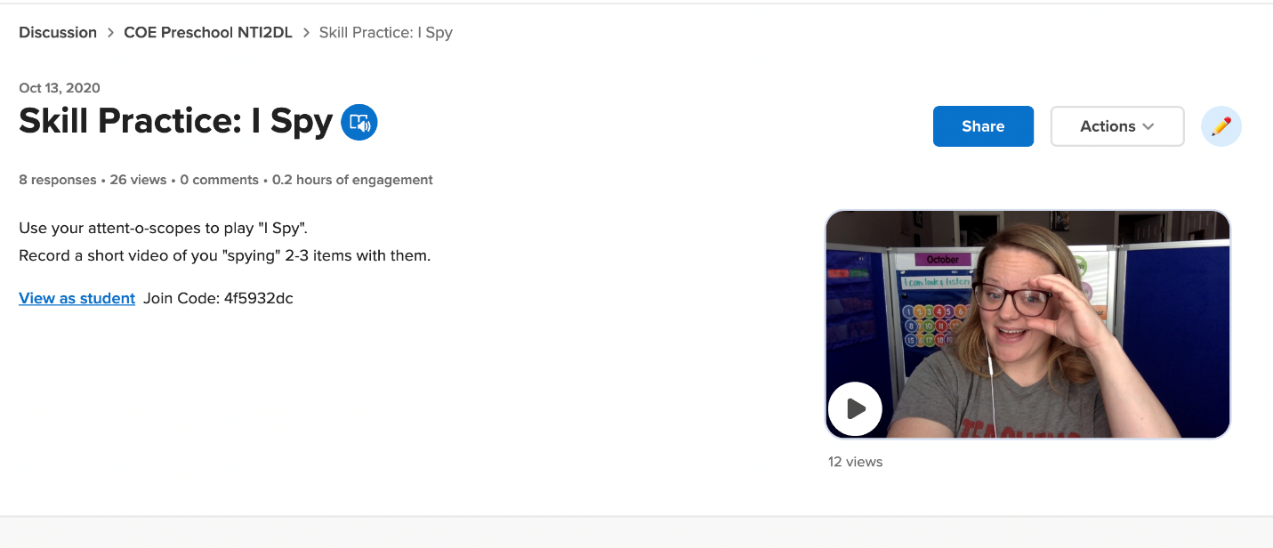

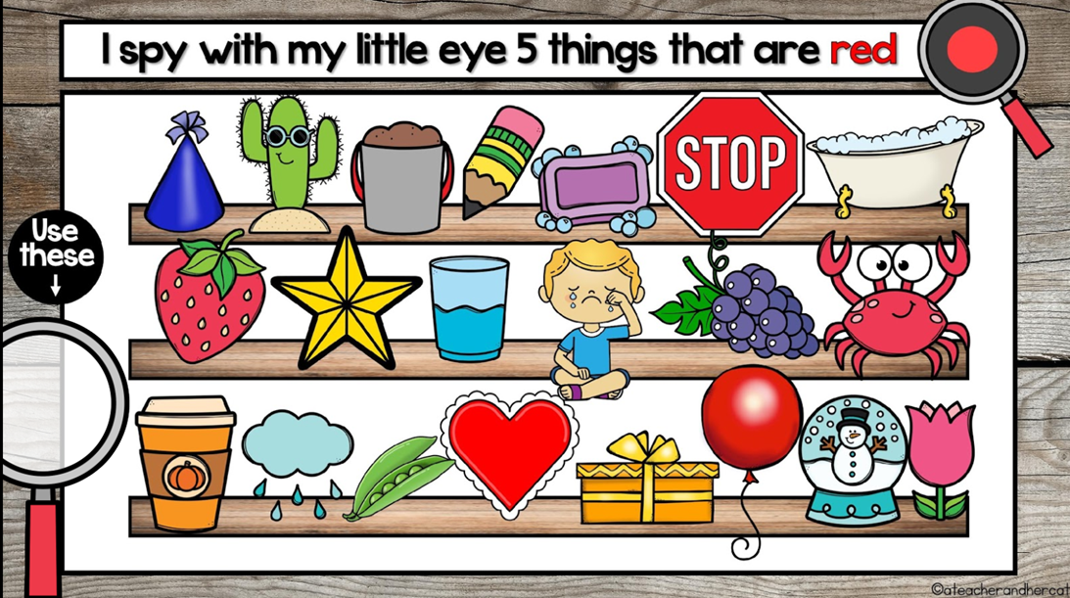

Ms. Martin has also created individual kits for each student that incorporate multi-step directional tasks, including modifications and accommodations for students who need this support, to build focus/attention, task completion, and interactions throughout virtual learning. Through the use of individualized kits, students are provided with hands-on learning extensions to make the Virtual World come to "life”.

Below you will find a sample of Ms. Martin’s weekly lesson plan and some of the activities used to engage her students while learning virtually.

FCPS Preschool Program NTI-2DL Activity Lesson Plan Theme: Eric Carle

|  |  |  |  |  |  |
| --- | --- | --- | --- | --- | --- |
|  | | |  | | |
| Monday | Tuesday | Wednesday  Read, Talk, Play Day | | Thursday | Friday |
| Question of the Day:  Can you label, by name, a part of a book?  Morning Meeting Activities-  -Good Morning Song  -Greetings  -Counting/Letter/Calendar Review  -5 Steps/Super Scholar Chant  -Music/Movement: Awesome Rainbow  -Story: The Very Hungry Caterpillar Storybook video  Small Group Activity(ies):  Parts of the Book Google Slide Activity  Butterfly Activity Bag: Lesson Plan  Meaningful Conversation Starter:  Can you think of things that fly in the springtime?  Individualized Instruction (Targeted Goals):  Sensory Calendar  FlipGrid Social Chat  Sorting/Labeling (I SPY- Following Multi-Step Directions  Live Buddy Chat | Question of the Day:  What is the season that comes after Winter?  Morning Meeting Activities-  -Good Morning Song  -Greetings  -Counting/Letter/Calendar Review  -5 Steps/Super Scholar Chant  -Music/Movement: Spring is Here  -Story: Spring is Here  Small Group Activity(ies):  Season Sorting Game  Meaningful Conversation Starter:  Do you think you could describe spring?  Individualized Instruction (Targeted Goals):  Sensory Calendar  FlipGrid Social Chat  Sorting/Labeling (I SPY-  Following Multi-Step Directions  Second Steps Lesson:  Unit 4: Friendship Skills and Problem Solving  Week 5: Saying the Problem  Live Buddy Chat | Question of the Day (posted in Google Classroom):  What letter does Carle and caterpillar start with?  Meaningful Conversation Starter (posted in Google Classroom):  What do you like about this season/weather?  Posted Book Reading (Title):  Book: The Very Hungry Caterpillar  Asynchronous Activity: Very Hungry Caterpillar Sequencing Task (SLIDE 6)  Individualized Instruction (Targeted Goals):  Sensory Calendar  FlipGrid Social Chat  Sorting/Labeling  Following Multi-Step Directions  Spring Scavenger Hunt:  Live TALK TIME | | Question of the Day:  What is something that you need to use in rainy weather?  Morning Meeting Activities-  -Good Morning SOng  -Greetings  -Counting/Letter/Calendar Review  -5 Steps/Super Scholar Chant  -Music/Movement: Singing in the Rain  -Story: Raindrop Plop  Small Group Activity(ies):  3D Umbrella Activity Bag: Lesson Plan  Meaningful Conversation Starter:  What was your favorite thing about today? Why?  Individualized Instruction (Targeted Goals):  Sensory Calendar  FlipGrid Social Chat  Sorting/Labeling I-SPY-  Following Multi-Step Directions  Second Steps Lesson:  Unit 4: Friendship Skills and Problem Solving  Week 5: Saying the Problem | Question of the Day:  Can you name 1 thing that happens in spring time?  Morning Meeting Activities-  -Good Morning SOng  -Greetings  -Counting/Letter/Calendar Review  -5 Steps/Super Scholar Chant  -Music/Movement: Shake Your Sillies Out  -Story: The Little Cloud  Small Group Activity(ies):  Book Scavenger Hunt Lesson Plan  Meaningful Conversation Starter:  How did someone help you today? How did you help someone else?  Individualized Instruction (Targeted Goals):  Sensory Calendar  FlipGrid Social Chat  Sorting/Labeling (I SPY- Following Multi-Step Directions  Live Buddy Chat |

Special Education Cooperatives

[](https://www.ckec.org/) [](https://www.grrec.org/) [](https://sesccoop.org/)

[](https://www.kentuckyvalley.org/) [](https://www.ovec.org/) [](https://www.kyglec.org/)

[](http://www.kedc.org/) [](http://www.wkec.org/) NK

Early Childhood Regional Training Centers



Ashland RTC

Anderson County RTC

Berea RTC

Calloway County RTC

Simpson County RTC