**Special Education**





Greenup County teachers kicked off their teaming efforts in the spring using Google Classroom. By linking special education staff to each teacher's google classroom, the special education teacher and general education teacher worked together to provide accommodations and supports to students.  They also took part in one to one Facetime sessions with students and small group Google Meets.

But Greenup County isn’t stopping at Google to reach students. Speech Language Pathologists (SLP) are utilizing the SLP Assist program to assign lessons related to student's IEP goals. They are also using a Facebook Page. Their Facebook page provides parent supports and activities for speech language skills. In the Fall they will be adding the Presence Learning Teletherapy Platform. Through teletherapy they will provide ongoing NTI and virtual learning for all students.

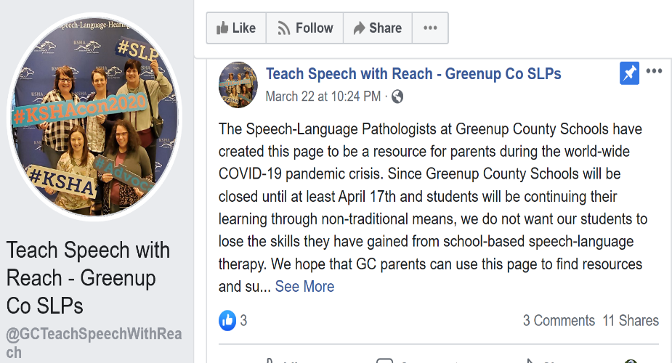

Each Preschool teacher at Greenup County also has their own YouTube Channel to post class specific videos.  They practice "wish you well" and other Conscious Discipline Social Skills as well as Just Kidding Yoga and relaxation techniques.  It has been great to see the families participate in these activities with our youngest students.  Below, Ms. Walker encourages her class to perform yoga moves while her son Kirk reads the book Yoga Bunny. During the fall, they will also offer virtual learning through Bitmoji classrooms and take-home activity kits that families will utilize throughout the year.

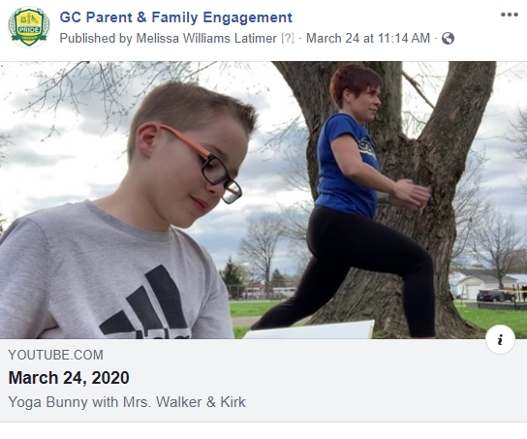

Greenup County staff are continuing to work on their virtual academy and NTI plans for the fall, utilizing a variety of technology platforms and in person accommodations to meet student needs. Below, staff are working to ensure that visuals are in place to assist students with social distancing.

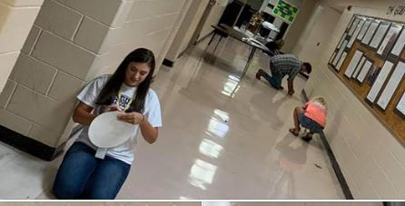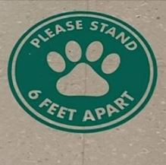

The Greenup County Schools food service program has continued to provide meals to students during NTI, Summer, and will continue for the Fall. Student’s choosing the virtual academy will have opportunities to pick up free meals weekly. Just another way we are meeting our student’s needs.

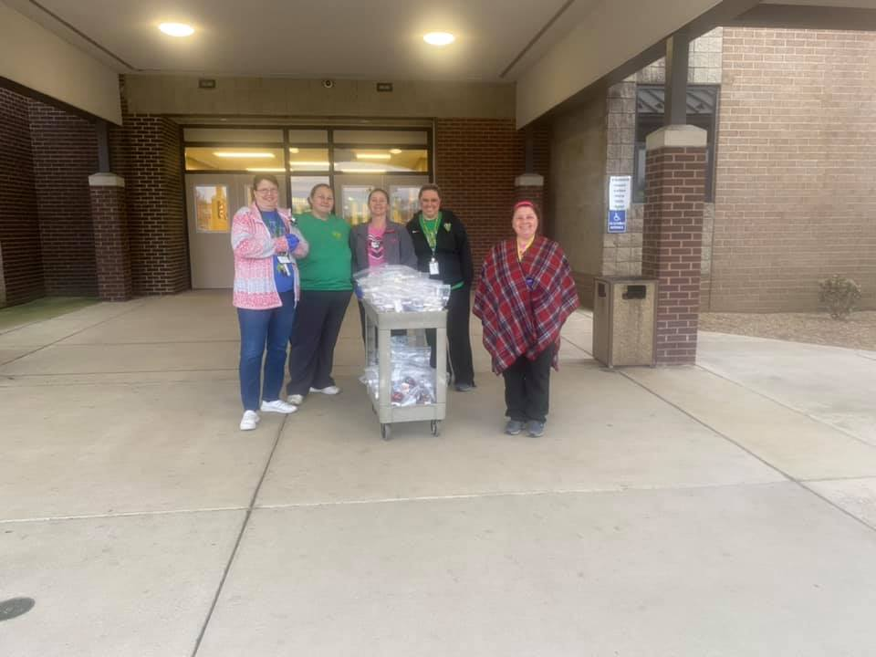

**Special Education Cooperatives**

