**Special Education**

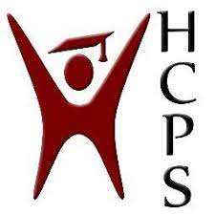

**Henry County Early Childhood Services**

Amid the mandated Coronavirus closure in fall of 2020, preschool teachers and service providers at Henry County Early Childhood Center (HCECC) quickly shifted their mode of instruction by providing age-appropriate at-home activities, creating Google classrooms and scheduling teletherapy sessions.

When KDE guidance advised that schools could bring limited numbers of students into the building during the shutdowns, HCECC principal Stephanie Melton immediately knew which students should receive small group in-person instruction and already had a plan in place. The first day of school for HCECC was originally scheduled to be on September 2 and small group instruction began just one week later on September 9. Those services were also offered during the second shutdown of this school year, just before Thanksgiving. Small groups reconvened on November 30 and continued through our scheduled winter break with all students returning in January 2021.

“Students who receive services through our special education programs including speech, developmental services and occupational therapy, as well as Response to Intervention (RTI) students, were a top priority,” Melton said. “We wanted to meet our requirements by continuing to offer special education services during the shutdown, and we wanted to begin the process of collecting data for our RTI students. We were fully cognizant that many of the students in those categories would greatly benefit from receiving those services in-person as opposed to online.”

With parental consent and cooperation, small groups of HCECC students were brought into school four days per week for half-day instruction during the mandated closures, following CDC and KDE guidelines. Transportation was provided to families that needed it, and online services and teletherapies were offered to families who were not comfortable attending in-person. In-person curriculum was aligned with at-home learning, but teachers honed in on the specific skillset needs identified in the Individual Education Plans (IEPs) of the students who were brought in for small groups. In-person students stayed in separate learning pods with their teacher and instructional aide(s) to receive RTI and developmental services, and additional service providers came into each classroom to conduct speech and occupational therapy.

Melton said her staffers were supportive of the decision to provide in-person services during the shutdown.

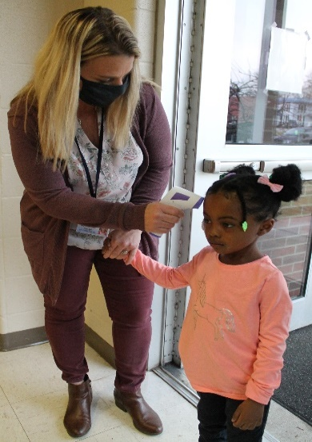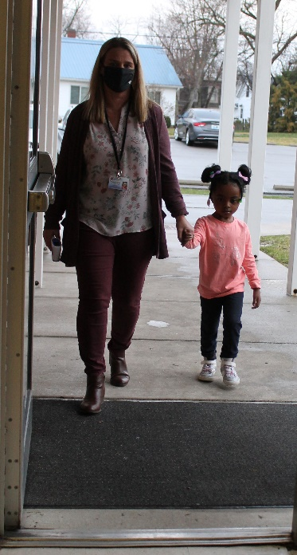

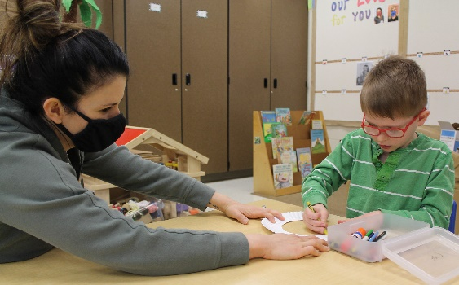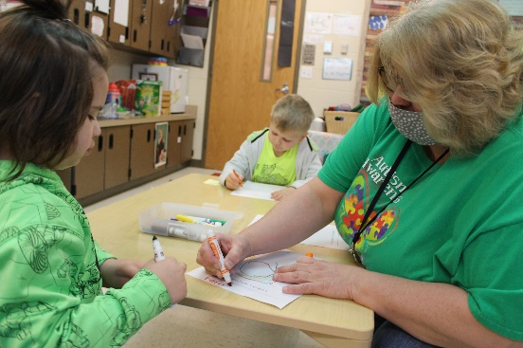

“I was most definitely on board with bringing in small groups,” said preschool teacher Amy Johnson. “I feel children learn much better in person with hands-on experiences. Preschool is mainly about establishing routines and it gave us the opportunity to work one-on-one with our students.”

With so many challenges associated with online learning like unreliable technology, spotty or nonexistent internet service, scheduling conflicts, creating an appropriate learning environment at home, access to materials and inconsistent attendance, online teletherapies were often ineffective.

“Maintaining the attention of our preschool students at home was incredibly challenging through a screen and therapy sessions often turned into parent coaching,” said speech pathologist Lauren Comer. “It’s much easier for students to focus in the classroom. In-person services allowed for a more personal connection with students and more opportunities for social communication.” Comer also pointed out how important peer models are for students and noted that in-person services provided opportunities for students to learn and experiment with their peers while building trust.

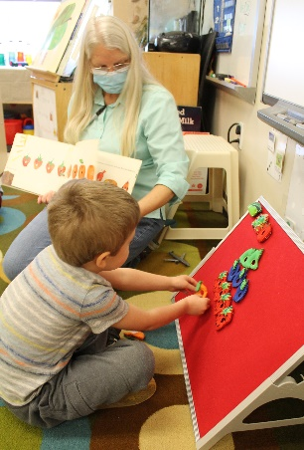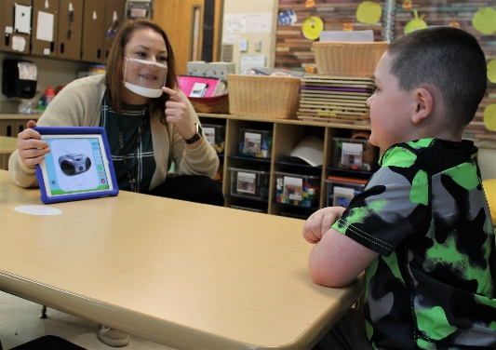

Many students who participated in small group in-person instruction during the shutdowns, both at the beginning of the school year and right before Thanksgiving, became unexpected leaders in the classroom. “The students in the small groups were already familiar with the routine and were able to be leaders in some situations that may never happen without this opportunity,” Johnson said. Small group in-person instruction also benefitted the entire family of the preschool student. During the shutdowns, many families experienced difficulties providing support to their children due to work, financial struggles, mental health issues, loss of childcare and more. The pandemic created chaos and our preschool students were affected in many ways.

“All students thrive with routine. Small group instruction helped our students create a routine and provided an appropriate learning environment,” Comer said. “Our families weren’t forced to choose between school work versus family time, which alleviated stress for our parents and created more time for family at home.”

By offering in-person learning for those targeted small groups, the staff of HCECC provided required services, assisted families during a very challenging situation, prevented learning loss, gave its vulnerable students an opportunity to learn the routines of the classroom, model from their peers and develop trust for their teachers.

“Every decision we make is to benefit our students; to put their needs first. Those students needed to be in school and our families needed our support,” Melton said. “We were excited to provide the opportunity for in-person small group learning during the shutdowns. It was absolutely the best choice we could have made for our students.”

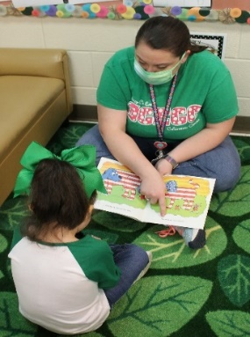

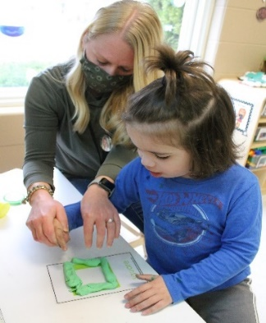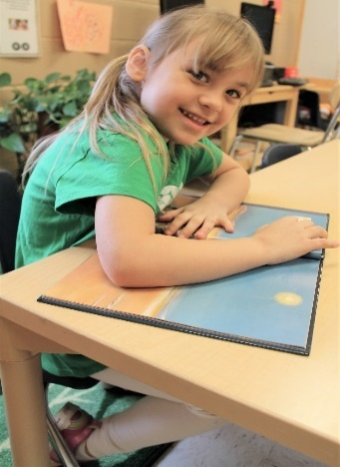

Special Education Cooperatives

[](https://www.ckec.org/) [](https://www.grrec.org/) [](https://sesccoop.org/)

[](https://www.kentuckyvalley.org/) [](https://www.ovec.org/) [](https://www.kyglec.org/)

[](http://www.kedc.org/) [](http://www.wkec.org/) 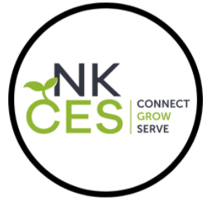

Early Childhood Regional Training Centers