Special Education
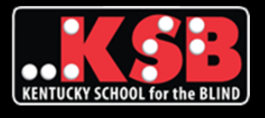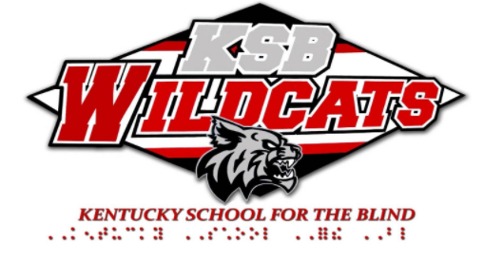
The Kentucky School for the Blind (KSB) began the 2020-2021 school year with remote learning through the Non-Traditional Instruction (NTI) model. During the summer, school staff utilized feedback from a parent survey about NTI that occurred last spring to plan for a smooth start to the new school year. New laptops and the accompanying assistive technology were ordered and set up for each student based upon the student’s unique learning needs. Teachers assembled accessible materials and supplies for each of the students in their classes. Teachers and staff compiled boxes of materials for each student to use for the first six weeks of school. The boxed materials were available for parent pick up at KSB or were delivered to students that live throughout the state by the network of Outreach Consultants. KSB students were set up and ready to go the first day of school! In the words of one KSB parent:
“…Teachers and therapists - one word - Wow!!! As an organized person I am blown away by the level of preparation that was required to pull this off! A laptop, a tablet, all programmed and ready to go, all materials Brailled and in print (for Mama). Each activity in a baggie and labeled. Y’all are amazing!!”
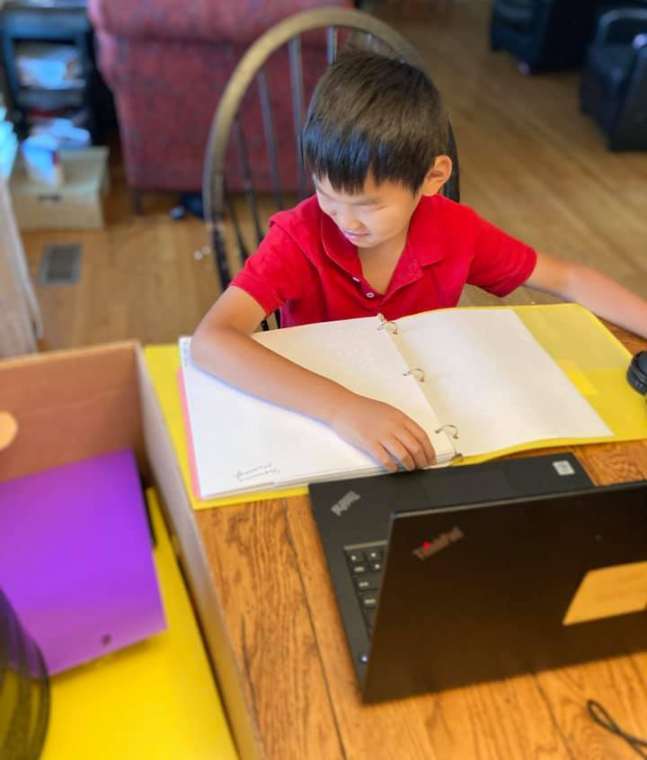

Student in home environment sitting at a dining room table reading a braille book with a laptop open in front of him.
In addition to all the materials necessary for school, KSB sent home packages of food to all families that requested one. With a huge effort by teachers, staff and parents, KSB has had a great start to the school year!!!
As we try to make our “new” normal feel more like our “old” normal, KSB is continuing one of its daily traditions: Good Morning KSB! When we met in person, the school staff and students would gather in the cafeteria each morning before school started. During that time we would share special event information, happenings that day in history, have staff or student “shout-outs” about something or someone they saw inspired them or deserved special recognition, and share student and staff birthdays. We are going to continue that tradition via a video on the school’s Facebook page. Each day one of our teachers will post a “Good Morning KSB!!!” video to help students and staff get an energized start to their day. In addition to the daily Facebook video, KSB will also be holding a Teams conference call for students interested in participating in sports. While we are not sure what our sports will look like this year, we do know that participating in sports is an important part of KSB life. The upcoming Teams meeting will be another way for our students and families to connect and look forward to the day when more traditional activities can take place again.
While KSB is currently not meeting in person, we are OPEN and delivering high quality instruction to children and youth who are blind or visually impaired, and with and without additional disabilities across the Commonwealth of Kentucky!
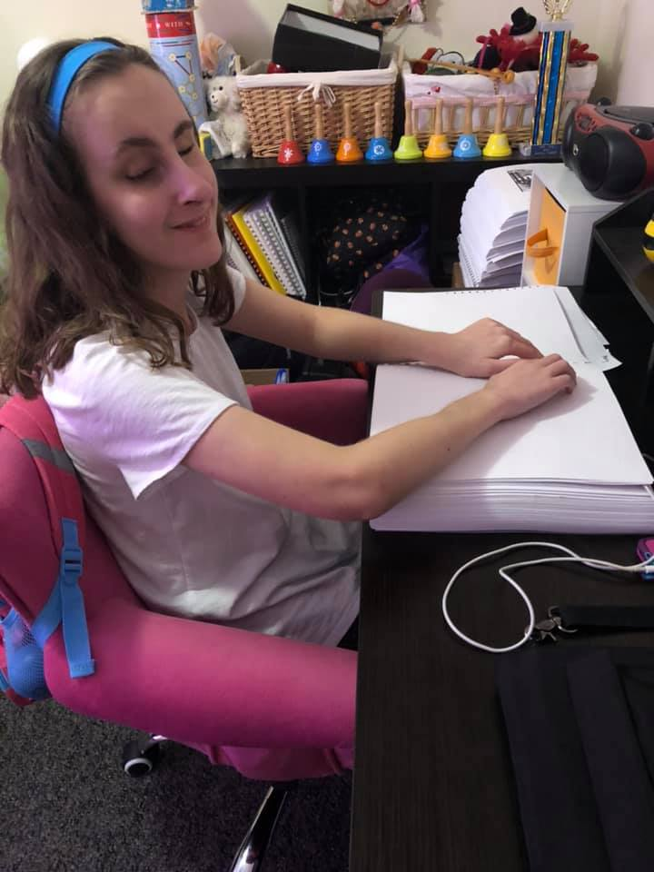

Student in home environment, smiling, while reading a braille textbook
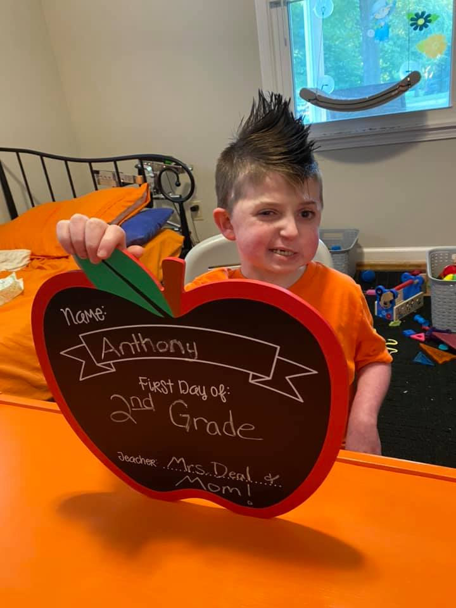

Student in home environment, smiling and holding an apple shaped sign that says First Day of 2nd Grade

Special Education Cooperatives
