Special Education

The Outreach division of the Kentucky School for the Deaf (KSD) is made up of a team of 8 deaf education consultants that provide technical assistance to districts who are serving Deaf and hard of hearing students across the Commonwealth. They provide support to district personnel working with students who are Deaf and hard of hearing as well as their parents/guardians. Since the team is located throughout the state, some level of remote, online work is commonplace in their routine. However, the COVID-19 Pandemic that led to state and nationwide shutdowns of everything from daycares and public schools to public libraries and government offices, created new hurdles that caused the team to quickly pull together to strategically plan and overcome in order to meet both the ongoing and newly identified needs of students and staff.

Initially, the team collaborated to gather and share resources that could specifically aid in the educational planning of Deaf and hard of hearing students that were now being served in a variety of remote teaching and learning approaches. They gathered and developed resources to guide district personnel in ensuring that their DHH students had equitable access to the instruction and materials in their Non-Traditional Instruction approaches.

In a typical year, the Outreach team provides regularly scheduled regional trainings as well as specialized statewide training opportunities for teachers of Deaf and hard of hearing students. The statewide closures resulted in weekly opportunities to meet with teachers in groups as well as individually to address rising challenges via the internet and phone. The team worked diligently to re-develop each of the numerous regional and statewide training opportunities that had been originally planned to take place in the spring offering them via Zoom in shorter sessions to accommodate the unusual circumstances that were plaguing educators who were doing new things in new ways from different places.

Additionally, as the Pandemic presented new social and emotional challenges for students due to isolation and lack of communication opportunities, KSD Outreach planned and hosted a variety of virtual social encounters for students. They offered Saturday morning opportunities for groups of elementary students to meet Kentucky’s newly famed interpreter, Virginia Moore. The group also partnered with the Deaf and Hard of Hearing Services division of the Department for Behavioral Health Developmental and Intellectual Disabilities to host social-emotional connecting experiences for middle and high school students with hearing loss.

“While the level of preparation it takes to be ready to provide multiple types of online events for multiple groups of vastly different audiences and being ready to conquer unknown technology hiccups as they happen has been far more stressful and labor intensive than planning our typical face-to-face events, Outreach has shown an impeccable level of dedication and teamwork to serve our low-incidence students across Kentucky. Ultimately, it’s all about the kids!” said Tony Peavler, Director of Outreach.

Due to the increased need for supports resulting from NTI, KSD Outreach ended the academic year with a 27% increase in Technical Assistance events from February to March. Additionally, they had a 243% increase in professional development opportunities in the 4th quarter.

Pictures from “Face to Face with Virginia” Elementary Social Events

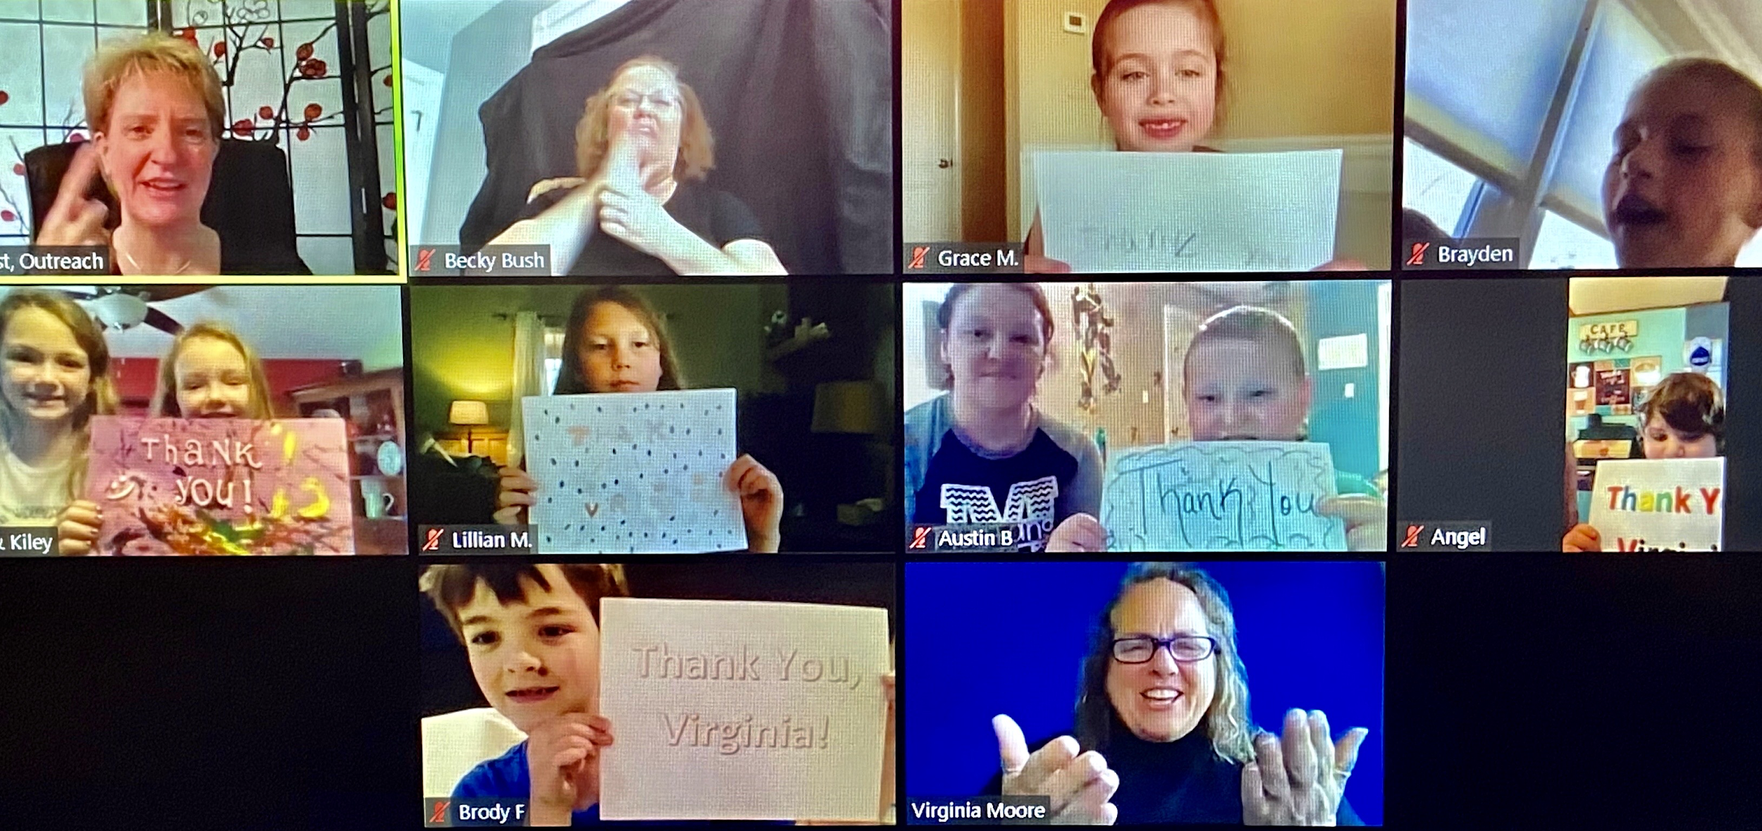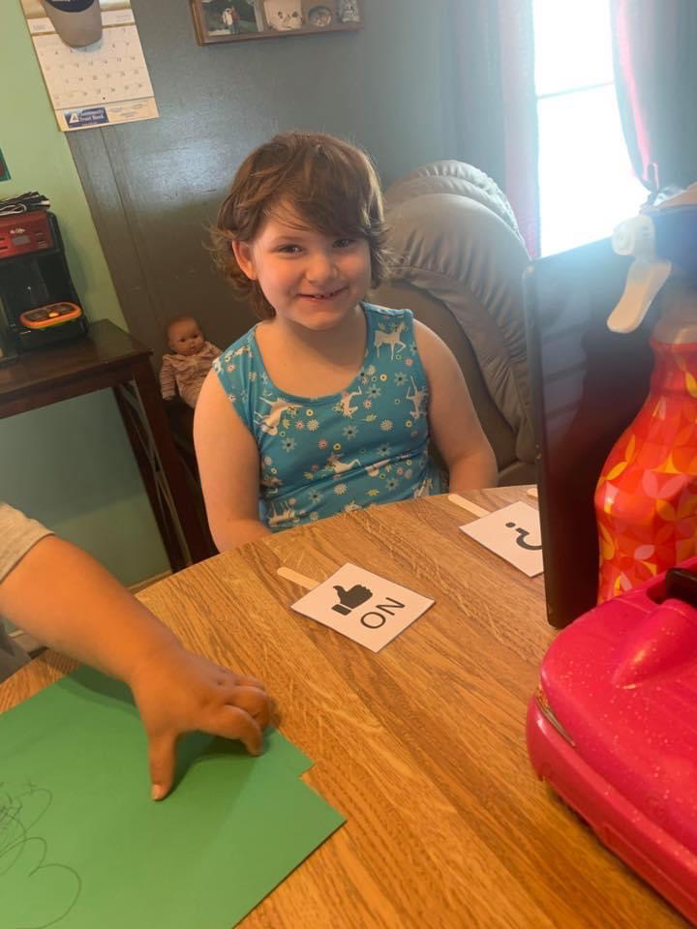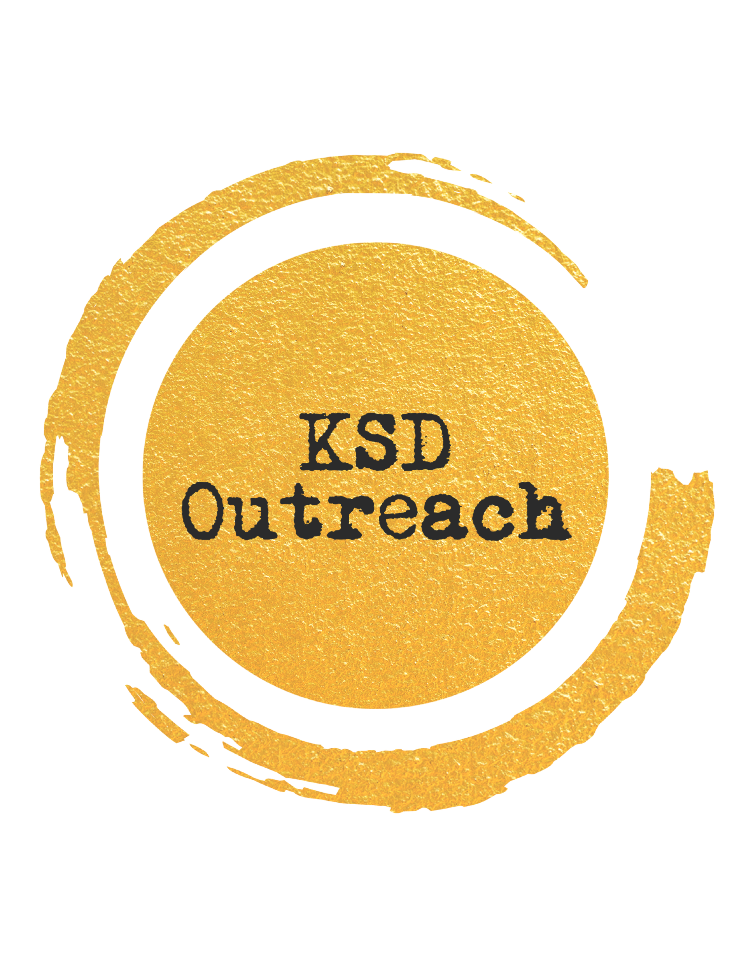
Special Education Cooperatives
