Special Education

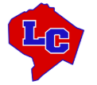

“The Lincoln County Schools Engage in a New Way of Teaching Students During COVID-19”

In less than 24 hours, Lincoln County Schools totally changed the service delivery of instruction to students across our district. The most drastic changes came to the service delivery of our Exceptional Children across the district. The mission of our district has always been to provide quality instruction for students, while meeting the needs of the total child. Overnight the mission became, “how do we take care of our students and families?”

We began by mobilizing our fabulous food service. The Lincoln County Schools Food Service Department has offered a free lunch for students since the decision to close in-person instruction on March 12th. The staff has prepared and delivered nearly 45,000 meals to Lincoln County students during the COVID-19 pandemic. After ensuring our families were fed and had needed items, we shifted the mission to now adress, “how will we provide quality educational experiences that meet the individual needs of our exceptional children across the district?”

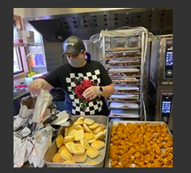

As a rural district, some of our students do not have the necessary internet capabilities needed to engage in on-line instruction. However, for those students who do have access, we began using teletherapy a week after the closure for our students receiving speech/language therapy, occupational therapy, and physical therapy. Ms. Feldman and Ms. Nyborg are speech therapists at Hustonville Elementary and Crab Orchard Elementary. They have continued conducting therapy sessions with students. They have used teletherapy to stay engaged with students.
According to Ms. Feldman, “It has been going great so far. It’s so wonderful getting to see the sweet faces of my students who I miss so much. It has been amazing getting to team up with parents to help students improve their speech and language skills.”

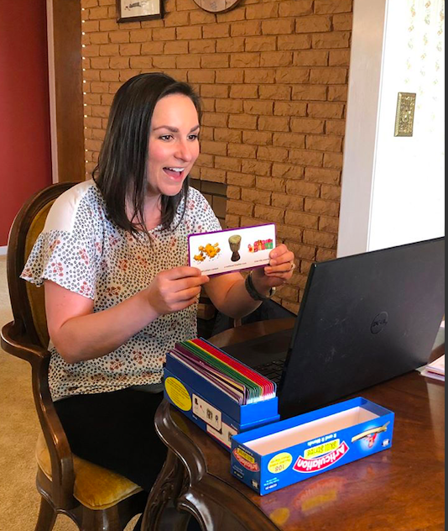
“It’s been a learning experience for sure,” said Ms. Nyborg. “We are all figuring out Zoom and how it works. It is a great way to be able to provide therapy services in a non-traditional way. It’s wonderful to see my students, talk with them and continue to give them needed intervention for their speech and language skills.

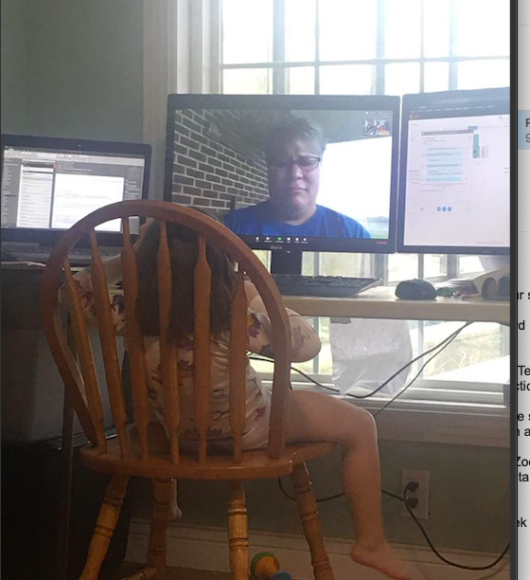

Between the two therapists, they’ve been able to work with about 70 students a week using teletherapy. This method of service delivery helped us ensure that our students were able to receive much needed related services.

During this time, we also implemented some new technology techniques for our students who communicate primarily through American Sign Language (ASL). Our interpreter, Ms. Taylor Hanna, used video chats and a messaging app called Marco Polo, which is like sending a text message but in video form. Marco Polo gave the student the opportunity to save the videos for future reference and clarification. Ms. Hanna was the constant communicator between the content teacher and students for such classes as Chemistry that require formulas and abstract concepts that often time require a high level of explanation. This learning was accomplished through video chats with the content teacher, the interpreter and students to ensure clarification of concepts and student success.

Our Exceptional Child (EC) Educators went above and beyond the call of duty to ensure that their Exceptional students had both their educational and basic needs met through this pandemic. Our EC teachers held daily Zoom lessons with their students, made daily contact with students and parents to assist in both the assignments of the general education classroom but also to provide direct specially designed instruction. Our Exceptional Child teachers used a detailed google document to track the amount and type of Specially Designed Instruction (SDI) provided for their students. Our Exceptional Child Teachers also used Loom videos to demonstrate how to complete a task, then pushed those videos to students. Our EC teachers, utilized Zoom and Google Hangouts each day to schedule a daily meeting time with a group of students so that they could meet with students and assist.

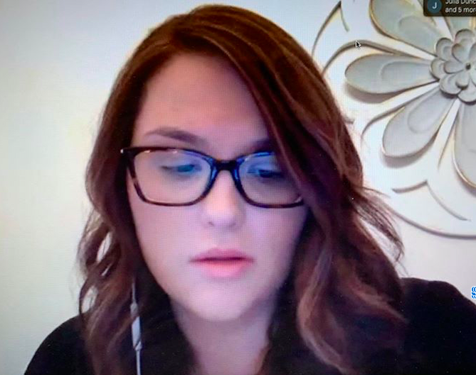

For our students that did not have the electronic capabilities, we made paper packets of work that contained the general education content, with any modification and accommodations that needed to be made for the student. EC teachers also made activities that specifically addressed each student’s area of disability in an effort to provide a level of Specially Designed Instruction to our students while they were home. In many cases we were able to engage the parent/guardian in the learning as well and use them to assist in gathering data related to student performance. Each EC teacher made their cell number available for parents to call if there were any concerns and our team was available beyond the designated hours set forth by our district.

Several of our EC staff took their so called, “show on the road, ” by traveling to homes to see a family they may not have talked to recently. Several of our staff traveled to homes at least once a week to gather paper packets of assignments from students and deliver them to school, while bringing a new set of assignments (using appropriate social distancing practices).

We are also extremely proud to say that all exceptional student Seniors graduated from Lincoln County High School this school year. Every exceptional Senior that began the school year was able to graduate with their class, as we made an intense effort to focus on our seniors through this pandemic.

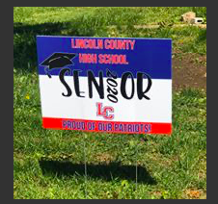

Many of our Exceptional Child Teacher shared that they were working harder during this pandemic to provide their students with education and support than during a “typical” school day. The countless hours of texts, calls, Zoom sessions, and other means of communicating to help their students was extremely amazing to be part of.

As the Director of Exceptional Children, it was extremely fulfilling to watch the dedication our staff showed to their students. There was constant communication between our EC teachers and families to ensure both basic needs and education needs were met. During this pandemic our EC staff truly lived up to their motto of #allaboutkids!

Special Education Cooperatives
