Special Education

Relationships and connections with students and families are paramount at Owensboro Public Schools. This pandemic has made this belief even more solidified for our staff and they were able to utilize their strengths to continue the foundational work that was set in the classroom even if they were not face to face with our students each day.

Our low incidence teachers were absolute rock stars during the Spring NTI period. Storm Rickard, Anthony Tate, and Windy Owens, OMS EBD self-contained classroom teachers, went above and beyond to show kids they were loved and were not forgotten even though they were not physically present in the classroom. During NTI Days, with the exception of a couple days, they emailed and/or sent texts to parents and students daily. On random days these teachers would make home visits (from 6 feet away), bring lunches (and eating with students from 6 feet away) and drop off/pick up packets in person as they made contact with students. They made a couple home visits at the request of a mom, to give a "let's get focused" speech to a particular student. They even checked in on a student that was no longer on the roster several times to ensure they still felt connected.

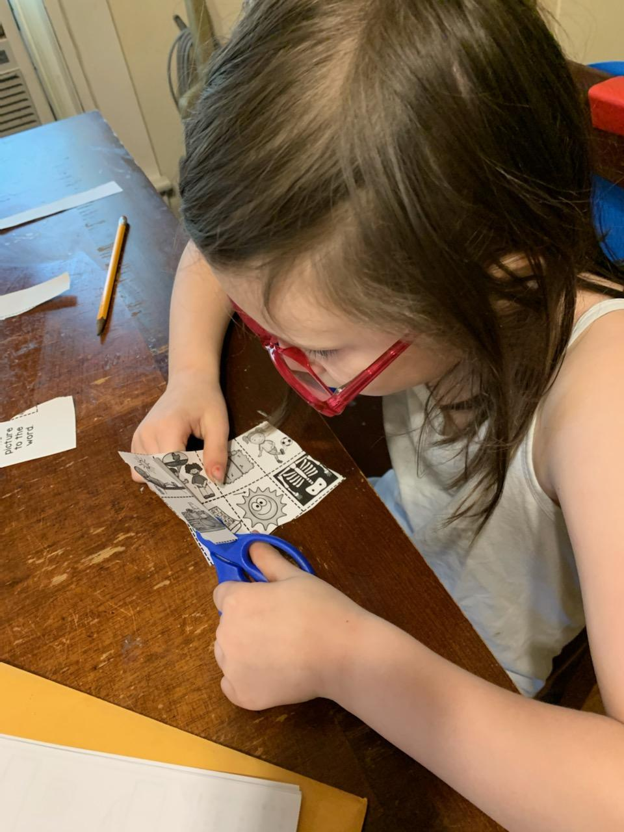
Karen Poe, K-2 teacher in our highly structured classroom, wanted to support her families. She tried to have Google Meets at least weekly so we could all see each other. She had video conferencing calls with some of the students, texted all the students' families daily, provided daily work that she individualized to make sure the kiddos were maintaining the skills they had while doing tasks they enjoyed doing. She even sent them books through Amazon. The books were about characters or topics she knew they loved. After all the work was completed, she sent thank you notes to the kiddos and to their parents and created certificates to 'brag' on what a great job they did completing their NTI work. Karen continues to have parents contact her to celebrate. Recently, a bathroom training victory was celebrated!

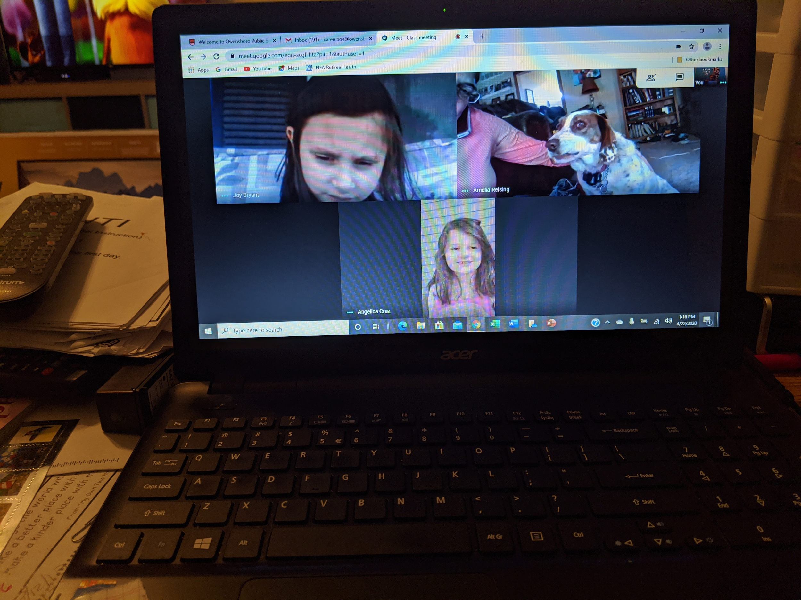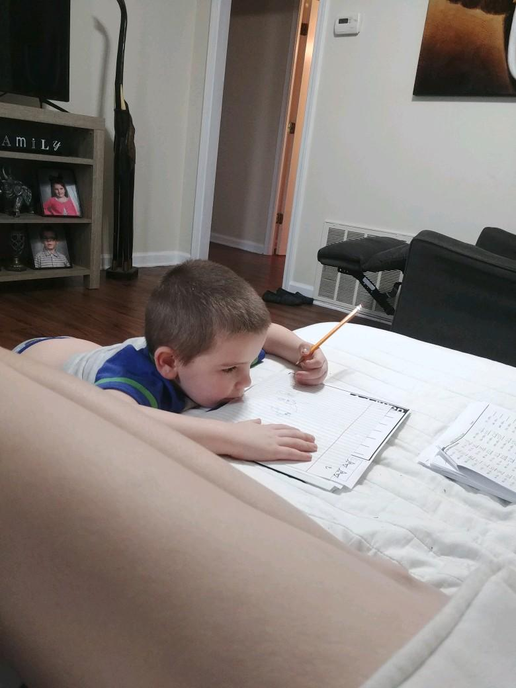

Lori Walters and Meghan Payne, Owensboro High School teachers in our multiple disabled room, created a joint Google Classroom. They used materials that were interactive and had lots of visual supports. For English/Language Arts, they read a book together. They did videos of reading a chapter and provided an adapted version of a book with visual supports and then created comprehension checks using Google Forms with added visual support. They also created a daily video (or nearly daily) literally walking their students through how to complete each assignment and submit through Screenshare on Loom. They did a daily Zoom/Google Meet just to check in. Every Tuesday and Thursday on the Google meet the "dance" teacher from Joy Johnson's Studios joined us for dance class. This was great for getting students to participate. They organized a drive by parade. The students loved it!!!! They also communicated regularly with parents and students through text, email, call, and Google Chat.

Special Education Cooperatives
