**Special Education** 

**Rowan County Schools**

Rowan County teachers are using many different on-line mediums to reach students during Non-Traditional Instruction (NTI) days. From Google Classroom to Facebook and YouTube, these teachers are streaming live, recording lessons and creating forms to keep the nontraditional school day as close to a normal school day as possible.   Below teachers from Rowan County provide live lessons to students from their homes.

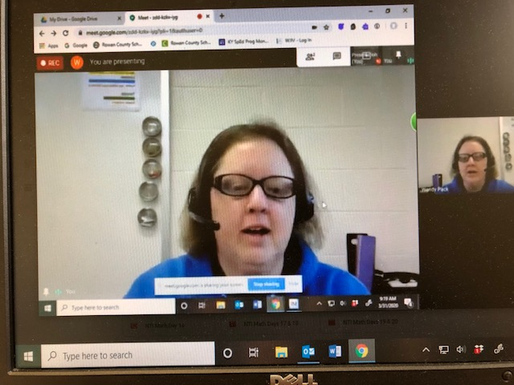 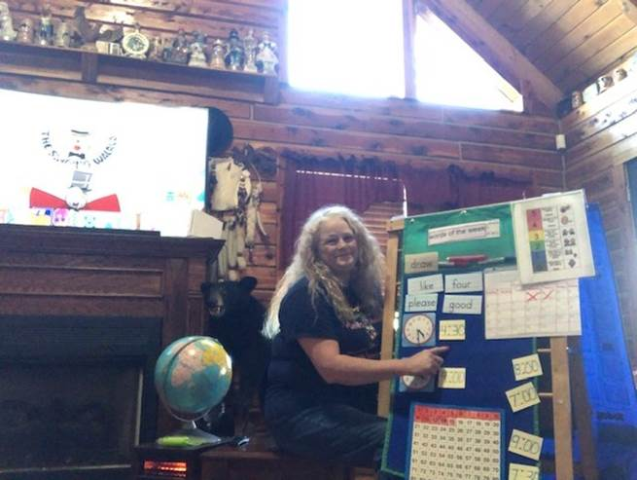

Rowan County is also providing daily lunch pick up for students during NTI days at all of their Elementary Schools as well as the Middle and High School. They are even offering sign-ups for meal delivery service staffed by school personnel who are driving meals to homes who don’t have transportation. This really goes above and beyond and shows the caring support of districts during this difficult time.

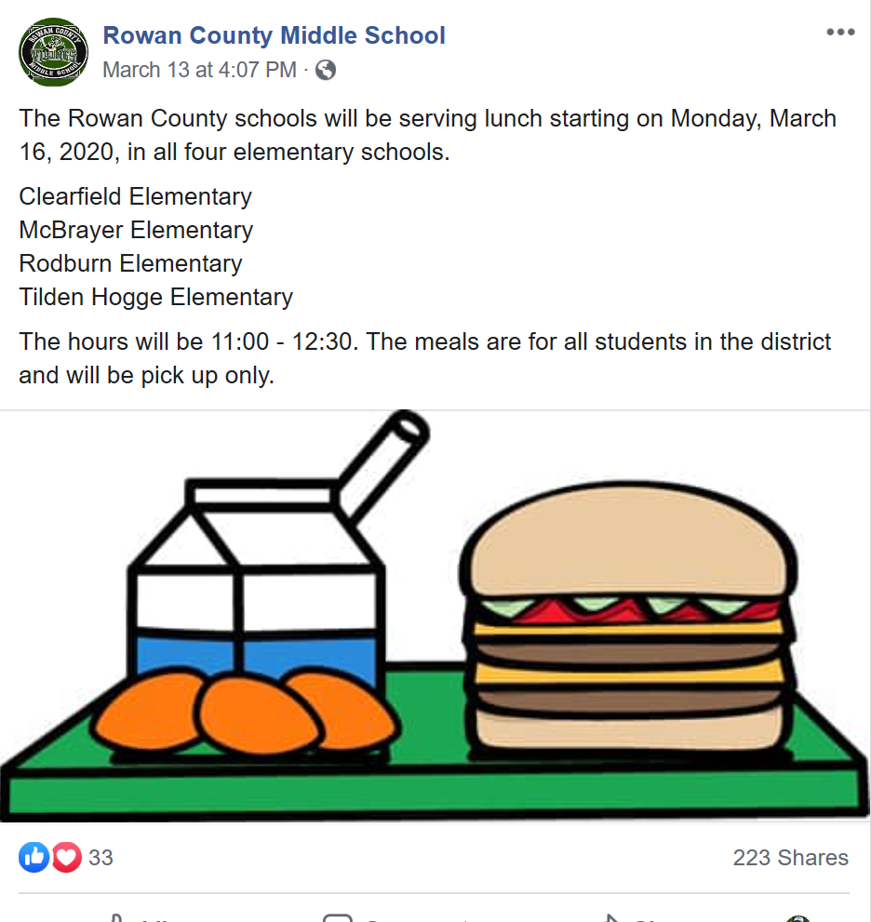 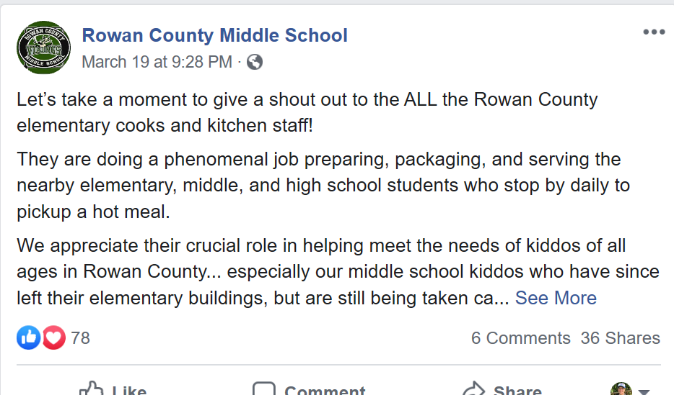

**Special Education Cooperatives**

