**Special Education**



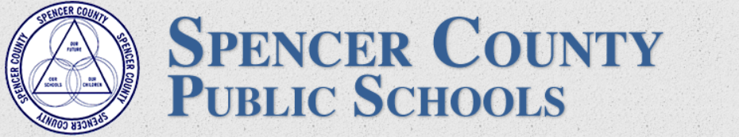

**Moderate to Severe Disabilities Professional Learning Community**

Tammy Hawkins, Special Education Consultant with Spencer County Public Schools, has been diligently working with her Moderate to Severe Disabilities Teachers in their Professional Learning Community this summer to prepare for instructing and meeting the learning needs of students on a digital platform. The teachers have each created unique Google Classrooms to serve the individualized needs of each student.

Lindsey Jaroszek, Moderate to Severe Disabilities teacher at Spencer County Elementary School, has designed a Google Classroom that includes links to videos to address student academic content in reading, math and social studies. Lindsey is also working with students on social emotional needs by linking the pictures that are seen in her classroom to common videos and activities around the subjects of Respect, Safety and Self-Advocacy.

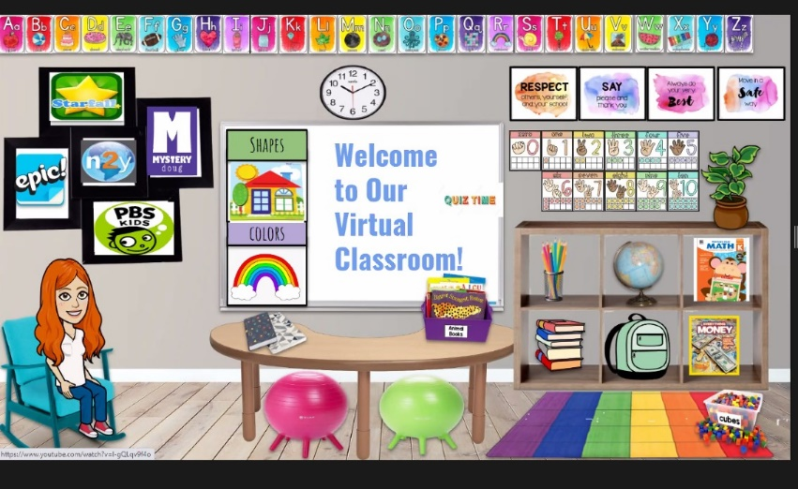

Jamie Ware, Moderate to Severe Disabilities teacher at Spencer County Middle School, has designed a Google Classroom that individualizes the activities for each day in her digital classroom. This includes common activities involving hygiene and mindfulness. These are skills that are addressed to meet the independent living skills each student will need to be successful. Jamie has also created a visual classroom that meets the unique needs of her students with sensory issues including visual overstimulation.

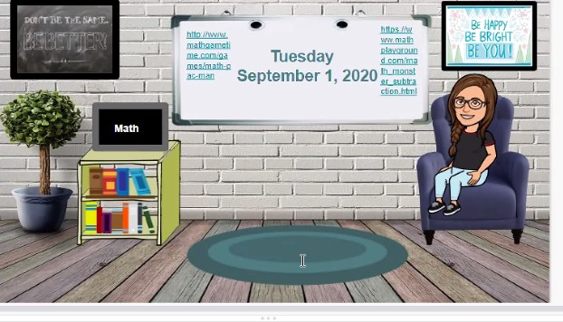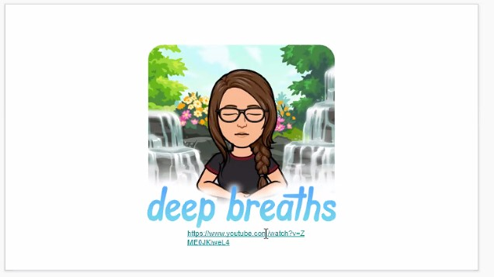

Rachel Coleman and Destiny Walburn are the Moderate to Severe Disabilities teachers for Spencer County High School. Each of these teachers has designed a digital classroom and digital activities to meet the individualized needs of their diverse students.

Rachel has designed activities that mirror the academic and independent living standards taught within her classroom. This includes interactive Google Forms, Google Slides and YouTube videos for instruction. Rachel is also working with her Instructional Assistants to create data sheets to monitor student progress through Google Forms and interactive student sessions.

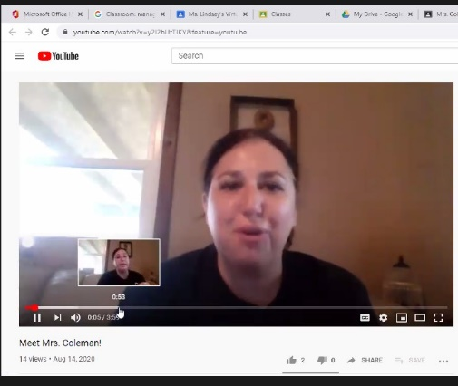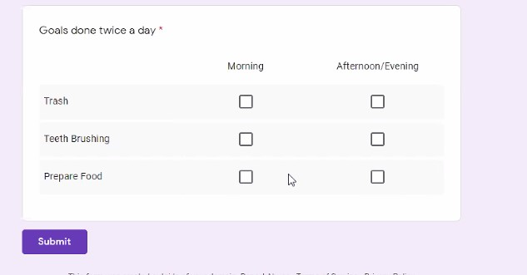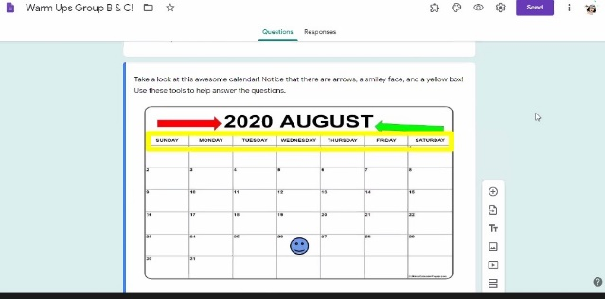

Destiny has designed a Google Classroom that allows access to all students as well as individualized Google Classroom for students to address individual goals and individual skill attainment. The individual classrooms include sections for students to practice self-advocacy with the use of interactive Google Slides. The individual classrooms have also been personalized with specific activities that are highly reinforcing for individual student engagement and activities to promote social emotional well-being. She has even included virtual experiences to community locations such as Walt Disney World.

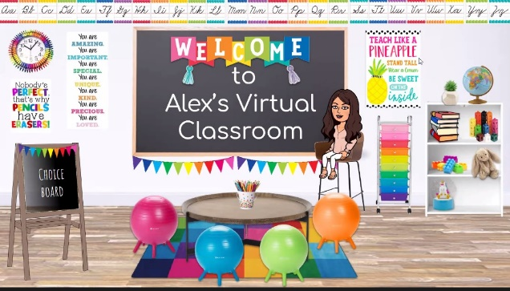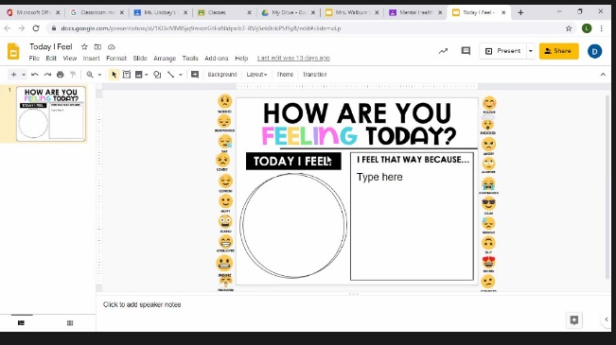

Spencer County Public Schools are striving to meet the needs of every student through innovative and engaging digital platforms and activities. Thank you to Tammy, Lindsey, Jamie, Rachel and Destiny for sharing the wonderful instruction being provided to their students in an engaging way in the virtual world.

**Special Education Cooperatives**

[](https://www.ckec.org/) [](https://www.grrec.org/) [](https://sesccoop.org/)

[](https://www.kentuckyvalley.org/) [](https://www.ovec.org/) [](https://www.kyglec.org/)

[](http://www.kedc.org/) [](http://www.wkec.org/) [](https://www.nkces.org/)