Special Education

Garrard County school district continues to recognize faculty and staff working tirelessly across the school district during this unprecedented worldwide event. Each Non Traditional Instruction (NTI) day, they are rising to the challenge to positively impact the lives of students and their families in such a meaningful, lasting and personal way. Each school day, they are providing quality NTI instruction through numerous communication tools including virtual learning through Google Classroom and Hangout. Staff are delivering food and NTI packets to students' homes and leading the pickup and drop-off line at schools. Staff are scheduling student NTI Spirit Days to motivate students and making K-12 instructional videos, offering resources to students and their families including educational and mental health supports. Also, the district has been intentional in continuing to maintain relationships with the community and they have lead a parade of homes on behalf of students and their families. Teachers miss the face-to-face instruction but they are still working to ensure needs are met. Staff are continuing with Admissions and Release Committee (ARC) meetings, Professional Learning Community (PLC) meetings and Professional Development (PD) using virtual tools and they are using this time to form even stronger relationships with students, families and the community. We salute Garrard County, who by their hard work and dedication, continue to support their students and families in so many ways. #WeAreGarrard #WeAreKYEducators #TEAMKentucky

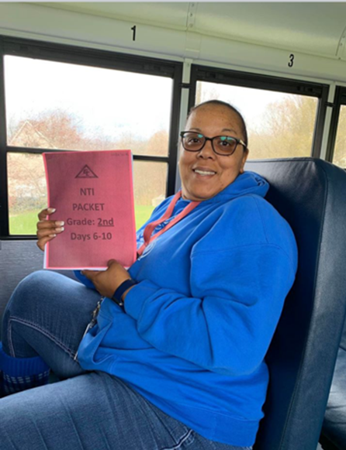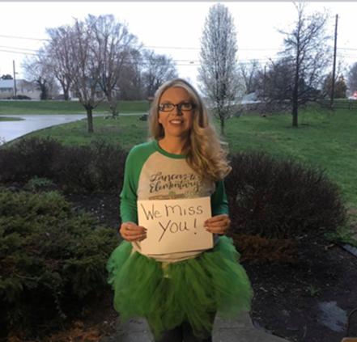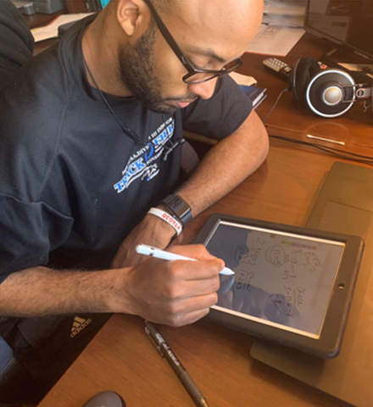

Special Education Cooperatives
