Special Education
Fairview Independent
At Fairview Independent Schools, ARC meetings are still being conducted to meet annual timelines. The district uses Google Hangouts to provide teleconferencing between the Director of Special Education, exceptional child education teacher, general education teacher, related service personnel, parent/guardian, and students as needed.
“I’m very proud of each member of our team and the work they’ve put in to keep everything up and running during this difficult time.” says Fairview Director of Special Education, Kylie Haywood. She also relayed that the district is committed to bringing school to students as much as possible and says that her districts’ plans and procedures are providing appropriate, grade level instruction to each student and everyone agrees it’s been a positive experience for all. The photo below shows a teacher conducting an online ARC meeting from her home.
Fairview is also helping their community by handing out bottles of hand sanitizer. This past weekend, Fairview educators put together, with gloved hands, 300-three ounce bottles of hand sanitizer. These will be passed out drive-thru style by Fairview superintendent, Jackie Risden-Smith. She will be doing so while wearing a mask, gloves, and following appropriate social distancing guidelines. Fairview hopes by doing just this small act during these challenging times that they will make a difference in keeping everyone healthy in their community. #FutureFocused #TeamFairview

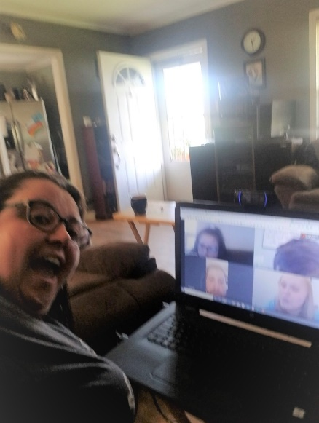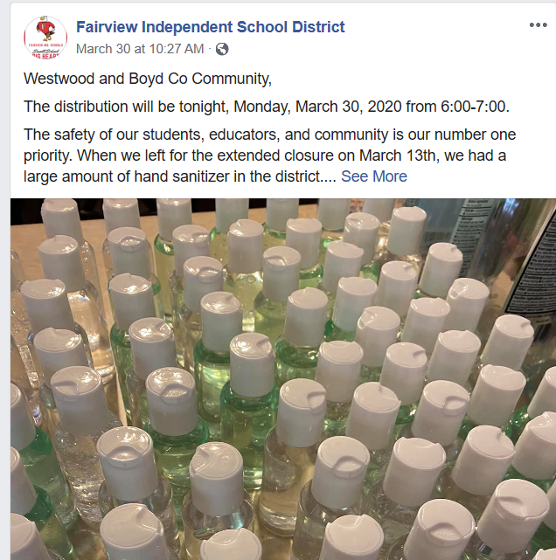
Special Education Cooperatives
