Special Education
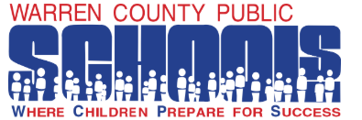

Warren County Public Schools (WCPS) has three full-time Occupational Therapists who are Nicole Martin, Amanda Degenhart, and Amy Lupardus. When they heard that WCPS would be utilizing NTI due to COVID-19, they were worried about how they would best reach their students. One way the Occupational Therapy department is assisting students is by providing activities created through a website. This website was created by their team very quickly to ensure families had access to activities and, more importantly, something visual to which they could refer. They also wanted to make sure they provided a variety of activities and topics that families could choose from that best met their child’s needs. The use of a website was one way the WCPS Occupational Therapy department is supporting students and their families during a difficult time.

Check out their resources here! Warren County OT Activities for Home

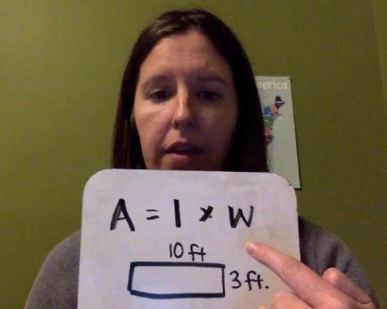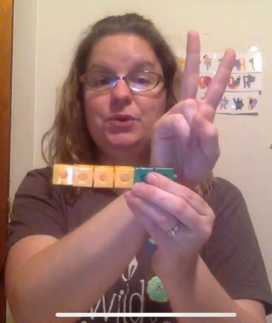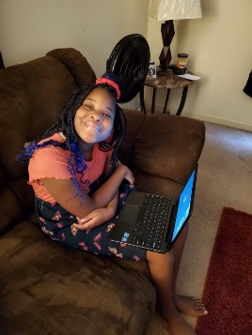

Miranda Stewart and Stacey Heston, Teachers for the Deaf/Hard-of-Hearing, Lindsey Spicer, Certified ASL Interpreter, and Peggy Wallace, DHH instructional assistant, needed to find unique ways to provide access and communication for their students who are Deaf/Hard-of-Hearing during NTI Days. Mrs. Heston had video meetings with middle and high school students to provide support for assignments in other core content classes. Students completed assignments in individualized teacher-made Google classrooms. For two students whose parents do not speak English, Mrs. Heston and Mrs. Stewart used the phone language line translator to call parents and communicate about getting the students set up on Google programs, as well as conduct virtual ARC meetings and a collaborative virtual ARC for a KSD student. In addition, because the DHH students need visual instruction using ASL, the staff worked extra hard to make ASL instructional videos of math, reading, and vocabulary lessons, and science/social studies content topics, as well as daily or weekly live video meetings with students to provide the individualized ASL instruction they needed to complete their work from other content area classes. Ms. Spicer created videos with ASL of core content assignments for the students and provided ASL support on assignments in all classes, including interpreting in class google video meetings to provide communication access for the students. Also, because it is a district program, the students can live anywhere in Warren County, so they drove to the students’ homes for porch pick up/drop off of work and materials. They also delivered special birthday gifts to a few students who celebrated birthdays during the time and special yard signs for a sixth grader and a senior.

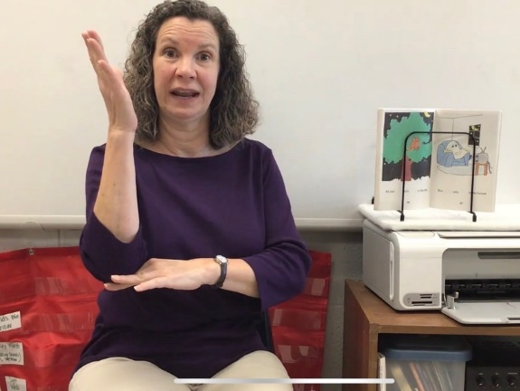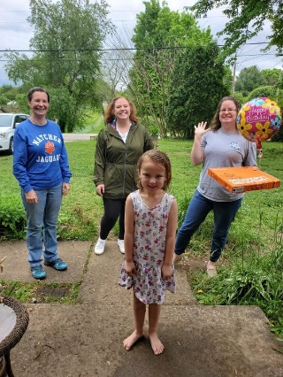

Special Education Cooperatives
