Introduction:
The purpose of this document is to provide more information about how to define local norms and when to use them. In addition, this document offers an explanation of how to calculate local norms and procedures for districts to follow in order to maintain identification consistency.

What is the Difference between National and Local Norms?
The gifted regulation 704 KAR 3:285 states that either national or local norms must be used by a district to identify a student for gifted services. National norms are standardized tests designed to compare and rank test takers in relation to one another using national standards. The raw scores of students from across the United States are used to establish National norms. Local norms allow for within-group comparisons. Students are compared against students who share similar characteristics such as grade, race or school attended, rather than against the student body as a whole. Local norms are calculated using students with similar backgrounds from one or more districts in a region.

When Might Local Norms be Used?
There are at least two main reasons for a district to choose local norms for identification. One reason would be to insure the district’s GT population is proportional to the district’s total population, including subgroups. The other reason would be to ensure equity and access within the GT program.

In order to ensure proportionality, the district should review the proportionality of the total district population to the district’s GT population. To compare data, the Infinite Campus Opportunity and Access Report, School Report Card and district diagnostic data must be evaluated. In comparing data, the district must review all subgroups such as minority, Free and Reduced Lunch (FRL) and special education. For example, a district’s FRL population may total 67 percent. However, when reviewing the GT FRL, the program population is 0 percent. In this example, the district has a disproportionality of 67 percent. A district GT program should strive to have about 80 percent to the total district underrepresented subgroup. Below is the section from the Opportunity and Access Report that could be used to examine proportionality data.

Table 1 – Opportunity and Access Report

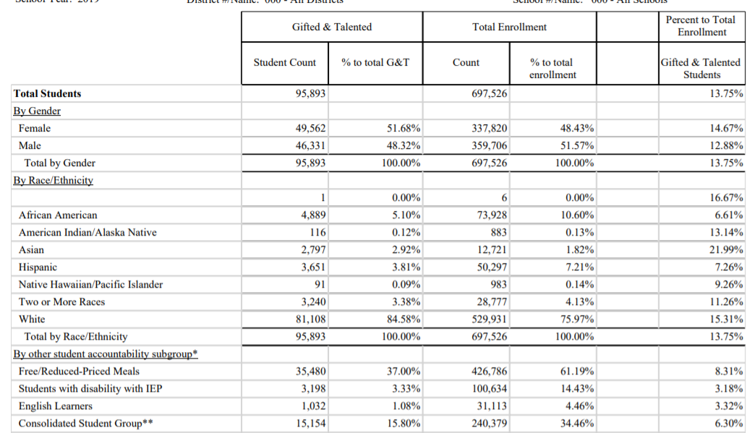

It is also important when reviewing GT category student totals, to review the representation of the subgroup population. For example, a district has 100 General Intellectual Ability (GIA) students. Within the 100 students, 95 students are white and 5 students are Asian. If there are few or no underrepresented students in a category, the district must begin a dialogue to ensure students are not being overlooked.

A district might also consider using local norms if a trend occurs where very small percentages of students are being identified overall in the district or very few students are being identified in certain GT categories. In Kentucky, several categories such as GIA and Specific Academic Aptitude (SAA) require a score at the 9th stanine or 96th percentile or above. If students are scoring at the 96th percentile in a category, a reasonable assumption would be that three to four percent of the district should be identified in a given category. However, if only one to two percent of students are being identified or if a district sees that there are no underrepresented students in a category, the district must review their identification process and determine 1) Is the process being implemented with fidelity and 2) If the process is being implemented with fidelity, does the process need to be changed in order to ensure students are not being missed, especially students from underrepresented populations.

How Should Local Norms be used?

There are several guidelines to consider in order for there to be consistency when using local norms. By using the process below, there will be consistency across the Commonwealth when using local norms in each district.
- Use the largest group possible when administering the assessment. However, a minimum of 100 students will also produce accurate results. If the district decides to use a smaller test group, a random selection can be obtained by choosing the third or fifth student (or any other number) from the entire list of students.
- All students should be in the same grade level. If there are not enough students to compose a group of 100, students from two or more districts who have similar demographics could be tested together.
- When using local norms, students must be tested each year to determine the local norms for the group. Norms from a previous year can’t be used as a baseline for a new group of students.
- To be identified for GIA or SAA, the 9th stanine or 96th percentile and above must be used to be identified in these areas.
- To calculate results using local norms, the district must choose one of the methods below:
  - Request a scoring company to send locally normed scores by grade level
  - Calculate by hand using tool the HOPE Teacher Rating Scale (Manual)
  - Use the calculation document posted on the GT Resource Webpage on the Kentucky Department of Education website

Should there be Reciprocity?

When discussing the issues with shareholders, the consensus was to note “local norms” in the student data information system, Infinite Campus, and then to differentiate services for students when they move to a new district. Due to limited GT staff, many of those polled stated they would rather differentiate services for students than to spend extra time re-evaluating students for gifted services. Staff said they would rather spend time serving students, rather than re-evaluating students.

Also, GT staff indicated a student’s self-esteem might be affected if they were identified as gifted in one district, but then not identified as gifted if they transferred to a new district. Therefore, the majority stated that there should be reciprocity when using local norms, even though local norms would not be the same from district to district.

Resources:
- HOPE Teacher Rating Scale (Manual): Involving Teachers in Equitable Identification of Gifted and Talented Students in K-12 by Marcia Gentry Ph.D., Scott J. Peters Ph.D., Nielsen Pereira, Ph.D., Jason McIntosh
- Using Local Norms to Identify High-Performing Students for TAG - Missouri Department of Education
- Gifted Identification Chapter 3 - Revised - Colorado Department of Education

