Student Work Annotations

Based upon the Science ERQ Rubric

Evolution of Swallows

Grade Level:
9, 10, 11, 12

Designed and revised by Kentucky Department of Education staff
in collaboration with teachers from Kentucky schools and districts.

This work is licensed under a Creative Commons Attribution-NonCommercial-NoDerivatives 4.0 International License.

Background Information About the Task

Task Overview

Students will analyze and interpret data about cliff swallows living in a new environmental that did not exist before the highway was built and describe advantages and disadvantages of shorter and longer wings for flight under highway bridges. Students will use patterns in data to predict which wing shape will allow them to be more successful in the new environment.

Dimensions

Disciplinary Core Idea (DCI)
- LS4.C Adaptations
  - Natural selection leads to adaptation, that is, to a population dominated by organisms that are anatomically, behaviorally, and physiologically well suited to survive and reproduce in a specific environment. That is, the differential survival and reproduction of organisms in a population that have an advantageous heritable trait leads to an increase in the proportion of individuals in future generations that have the trait and to a decrease in the proportion of individuals that do not.

Science and Engineering Practice (SEP)
- Analyzing and Interpreting Data
  - Apply concepts of statistics and probability to scientific questions.

Crosscutting Concepts (CCC)
- Cause and Effect
  - Empirical evidence is required to differentiate between cause and correlation and make claims about specific causes and effects.

Performance Expectations (PE) to which task is correlated
- HS-LS4-3
  - Apply concepts of statistics and probability to support explanations that organisms with an advantageous heritable trait tend to increase in proportion to organisms lacking this trait.
- HS-LS4-4
  - Construct an explanation based on evidence for how natural selection leads to adaptation of populations.

Evolution of Swallows
The original version of this Life Science high school task may be found at: https://docs.google.com/document/d/1_emVdXUuQX52wZvlk7Ke_FNxexOR_sEkqRCjjoR39nw/edit

Evolution of Swallows
Evolution of Swallows

In the 1970's along the I-80 highway in Keith County, Nebraska, drivers started noticing large numbers of dead swallows on the road. This led to a 45-year long study on swallow roadkill to figure out why this was happening."

Cliff Swallows traditionally built their nests on vertical cliff faces. However, with the expansion of roads, they have adopted many bridges, overpasses, and culverts as their colonial nesting sites. Their nests are grey or brown with openings at one end. Cliff Swallows zoom around in complicated aerial patterns to catch insects for food.

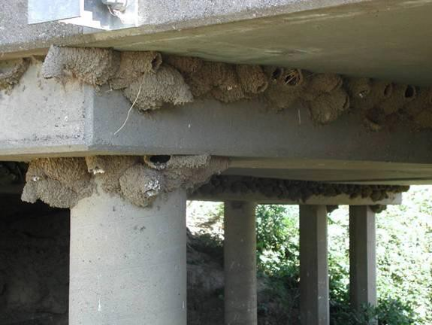

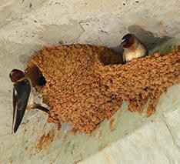

Image source: http://www.cell.com/cms/attachment/2021743115/2041577164/gr1_lrg.jpg
Source of data: Brown, C. R., & Brown, M. B. (2013). Where has all the road kill gone? Current Biology, 23(6), 233-234.

Question 1. What do you think are some of the challenges for cliff swallows living in this new environment that did not exist before the highway was built?

Question 2 . The table below shows some disadvantages and advantages
of shorter and longer wings for bird flight. Consider the kind of flight the cliff swallows who live under highway bridges might need to get food from the road.

Do you think birds with longer wings or shorter wings are more likely to have an advantage that allows them to survive better in this new environment? Explain your answer.

Longer wings | Shorter wings
- Require less energy to use because there’s less drag  - Harder to change directions quickly, turning is slow  - Take off speed is slow | - Require more energy to use  - Easier to change direction quickly  - Allow birds to take off quickly

Question 3. As shown in the picture above, cliff swallows use human-made structures like bridges and overpasses as nest building sites.

The graphs below show what is happening in the cliff swallow population from 1984 to 2012.
Note: Wing length is a heritable trait.
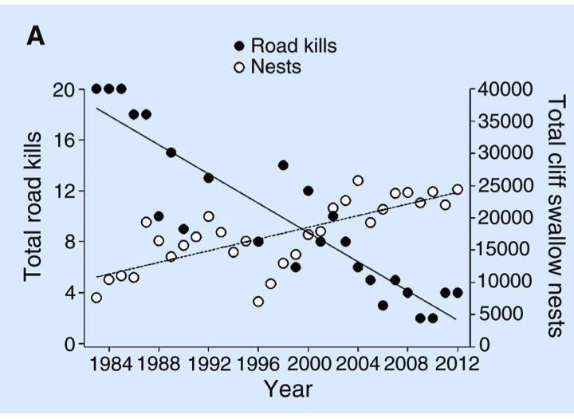

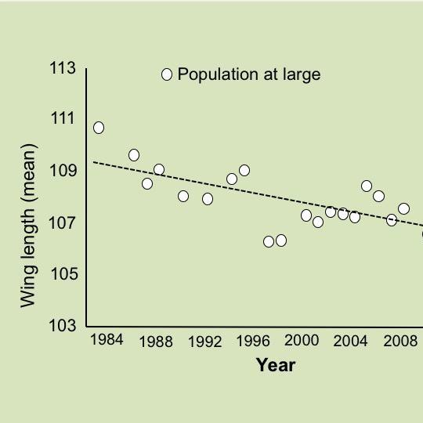

In chart A, The Y axis on the left side shows the total number of swallows killed by cars (road kill). The black dots show the number of swallows killed each year from 1984-2012. There is a second Y axis that shows the total number of cliff nests. The white dots show how many nests were observed each year from 1984-2012.

Question: | Your answer:
1. What is happening to the average wing length over time? | Choose one correct answer:  - Individual swallows’ wings are getting shorter.  - The proportion of swallows with shorter wings is increasing in the population.  - Individual swallows’ wings are getting longer.  - The proportion of swallows with longer wings is increasing in the population.

2. Describe the survival advantage of shorter versus longer wings for cliff swallows. Support your answer with a pattern you observe in the data.

3. How could the total road kills go down, as the nests are going up? (Nests are something scientists use to estimate the size of adult swallows surviving long enough to reproduce.)

4. What about the environment contributes to a change in the average wing length in the cliff swallow population over generations?

5. What is the role of natural selection in explaining the change in average wing length in the population over generations?

Question 4. Draw a dot on the chart below to indicate what you predict the average wing length will be in 2020. How did you estimate where to place the dot? What do you assume in the environment was changing or staying the same in the future?
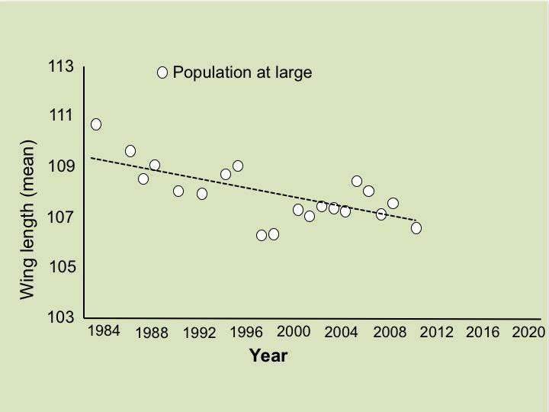

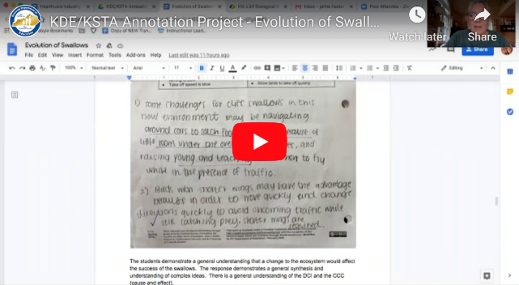
Evolution of Swallows
A video recording of the teacher discussing the annotation can be found at: https://youtu.be/I_sRVBfESQ0

Annotated Task

Below are notes from the teacher in analyzing the questions in order to determine what the students are actually being asked to demonstrate.
Questions 1 and 2
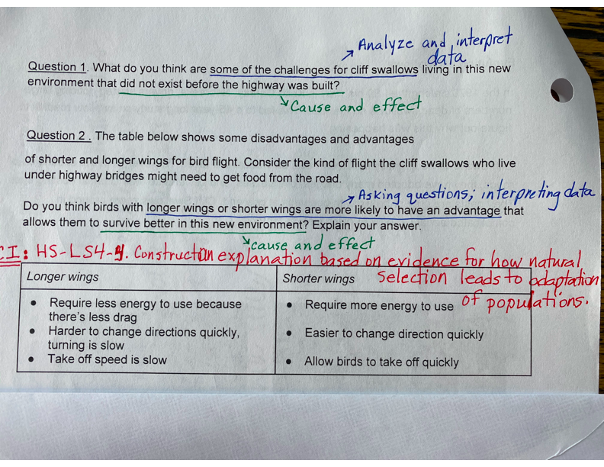

Question 3
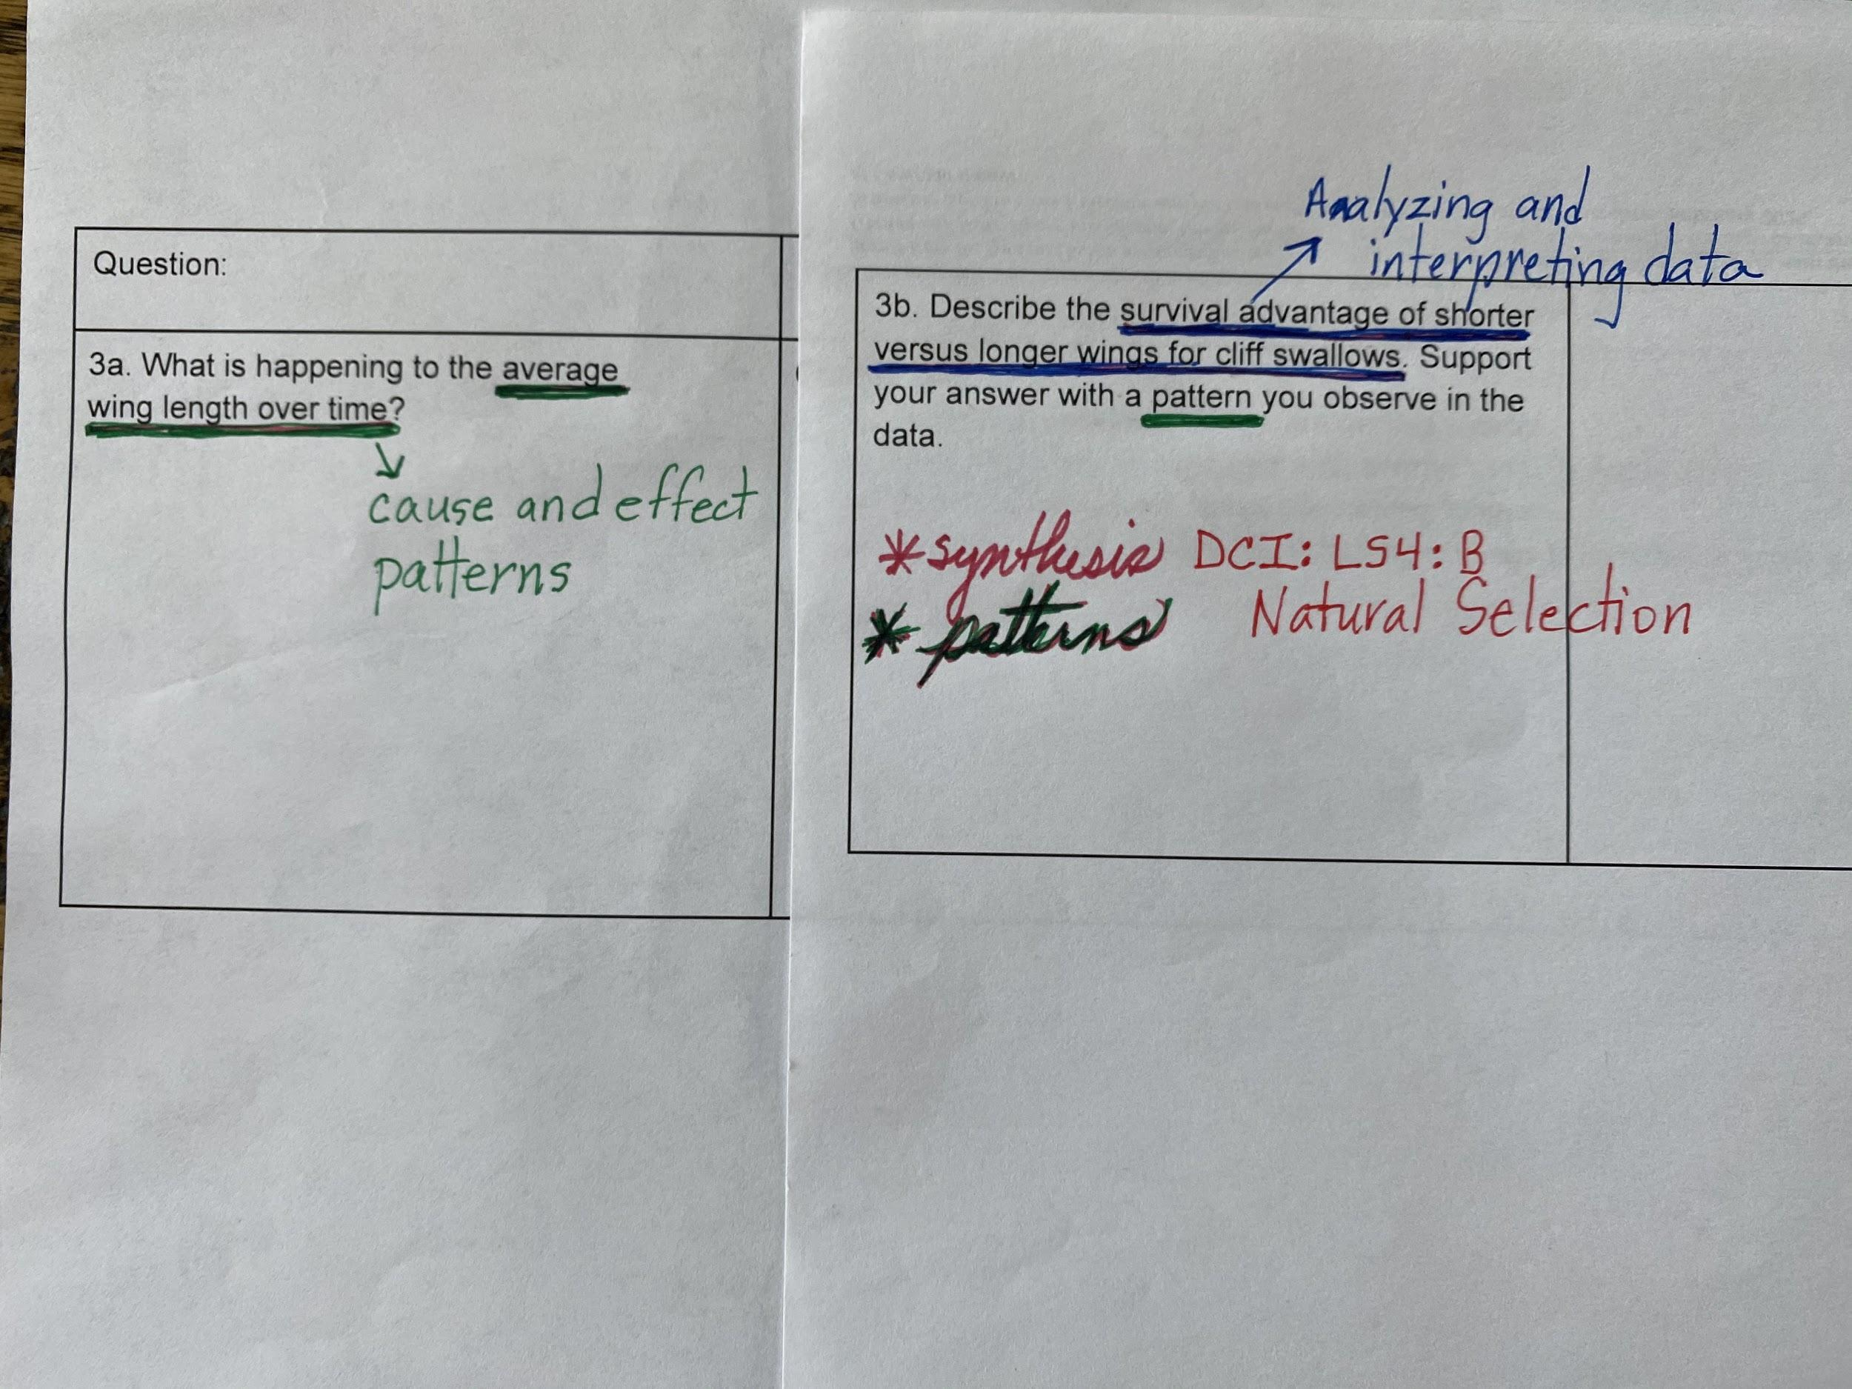

Question 4
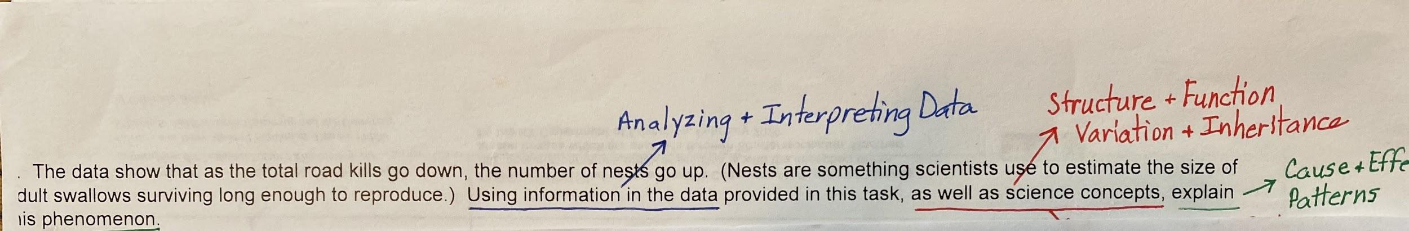

Student Samples
Question 1 and 2

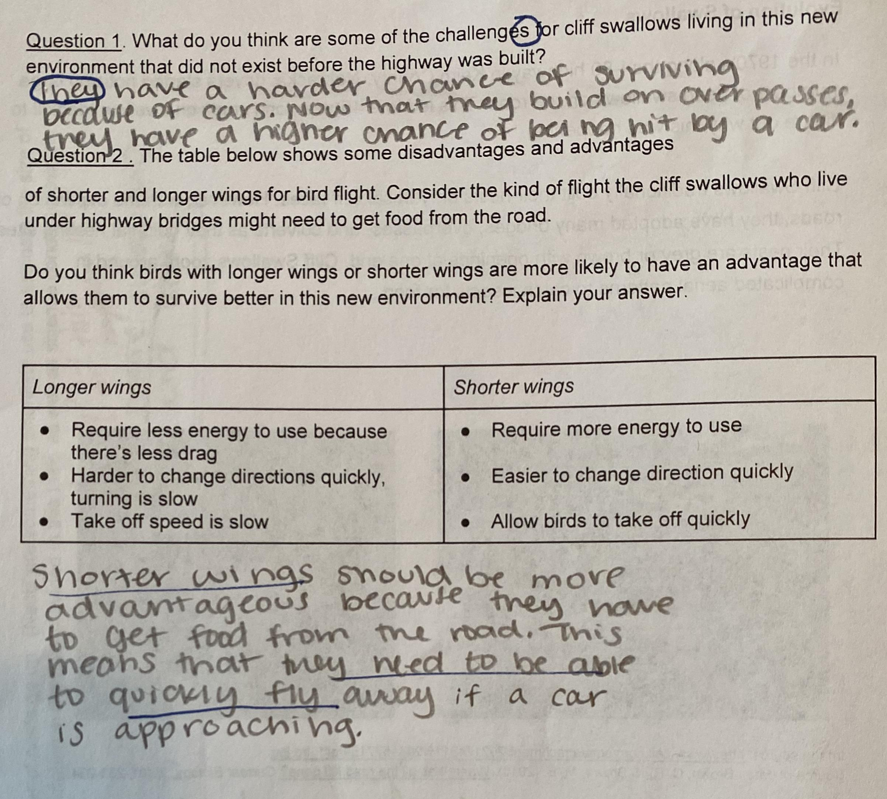

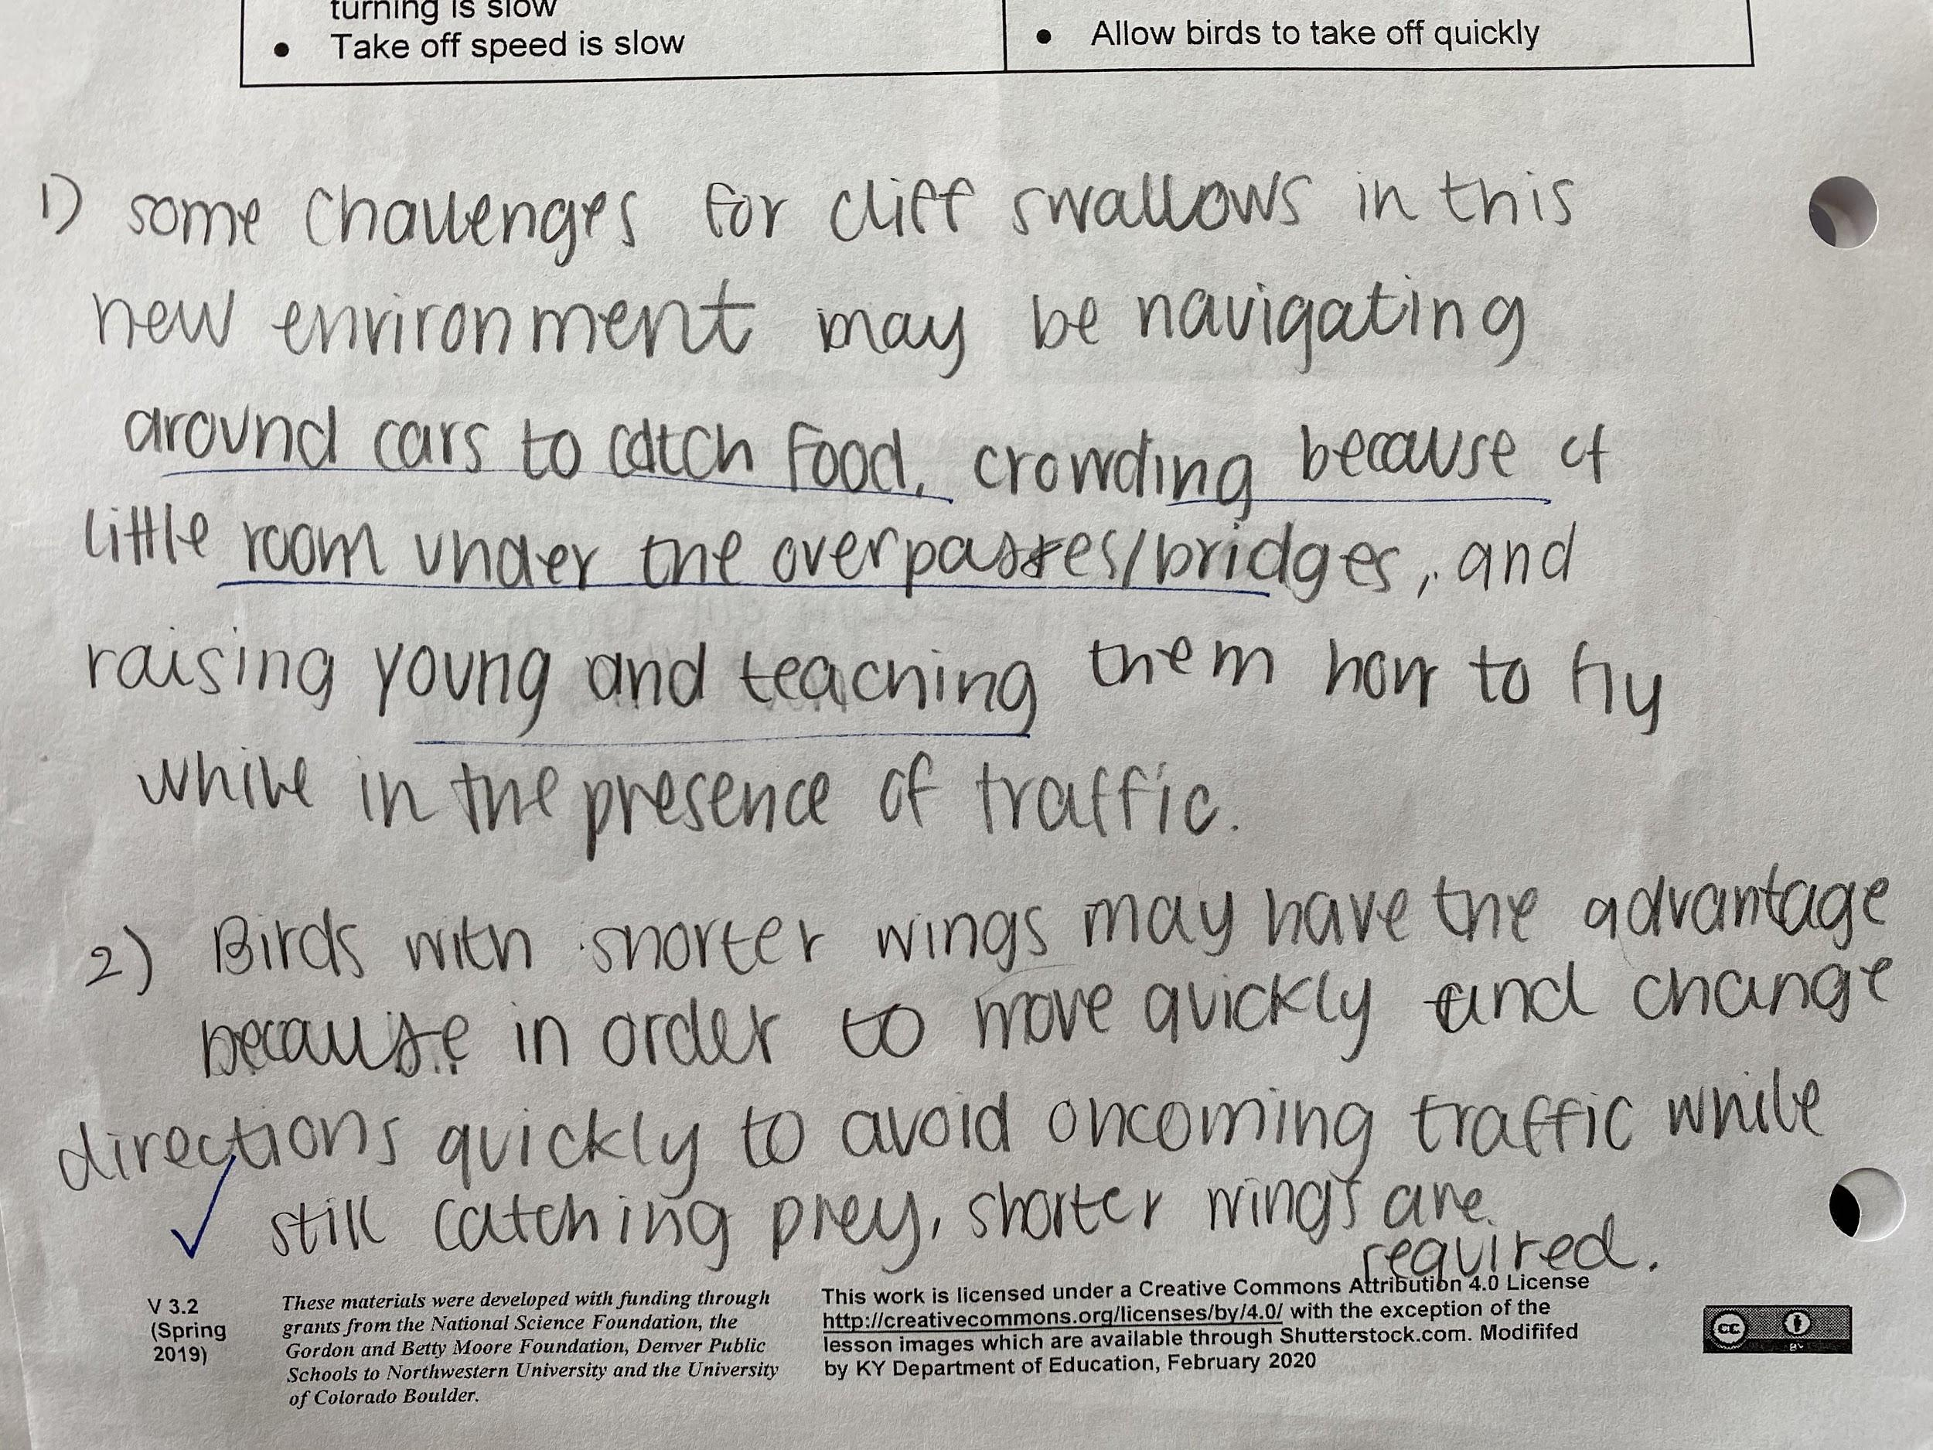

The students demonstrate a general understanding that a change to the ecosystem would affect the success of the swallows. The response demonstrates a general synthesis and understanding of complex ideas. There is a general understanding of the DCI and the CCC (cause and effect).
- “Shorter wings should be more advantageous because they have to get food from the road.”
- “They need to be able to quickly fly away...”
- “Some challenges for cliff swallows in this new environment may be navigating around cars to catch food”
- “Crowding because of little room under the overpasses/bridges and raising young and teaching them how to fly while in the presence of traffic.”

Question 3
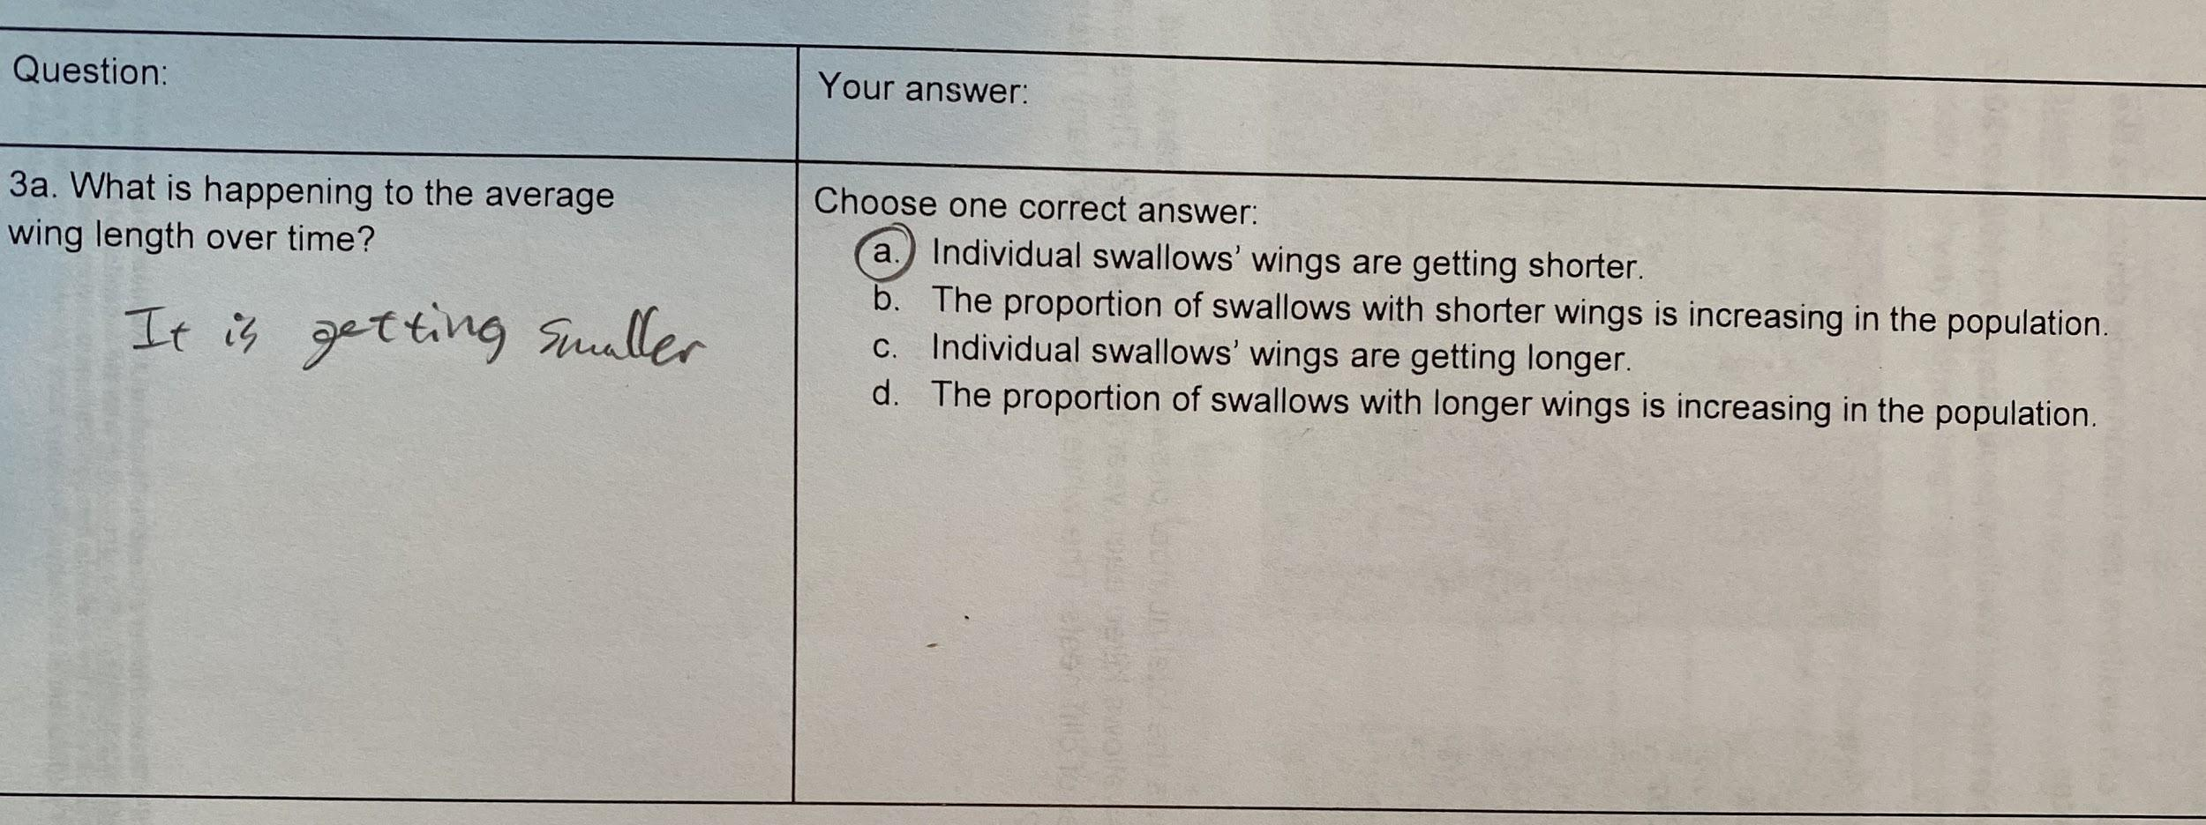
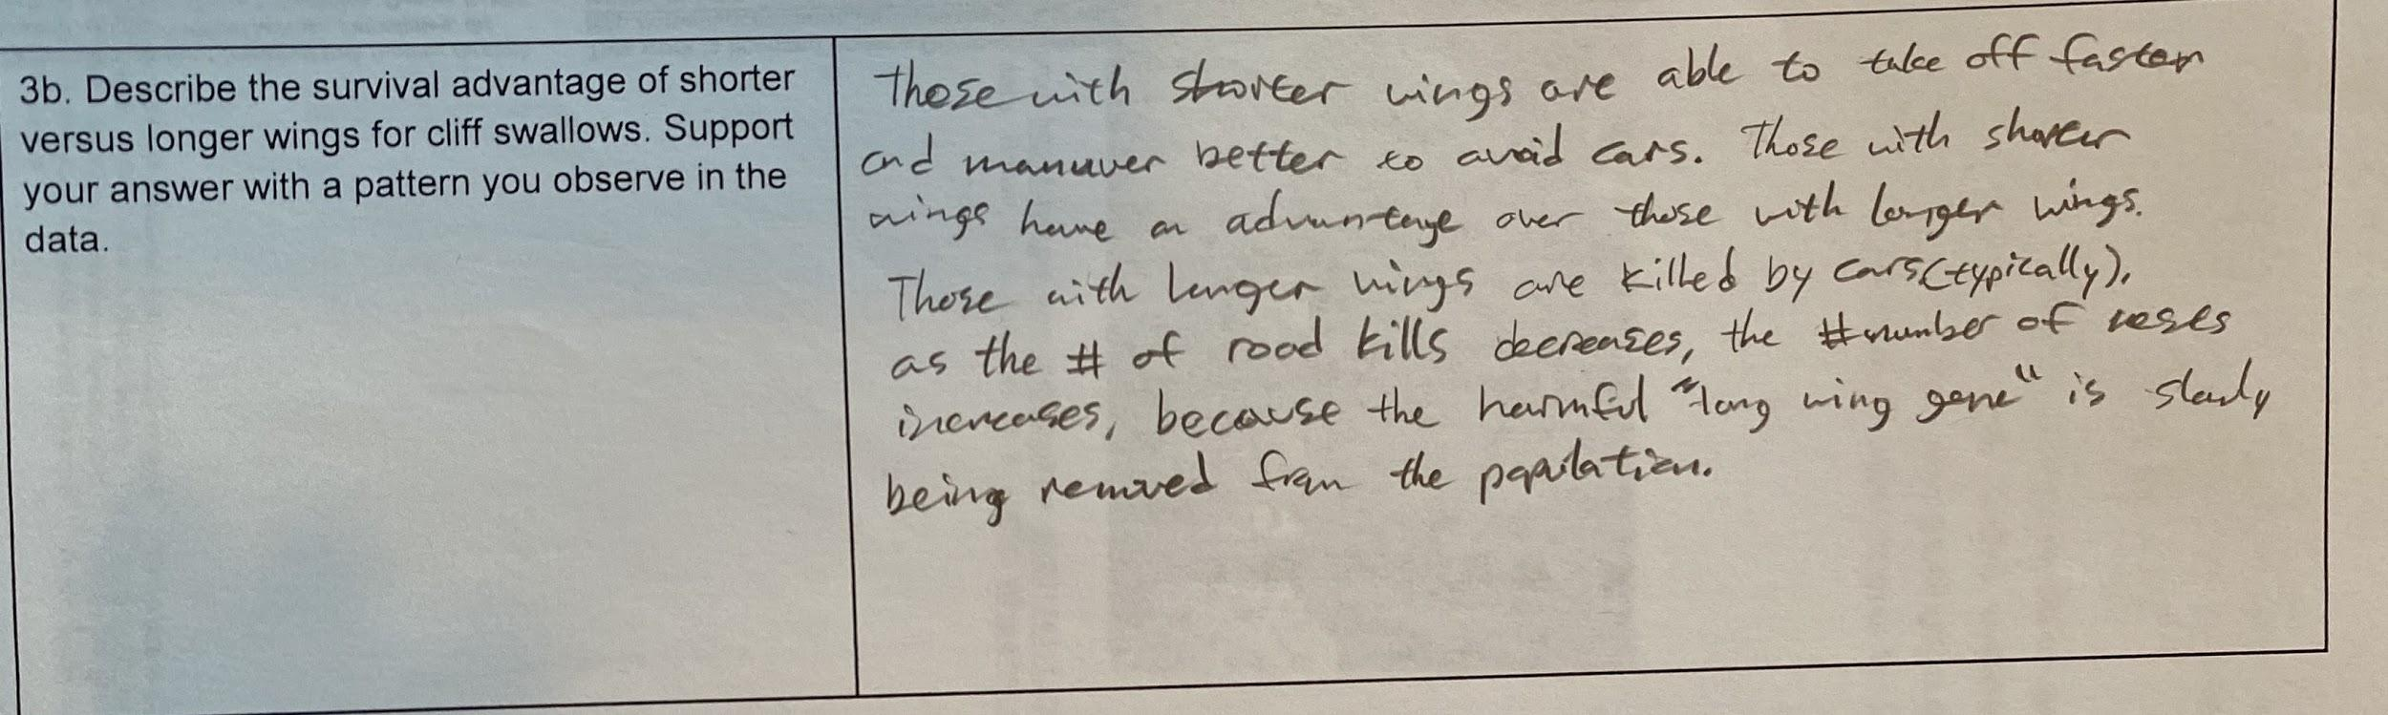
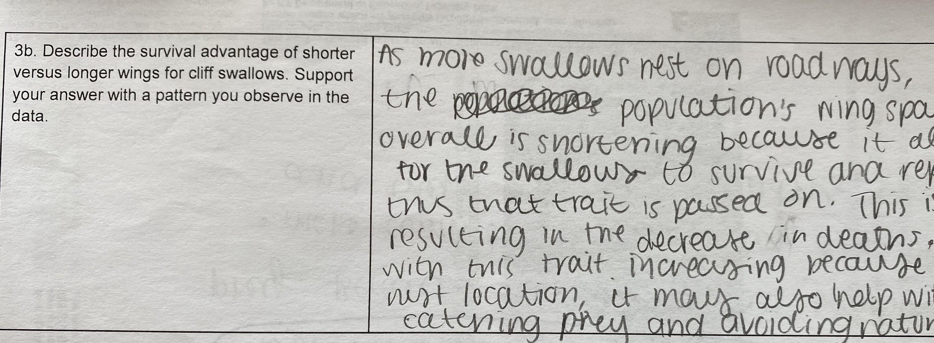
The student refers back to the data from the graph to describe the survival advantage of shorter versus longer wings for cliff swallows. The responses show a general coherence and understanding of the practice (analyzing and interpreting data and constructing a design solution).
- “Those with shorter wings are able to take off faster and maneuver better to avoid cars.”
- “Those with shorter wings have an advantage over those with larger wings...longer wings are killed by cars..”
- “Shortening allows for the swallows to survive and reproduce, thus that trait is passed on.”

Question 4
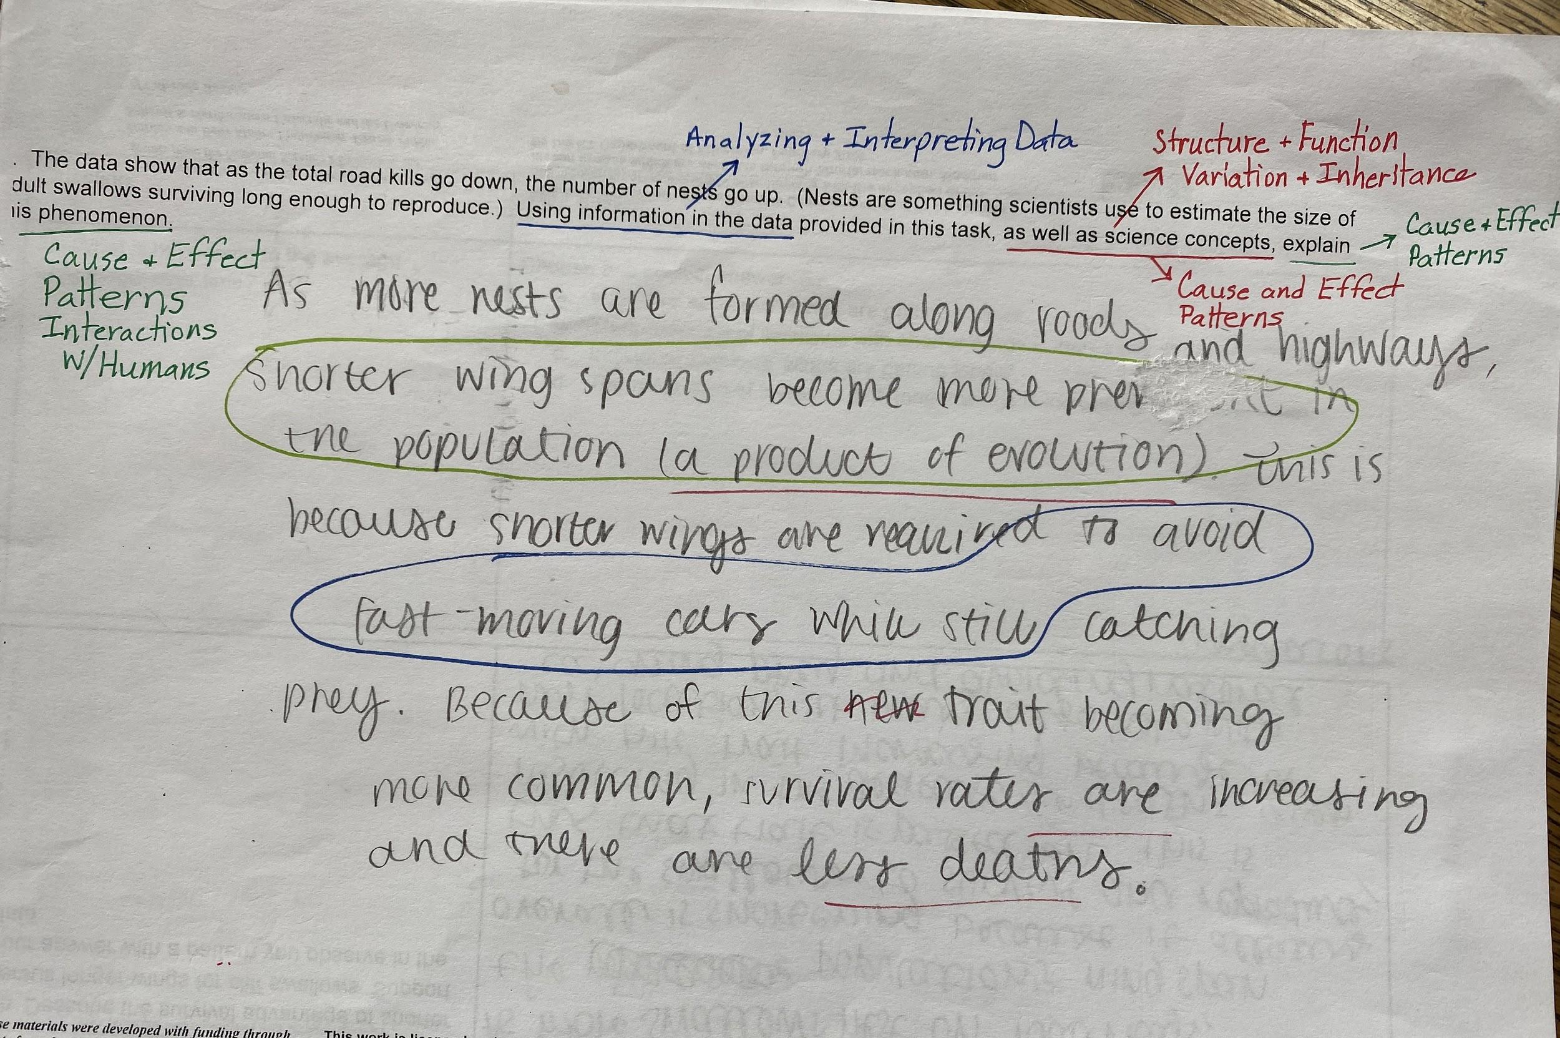

Students show an understanding of the cross-cutting concept of cause and effect as well as recognizing patterns in data.
Constructing explanations based on evidence from multiple sources as well as background information to synthesize the conclusion that natural selection leads to adaptation of populations.
- “Shorter wingspans become more prevalent in the population (a product of evolution)”.
- “To avoid fast-moving cars while still catching prey”.

Sample of Student Feedback on 3-Dimensional Style Task:
*This form seemed easy as I enjoyed reading the text and graphs.
*You can reason and make connections to the graph which helps understanding.
*Felt easier because information is there--I felt sure of my answer/understanding.
*Rather have 4 options (as in multiple choice); this took more effort.
*I liked that you got to “do stuff” instead of just “know stuff”.
*Didn’t like all the writing.
*Even though I like this style as well as multiple choice. Building a concept made more sense than simple recalling information.

