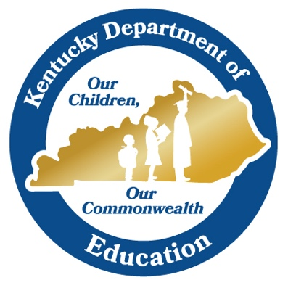

Student Work Annotations

Based upon the Science ERQ Rubric

Introduction

Designed and revised by Kentucky Department of Education staff
in collaboration with teachers from Kentucky schools and districts.

This work is licensed under a Creative Commons Attribution-NonCommercial-NoDerivatives 4.0 International License.

Overview
Science, simply put, is the pursuit of understanding of the natural world. In order to reach that understanding, science incorporates both a body of knowledge and a process by which to connect discrete “facts” into a coherent and comprehensive understanding of natural and designed phenomena.

A Science Framework for K-12 Science Education expresses a vision for science education expectations in the K-12 setting.

The overarching goal of our framework for K-12 science education is to ensure that by the end of 12th grade, all students have some appreciation of the beauty and wonder of science; possess sufficient knowledge of science and engineering to engage in public discussions on related issues; are careful consumers of scientific and technological information related to their everyday lives; are able to continue to learn about science outside school; and have the skills to enter careers of their choice, including (but not limited to) careers in science, engineering, and technology. (NRC Framework, 2012, p.1)

It is traditionally thought that the process of science is a linear model that is commonly known as the “scientific method.” Instead, this process incorporates science and engineering practices (practices) in strategic ways.

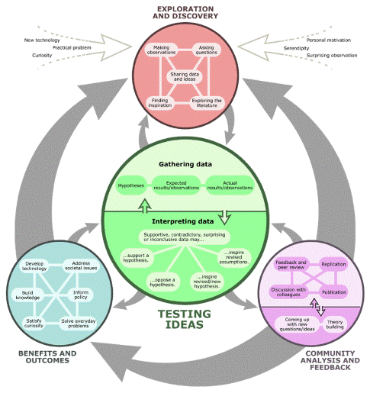

“How science works: the flowchart.” Understanding Science. University of California Museum of Paleontology. 24 July 2020 (https://undsci.berkeley.edu/article/scienceflowchart)
As defined by the Kentucky Academic Standards (KAS) for Science, students should engage with the practices as they come to understand the natural world. Instructional design should incorporate these opportunities for students.

Classroom tasks in which students engage can provide evidence not only of student understandings of core ideas, but also their ability to
- Synthesis their understandings
- Effectively utilize the dimensions of science in a coherent fashion
- Utilize the practices and crosscutting concepts in service of conceptual understandings

These are the core expectations defined in the KAS science rubric used in the evaluation of constructed response questions on the K-PREP science assessment.

This resource demonstrates how this rubric can be used with classroom tasks to show teachers where students are in their ability to communicate their understandings of a phenomenon.

Note on using the rubric:
The score associated with each description should not be used to predict student performance on the state assessment. Constructed response questions are a component of the entire score. More information about scoring and performance levels can be found in the K-PREP 2019 Technical Manual.

Using this Resource
This resource contains five (5) tasks with annotated student work. The annotations describe what is evidenced in the student response. The samples provided are:
- Planning for a Playground (elementary)
- Deer Population (middle)
- Evolution of the Andes (middle)
- Evolution of Swallows (high)
- Star Lifespan and Luminosity (high)

Each task is laid out as follows:
- Background Information
  - Task Overview—what the students are expected to demonstrate, with the three dimensions clearly identified
  - Dimensions—the specific elements of each dimension with which students will engage
  - Performance Expectations (PEs)—those standards for which the task is correlated.
- Task
- Annotated Student Samples

Some tasks also include a recorded video describing the annotation process.

The rubric contains four (4) big ideas, or categories:
- Synthesis and Understanding—Students take the information provided in the task and begin to make sense of it.
- Coherence—Students effectively use the dimensions as expected (i.e., develop an argument with appropriate evidence and use of core ideas).
- Connection to the Dimensions—Students use the dimensions appropriately
- Flaws in logic—Students’ thinking demonstrates misconceptions or their synthesis of the information provided is incomplete.
While all these ideas are connected, teachers may choose to focus on a single component when looking at student work.

This resource was designed to provide examples of student thinking based upon the descriptions presented in the KAS science rubric. Therefore, the focus was not a “correct” response. Students may be very proficient in being able to synthesize information or demonstrate coherence, but a misconception or misuse of a practice may result in a “wrong” answer. Teachers can, therefore, use this as a guide to provide descriptive feedback to the students. Teachers can also identify patterns of class level understandings to inform instructional shifts.

Acknowledgements
The Kentucky Department of Education would like to thank the Kentucky Science Teachers Association Board of Directors for their assistance in the development of this resource.
- Angela Greene, Middlesboro Elementary School
- Stephanie Harmon, Rockcastle County High School
- Jamie Hester, Boyle County High School
- Olga Payne, Daviess County Middle School
- Jamaal Stiles, Bloomfield Middle School

