Instructions to submit the “Pledge of Collateral”

through the

SEEK Web Based Form

Kentucky Department of Education
Office of Finance and Operations
Division of District Support
District Financial Management Branch

Dated: 8/6/21

Pledge of Collateral (formally known as Bond of Depository) Web Based Form Submission Instructions

- The Pledge of Collateral requirements are summarized in KRS 160.570. There is no longer a “penal sum” calculation requirement which was utilized by a district to calculate a bond amount guaranteed by the district’s depository institution. For FY2021-22, a district must simply provide a Pledge of Collateral which will demonstrate collateral in an amount at least equal to deposits in the form of secured funds or a surety bond. In accordance with KRS 160.570, If the collateral is in the form of a surety, then the board of education shall enter into an agreement with its depository institution whereby the premium on collateral guaranteed by the surety company may be paid either by the board, or by the depository, as evidenced in KRS 160.570 (2). If the district board of education pays the premium, the depository shall allow the board not less than two percent (2%) interest on its average daily or average monthly balances.

- The depository selected shall, before entering upon its duties, provide collateral in accordance with KRS 41.240 and 66.480. According to KRS 41.240, the depository institution should pledge or provide enough collateral which, together with FDIC insurance, equals or always exceeds the amount of public funds on deposit. The pledged (collateral) amount is determined by the depository institution and entered in SEEK as it has been in the past and is due to the Kentucky Department of Education (KDE) annually by July 1, with approval from the Commissioner of Education. NOTE: All hard copy documentation is to be maintained at the local school board. The FDIC amount is $250,000, so if the account has less than $250,000, a Pledge of Collateral is NOT required for that account because it is FULLY covered under the FDIC insurance.

- On June 1, KDE will open the window in the SEEK application to allow the districts to update, delete and/or add their collateral information through the “Pledge of Collateral” Web Form.

- In order to utilize the new web form, the district user must have a KDE Web Applications login ID and associated permissions. The login ID is the same ID utilized to submit SEEK data like the Fidelity Bond and Staff data to KDE.

- If the district user does not have a KDE Web Applications login ID, they will need to register for an account at KDE Application Login - https://applications.education.ky.gov/Login/.

- Once they have registered, they will need to contact the districts WAPPOC or the KETS Service Desk to be granted access to the SEEK Application.

- Go to the login screen located at “SEEK District Data Submission” – https://opsupport.education.ky.gov/webforms/Login.aspx login screen. NOTE: The district must use Internet Explorer web browser for the web form to work properly.

- The login process has changed effective June 2021. On your first login, you will enter your “Username” and “Password” for SEEK.
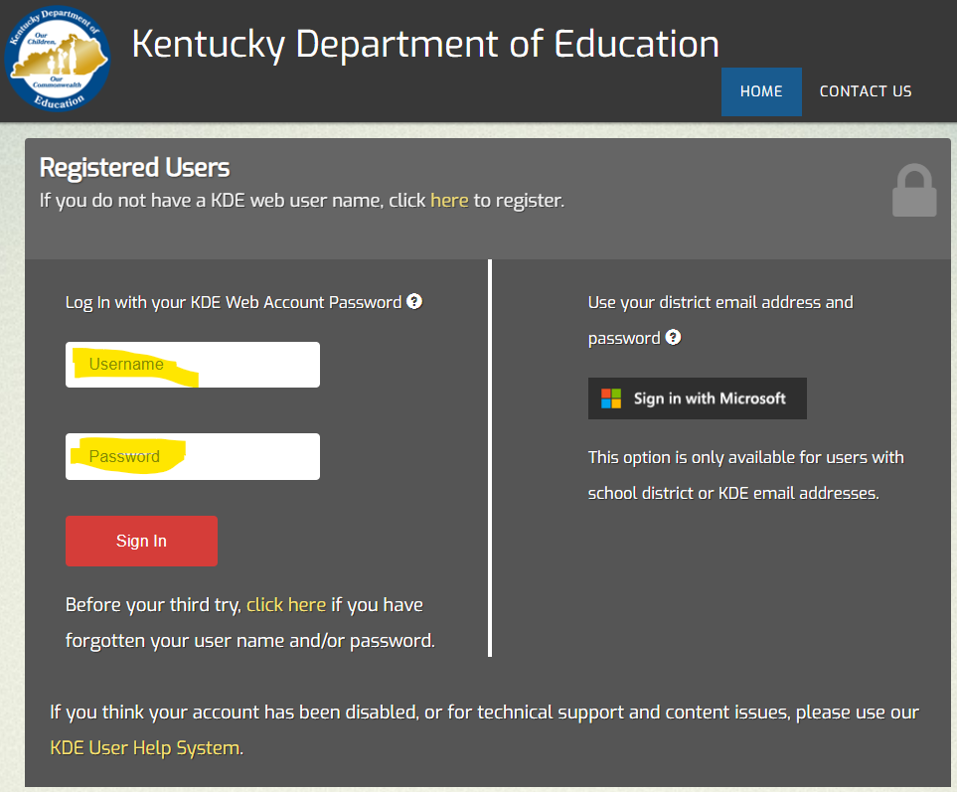

- Once you click the “Sign In” button, it will prompt you to log in using your Microsoft email. Click on your work email and sign in.
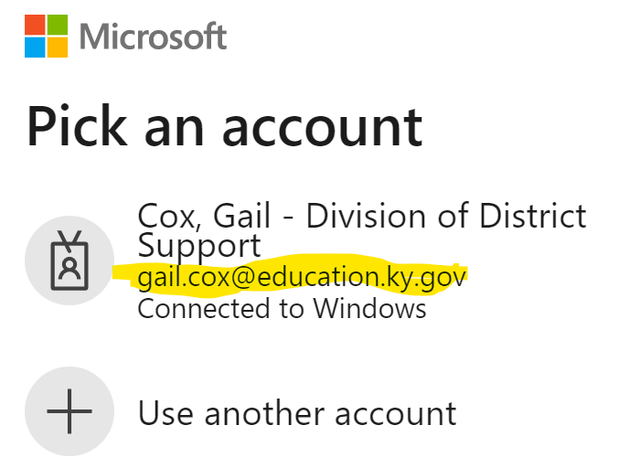

- Once signed in, it will take you to the “Applications” page where you will see all the applications you can access. You will click on the SEEK link.
  - 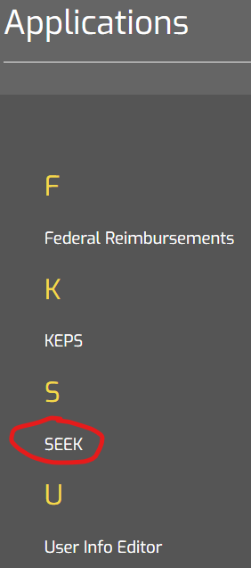

- Once logged in the SEEK District Data Submission, the Home page will appear. Click the Other Forms link on the left side of the screen.
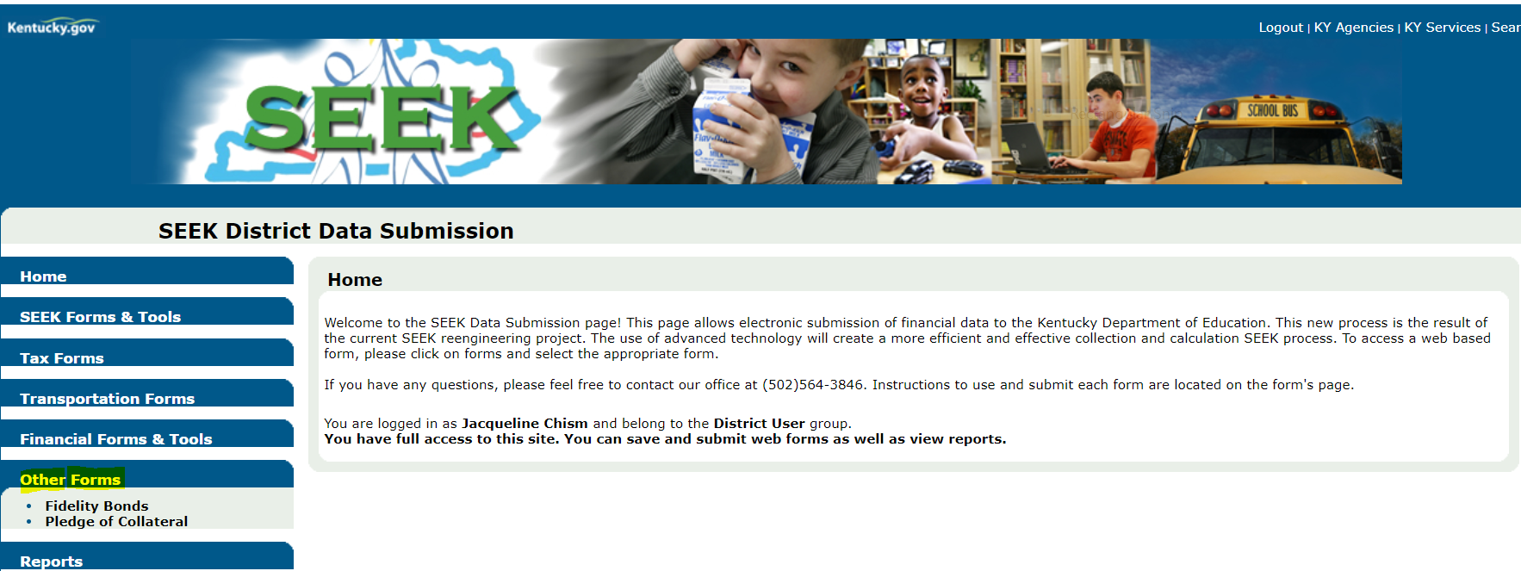
- Click on the Pledge of Collateral link.
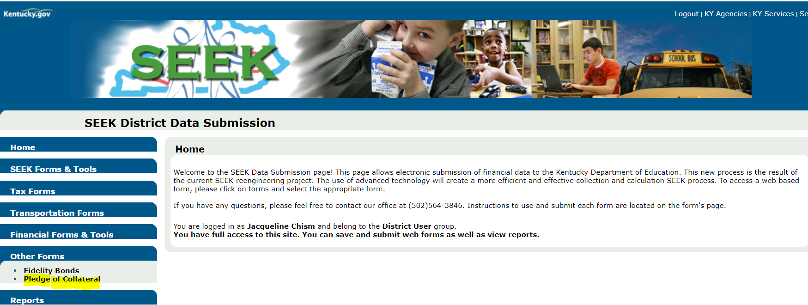

- The District field will automatically be populated with the district name you have permissions to enter information. If you have more than one district you are entering data for, please use the drop-down arrow key to select the proper district.
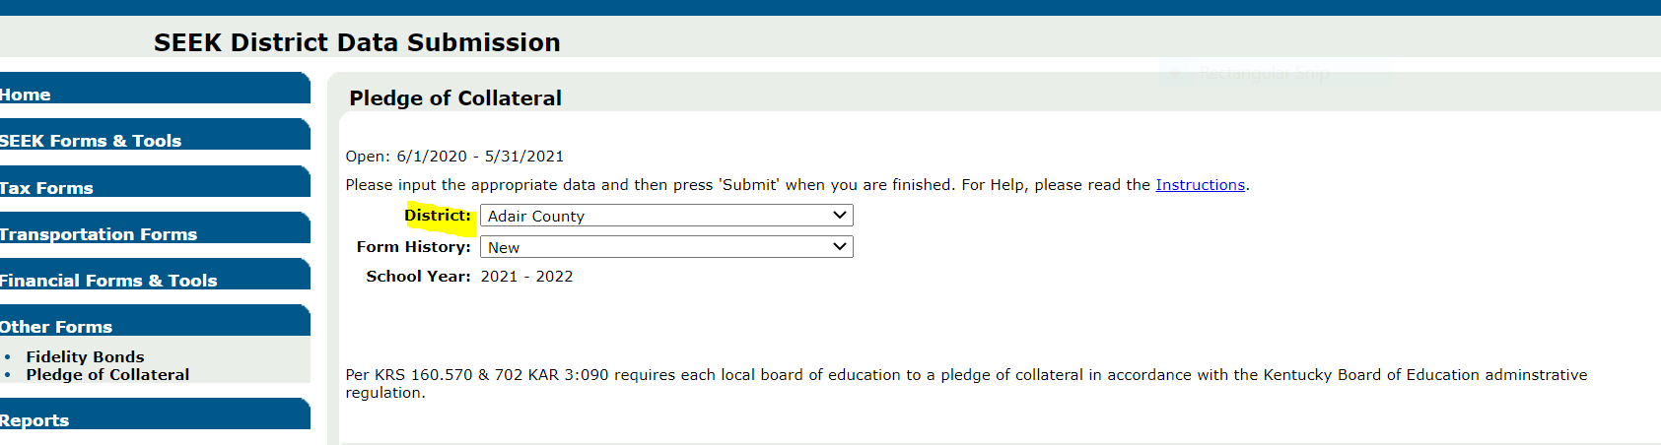

14)In the Form History field:
- “NEW” will automatically display in the box if this is a new FY and the district hasn’t submitted any information.
- “SAVED” will appear when the district has started entering information and they had clicked on the save button before closing the form without submitting the information to KDE.
- “PENDING” will appear if the form is waiting for approval from KDE
- “APPROVED” will appear when approved by KDE
- “DECLINED” will appear if KDE has denied the Pledge of Collateral for some reason and will reopen the window for the district to correct and resubmit. This will remove the new information the district submitted and will default back to last approved information.
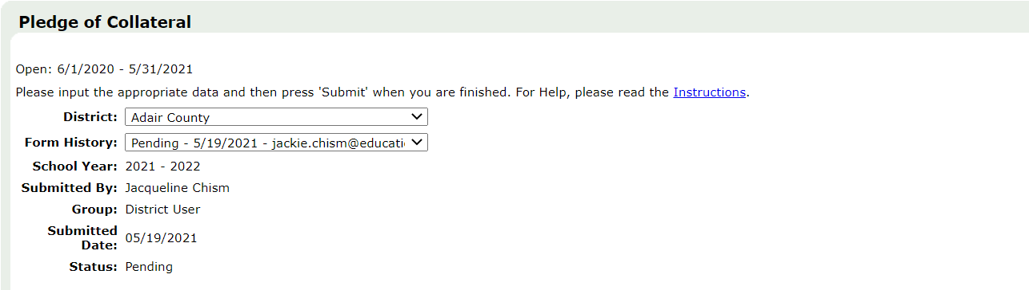

- The SEEK District Data Submission – Pledge of Collateral Screen will automatically populate the following fields’ information:
- School Year – The current Fiscal Year will show by default.
- Submitted By – This is the person that logged in and submitted the districts information to KDE.
- Group – User Group, which would say ODSS – District User
- Submitted Date – Date information was submitted to KDE
- Status – New, Pending, Denied or Approved
- There is a link to the Web Form Instructions in the top right corner of the “Pledge of Collateral” web form.
- UPDATING, DELETING AND/OR ADDING A PLEDGE OF COLLATERAL
Scroll down to see the section called “Pledge of Collateral”. This is a list of previously approved “Collateral Pledges” the district has submitted to KDE.
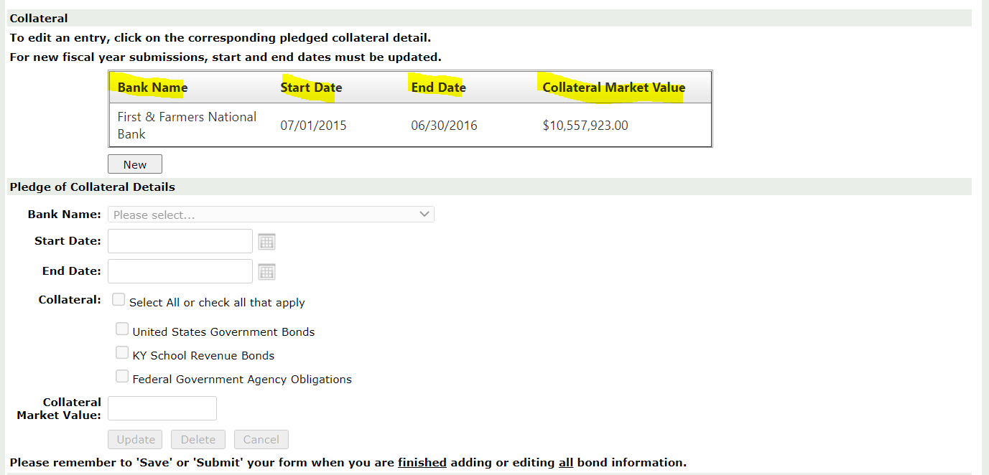

- The district will have to do something with the current collateral pledge record(s) every year - whether to UPDATE the information or DELETE the record.

- NOTE: If you are seeing an EDIT button, the screen is not appearing properly and will NOT let you submit your information. See the steps 4-6 below to fix this problem.

- In your Internet Browser click on “Tools”.
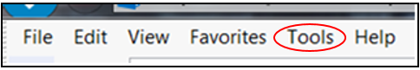

- Click on “Compatibility View Settings” and add the ky.gov website to this setting, then click Close.
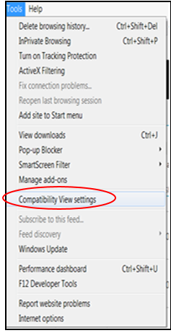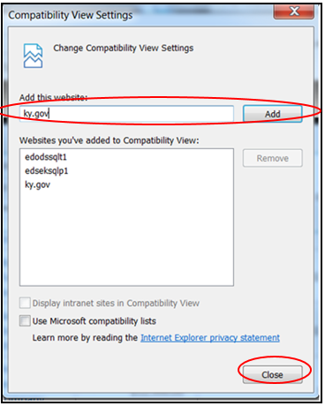

- You may need to logout and log back in for the website to appear like the screenshot in step 8. If it doesn’t and you performed steps 4-6, then contact KDE.

- For the district’s convenience, we have put brief instructions above the current depository records. It states, “To edit an entry, click on the corresponding detail”, so click on the depository record to populate the depository details for editing. The statement “For new fiscal year submissions, start and end dates must be updated,” only applies when editing a record.

- To UPDATE a depository record, click on the “Bank Name” that is listed under “Pledge of Collateral”. This will populate the “Collateral Details” for you. (NOTE: Remember to use Internet Explorer browser or the web form will NOT appear correctly.)
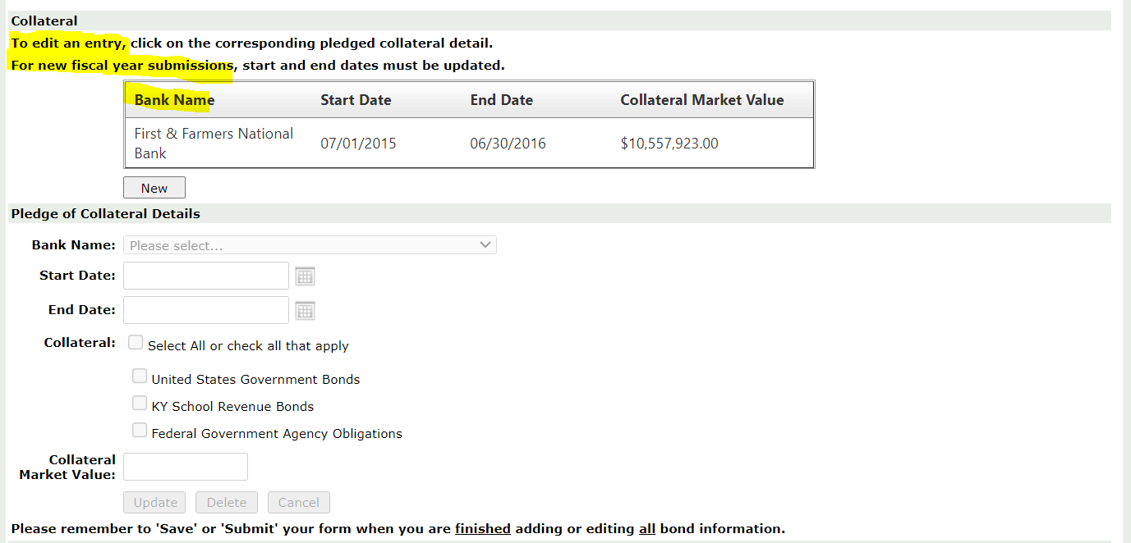

- If the collateral pledge expires 6/30/2019 and the bank is the same, change the Start Date to 7/1/2019 and the End Date to 6/30/2020 to follow the FY. If this information is not updated, an error message will appear. Sometimes the error message will appear at the top of the screen.
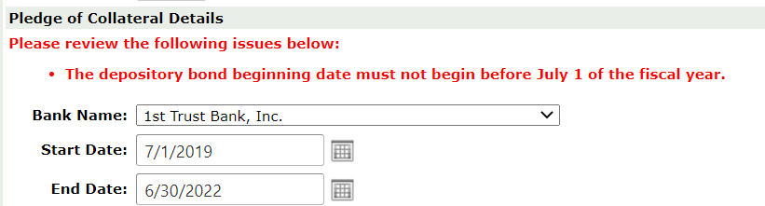

- The web form has been set to a 1-year period, which must follow the current FY dates beginning with 7/1 and end with 6/30. This rule will apply to each FY.

- Next is the “Collateral”. If updating the record, more than likely this has not changed, but verify with the bank if there are changes. (See steps # 21-26 under NEW on where to find the Collateral.
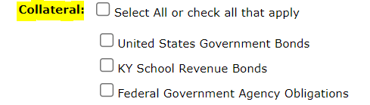

- NOTE: If you have a “Letter of Credit”, it will fall under the “Federal Government Agency Obligations”.

- Next is the “Collateral Market Value”. For this example, the amount is $1,500,000.00. Ensure this amount is the agreed upon collateral amount between the district and depository.

- Once all the information has been entered, click the “Update” button.

- This will populate the “Pledge of Collateral” information table. The only thing that will not appear here is the “Collateral”. If there were any errors, a message would appear in red above the “Collateral Details” or at the very top of the screen, so please be sure to check there if the “Collateral” information does NOT reflect the changes.
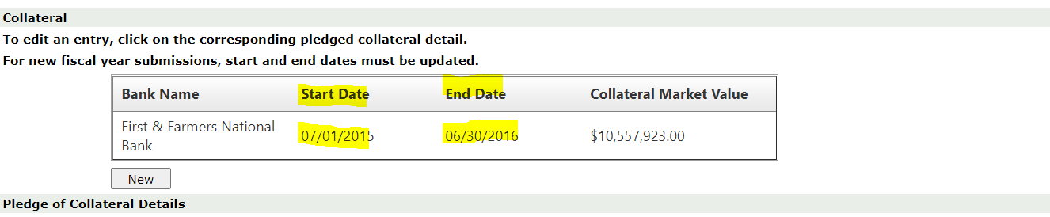
- If there is more than one record, complete steps # 8 – 16 to UPDATE the record, or follow steps #18 - 21 to DELETE a record.

- Once all the collateral information has been verified and updated, go to step # 40 to complete the submission process.

- To DELETE one of the Collateral Market Values, click on the “Bank Name” that needs to be removed, under “Pledge of Collateral”. This will populate the “Collateral Details”, then click on the “DELETE” button. This will remove that bond from the web form and remove the record from the table.
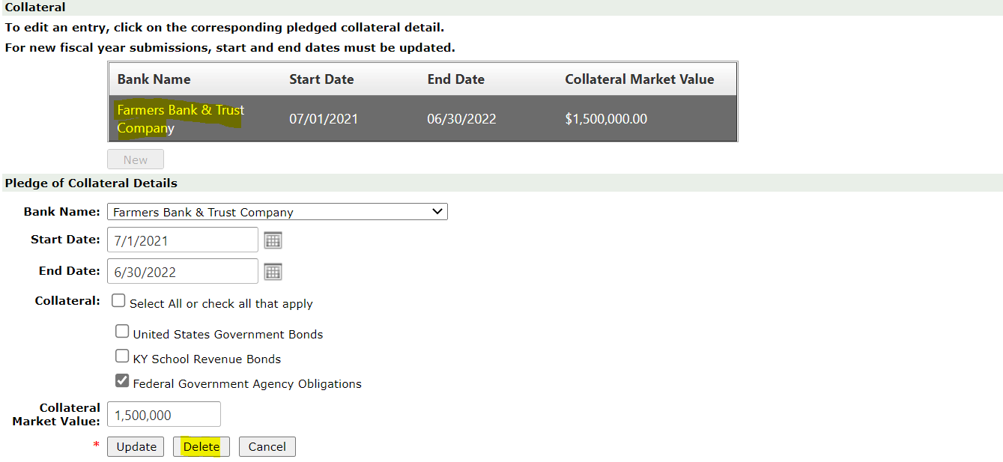

- Once the current record(s) have been UPDATED or DELETED, go to steps #36 -38 to complete the submission process. If there is a NEW record to add, continue to the next step.

- A NEW record can only be added if you have UPDATED or DELETED the current records. There can only be one record per bank.

- To add a NEW record, click the “New” button under “Pledge of Collateral”. This will give blank fields under the “Collateral Details” to enter all the collateral information.
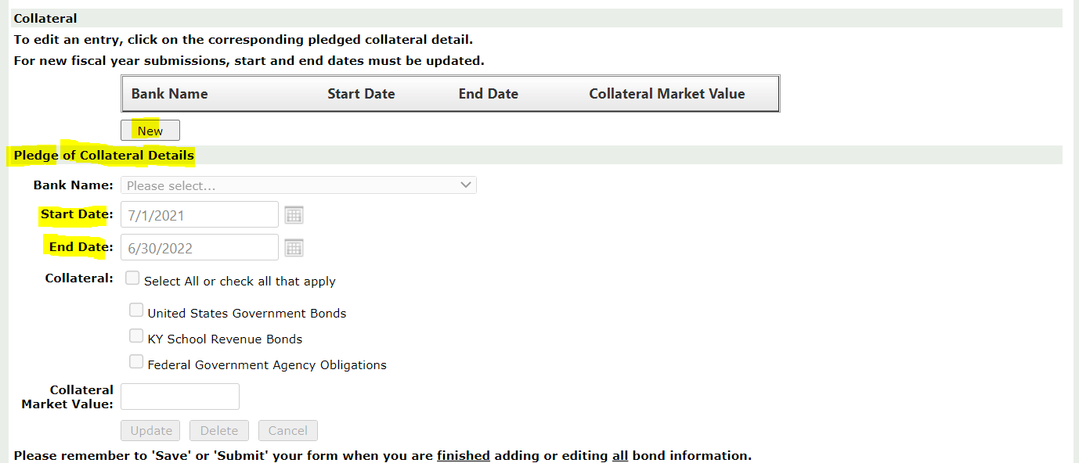

- For a NEW record, it automatically populates the Start Date and End date to follow the fiscal year; again, this is only for a one-year period.

- On the NEW record, enter the “Bank Name”. This information is found on the “Pledge of Collateral” agreement the bank completed. It is located at the bottom of the form beside “Name of Bank” (See example below).
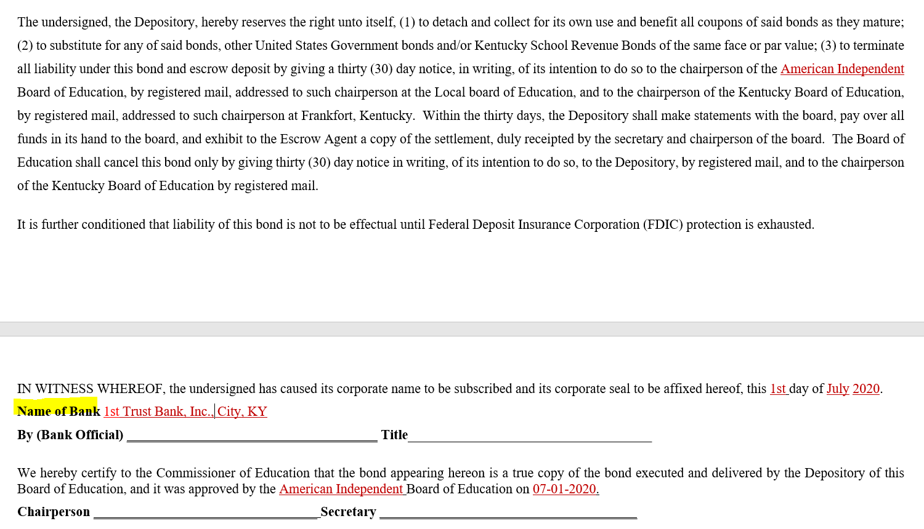

- To select the bank, click on the drop-down box next to the “Bank Name” and select the Springfield State Bank as shown in the example below. NOTE- If the bank is NOT listed, contact KDE.
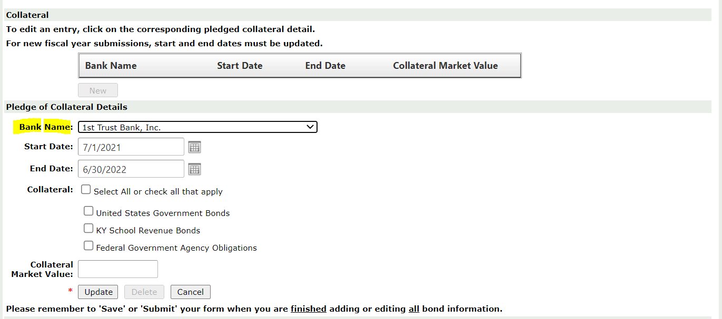

- Next is the “Start Date” this is set by default to the beginning of the FY (Example: 7/1/2020). This date can be changed to any date in the current FY. The “End Date” is automatically populated to one year from the “Start Date” (Example: 6/30/2021). This date can be changed to a date before the one-year period according to the start date.
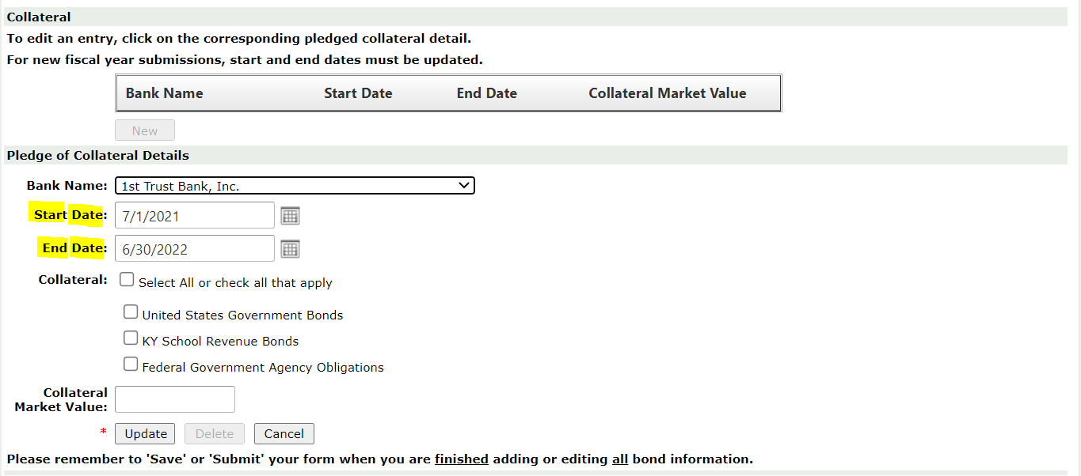

- The “Start Date” is found on the “Pledge of Collateral” agreement at the end of the first paragraph. (Example: Beginning July 1, 2020). (NOTE: The web form is on a yearly basis, so you must use the FY dates according to the web form.)
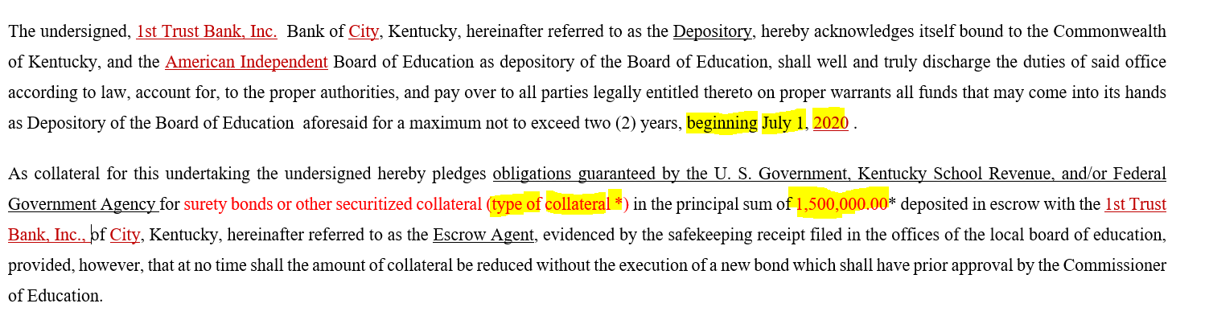
- Next is the “Collateral”, which is found in the second paragraph on the “Pledge of Collateral” agreement or listed on the “Listing of Pledged Collateral” the bank is required to provide to the district. In the web form, check the individual boxes, or if all apply, check the “Select All” box. This will put a check mark in all the boxes. On this record, they have listed “US Government & KY School Revenue Bonds” as collateral, so the two boxes shown below will need to be checked. (NOTE: There must be at least one checked.)
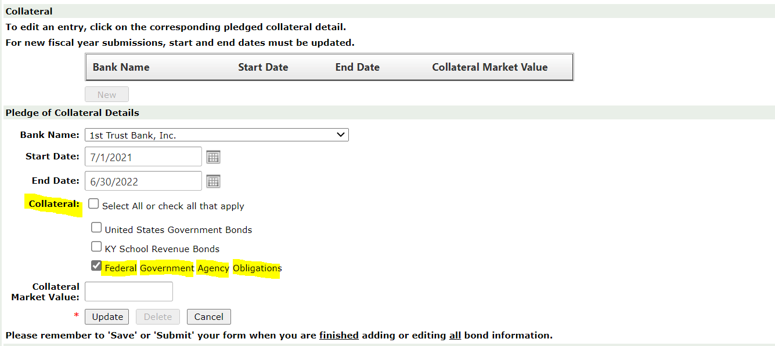

- Next is the “Collateral Market Value”. In this example, the amount is $xx. (NOTE: The “Collateral Market Value” is the board of education and depository’s agreed upon collateral as noted in the “Pledge of Collateral” agreement.
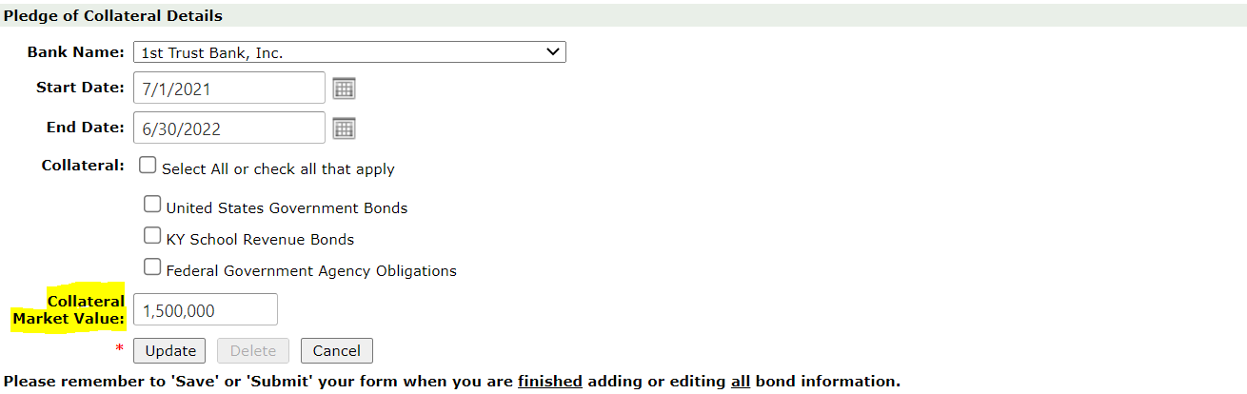

- Once all information is entered, click on the “Update” button. This also SAVES the information.
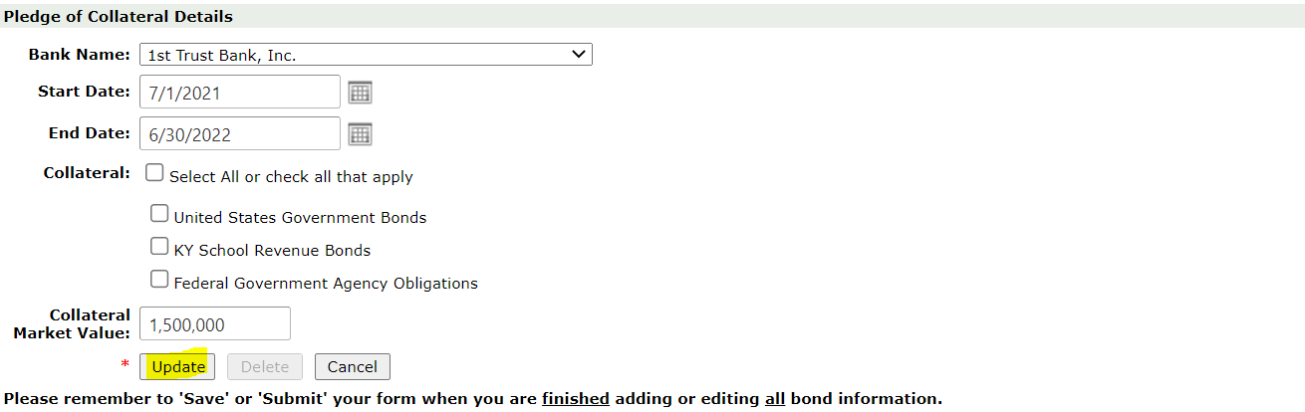

- This will populate the “Pledge of Collateral Information” table. The only thing that does not appear here is the type of collateral. If there were errors, there would be an error message in red above the “Collateral Details” or at the very top of the screen, so please be sure to check if the “Collateral” information does NOT populate.
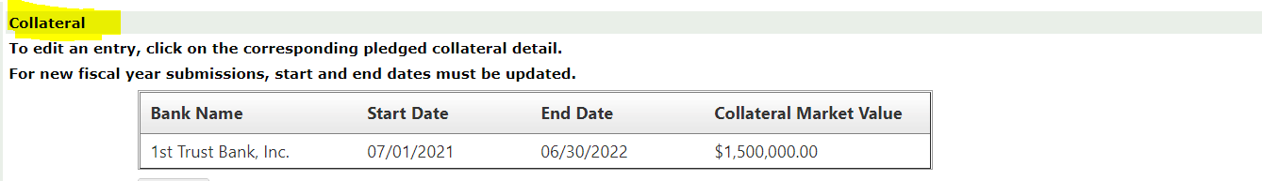
- If there is more than one NEW record, complete steps # 25 – 36.

- If there are errors, there will be an error message in red above the Collateral Details, or at the top of your screen. If the information does NOT change, please check the top of the screen for any error messages. Correct all errors before proceeding.
- The next step would be to confirm the information reported is true and accurate and has been approved by the local board of education. If the board has approved the pledged collateral, the district can still affirm and submit the information to KDE. The required signatures and dates on the original copies are for the local board of education’s documentation only. Once approval has been verified, put a check mark in the box below this statement.
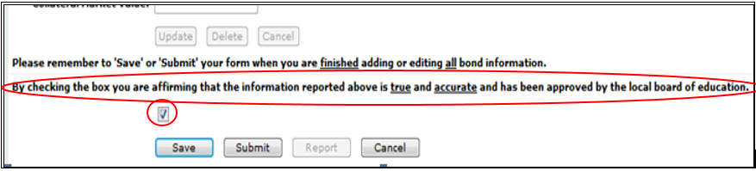

- Once this box has been checked, the “Submit” button will be highlighted, allowing submission of the information to KDE. The district does NOT need to click on SAVE (when the district clicked on UPDATE, it automatically saved the information). The SAVE button is used for exiting the program without submitting to KDE.
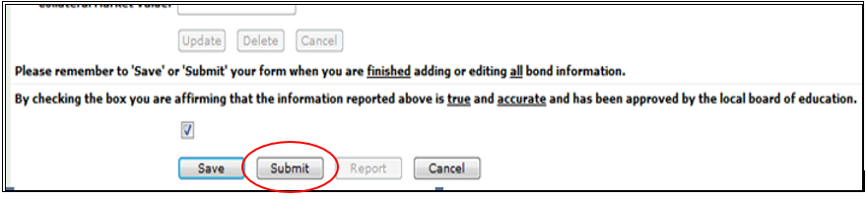

- If the form is NOT entirely completed and the district needs to close the form, click on the “SAVE” button. This will save the information so the district can log back into SEEK later and complete the process. (NOTE: Saving the form does NOT submit it to KDE.)
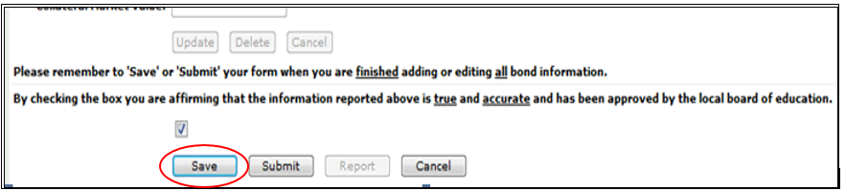

- Once the “Submit” button has been checked and the information has been submitted to KDE, a “Confirmation” message will appear on the screen. If there is no confirmation, there is a problem, so go back into the form and check. This is the only confirmation you will receive.
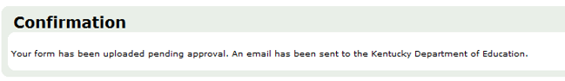

- If the Pledge of Collateral has NOT been approved, but has been reported with incorrect information, or if the district needs to make a change to the record, they will need to contact KDE so the Pledge of Collateral can be denied. When the information is denied by KDE, the window is re-opened, but all information that was changed or added will be lost. The information will revert to the last approved information.

- Once the Pledge of Collateral has been approved by the Commissioner of Education, the district will receive an email stating it was approved, along with a link to the list of approved collateral pledges. For the new FY, this is generally communicated in August.

- For a list of your district’s pledged collateral, log into the SEEK Application and go to the Pledge of Collateral and scroll to the bottom and click on the “Report” button. This will show a report listing for all the districts’ collateral records. This report will only work if the Pledge of Collateral is in “Approved” status reported under “Form History”.
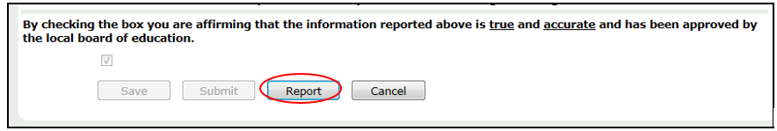

- It will open the “Reports Manager” window. Click on the dropdown button beside Report: and click on “Pledge of Collateral”.

- The current “Fiscal Year” should show automatically. The report can be saved in a different format by clicking on the dropdown box beside “Save As”. Click on the “Run” button to generate the report.
- Below is an example of the report. Print the report and retain for the district’s records.
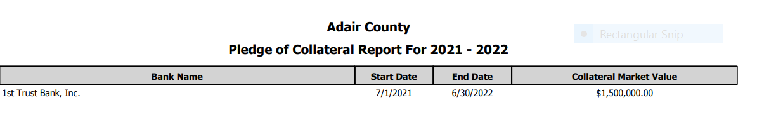
- If the Pledge of Collateral has been approved and the district needs to make a change to the information, then contact KDE so the window can be re-opened for changes. Resubmission of the district’s information will need to go through the approval process again. To view a list of all Collateral Pledges that have been approved by the Kentucky Department of Education’s Commissioner, go to the website at Bond of Depository - Kentucky Department of Education under the “Pledge of Collateral Approval Reports” section.

Please forward questions relating to the Pledge of Collateral to 502-564-3846, Jackie Chism, extension # 4445 or Jackie.chism@education.ky.gov or Gail Cox, extension # 4462 or gail.cox@education.ky.gov.

