Parent Address

Date

Dear [Mr./Ms. LastName]:

This is a follow-up to the attendance letter sent on DATE. Our records indicate that CHILD’SNAME has been chronically absent from school for ## days. A student is chronically absent from school when s/he has missed 10 percent or more of the days enrolled (that is about 17 days of school). Chronic absenteeism is an early warning sign of academic risk, regardless of whether those absences are excused or not.

Missing just a day or two days every month can:

* Make it harder to learn to read by the third grade;
* Cause strong students with good grades to fall behind in class; and
* Put students at risk of not graduating from high school.

Research shows that coming to school regularly matters. It might not seem like it, but even take-home assignments cannot make up for too many absences.

We think it is critical to resolve any problems that may be causing STUDENTNAME to miss school. Please call me at ____________________at your earliest convenience. [OR SCHOOLSTAFFMEMBER will be contacting you to set up a time to meet with your child’s learning team to discuss supports.] We would like to learn more about what is making it difficult for your child to get to school and to work together to overcome these challenges.

We look forward to working with you to improve your child’s attendance and school experience.

Sincerely,

Principal

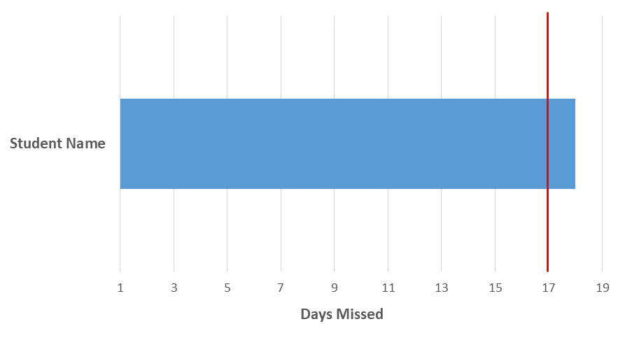

**At Risk of Falling Behind**

**Your Student is Now Considered Chronically Absent**